**ASS-5.2**

1. MapReduce program to calculate the total units sold for each Company

DRIVER CLASS

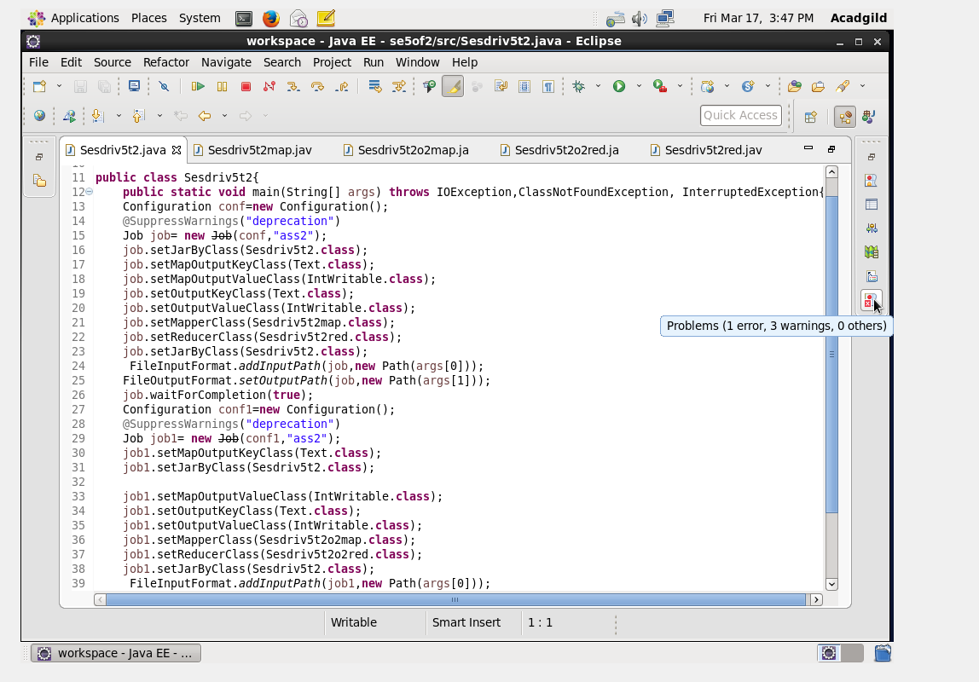

The driver class just defines the path of input file and where output to be stored

MAPPER CLASS OF TASK1: 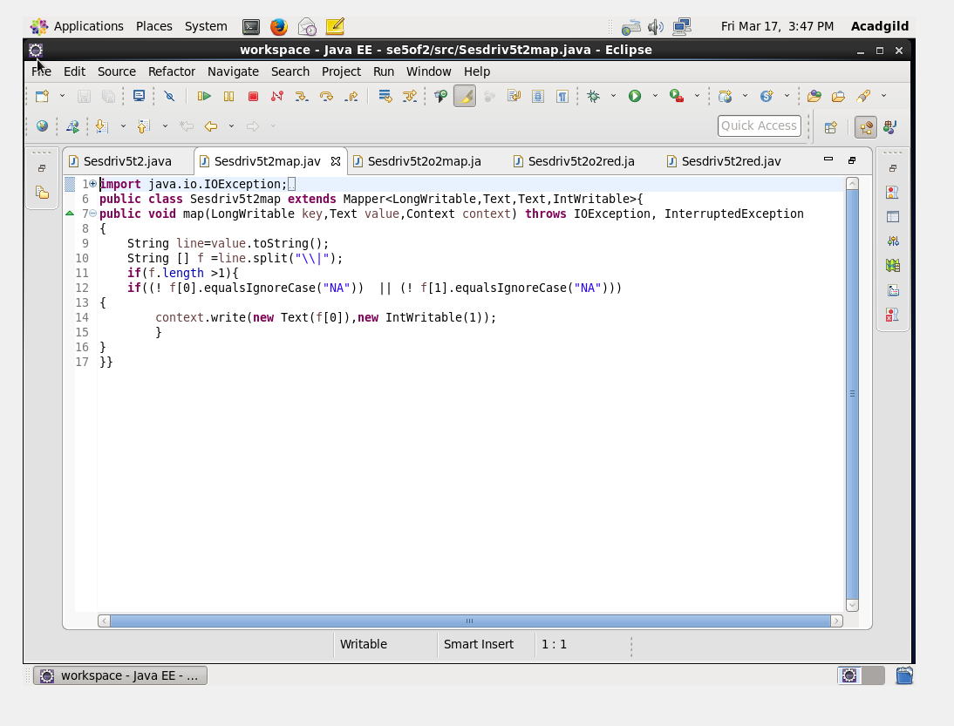

This mapper class refines the total no of items each company sold items and gives the count of items.

TASK 2:MapReduce program to calculate the total units sold in each state for Onida company.

MAPPER CLASS OF TASK 2:

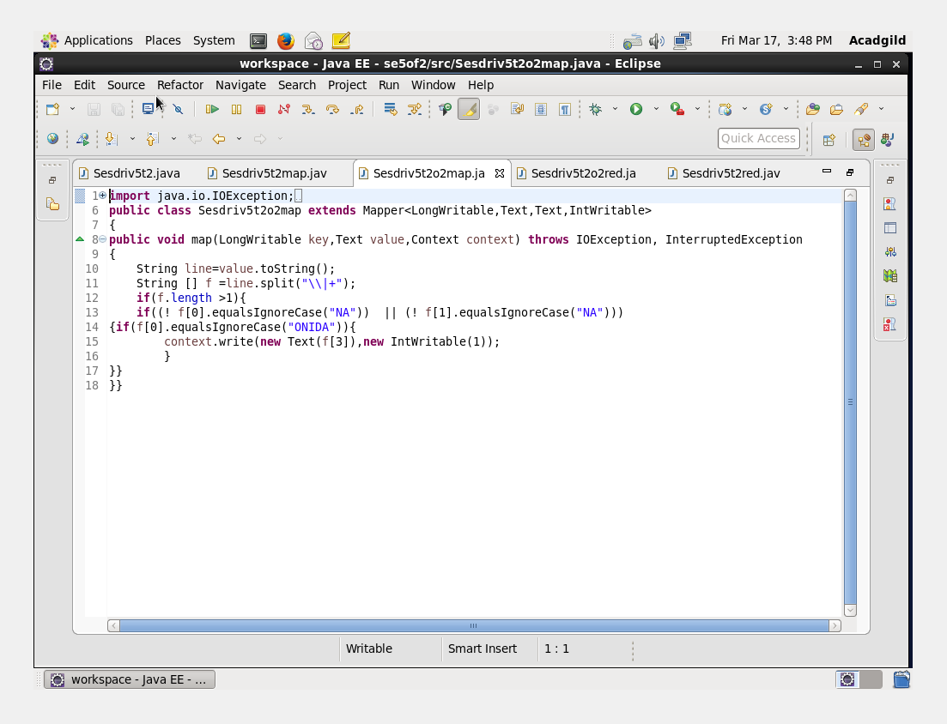

This mapper class refines only onida sold items and gives the count of items.

REDUCER CLASS :

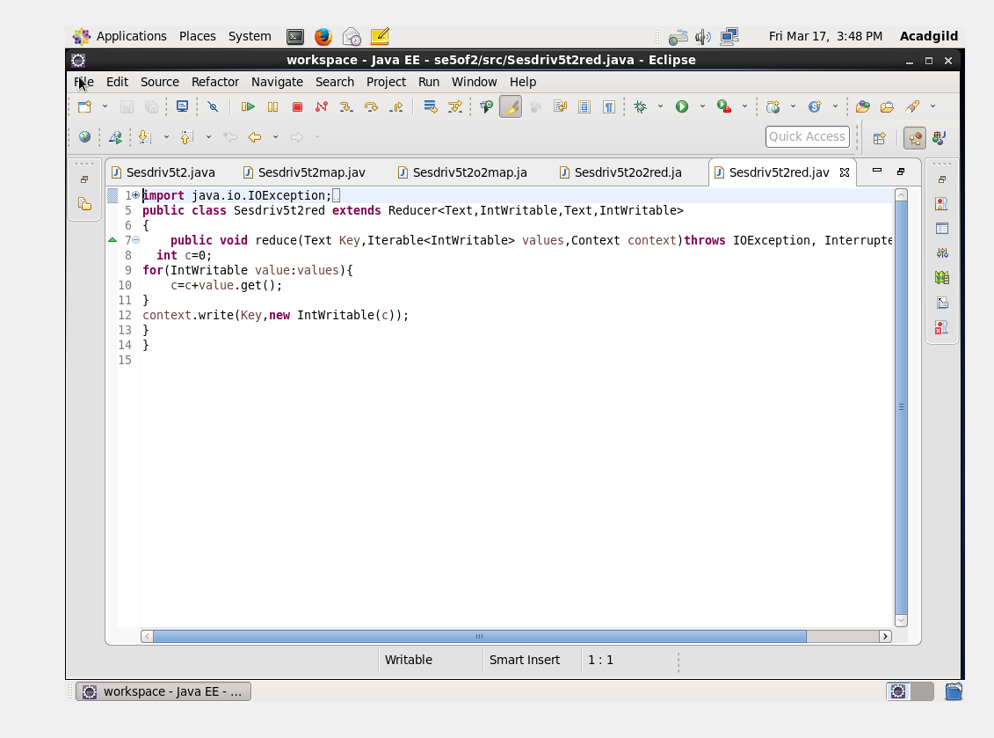

OUTPUT TERMINAL

1

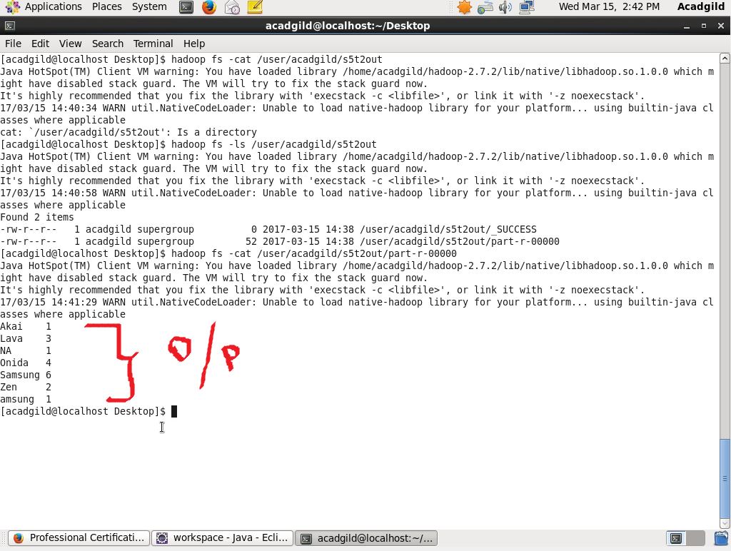

This output shows no of items sold in each company

2. 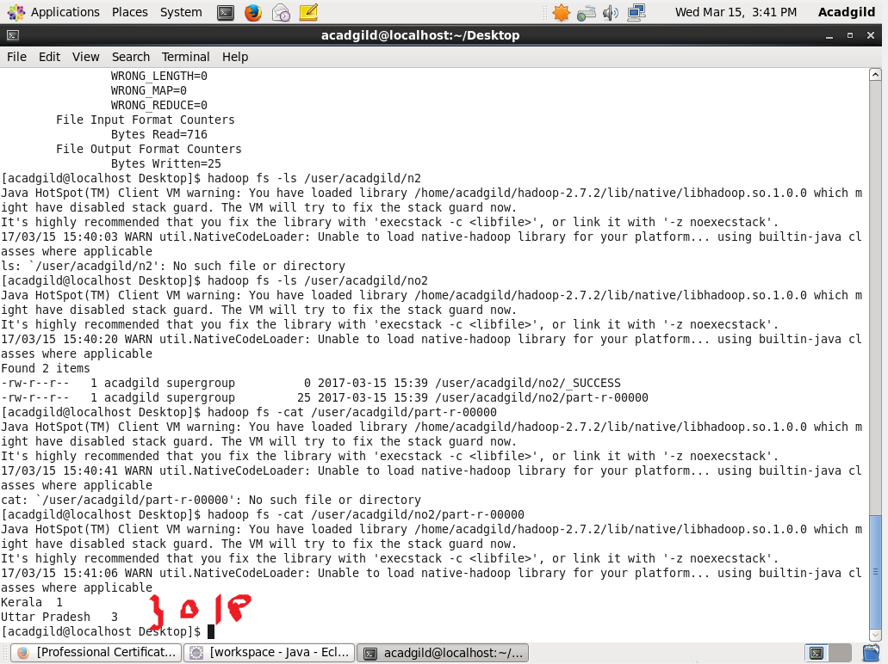

This output shows no of items sold by onida company in each state