**ASS-5.3**

1. Map reduce program for counting number of ratings given by each user.

DRIVER CLASS:

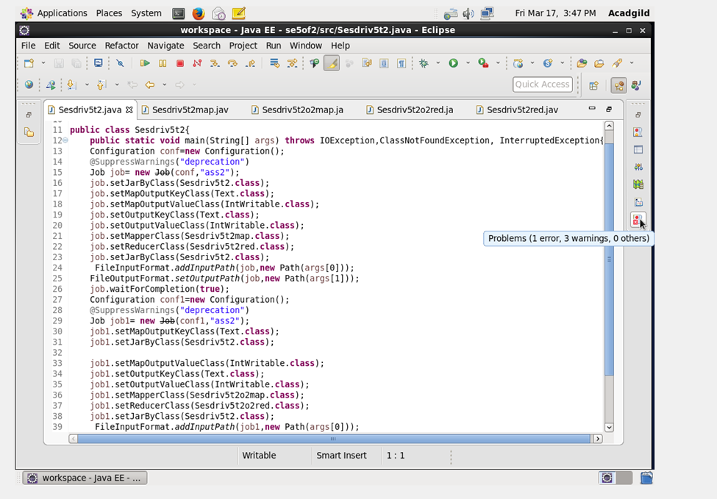

MAPPER CLASS OF TASK 1:

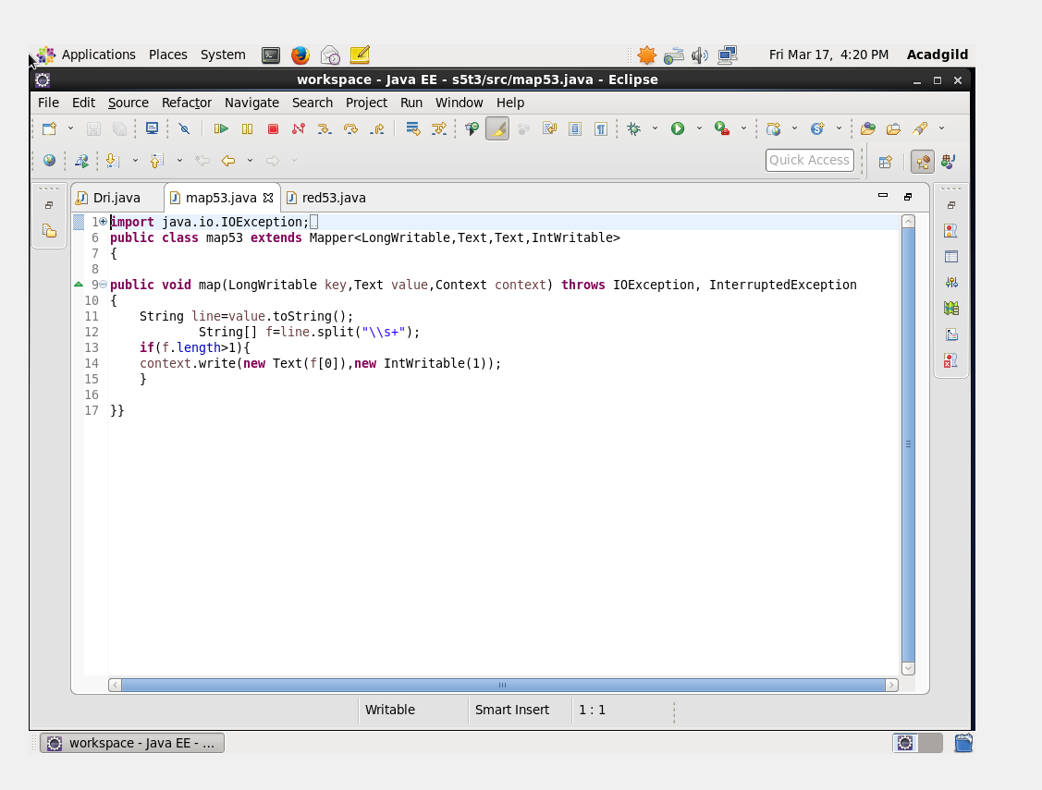

1. MAPPER CLASS OF TASK 2 :Map reduce program for counting number of ratings received by each movie

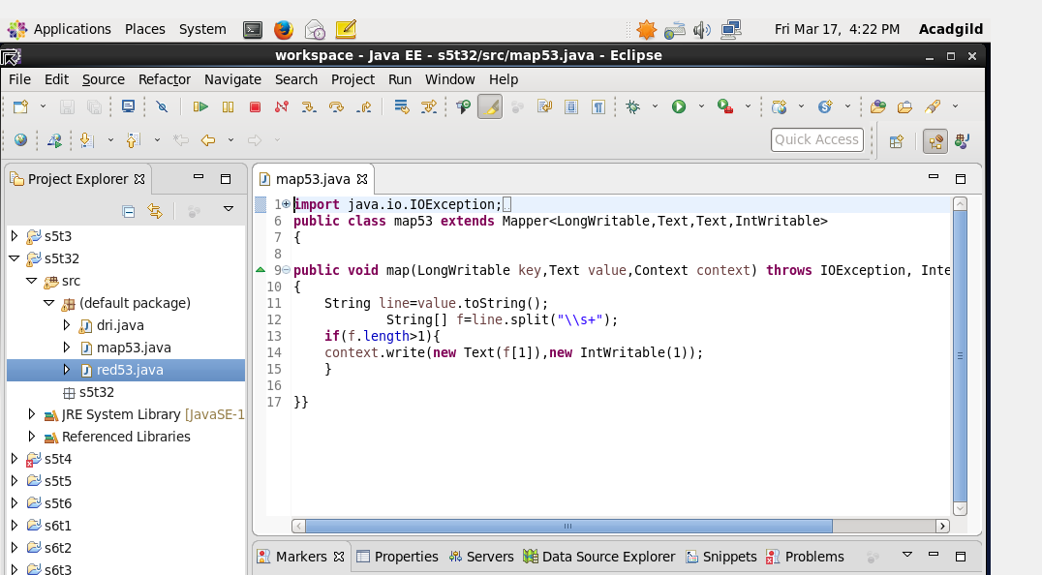

REDUCER CLASS: 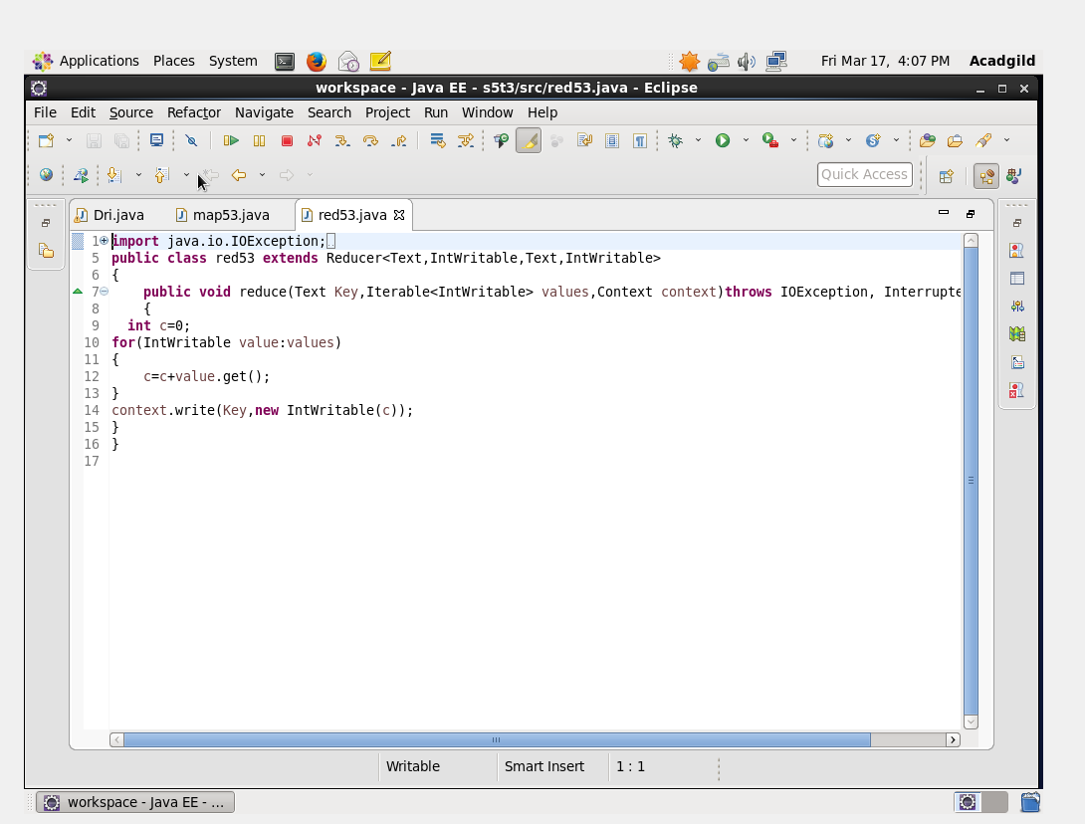

OUTPUT RUN TERMINAL:

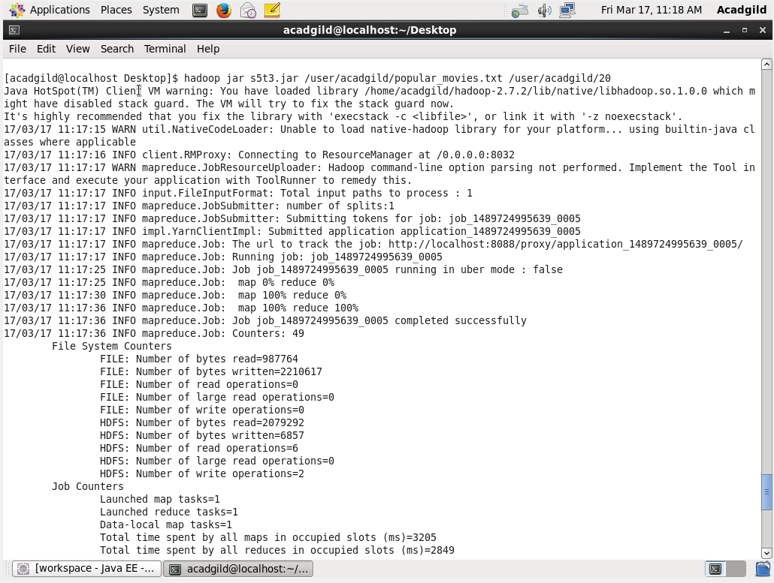

OUTPUT FOR TASK 1 : counting number of ratings given by each user.

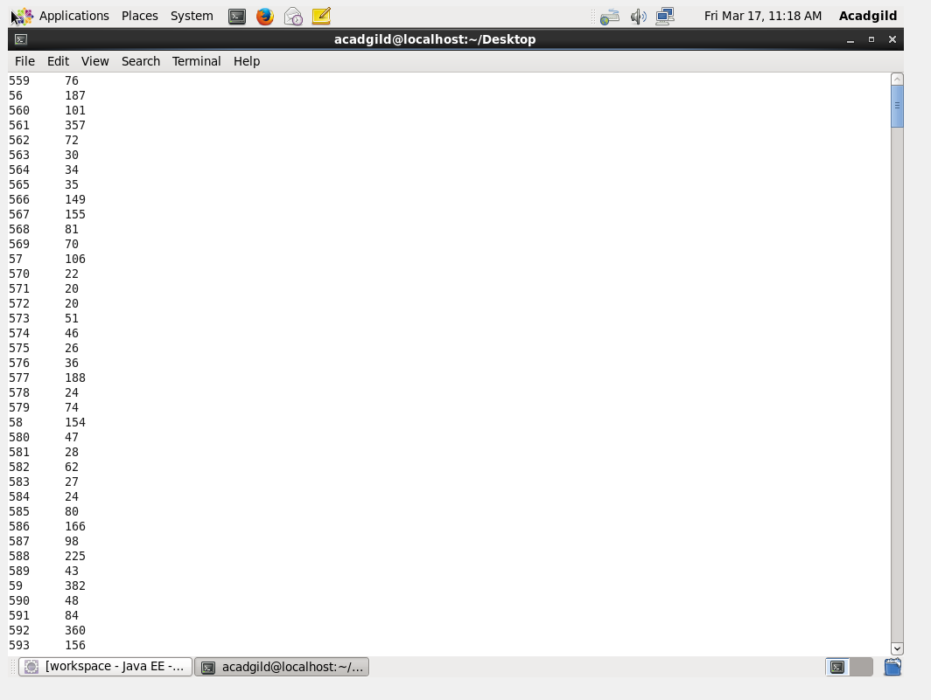

OUTPUT FOR TASK 2: number of ratings received by each movie

