**ASS-5.4**

1. mapreduce program to find out number of males and females died in the titanic tragedy.

Driver class:

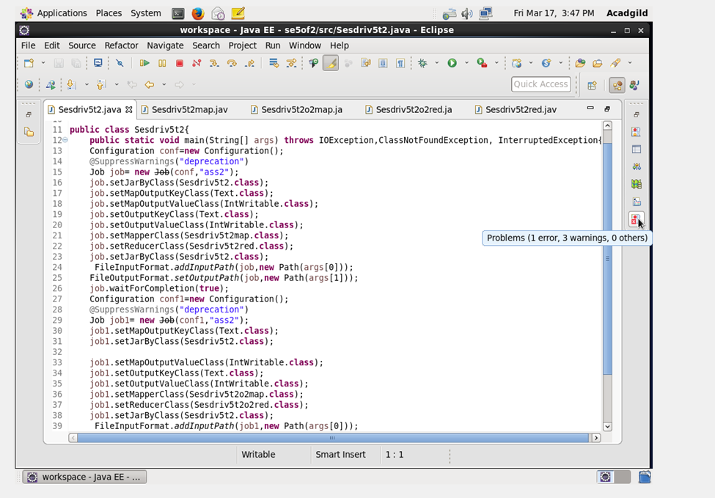

Mapper class :

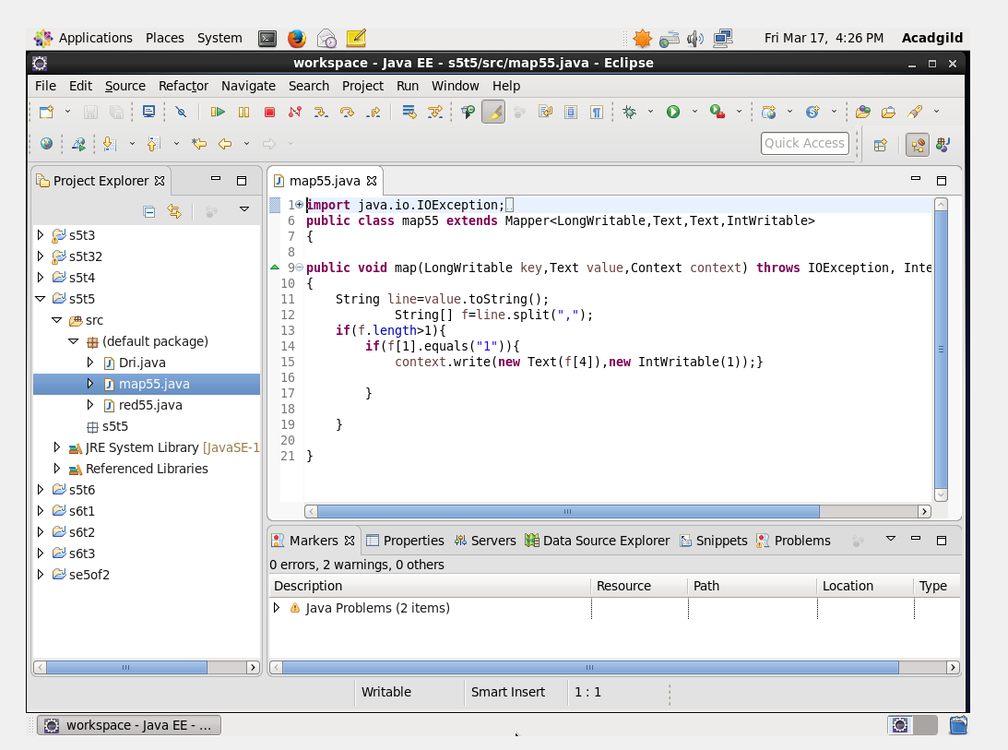

Reducer class:

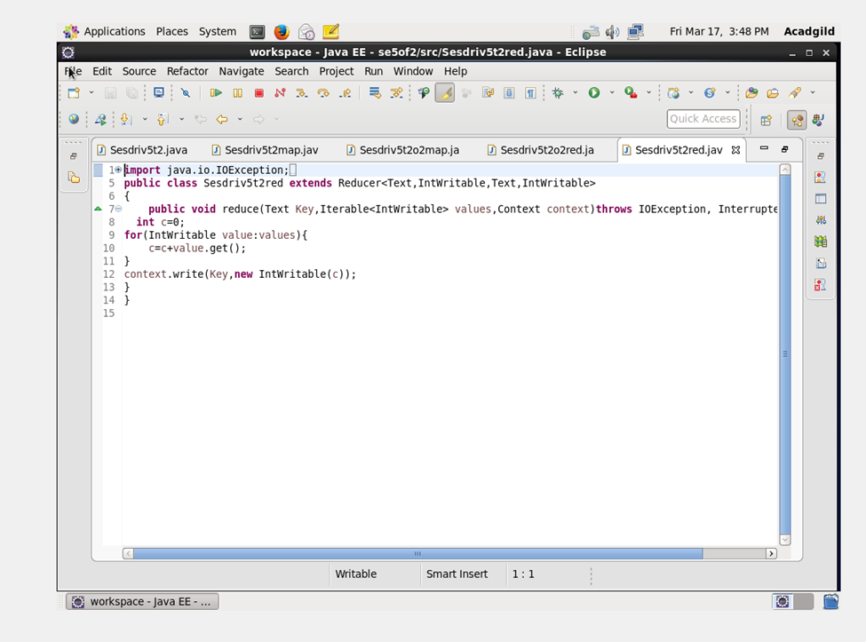

OUTPUT TERMINAL:

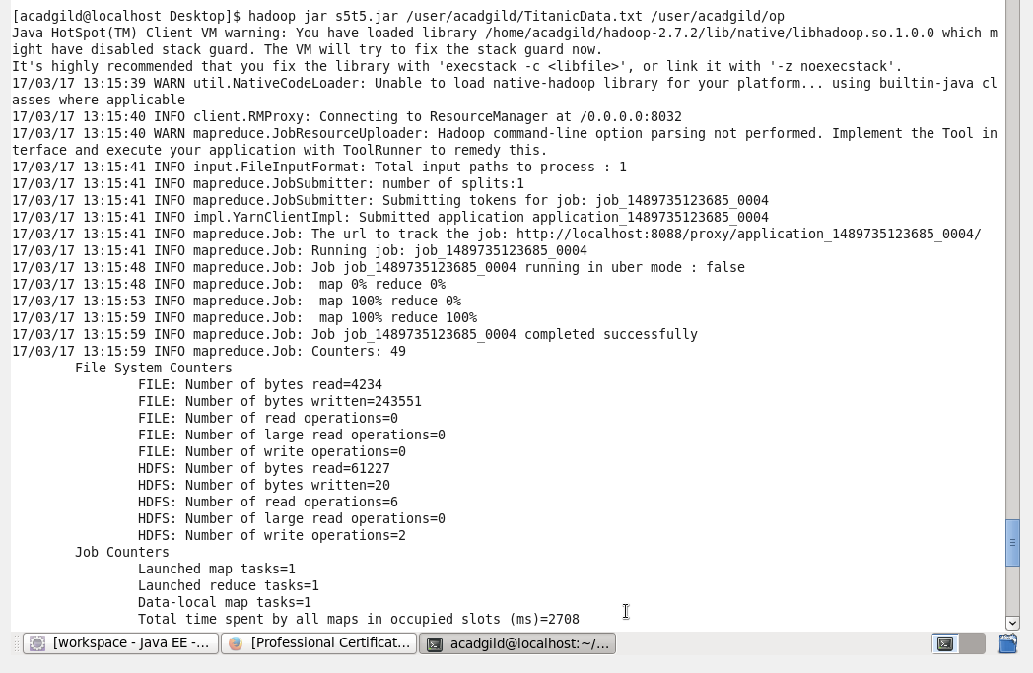

OUTPUT