**ASS-5.5**

1. mapreduce program to find out number of males and females survived in the titanic tragedy.

Driver class:

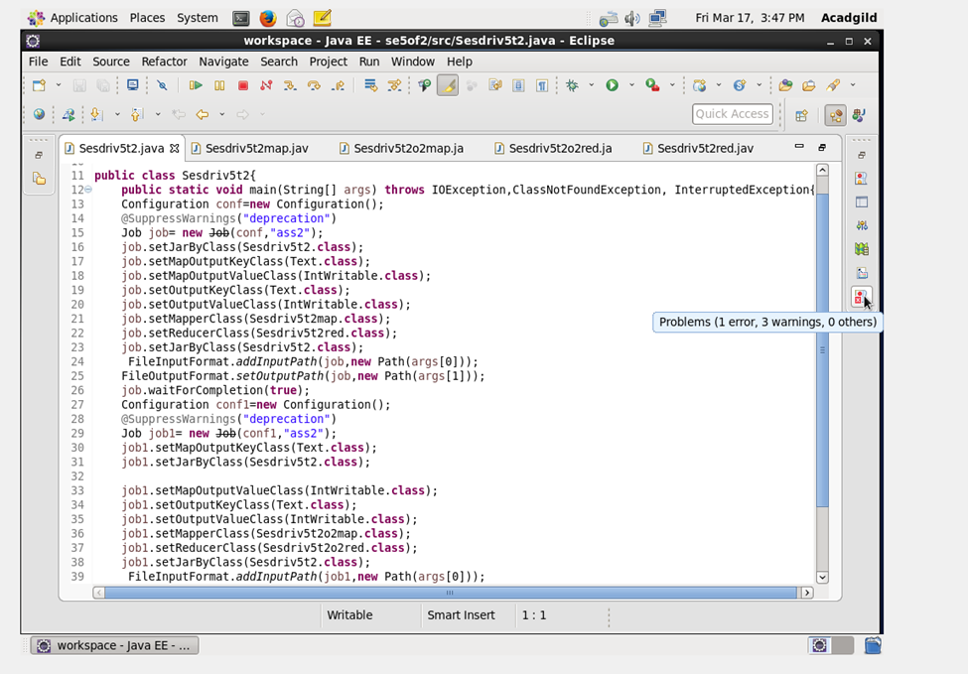

MAPPER CLASS:

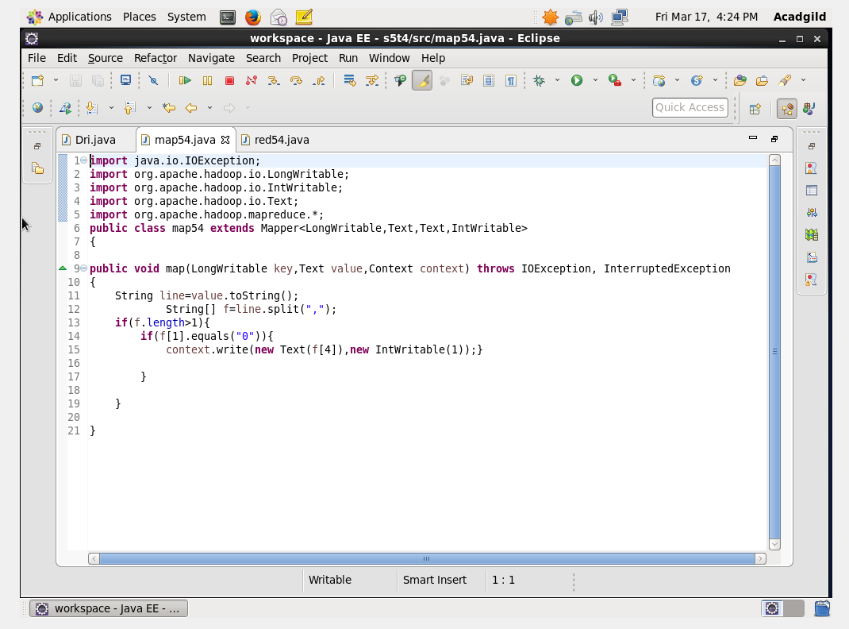

REDUCER CLASS:

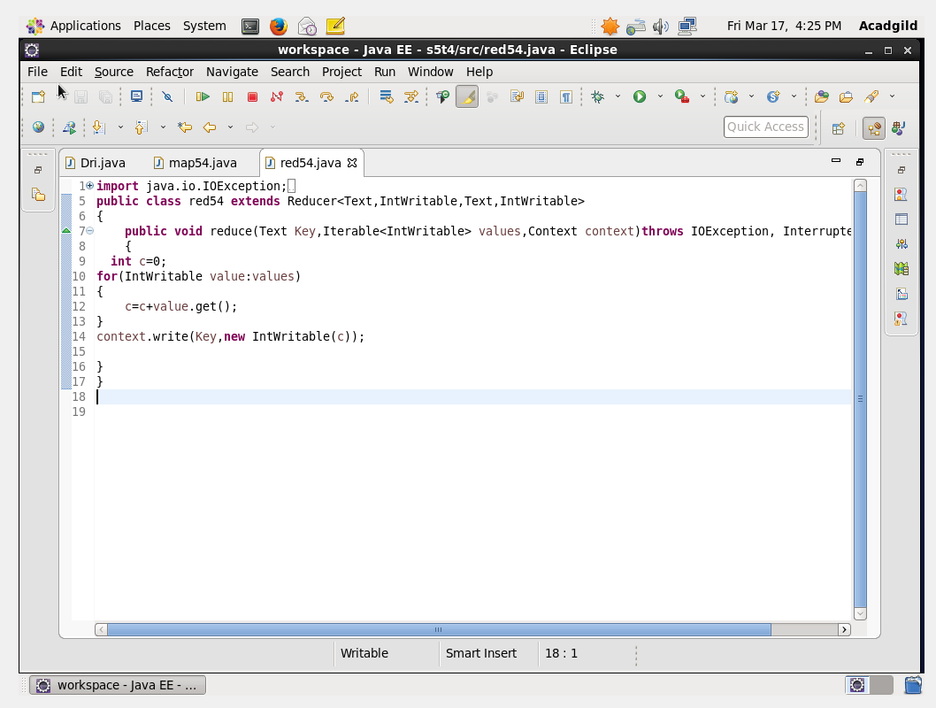

OUTPUT TERMINAL:

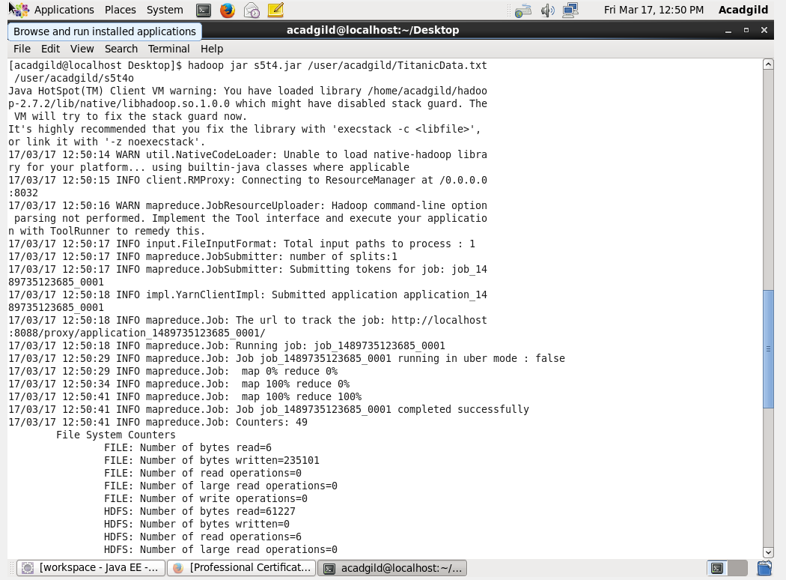

OUTPUT:

