**ASS-5.6**

1. Map reduce program to find the total number of people travelled in titanic.

DRIVER CLASS:

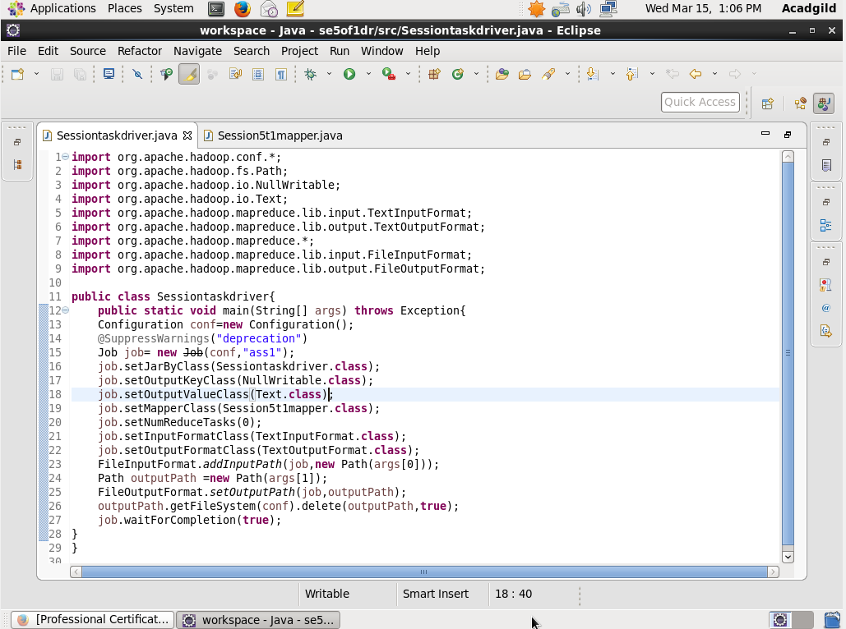

MAPPER CLASS:

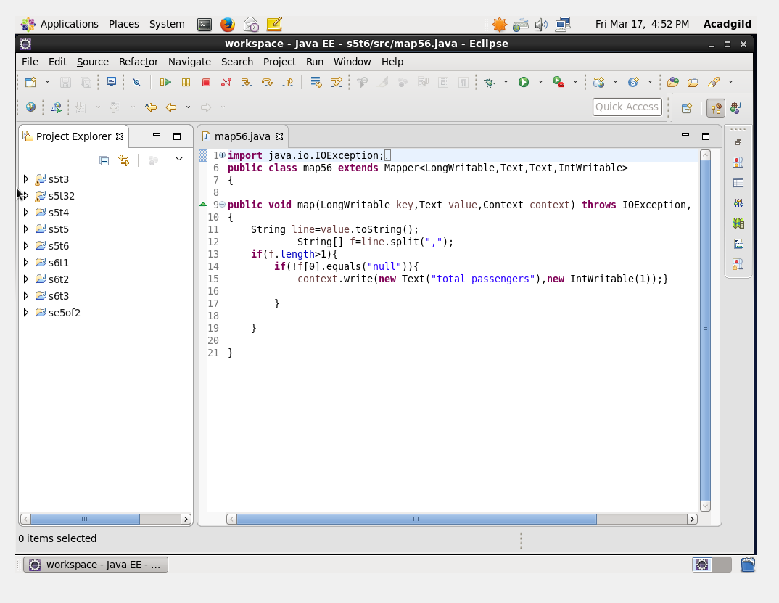

RUN TERMINAL:

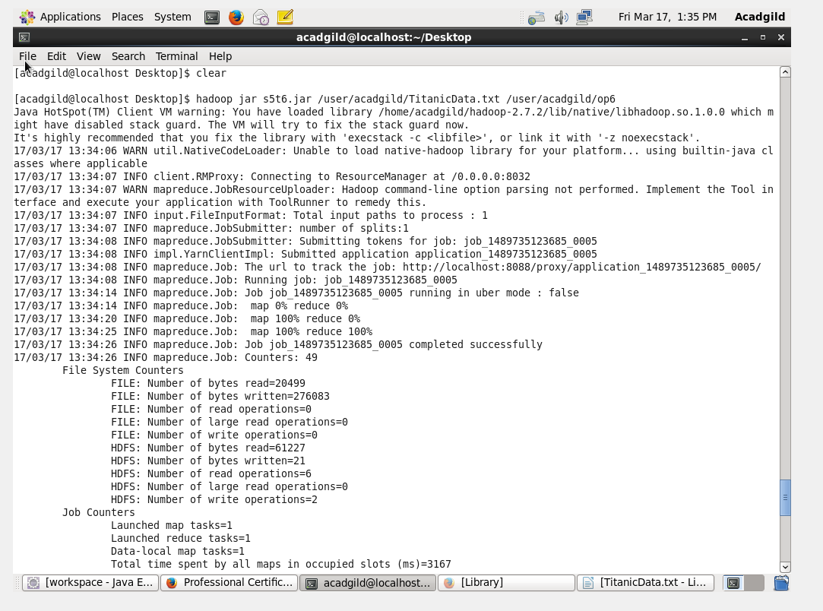

OUTPUT TERMINAL:

