**ASSIGNMENT-6.6**

DRIVER CLASS:

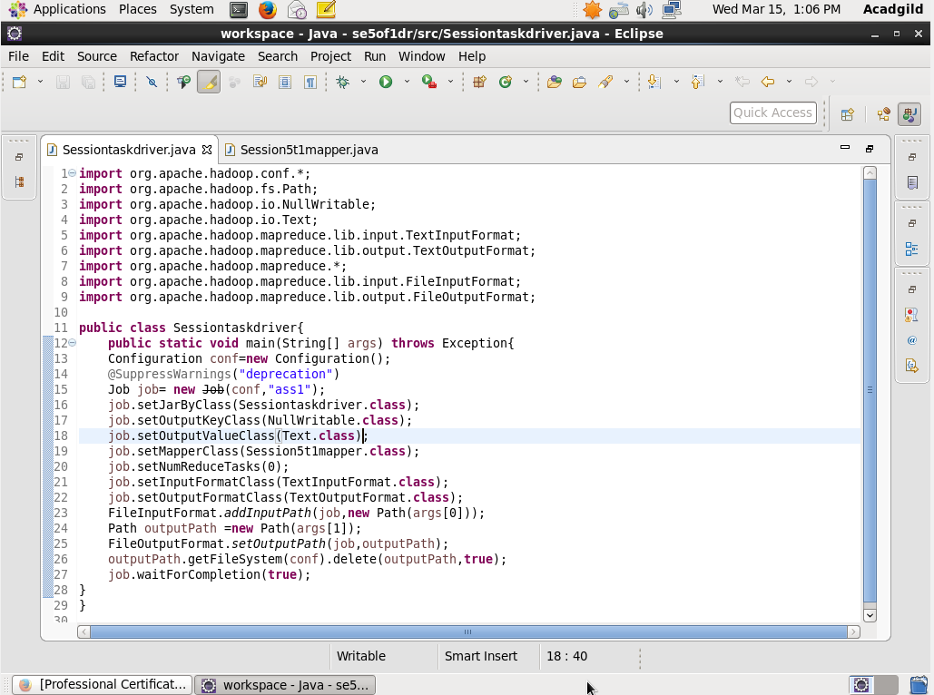

MAPPER CLASS:

1. Find out how many people has chosen their destination as MIA and MCO

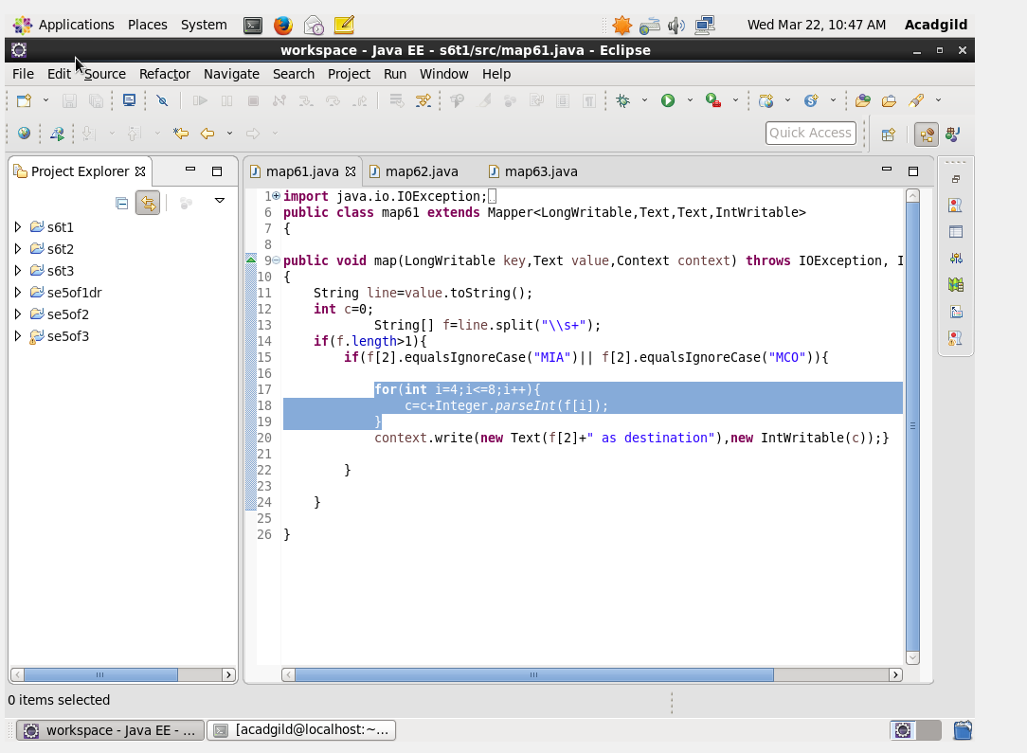

2.Find out the number of people undertaken the trips from the places MIA and HOU

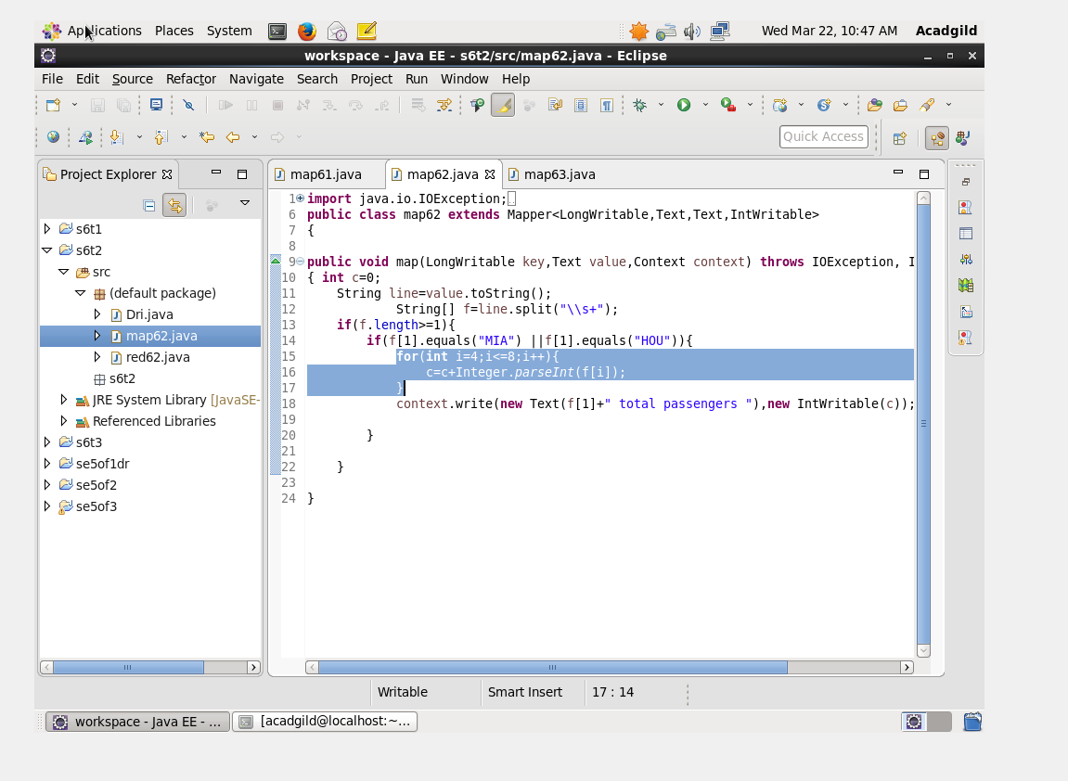

3.Find out how many people has chosen airline mode of travel for the places LAS and LAX

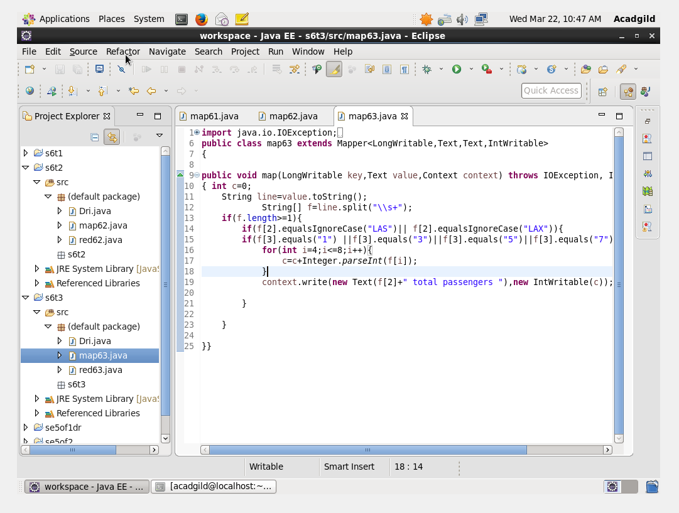

REDUCER CLASS:

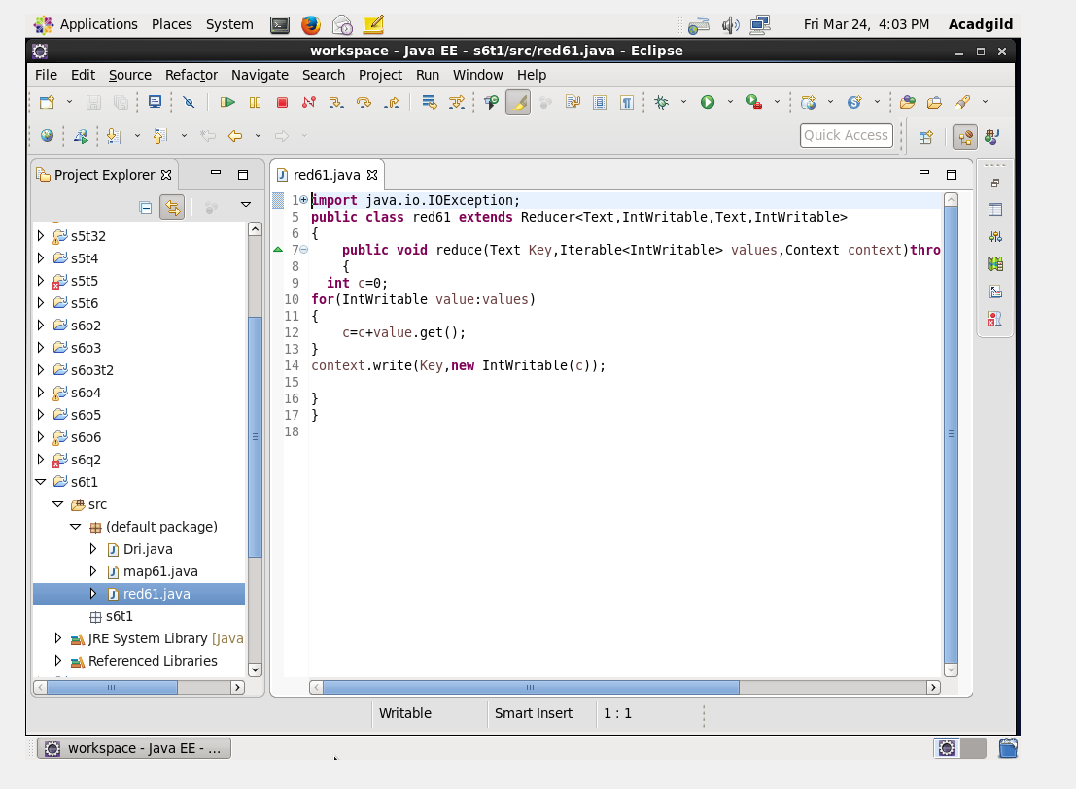

RUN:

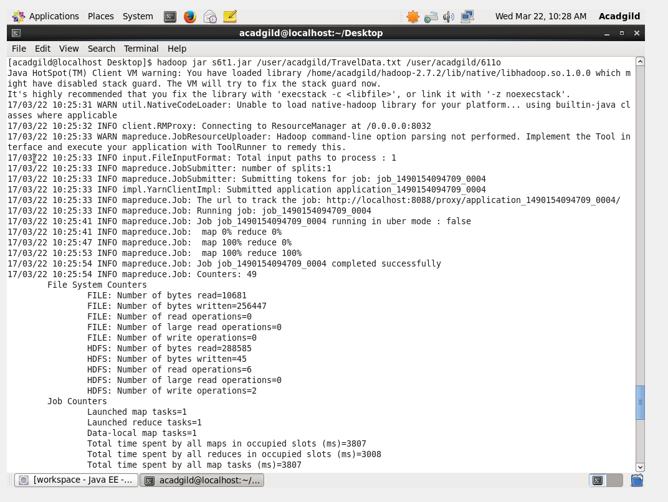

OUTPUT TERMINAL:

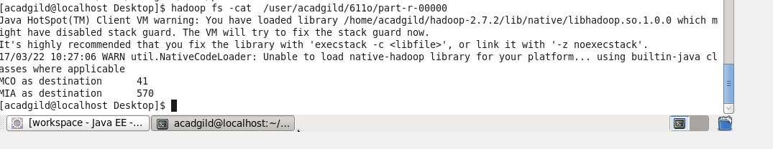

Thus the no of person who choosed MCO as destination is 41 and MIA is 570.

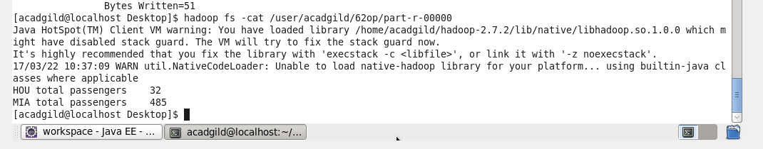

The no of person who choosed HOU AND MIA as departure point is 32 and 485

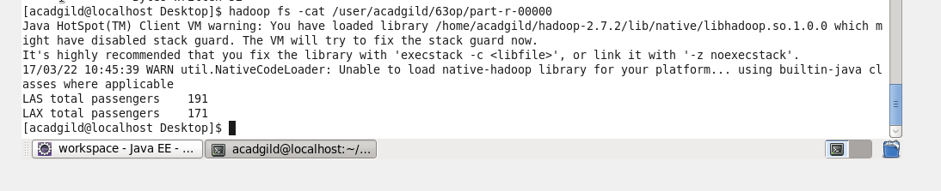

The no of persons who booked airticket to LAS AND LAX is 191 and 171