**ASSIGNMENT-6.2**

1. Use key value output format to save the output of Session 6 – Assignment 1(Travel Data analysis) and save the output as comma (,) separated instead of tab(\t) separated.

DRIVER CLASS:

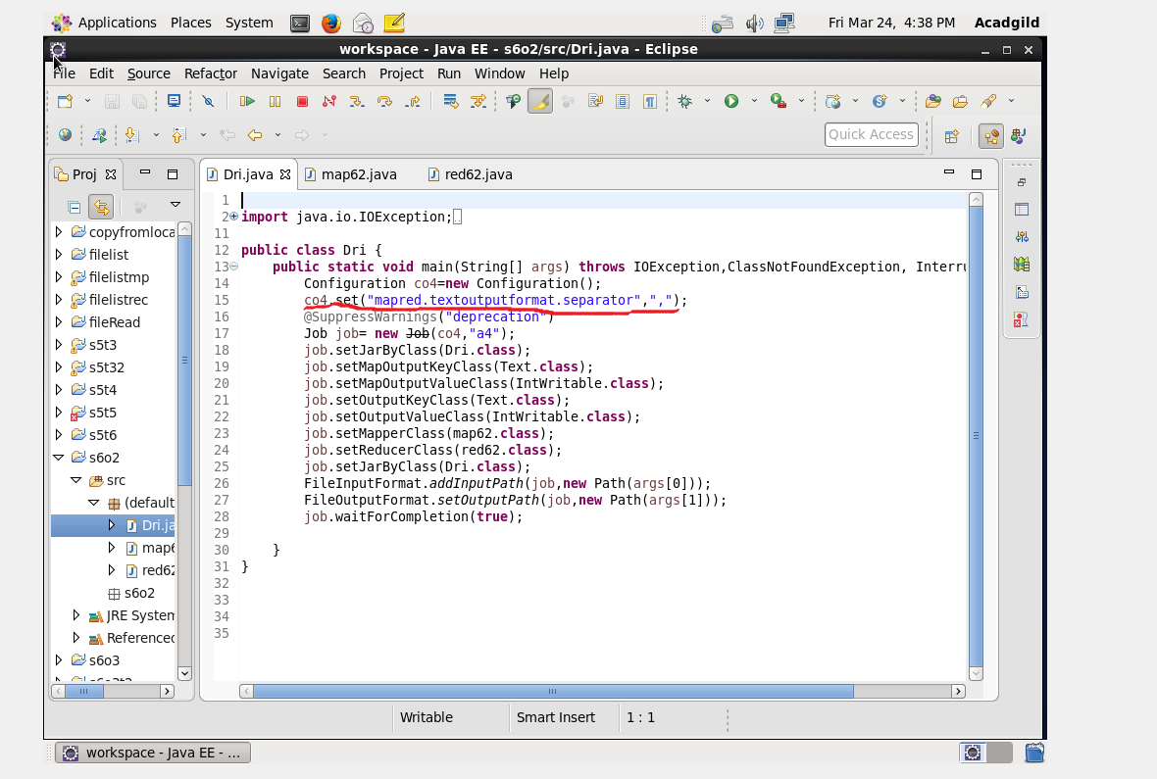

We need to get an output with key value separated by a comma rather than tab which is a default format.hence we are using text output format separator to change into comma.

MAPPER CLASS:

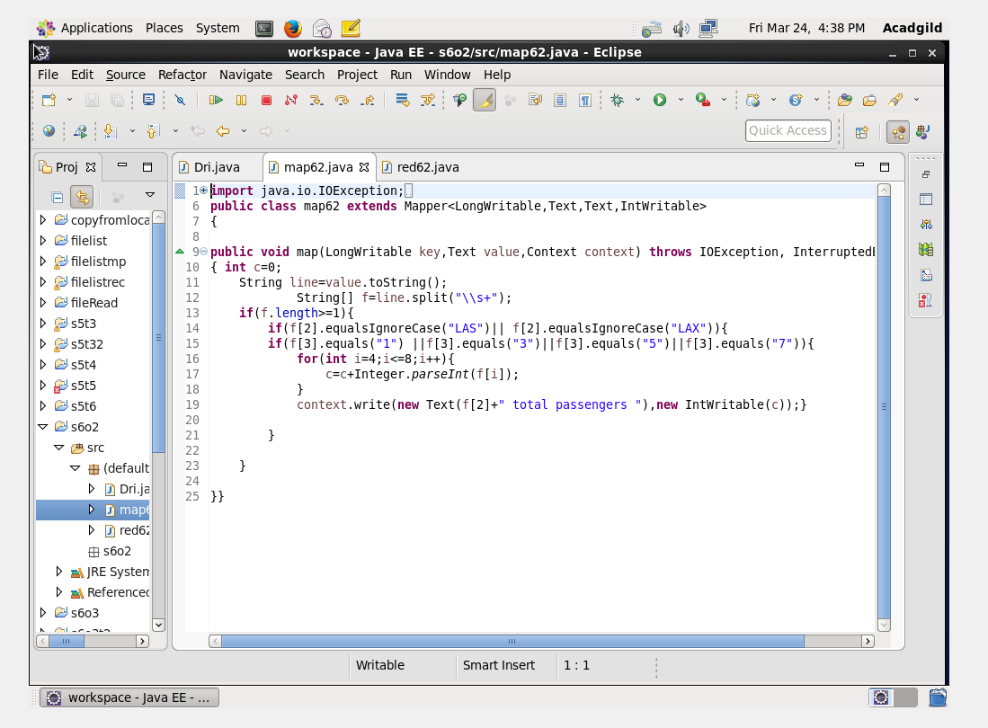

2.Find out the number of people undertaken the trips from the places MIA and HOU

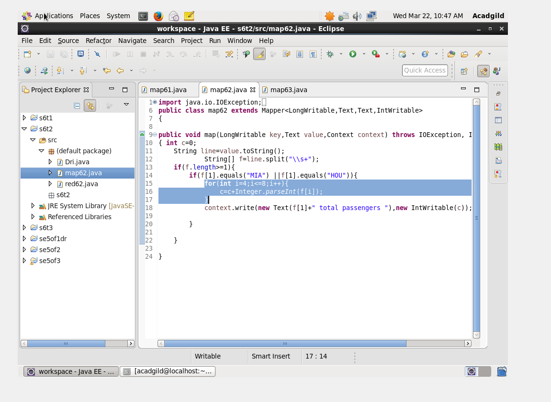

3.Find out how many people has chosen airline mode of travel for the places LAS and LAX

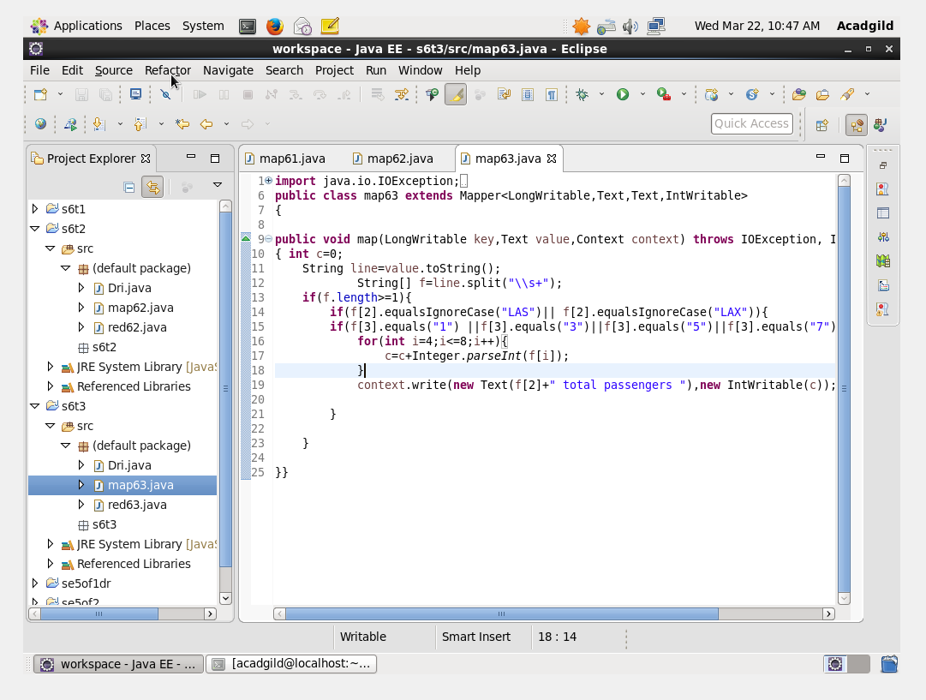

REDUCER CLASS:

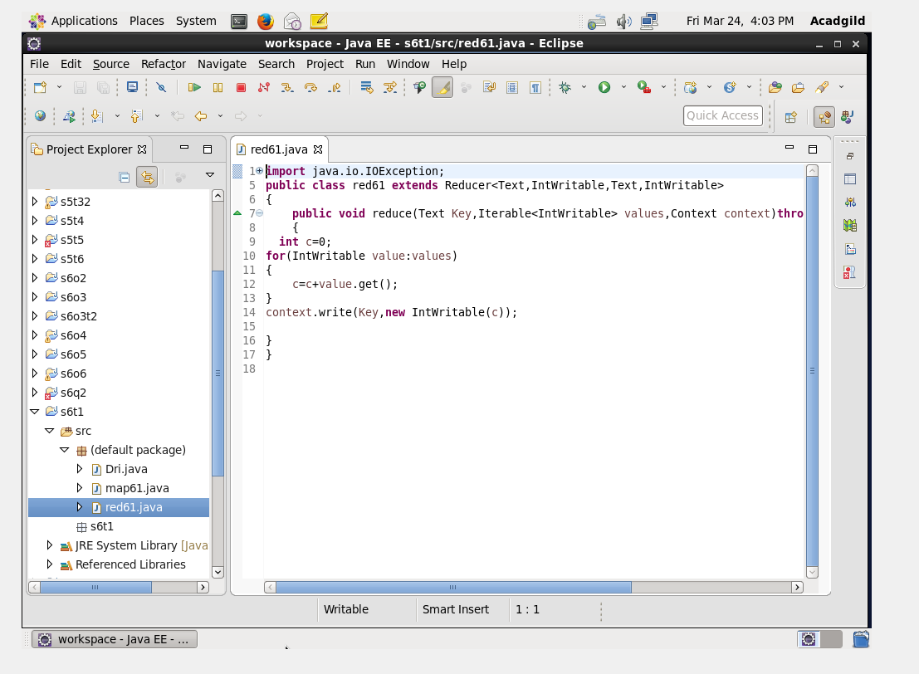

RUN TERMINAL:

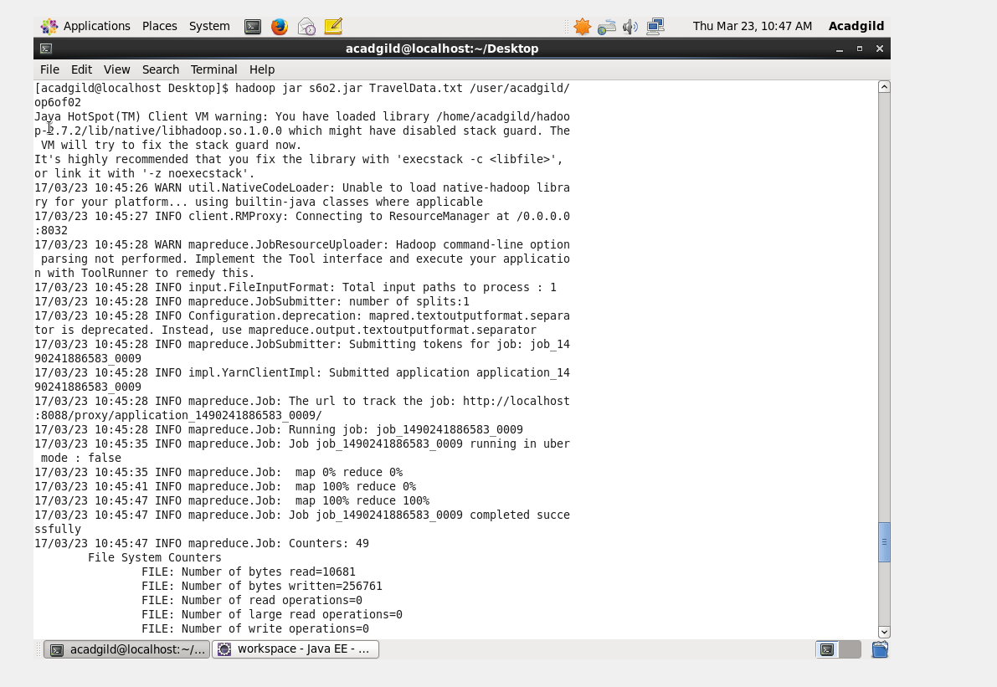

OUTPUT TERMINAL:

