ASS-6.3

2. Find the number of GoogleKnowledge occupation types in each group, who have been guests on the show.

MAPPER CLASS:

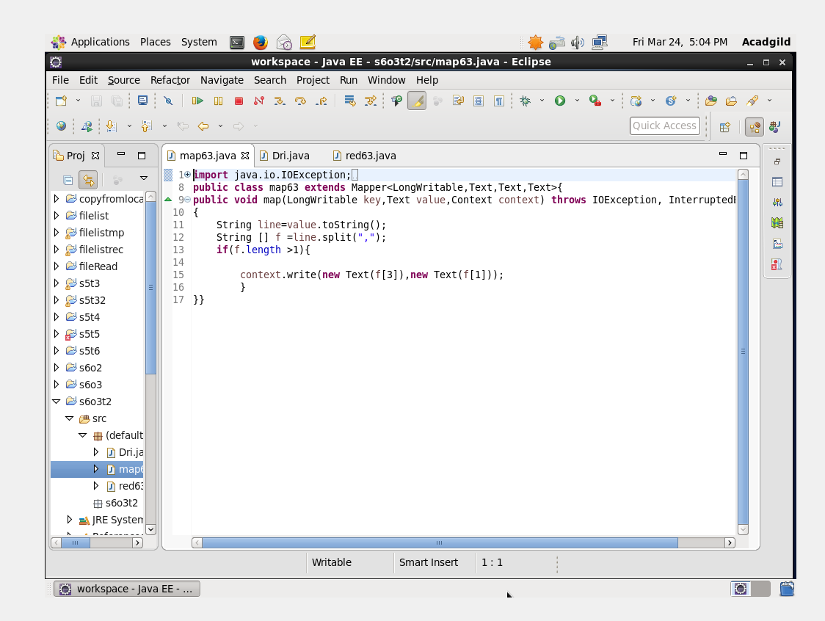

In this question we need to find number of categories in each occupation,taking google occupation as a key and category name as value,we are sending these value to the reducer.In reducer these categories are included in a hashset to remove the repetitions and the size of the hashset gives the no of categories in each occupation.

REDUCER CLASS:

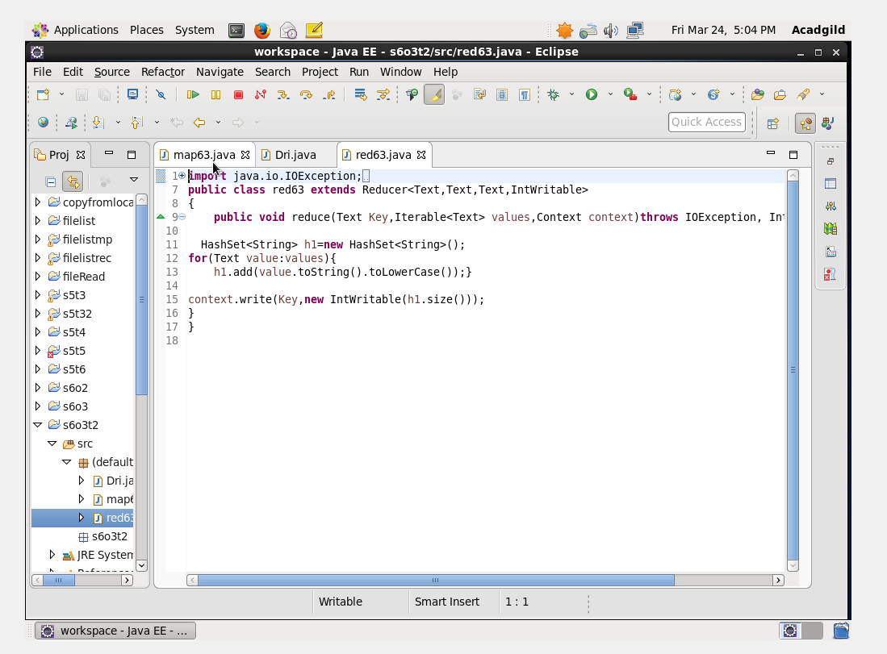

RUN:

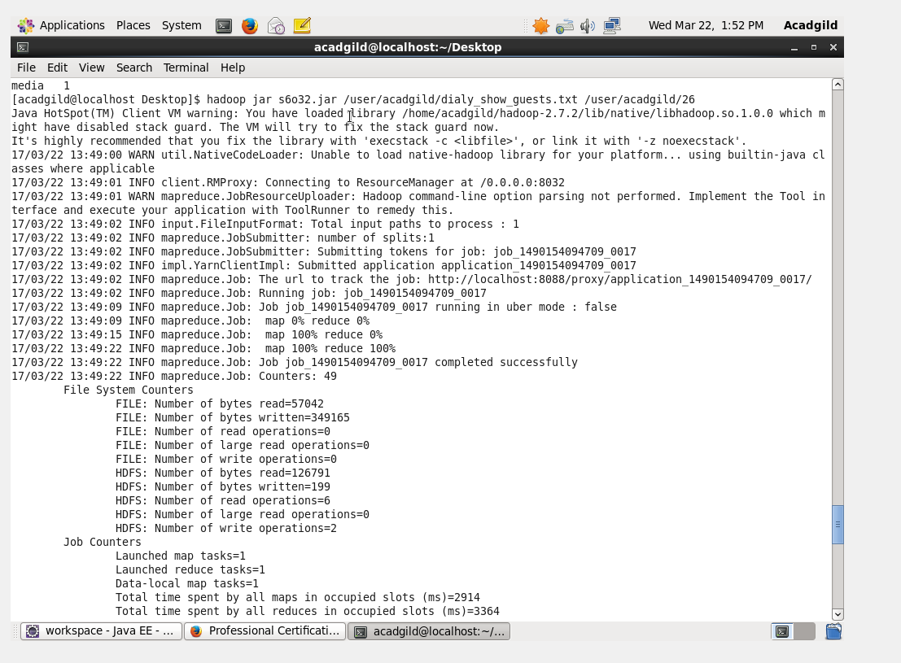

OUTPUT TERMINAL:

