**ASSIGNMENT-6.3**

1. Find the number of GoogleKnowlege_Occupation people who were guests in the show, in a particular time period. Take the time period as 1/11/99 to 6/11/99 i.e., 6 months

DRIVER CLASS:

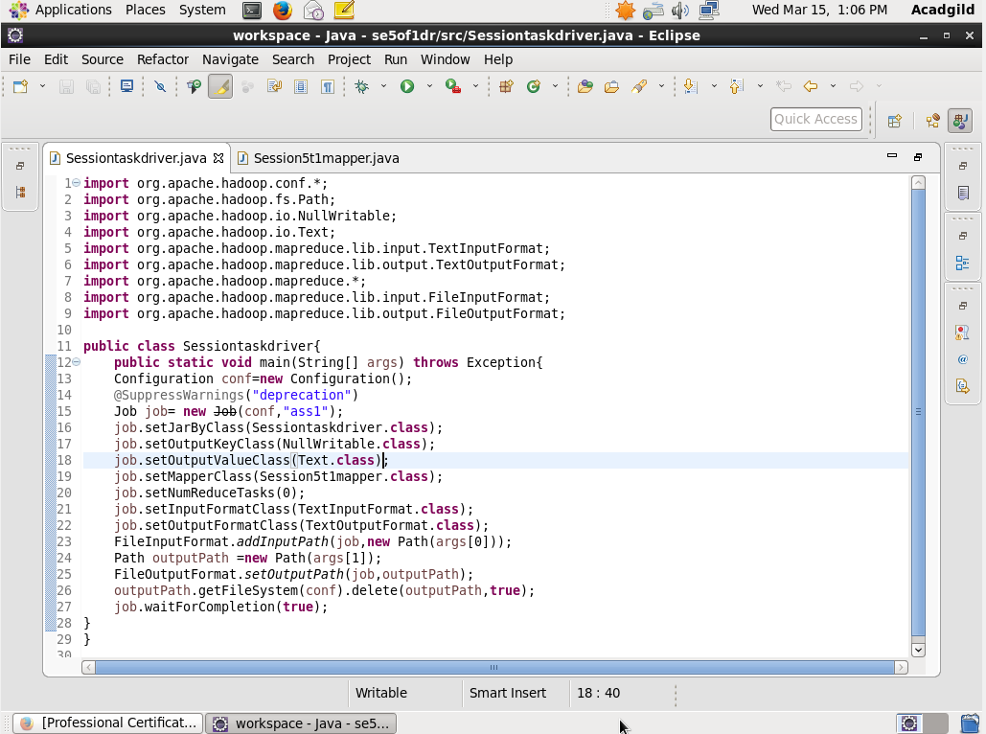

MAPPER CLASS:

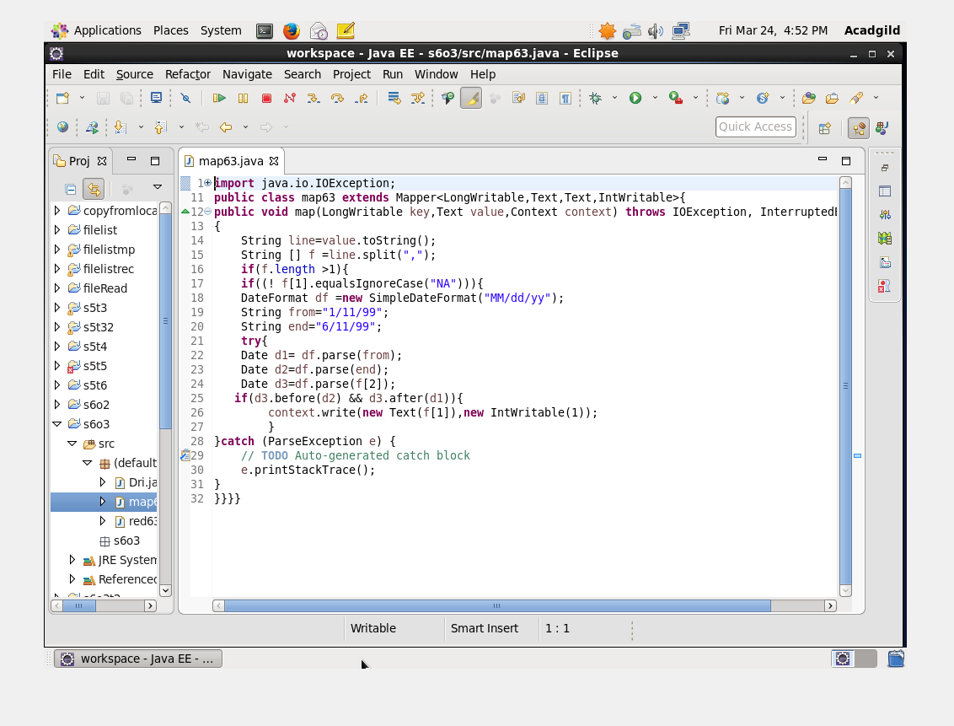

HERE THE DATA IS FILTERED BASED ON TWO CONDITIONS .ONE ON THE SPECIFIED TIME PERIOD AND THE OTHER IS THAT IT SHOULD HAVE GOOGLE OCCUPATION KNOWLEDGE PEOPLE.SO TO GET THE SECOND CRITERIA THE SECOND COLUMN SHOULD NOT BE NIL AND FOR THE FIRST CRITERIA DATE IS FILTERED OUT.

REDUCER CLASS:

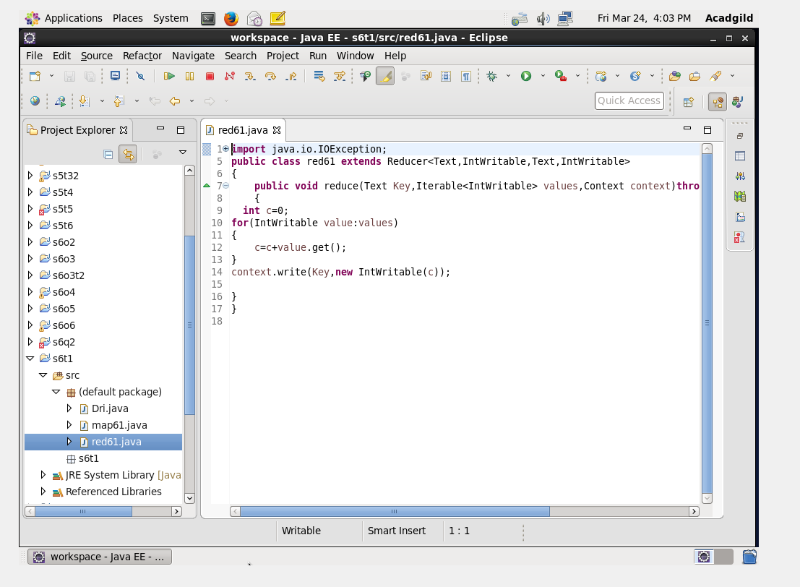

RUN:

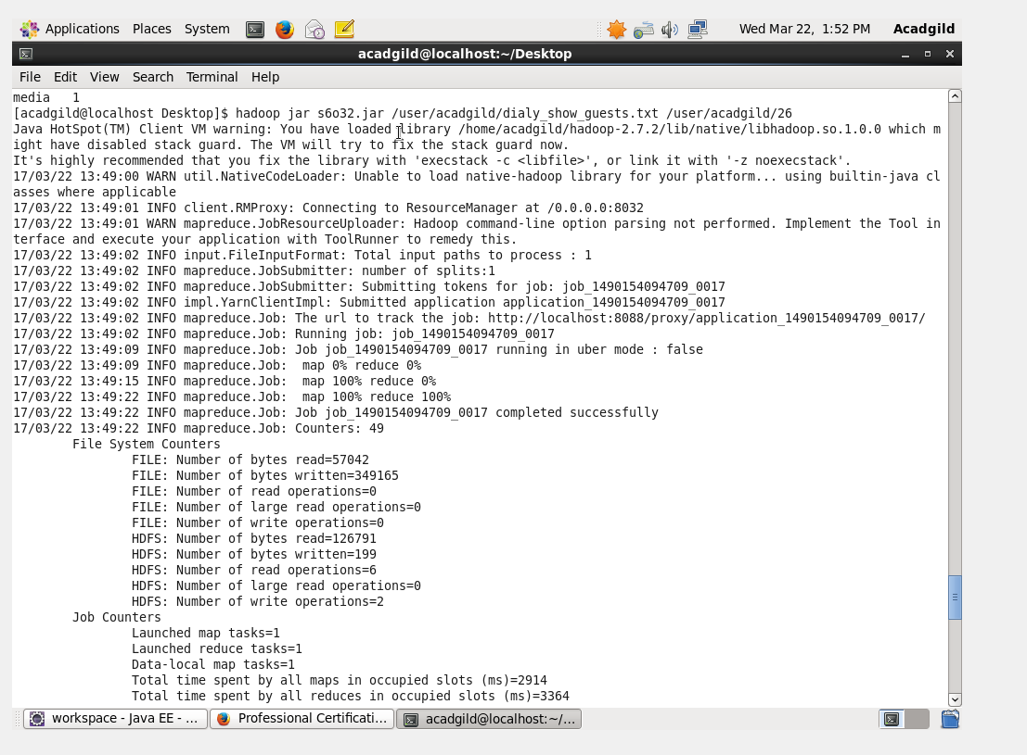

OUTPUT TERMINAL

