**ASS-6.5**

1. Write a mapreduce code to find out number of males and females survived in the titanic tragedy and save the output in sequence file output format.

DRIVER CLASS:

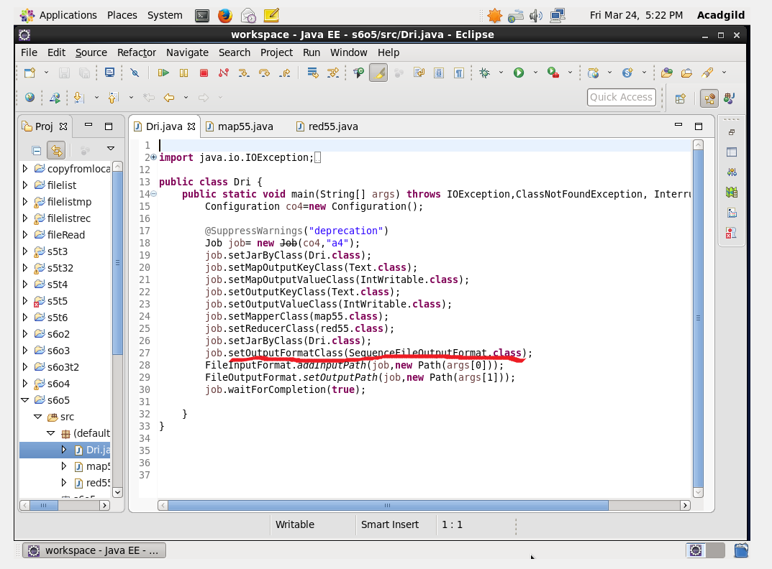

MAPPER CLASS:

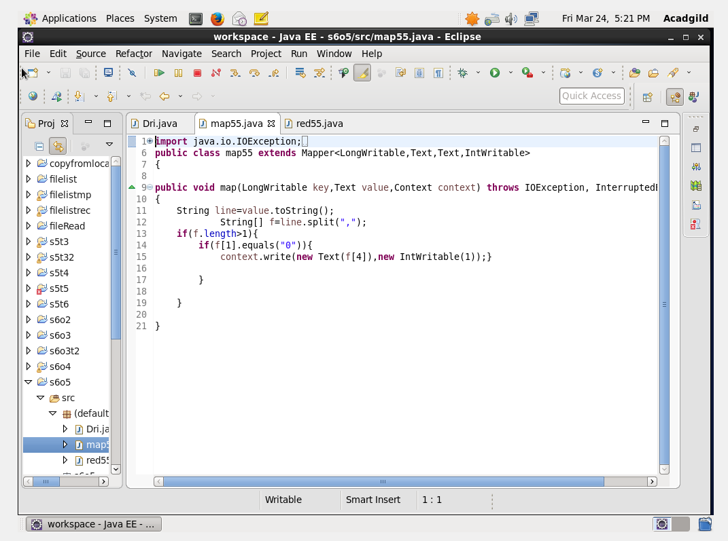

REDUCER CLASS:

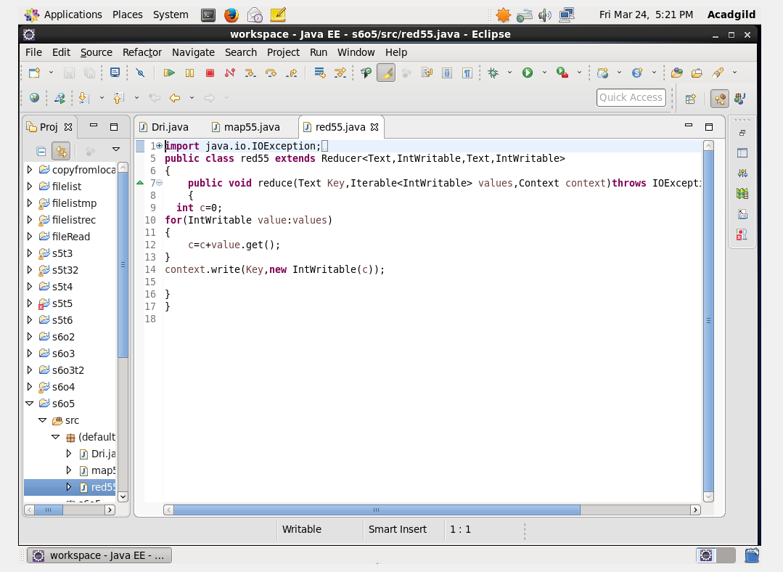

RUN:

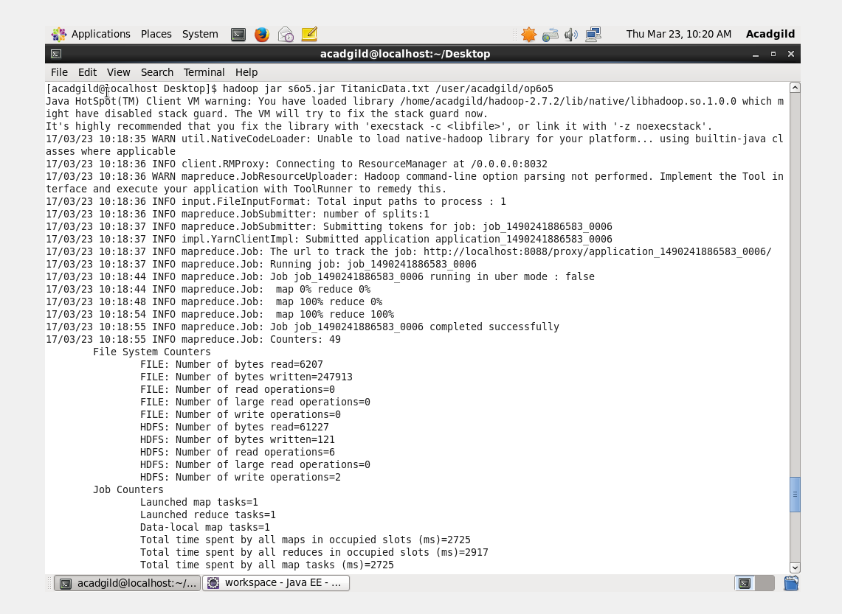

OUTPUT TERMINAL:

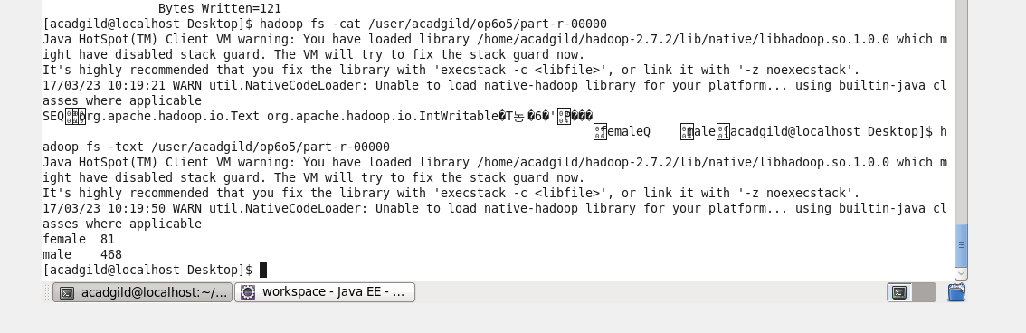

THE OUTPUT IS IN SEQUENCE FILE FORMAT AND TO DISPLAY THE ORIGINAL FILE WE CAN USE THE TEXT COMMAND TO DISPLAY THE ORIGINAL CONTENT.