**ASS-6.6**

1. Write a map reduce program to use Sequence file as input and save the output in key value output format.

DRIVER CLASS:

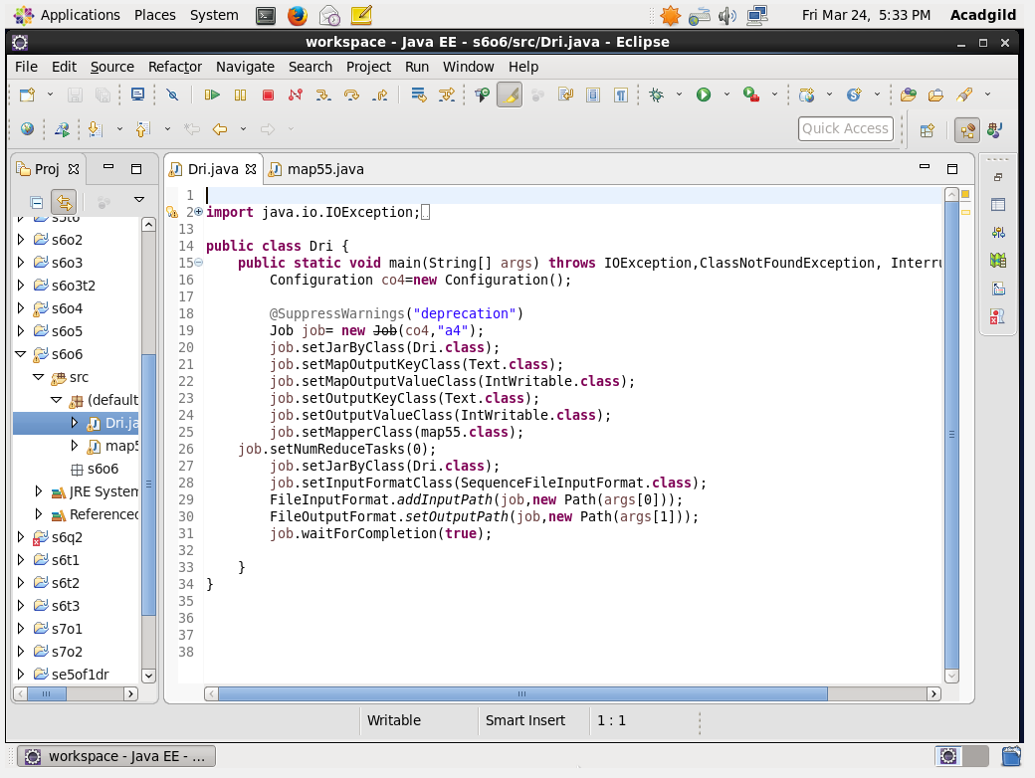

THE OUTPUT FROM THE PREVIOUS ASSIGNMENT IS TAKEN AS INPUT AS A SEQUENCE FILE INPUT AND IT IS READ AS A TEXT FILE.

MAPPER CLASS:

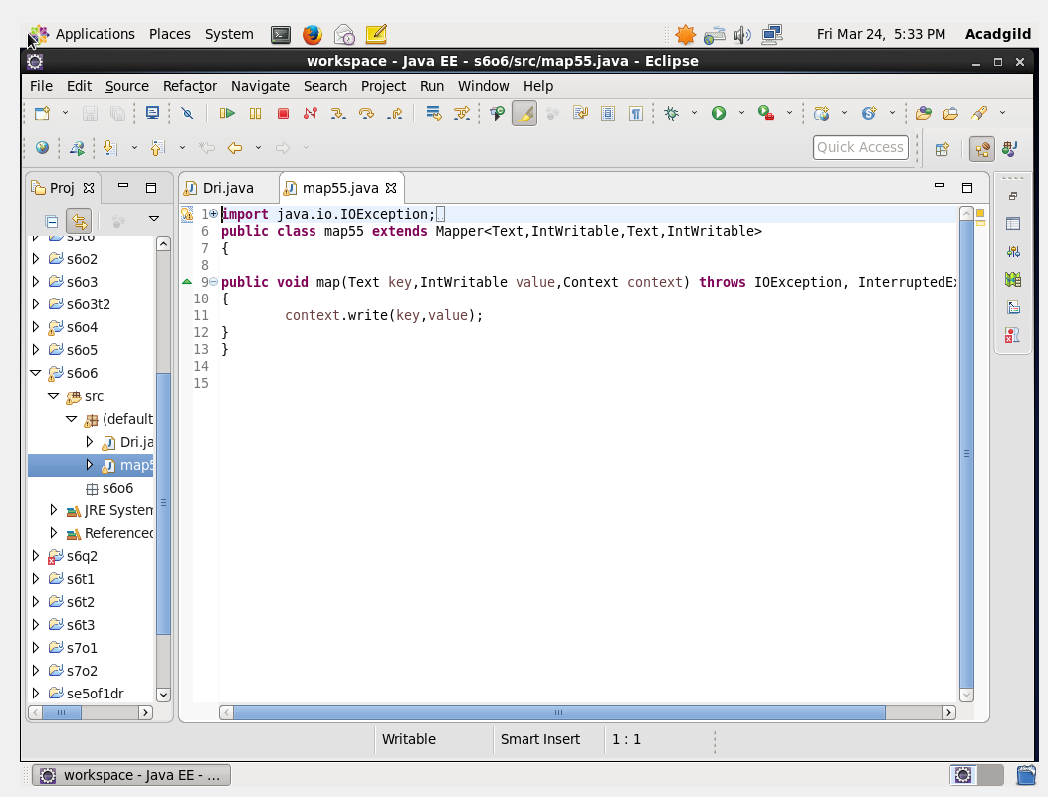

RUN: 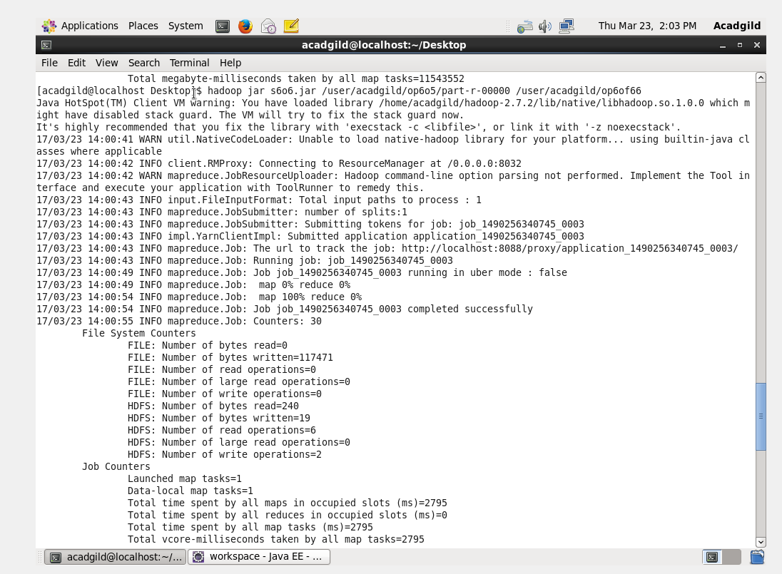

OUTPUT TERMINAL:

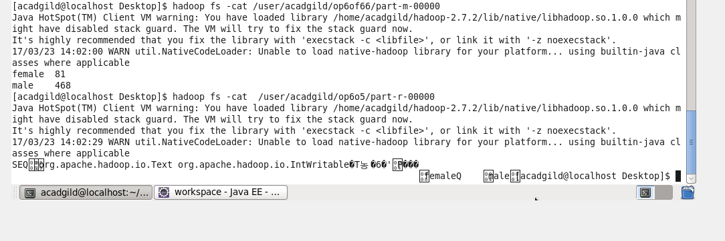

SO THE OUTPUT IS IN TEXT FORMAT,THE INPUT FILE IS IN TEXT FORMAT.