**ASS-7.1**

1. Write a Mapreduce program to modify Sales of different TV Task 2 ( refer session 5 assignment 2 ) to use a custom partitioner with 4 reducers. Make sure that all records whose company name starts with A-F (upper or lower case) should go to 1st reducer, those starting with G-L to 2nd reducer, those starting with M-R to 3rd reducer and others to 4th reducer.

Driver class:

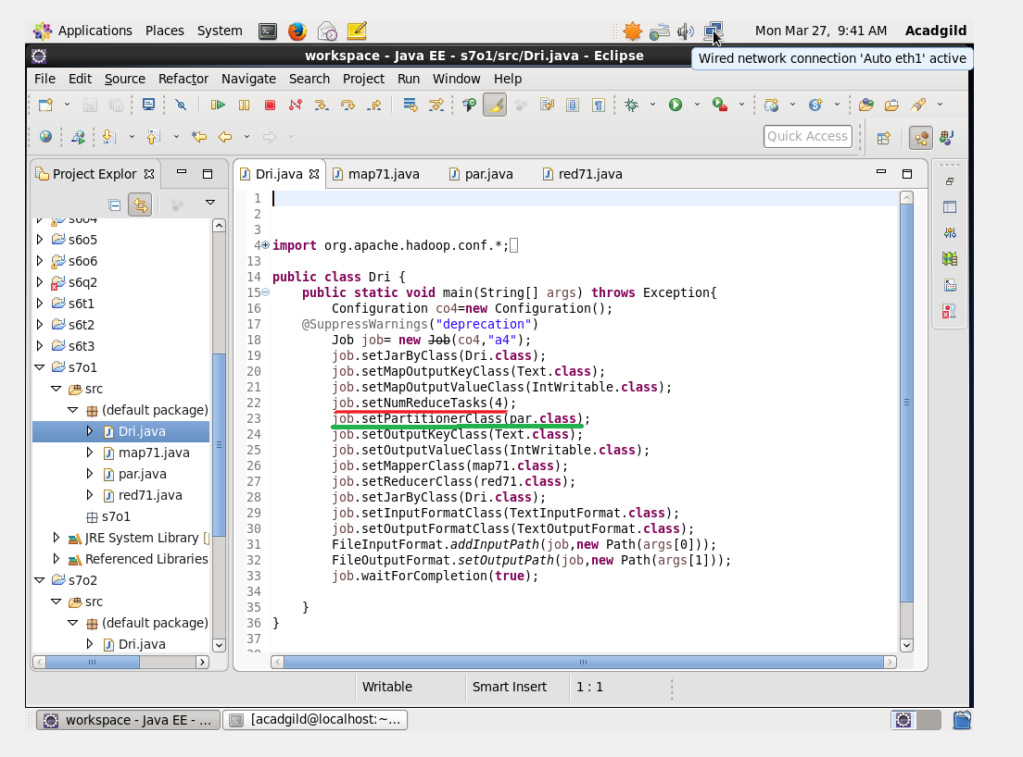

This question requires partitioning the companies based on their first letter and this can be done by partitioning and then reducing.since they require 4 classification we use 4 reduce tasks .

Mapper class:

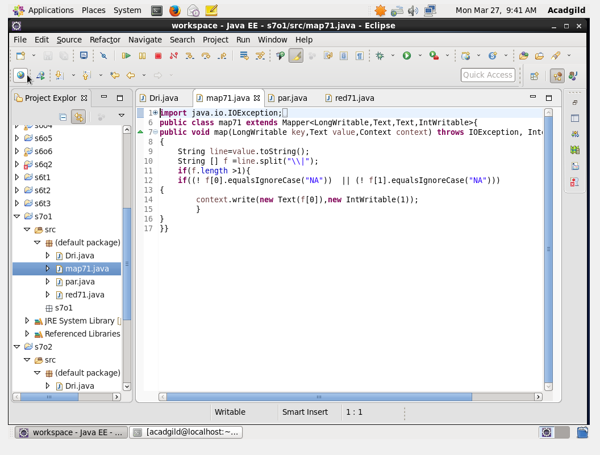

It is similar to ass5.2 we just map the elements when they contain company name

Partitioner class:

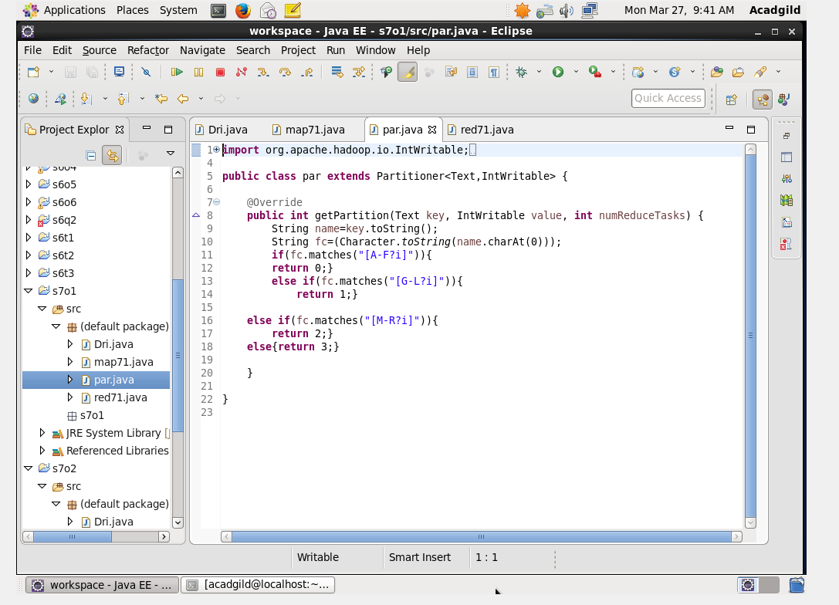

In this partitioner class we are classifying the companies based on their first alphabet and based on their alphabet each one given its reducer task no it must undergo .then based on the number reduction undergoes.

Reducer class:

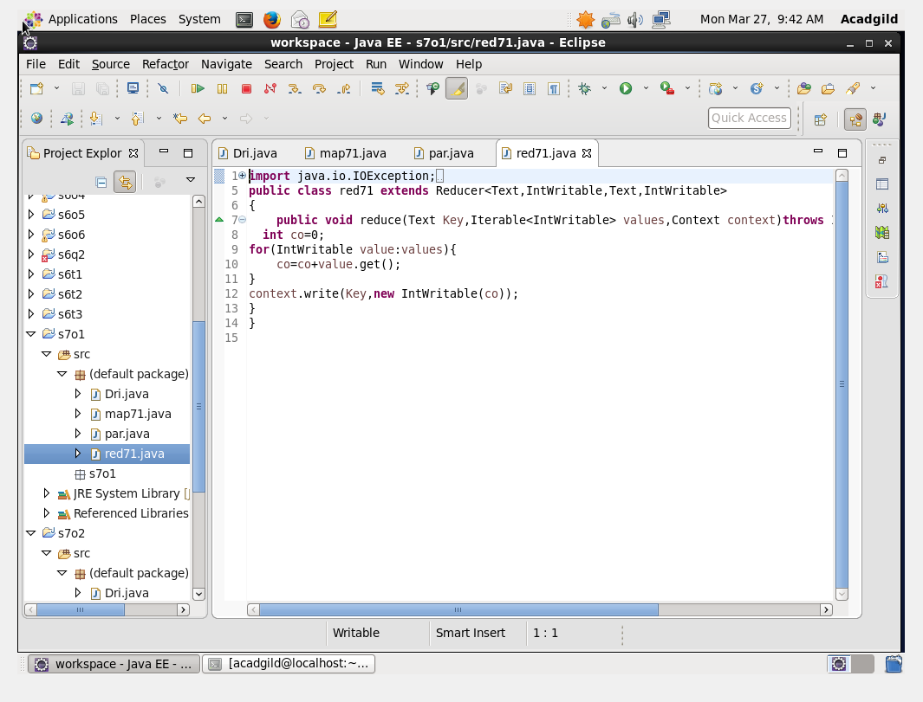

Run:

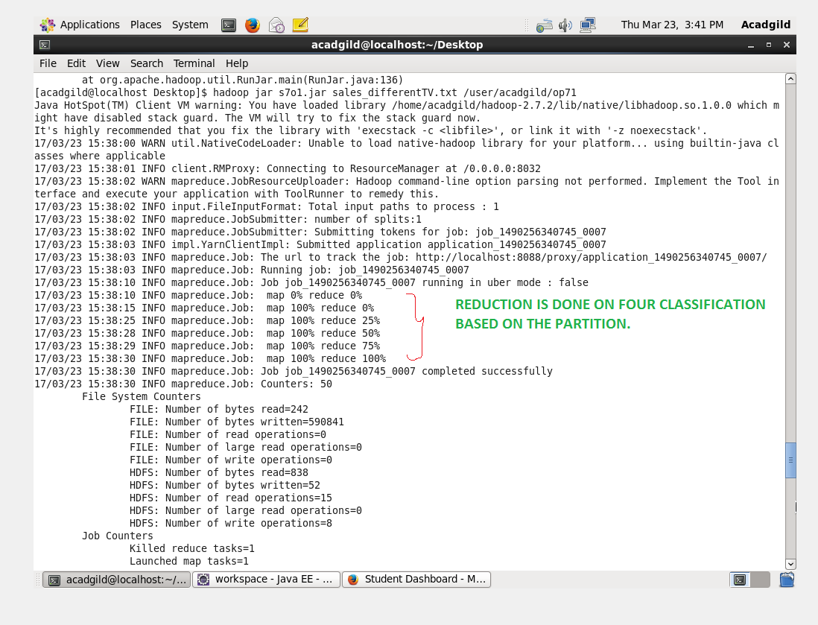

So based on the partition reduction is done on four parts.

OUTPUT TERMINAL:

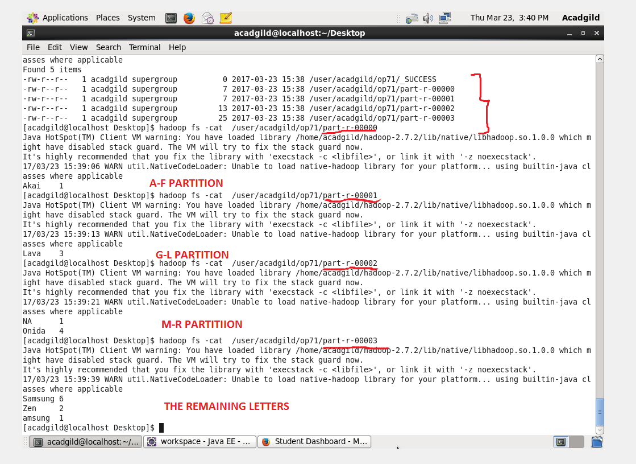

2.Modify Sales of different TV Task 2 (refer session 5, assignment 2) to take advantage of Combiner.

DRIVER CLASS:

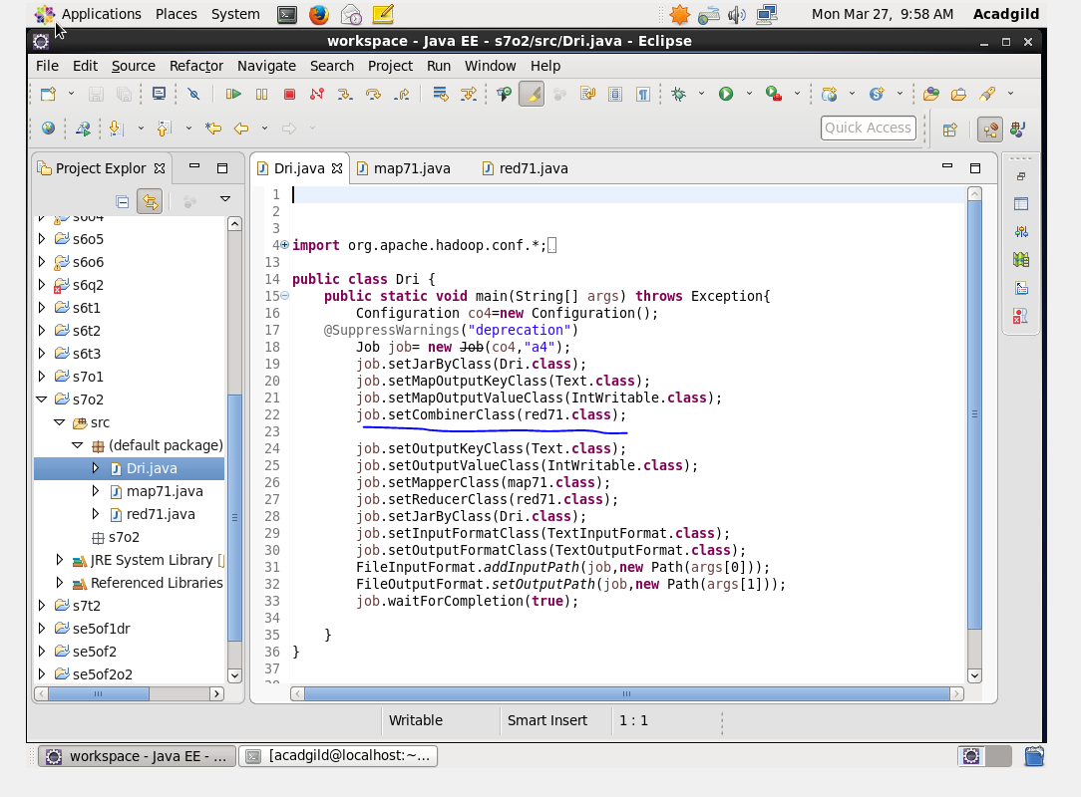

The other method to reduce is to use combiner.combiner is mainly used to reduce the data shuffle in mapper and reducer.

Mapper class:

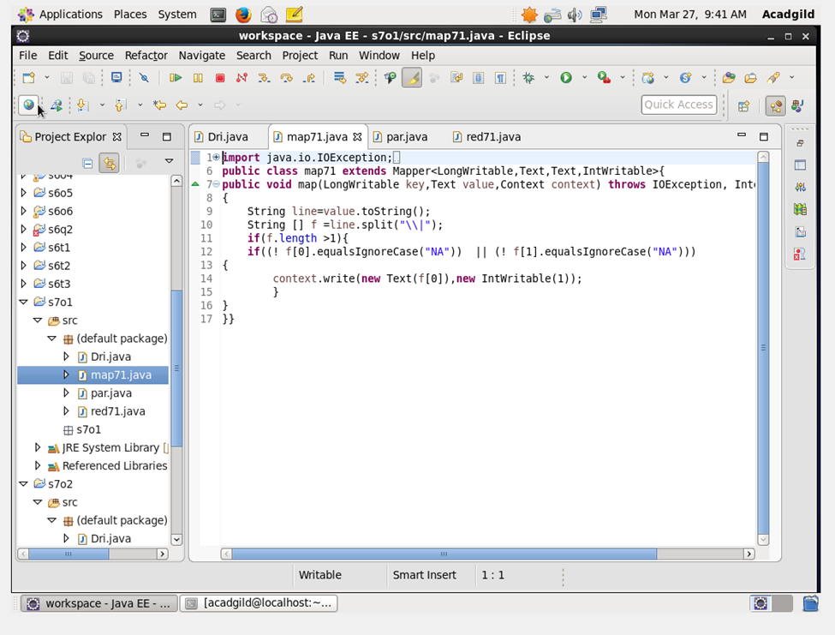

Reducer class:

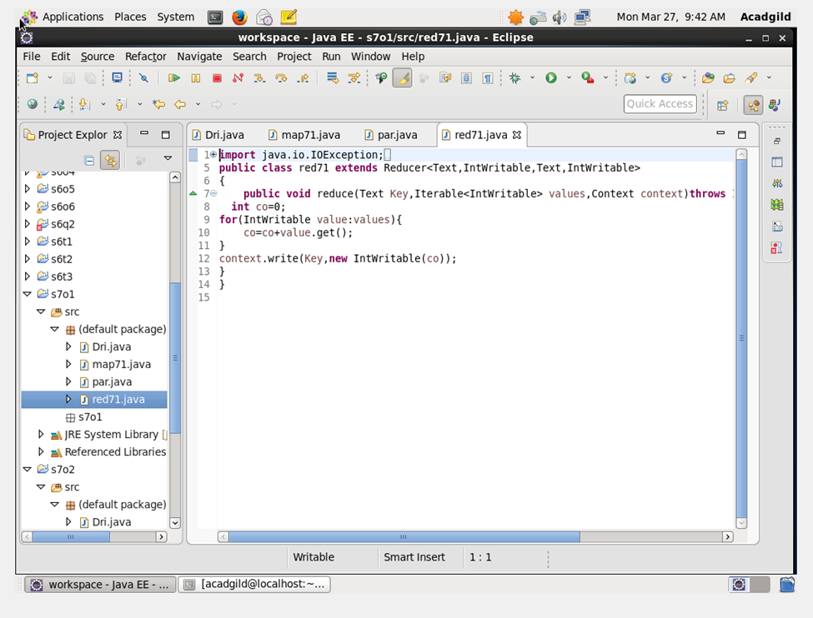

Run:

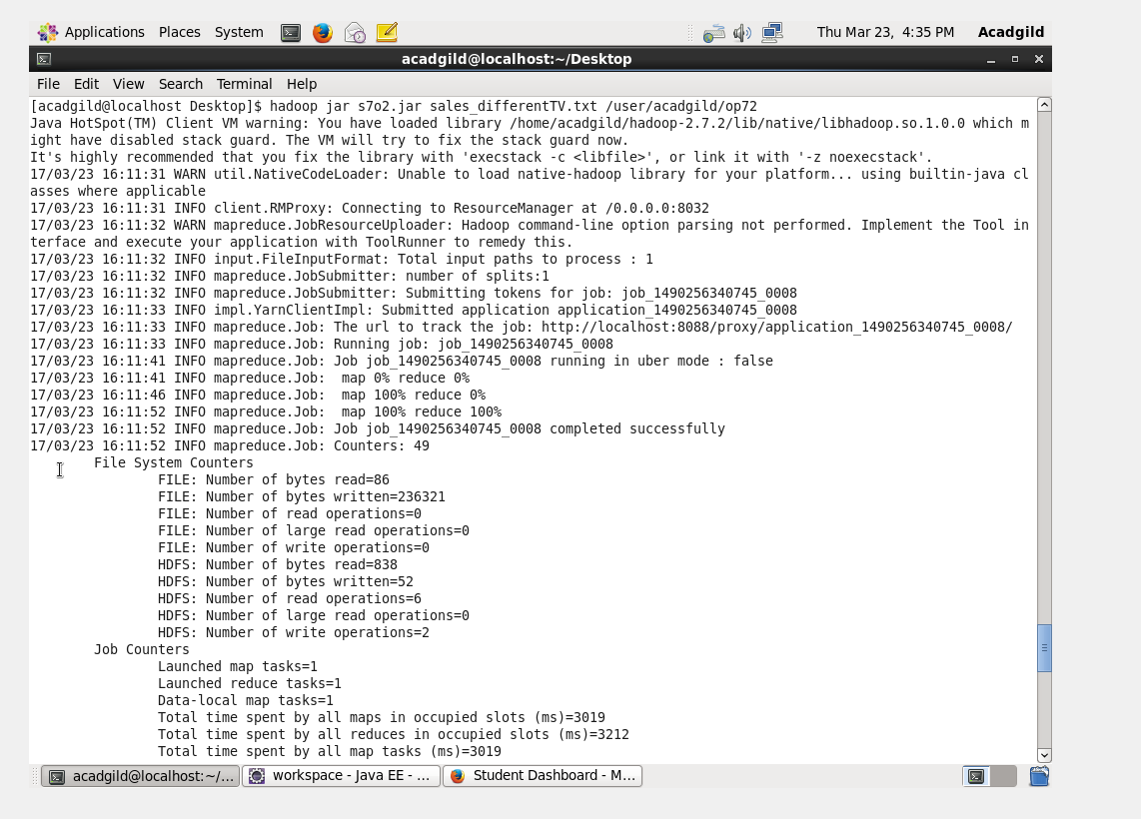

Output terminal:

