**Ass-7.2**

1.Modify Sales of different TV Task 3 (refer session 5, assignment 2) to take advantage of Combiner.

DRIVER CLASS:

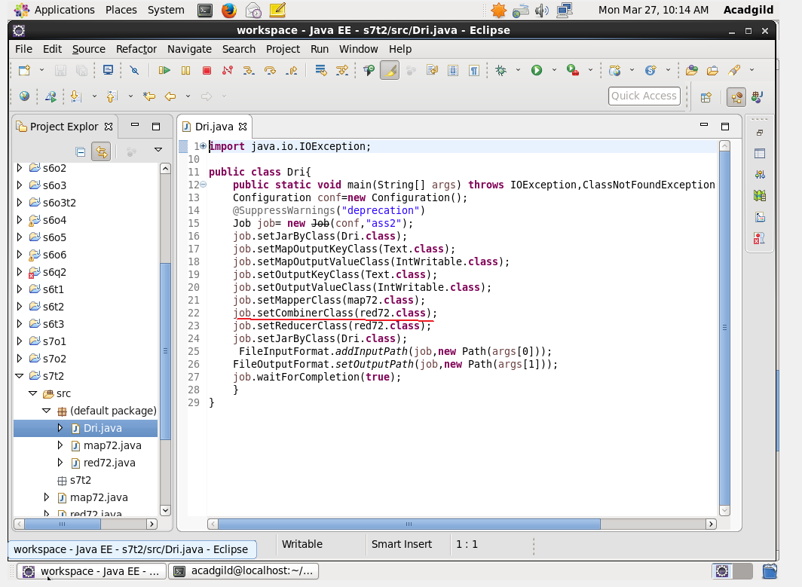

In this program the reducer class is considered as the combiner class.The combiner class just reduces the amount of data transfer from mapper to reducer and hence to improve the data transfer.Here the datas are reduced based on the reducer class.

MAPPER CLASS:

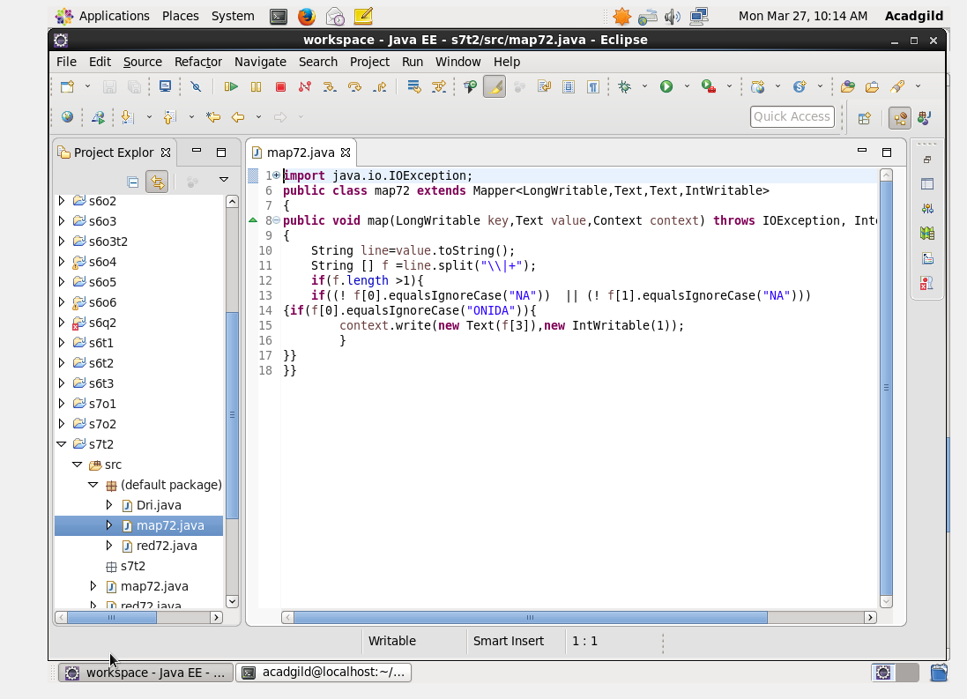

REDUCER CLASS:

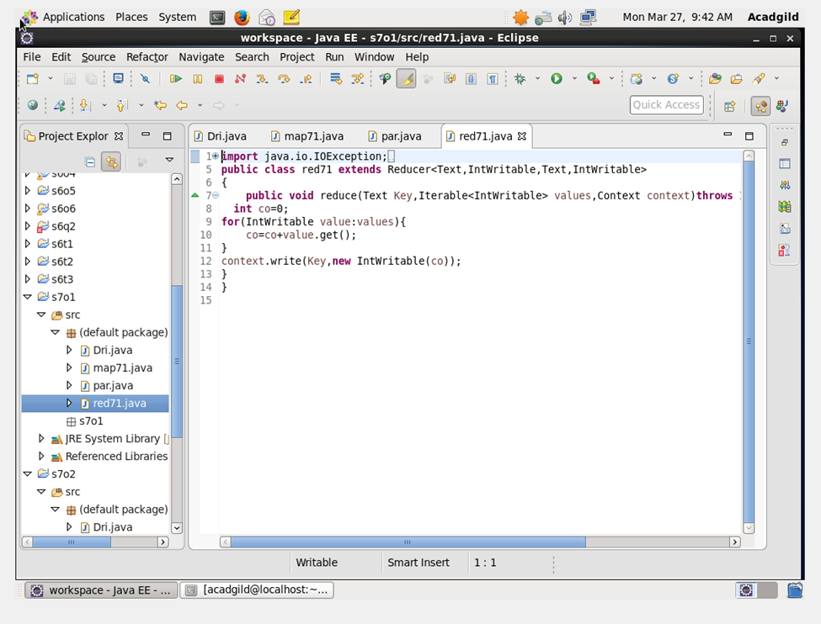

RUN:

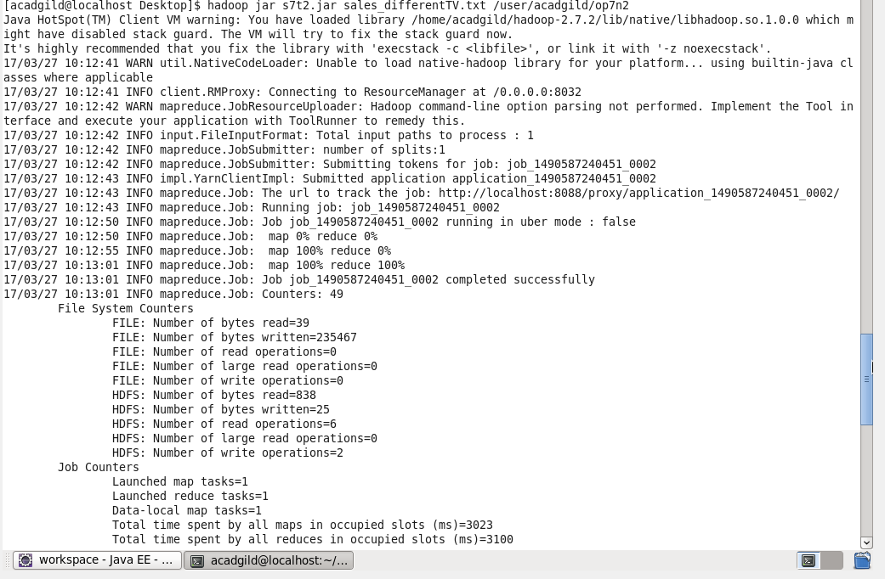

OUTPUT TERMINAL:

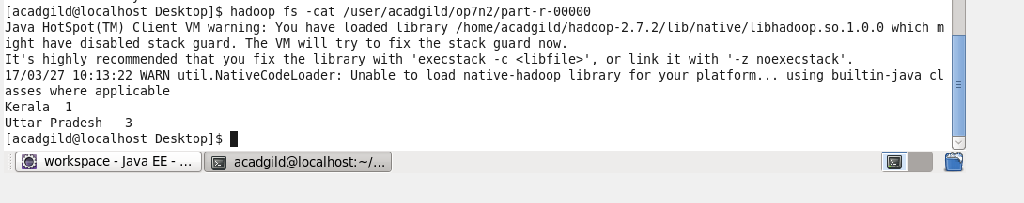

2. Write a Mapreduce program to view the total sales for each product for every Company corresponding to each size. Make sure that all records for a single company goes to a single reducer and inside every reducer, keys must be sorted in descending order of the size. You may write a custom WritableComparable for this purpose.

DRIVER CLASS:

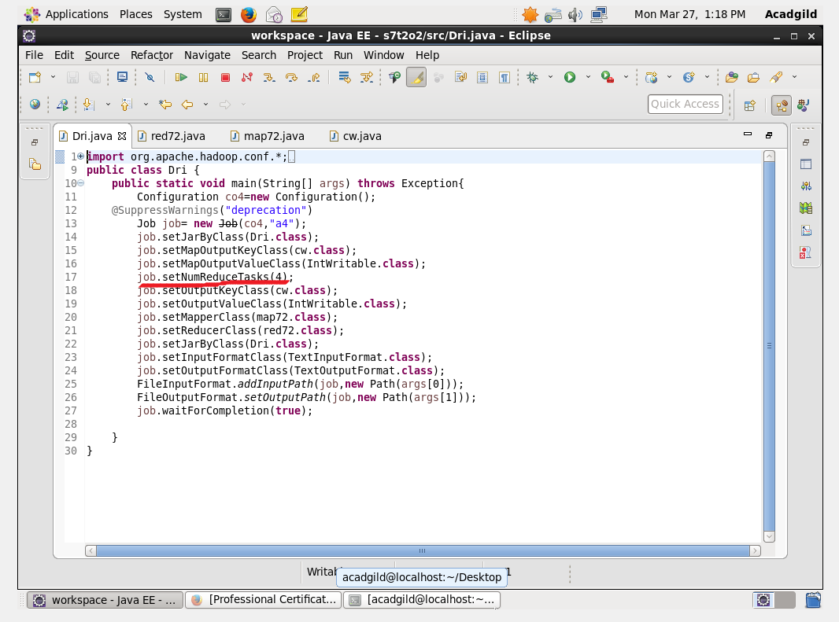

In this we are partitioning the companies that each company goes to a separate reducer and the sales are counted and should be displayed in descending order of the size of the product.

So we need company name,size,count ,to implement this we are using composite key .so that multiple datas can be sent as input name and size in datain and then it is compared with other input and counted.

Mapper class: 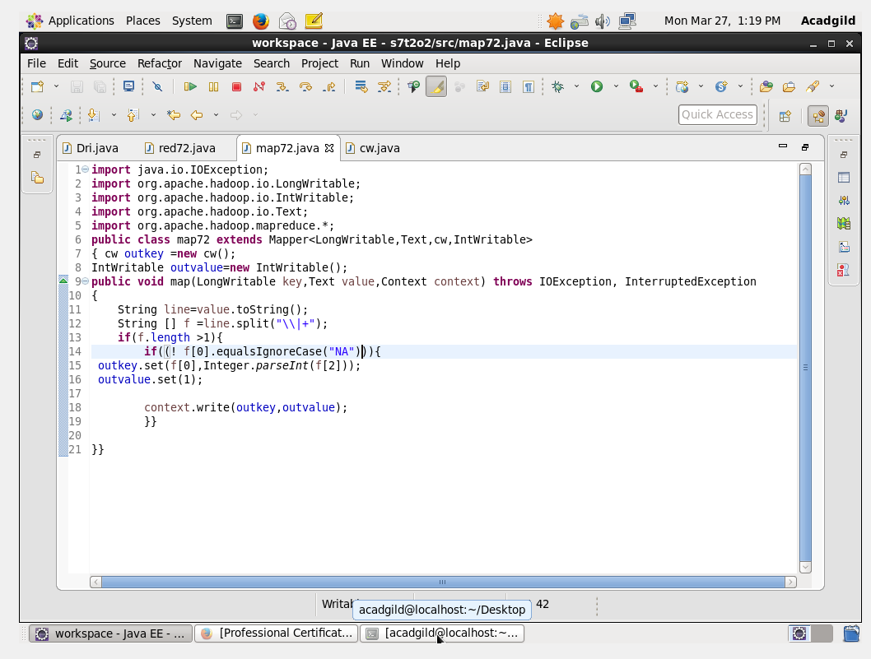

Reducer class:

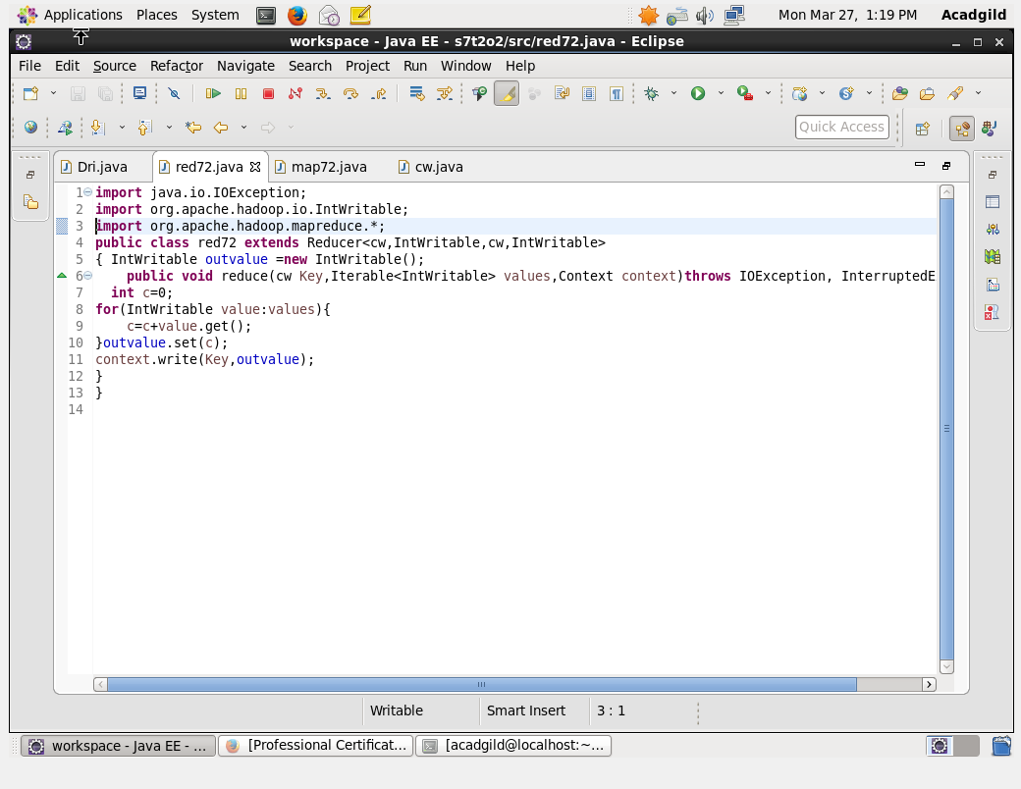

Writablecomparable class: 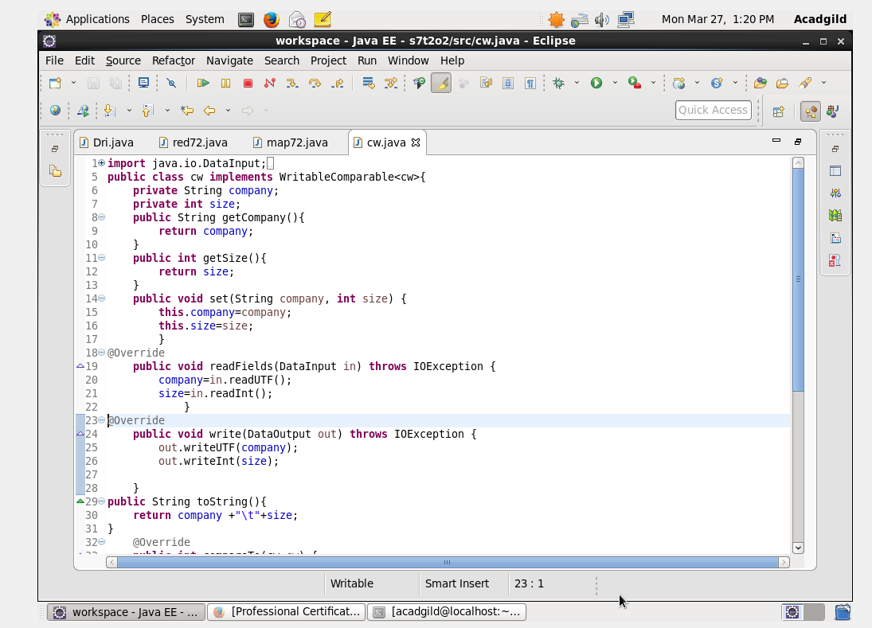

So the company name,size is obtained as input and compared with the previous value .if the company name is same ,then the size is checked and sorting is done on descending order of the size.

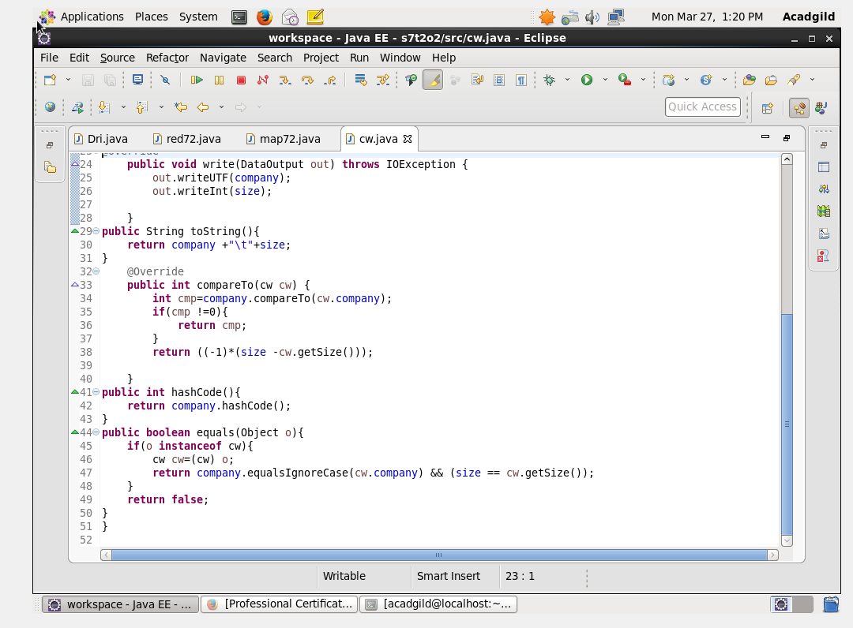

Run:

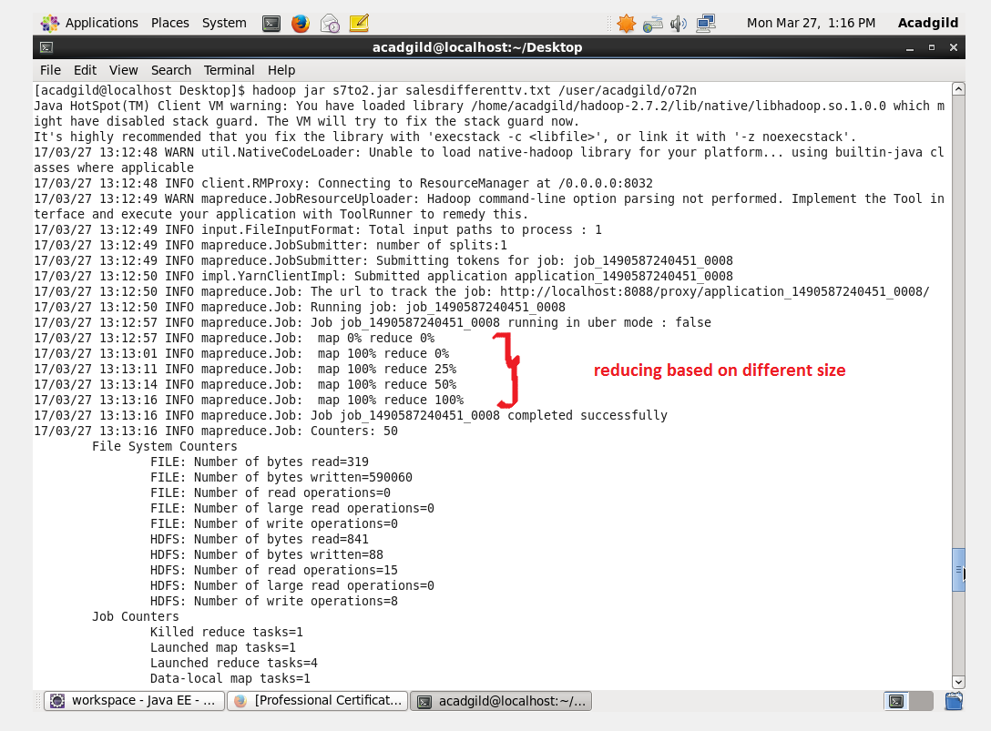

Output terminal:

