**ASS-7.3**

1. Write a custom key to evaluate the number of people who died and the number of people who survived, along with their genders.

Driver class:

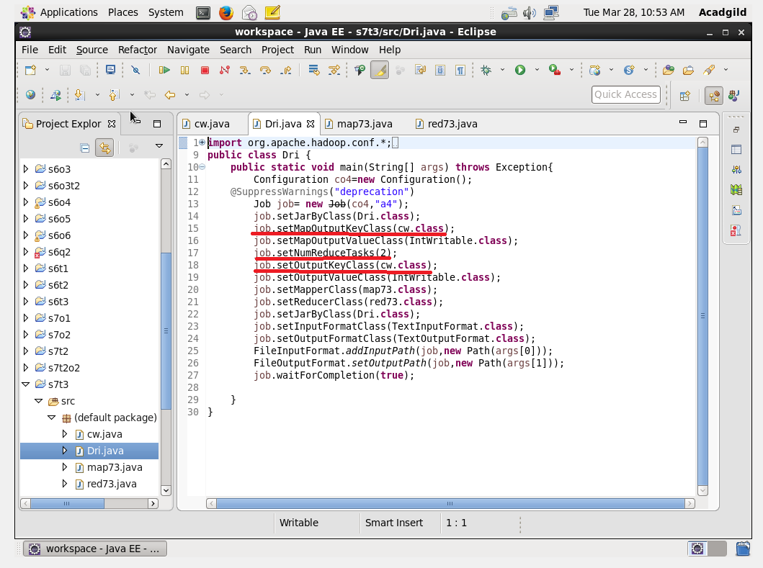

Mapper class:

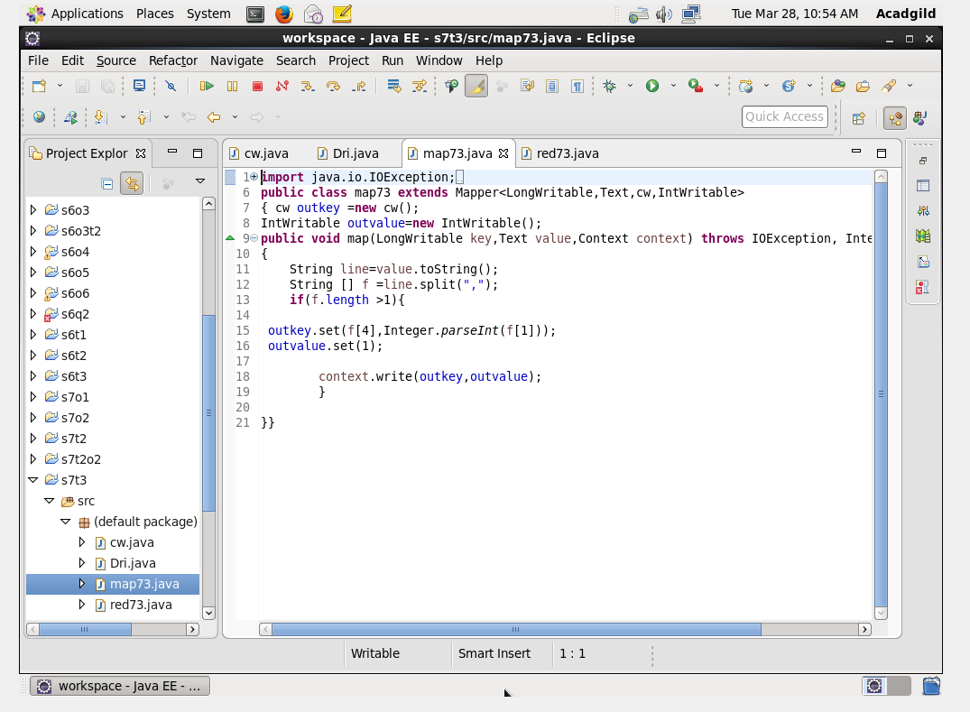

Reducer class:

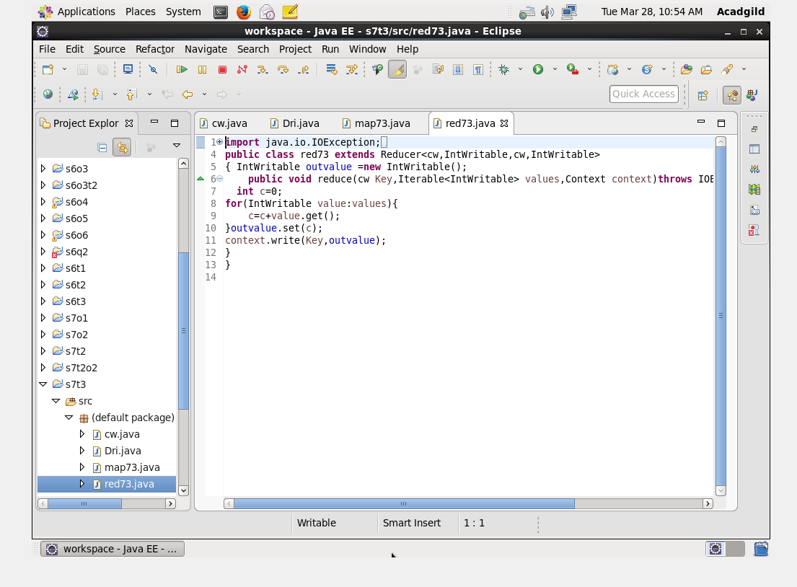

Writablecomparable class:

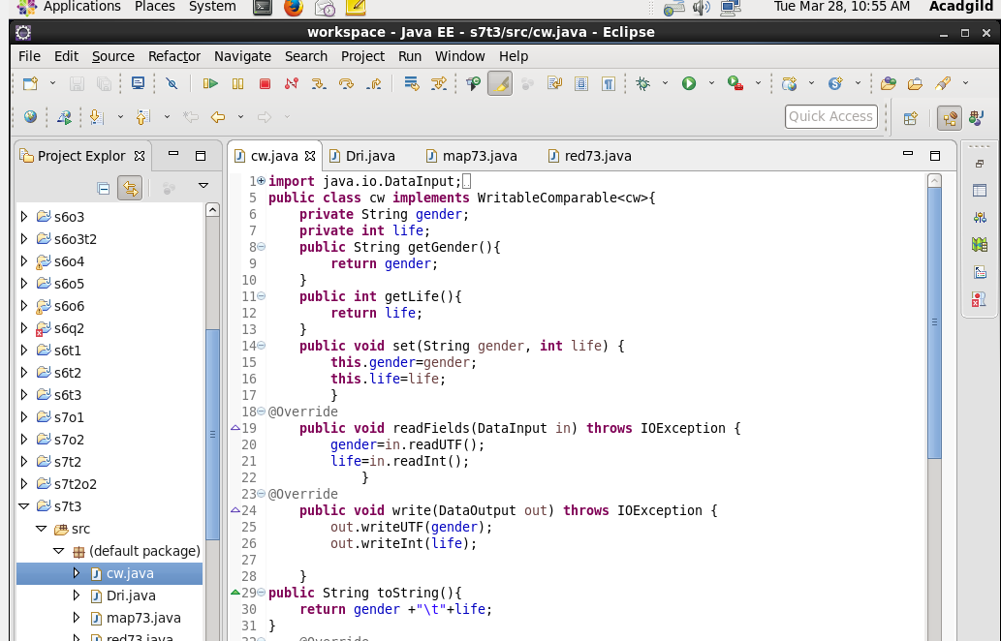

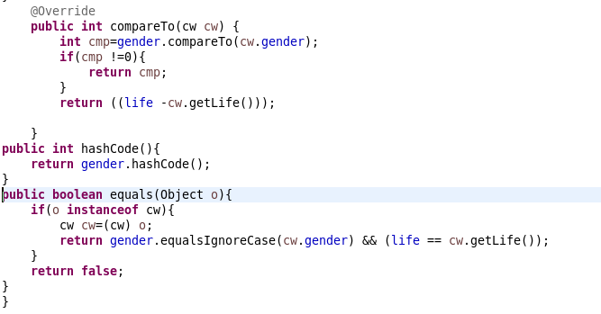

Run:

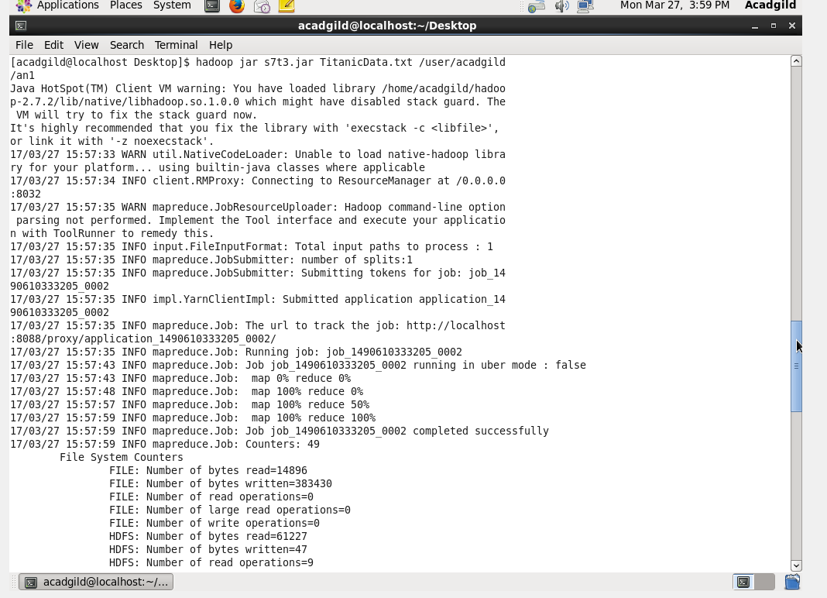

Output terminal:

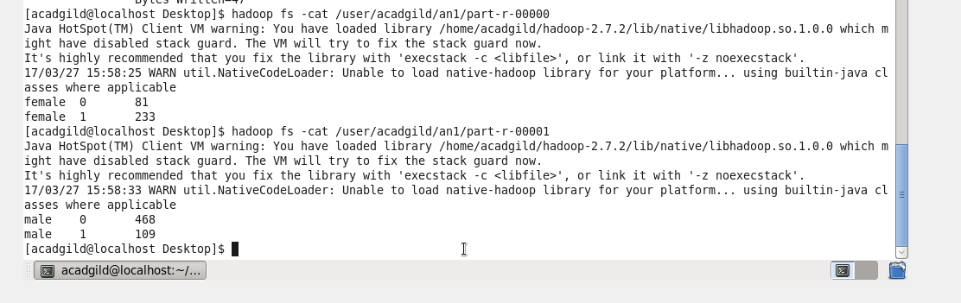

Female survived-81 and died-233

Male survived -468 and died-109