**ASS-7.4**

1.Write a word count program using partitioner and implement the following logic in the partitioner words with length 5 should go into reducer 1 and words with length 6 should go into reduer 2 and the rest of the words should go into reducer 3.

Driver class:

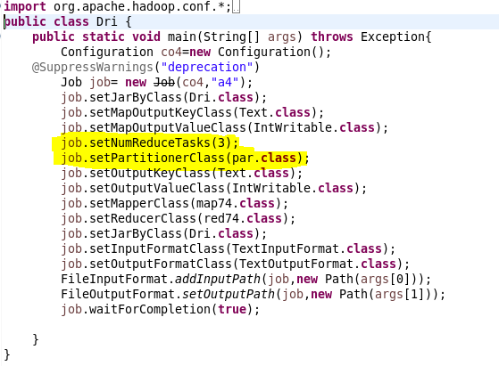

First we are initializing the mapper class, partitioner class ,reducer class and no of reducer class. Here we require 3 reducers ,so we are setting it by numReduceTask as 3 ,then to divide the data set to the corresponding reducer class we need a partitioner class .

Mapper class:

In mapper class ,we are tokenizing the given input by space and the key value is taken from the given data .These value along with key is sent to partitiioner.

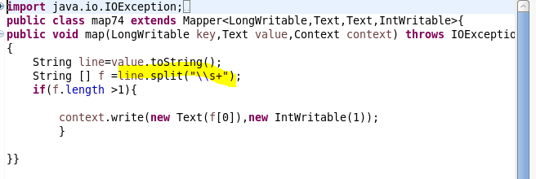

Partitioner class:

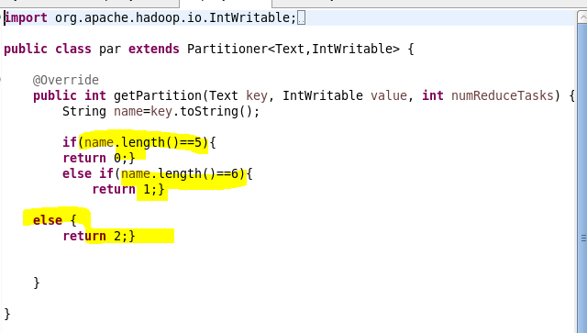

So the key ,the word should be moved to the corresponding reducer class based on its length ,if length is 5 then to reducer class 0 ,6 means to reducer class 1 or else to 2

Reducer class:

It is similar to other reducer class in previous questions,here we are counting the number of times the word repeated and the value is returned.



Run:

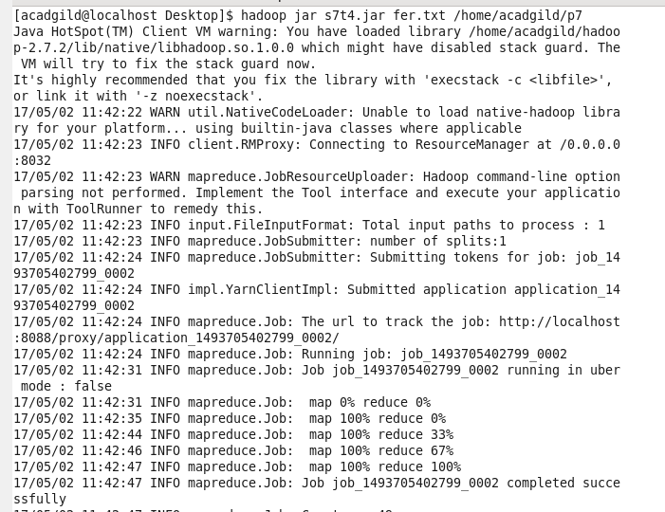

Output terminal