**ASS-7.5**

Write a map only job for the word count program and set the output format as sequence file.

Driver class:

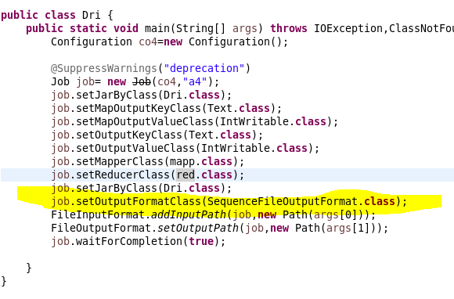

Driver class we initialize the mapper class, reducer class and the input and output format.to get a sequence file output format we are setting it to sequence file format.

Mapper class:

In mapper class ,we are tokenizing the given input by space and the key value is taken from the given data .

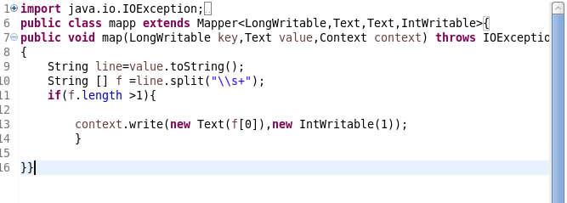

Reducer class:

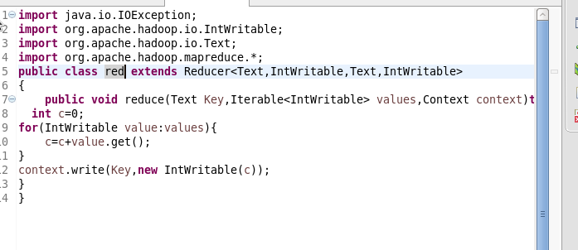

It is similar to other reducer class in previous questions,here we are counting the number of times the word repeated and the value is returned.

Run:

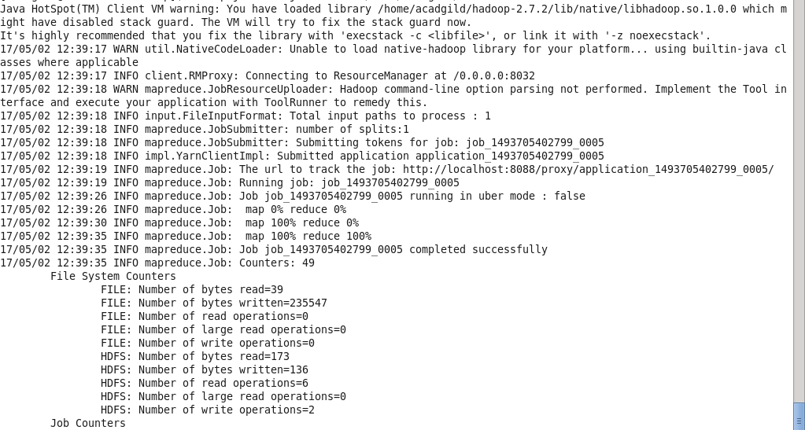

Output terminal:

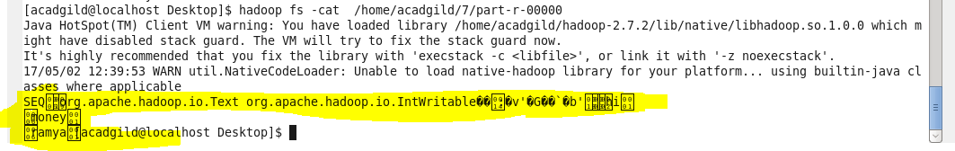

So the output is in sequence file

To display in text format we can use text command.

