**ASS-7.6**

Write a map reduce program save the output of the word count program in XML format. You need to write a custom writable to save the output in XML format.

DRIVER CLASS:

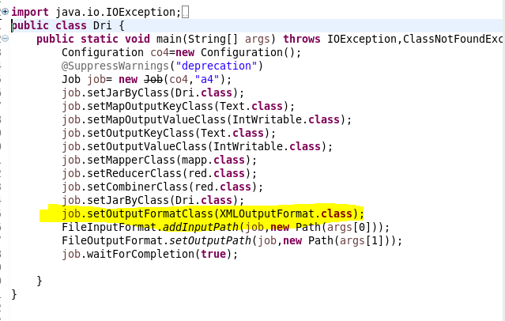

To save the output format in xml format we are setting the output format as XMLoutputformat .

Mapper class:

To include the input only that are not null we are initializing the condition and the key and value are obtained from the data set

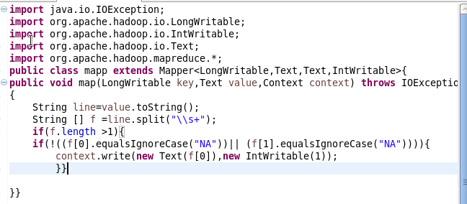

Reducer class:

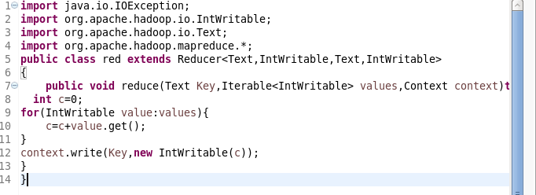

Xmloutputformat class:

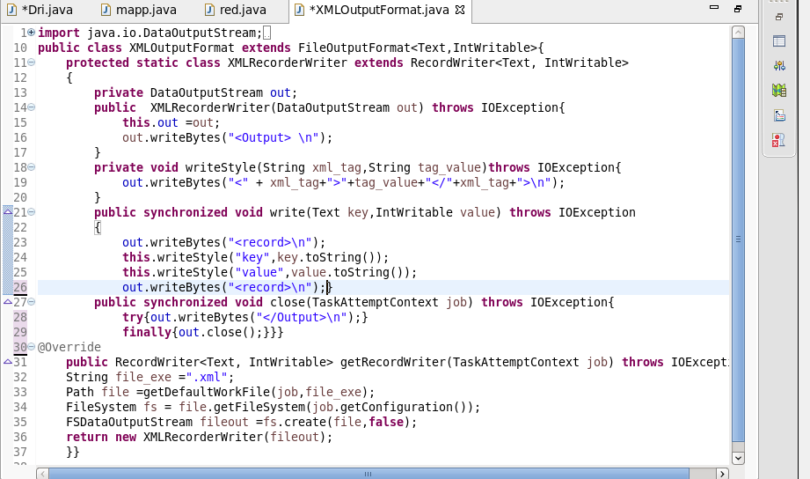

Run:

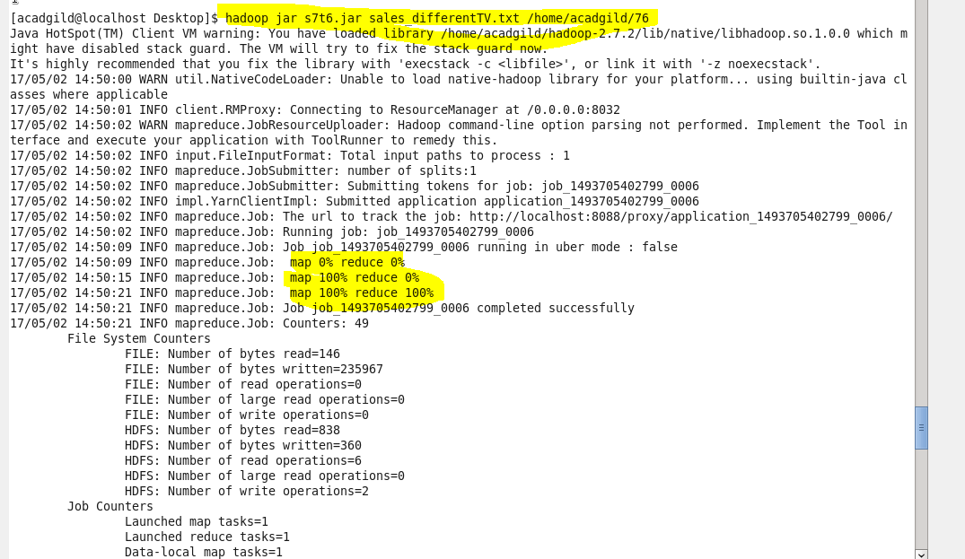

Output terminal:

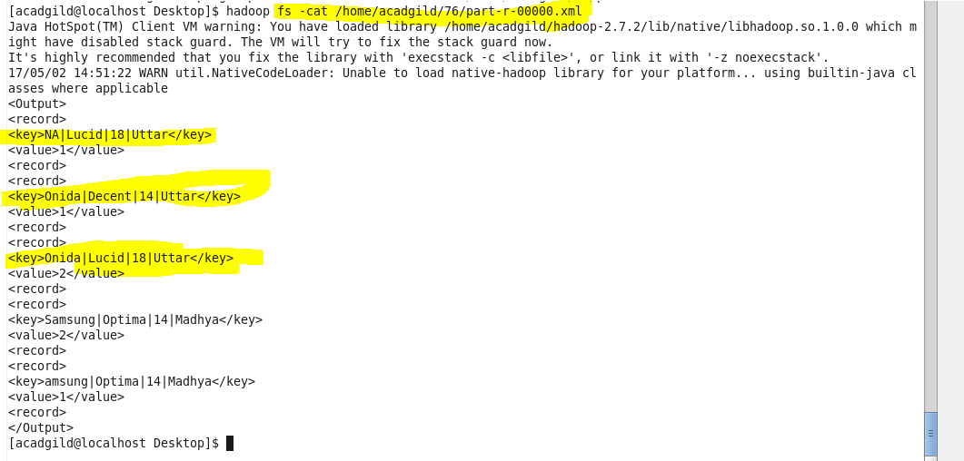

Thus the output is obtained in xml format.