**Ass-9.3**

1.Create two datasets employee and department of file type text where the columns are delimited by tab ( ‘\t’ ), and use these datasets to perform below Join operations :

Employee details: Department:

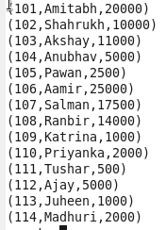 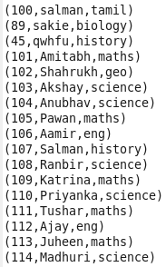

● SELF JOIN-This is used to join the table to itself.

Command: 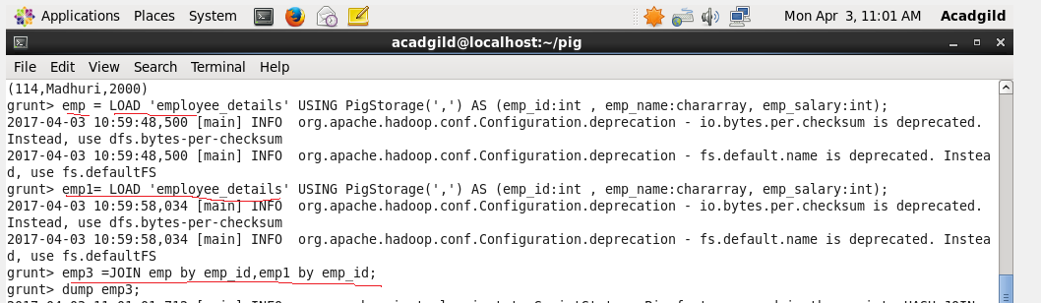

Output:

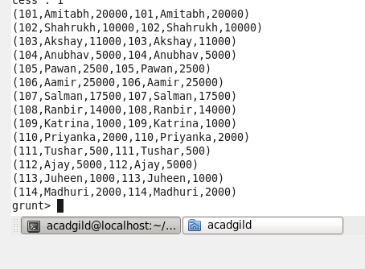

● INNER JOIN-In this the data which has common key in both table join together.

COMMAND: C:\Users\612912\Pictures\innerjoincmd.PNG

OUTPUT TERMINAL:

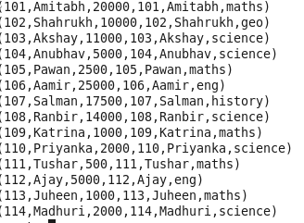

● LEFT OUTER JOIN –In this the left table data only included even if it is not in the second file.

COMMAND: C:\Users\612912\Pictures\outleftjoincmd.PNG

OUTPUT :

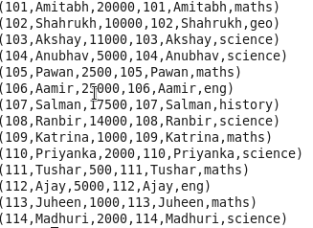

● RIGHT OUTER JOIN-This is similar to left outer join but it consider only the second data file instead of first file.

COMMAND:

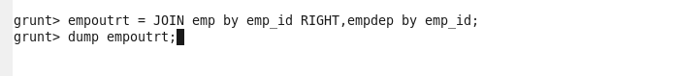

Output :

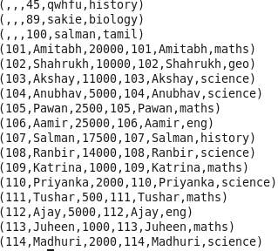

● FULL OUTER JOIN-This join combines both the file ,even if it is present only in any one of the file

Command:

C:\Users\612912\Pictures\fulloutercmd.PNG  
Output:

