**ASS-9.4**

1.Practice the relational operators in pig

The input data set is employee details

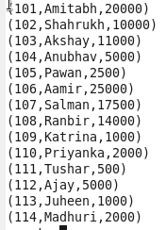

**Load**

To load the data either from local filesystem or Hadoop filesystem.

Syntax:

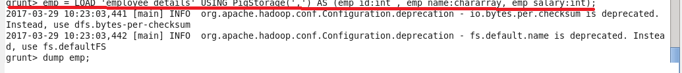

### Limit-Used to limit the number of outputs to the desired number.

### Syntax: C:\Users\612912\Pictures\screenshot\limit.PNG

### Order

Sorts a relation based on single or multiple fields.

Syntax: C:\Users\612912\Pictures\order by cmd.PNG

Here the data is displayed in the descending order of the salary.

Ouput:

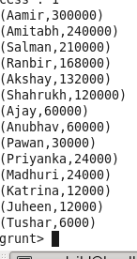

### Group

Groups the data based on one or multiple fields. It groups together tuples that have the same group key (key field). The key field will be a tuple if the group key has more than one field, otherwise it will be the same type as that of the group key.

Syntax: C:\Users\612912\Pictures\group by.PNG

OUTPUT:

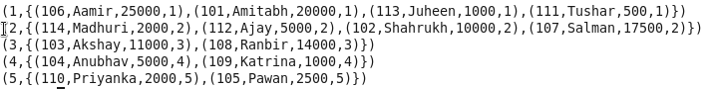

### Foreach

It generates data transformations based on desired columns of data.

Syntax:

C:\Users\612912\Pictures\foreach.PNG

### Filter

Filters a relation based on certain condition.

Syntax: Here it filers the data based on name starts with ‘a’

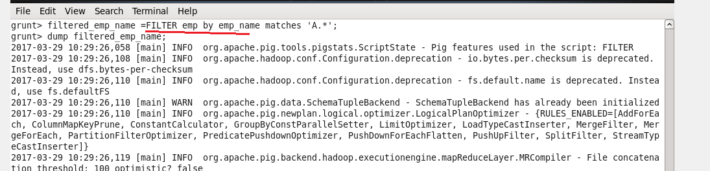

**STORE**-Store command is used to store the given file in the destined name

Just we are copying ,employee_details text file into pig, with this we are performing all functions using this text file.

Store command to store the content of emp_salary into the file empsalary



Output showing that the file is saved into empsalary

