**PART-1**

**Song Generation**

**Description:**

It can have lyrics with motivation for study and productive work. tempo ~90 BPM; 2 minutes. Upbeat piano study track with gentle some violine, cozy vinyl crackle, and a calm synth lead;

**Observation:**

The song generated was very much related to the description. It struggled to generate lyrics with the initial prompt/description, so I had to rephrase the prompt and mention specifically that there should be a lyrics about motivation. Without this specification, it was generating just BGM (Background Music) with piano and violin (similar to lo-fi music). There is a lot of repetition of the song lyrics instead on new verse, so it felt a little repeated. Overall, it had good music and lyrics generation for the given description.

**Suggestions:**

There can be a trigger button asking if there is any lyrics required or not, like how they have the option of including any instruments. That way it will be able to capture the lyrics much better. It can also include customization of the lyrics, and also include and audio input for the kind of tune the user wants. That way, people who feel like they are bad at singing, can also generate beautiful songs.

**PART-2**

**Video Generation**

**Does the generated video meet your expectations? Do you think it is a good video?**

Yes. It’s a clean video with readable captions and per-slide narration. I was expecting for the audio to get cut off like it happened in the class, but the generated video was in sync with the audio.

**Do you have any suggestions for improving the video?**

I would be nice to have a more human like voice for the video along with some transition to see some smoothness in the video. We can also incorporate the music generations AI with this video generation to provide suitable background music for the story line.

**If you have a suggestion for improving the video, what is the code for implementing it?**

The code below is for having smooth crossfades for better transition. I am replacing simple concatenate with crossfades

image_clips_xf = [image_clips[0]] + [c.crossfadein(0.6) for c in image_clips[1:]]  
final_clip = mp.concatenate_videoclips(image_clips_xf, method="compose", padding=-0.6)  
output_file_path = "class_exercise.mp4"  
final_clip.write_videofile(output_file_path, fps=24, codec="libx264", audio_codec="aac", bitrate="2000k")

**PART-3**

**NotebookLM**

**What is the link to the research paper?**

The source of the paper is from: <https://arxiv.org/abs/2406.03007>

**Does the generated video accurately summarize the paper’s content and contributions?**

The video generated gives and accurate summary of the paper regarding BadAgent. It includes the explanation of the problem, 2 modes of attack, experimental setup of the task, explaining the key results with the mitigation methods used. It was able to explain the content-level and action level attacks.

**Do you have any suggestions for improving the “Video Overview” feature?**

It would be better if I can select the mandatory table results to include in the summary. I also noticed that the result table was simplified to a basic version, that way it is missing a lot of minor details. Having the transcript of the summary would also help in finding a particular topic rather than watching the whole video for a search.

**PART-4**

**Article Revision**

**Test1**

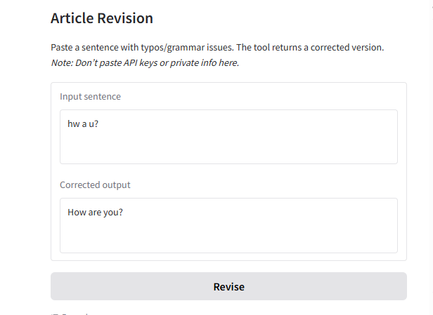

**Test2:**

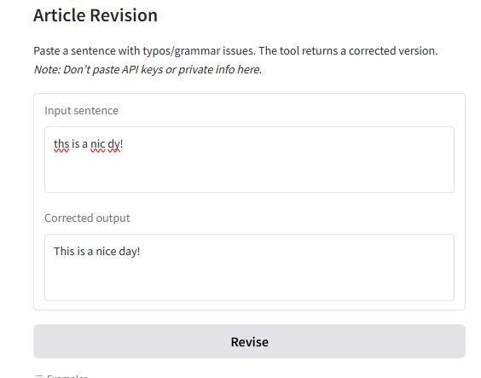

**Test3:**