**HW-4**

Hugging face space link Part 3

<https://huggingface.co/spaces/jayasri0305/Speech-recognition>

Gradio live link for PART 4:

<https://298151c09c0a3ebbe5.gradio.live/>

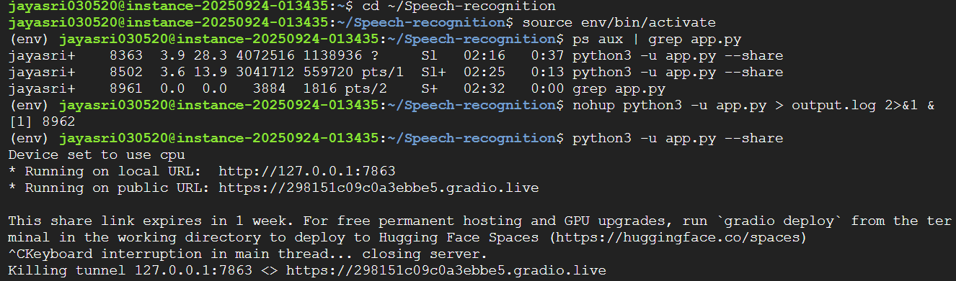

(command “nohup python3 - u app.py” does not work for me!)

