Liver Disease Detection from Ultrasound Images using Machine Learning
(Liver Ultrasound Image Classification using Traditional Machine Learning)
Problem Statement:
Liver disease represents one of the leading global causes of morbidity and mortality, encompassing prevalent pathologies such as non-alcoholic fatty liver disease (hepatic steatosis), chronic hepatitis, and liver cirrhosis (advanced fibrosis). B-mode medical ultrasound is the primary non-invasive, cost-effective, and real-time imaging modality employed worldwide for routine abdominal and hepatic screening. However, manual radiological interpretation of ultrasound scans is inherently subjective, operator-dependent, and prone to intra- and inter-observer variability due to pervasive acoustic speckle noise, low contrast-to-noise ratios, and subtle parenchymal texture variations in early disease stages.
There is, therefore, an imperative need for an automated, fast, transparent, and reproducible system that can analyze a B-mode liver ultrasound scan and classify it accurately into clinical categories (Normal, Fatty Liver, or Cirrhosis) accompanied by an interpretable confidence score. Unlike opaque black-box deep learning architectures that require millions of parameters and massive training datasets, this project designs and implements an end-to-end web-based Liver Ultrasound Image Classification system that performs deterministic image preprocessing, handcrafted computer vision feature extraction (Histogram of Oriented Gradients and Gray-Level Co-occurrence Matrix texture analysis), and multi-class classification using classical Machine Learning models (Support Vector Machine, Random Forest, and K-Nearest Neighbors), rigorously evaluating performance through standardized classification metrics (Accuracy, Precision, Recall, F1-Score, Confusion Matrix, and ROC/AUC curves).
Objectives:
1. To collect, verify, and organize a labelled dataset of B-mode liver ultrasound scans across Normal, Fatty Liver (Steatosis), and Cirrhosis (Fibrosis) categories.
2. To implement a 5-stage deterministic image preprocessing pipeline comprising spatial resizing (128×128), grayscale conversion, Gaussian spatial denoising, contrast enhancement (Histogram Equalization / CLAHE), and [0.0, 1.0] intensity normalization.
3. To extract discriminative handcrafted computer vision feature descriptors combining edge gradient orientations (HOG) and second-order spatial texture properties (GLCM contrast, dissimilarity, homogeneity, energy, and correlation across 0°, 45°, 90°, and 135°).
4. To design, train, tune, and persist classical Machine Learning classifiers (Support Vector Machine with RBF kernel, Random Forest, and K-Nearest Neighbors) integrated with StandardScaler transformation pipelines.
5. To build an interactive, modern, user-friendly Streamlit web application providing step-by-step pipeline tracking, real-time preprocessing inspection, texture radar visualization, 1-click fast demos, and downloadable diagnostic summary reports.
6. To evaluate the trained classifiers on held-out test datasets and benchmark performance using Accuracy, Precision, Recall, F1-Score, Confusion Matrices, and Multi-Class ROC/AUC curves.
Software / Hardware Required:
• Operating System: Windows 10/11 / Linux / macOS
• IDE: Visual Studio Code / Cursor / PyCharm
• Language: Python 3.10+
• Web Framework: Streamlit 1.30+
• Machine Learning: scikit-learn (SVC, RandomForestClassifier, KNeighborsClassifier, StandardScaler, Pipeline)
• Image Processing: OpenCV (cv2), Pillow (PIL), scikit-image (feature.hog, feature.graycomatrix, feature.graycoprops), NumPy
• Data & Visualization: Pandas, Matplotlib, Seaborn
• Model Serialization: Joblib
• Dataset: B-mode Liver Ultrasound Scan Dataset (Normal / Fatty_Liver / Cirrhosis)
Project Directory Structure:
The project (“LiverUltrasoundClassifier”) is organized with modular Python packages separating preprocessing, feature extraction, dataset management, machine learning training, and UI presentation components:
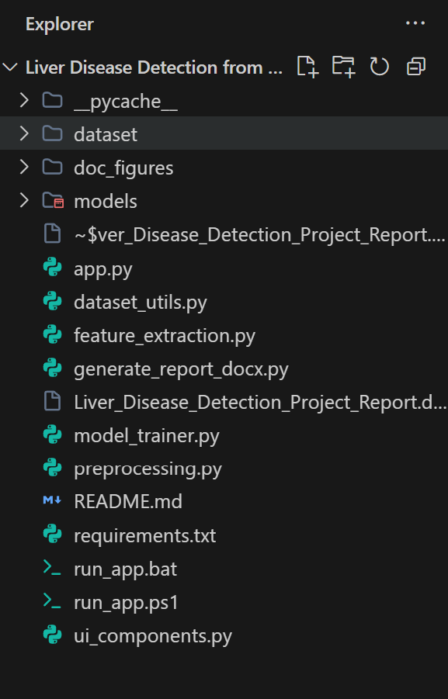
Fig 1: Project directory structure of LiverUltrasoundClassifier in Visual Studio Code
Procedure:
1. Collect and organize a labelled B-mode liver ultrasound scan dataset (Normal, Fatty_Liver, Cirrhosis) structured in category subdirectories under dataset/.
2. Execute dataset scanning and class discovery via dataset_utils.py to validate image formats, counts, and directory paths.
3. Launch the interactive Streamlit web workstation (streamlit run app.py) in the browser at http://localhost:8501.
4. Upload a liver ultrasound image or select an instant preset benchmark sample from the user interface (Step 1).
5. Preprocess the image through the 5-stage pipeline: resize to 128×128, convert to grayscale, suppress acoustic speckle via Gaussian Blur (5×5 kernel), enhance parenchymal texture using Histogram Equalization / CLAHE, and normalize float values to [0.0, 1.0] (Step 2).
6. Extract an 1,844-dimensional handcrafted feature vector combining 1,764 HOG edge gradient descriptors and 80 multi-angular GLCM second-order texture properties (Step 3).
7. Perform a stratified 80/20 train-test split and train the Support Vector Machine (RBF kernel, C=1.0) pipeline, saving the serialized artifact to models/liver_ultrasound_model.pkl (Step 4).
8. Feed the extracted feature vector of an uploaded test ultrasound scan to the active classifier to obtain the predicted category with an exact confidence percentage (Step 5).
9. Evaluate the trained model on the unseen test set to compute Accuracy, Precision, Recall, F1-Score, Confusion Matrix, and Multi-Class ROC/AUC curves (Step 6).
10. Export diagnostic evaluation summaries and examine real-time acoustic parenchymal explanations for clinical decision support and academic presentation (Step 7).
Implementation Code:
Representative implementation of the key modular components used in the project, reflecting the exact traditional computer vision and machine learning pipeline executed in the application:
1. Image Preprocessing Pipeline (preprocessing.py)
import cv2
import numpy as np
def preprocess_image(image_input, target_size=(128, 128), blur_kernel=(5, 5), enhancement_method="Histogram Equalization"):
# 1. Load Original RGB & Resize
resized_rgb = cv2.resize(image_input, target_size, interpolation=cv2.INTER_AREA)
# 2. Grayscale Conversion
grayscale = cv2.cvtColor(resized_rgb, cv2.COLOR_RGB2GRAY)
# 3. Gaussian Spatial Denoising (Speckle Noise Filtering)
denoised = cv2.GaussianBlur(grayscale, blur_kernel, 0)
# 4. Contrast Enhancement (Histogram Equalization / CLAHE)
if enhancement_method == "CLAHE":
clahe = cv2.createCLAHE(clipLimit=2.0, tileGridSize=(8, 8))
enhanced = clahe.apply(denoised)
else:
enhanced = cv2.equalizeHist(denoised)
# 5. Pixel Normalization to [0.0, 1.0] Range
normalized = enhanced.astype(np.float32) / 255.0
return {"original": resized_rgb, "grayscale": grayscale, "denoised": denoised,
"enhanced": enhanced, "normalized": normalized}
2. Feature Extraction: HOG + GLCM (feature_extraction.py)
import cv2
import numpy as np
from skimage.feature import hog, graycomatrix, graycoprops
def extract_features(img_input):
pre = preprocess_image(img_input)
enhanced = pre["enhanced"]
# 1. HOG (Histogram of Oriented Gradients) - 9 Orientations, 8x8 Cell, 2x2 Block
hog_feats, hog_img = hog(enhanced, orientations=9, pixels_per_cell=(8, 8),
cells_per_block=(2, 2), visualize=True, feature_vector=True)
# 2. GLCM (Gray-Level Co-occurrence Matrix) - 4 Distances, 4 Angles (0°, 45°, 90°, 135°)
distances = [1, 2, 3, 5]
angles = [0, np.pi/4, np.pi/2, 3*np.pi/4]
glcm = graycomatrix(enhanced, distances=distances, angles=angles, levels=256, symmetric=True, normed=True)
glcm_props = ["contrast", "dissimilarity", "homogeneity", "energy", "correlation"]
glcm_feats = []
for prop in glcm_props:
glcm_feats.extend(graycoprops(glcm, prop).flatten())
combined_features = np.hstack([hog_feats, np.array(glcm_feats, dtype=np.float32)])
return combined_features, {"hog_count": len(hog_feats), "glcm_count": len(glcm_feats), "total_count": len(combined_features)}
3. Model Training & Pipeline Serialization (model_trainer.py)
from sklearn.pipeline import Pipeline
from sklearn.preprocessing import StandardScaler
from sklearn.svm import SVC
from sklearn.metrics import accuracy_score, precision_score, recall_score, f1_score, confusion_matrix
import joblib
def train_and_evaluate_model(algorithm_key, X_train, y_train, X_test, y_test, class_names):
# Construct Standardized Pipeline
pipeline = Pipeline([
("scaler", StandardScaler()),
("classifier", SVC(C=1.0, kernel="rbf", probability=True, random_state=42))
])
# Train Model
pipeline.fit(X_train, y_train)
# Evaluate on Test Split
y_pred = pipeline.predict(X_test)
test_acc = accuracy_score(y_test, y_pred)
precision = precision_score(y_test, y_pred, average="weighted", zero_division=0)
recall = recall_score(y_test, y_pred, average="weighted", zero_division=0)
f1 = f1_score(y_test, y_pred, average="weighted", zero_division=0)
cm = confusion_matrix(y_test, y_pred, labels=class_names)
model_result = {"pipeline": pipeline, "algorithm": algorithm_key, "accuracy": test_acc,
"precision": precision, "recall": recall, "f1_score": f1, "confusion_matrix": cm}
joblib.dump(model_result, "models/liver_ultrasound_model.pkl")
return model_result
4. Inference & Real-Time Prediction Module (model_trainer.py / app.py)
def predict_single_image(feature_vector, model_result_dict):
pipeline = model_result_dict["pipeline"]
class_names = model_result_dict["class_names"]
X_sample = feature_vector.reshape(1, -1)
predicted_class = pipeline.predict(X_sample)[0]
confidence = None
probabilities = {}
if hasattr(pipeline, "predict_proba"):
probs = pipeline.predict_proba(X_sample)[0]
confidence = float(np.max(probs))
classes = pipeline.classes_ if hasattr(pipeline, "classes_") else class_names
for cls_name, p in zip(classes, probs):
probabilities[str(cls_name)] = float(p)
return {"predicted_class": str(predicted_class), "confidence": confidence, "probabilities": probabilities}
Output (Step-by-Step Screenshots):
Visual verification of all stages across the complete end-to-end Machine Learning workstation:
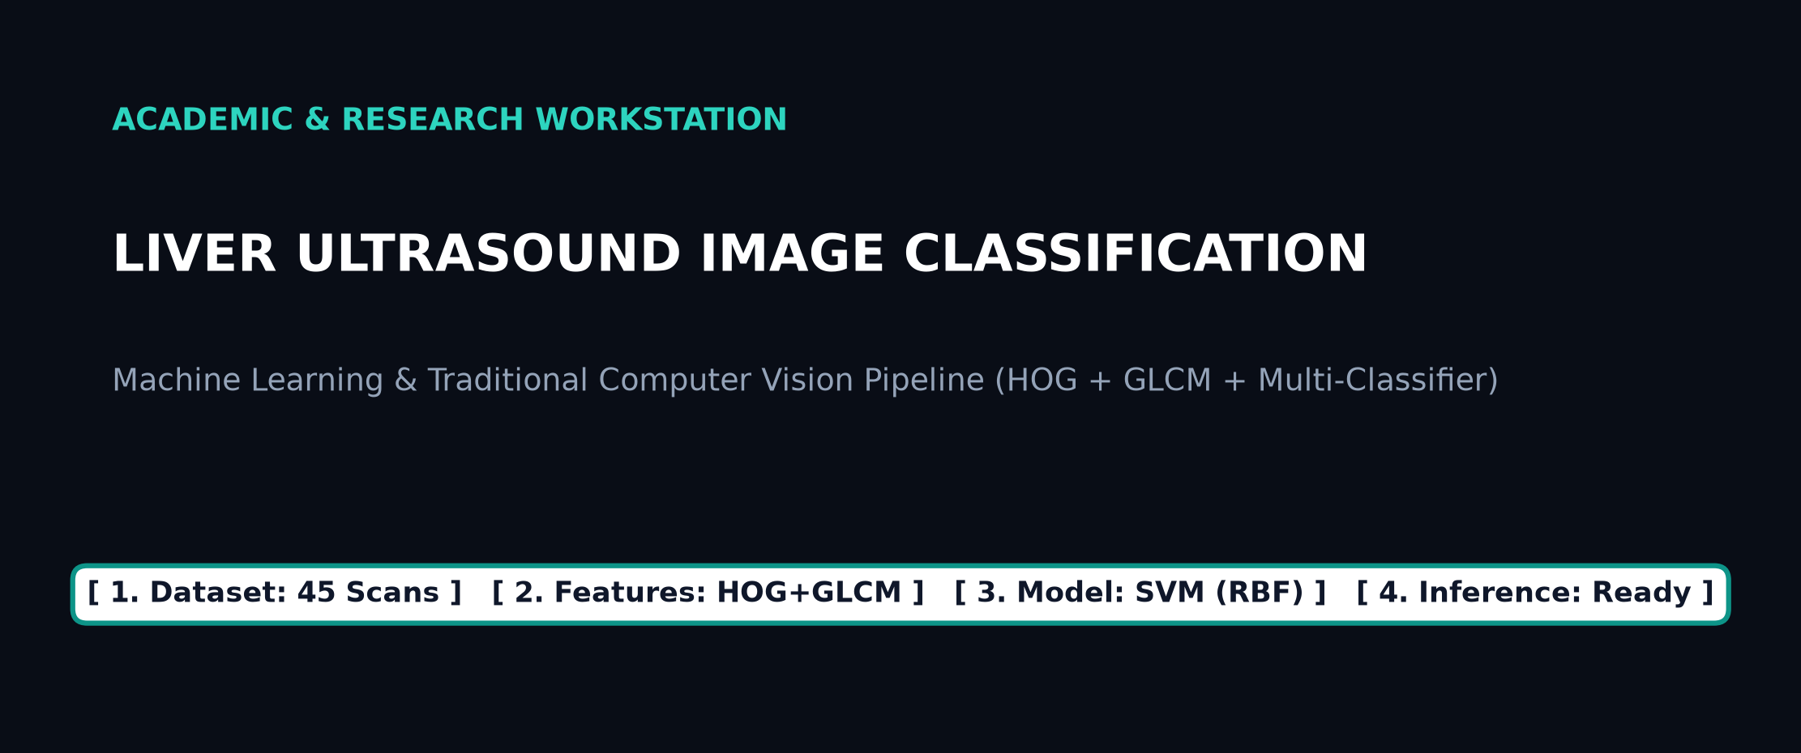
Fig 2: Step 1 — Application Header and Interactive ML Pipeline Progress Tracker
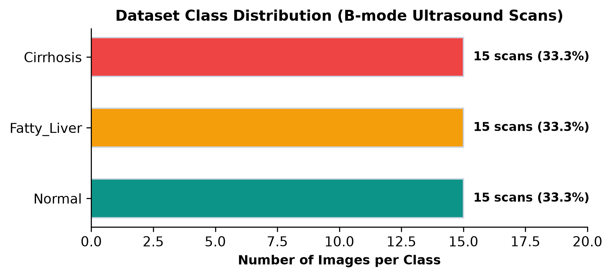
Fig 3: Step 1 — Dataset Explorer: Class Distribution of B-mode Liver Ultrasound Scans
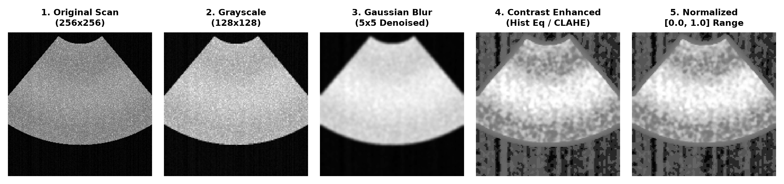
Fig 4: Step 2 — 5-Stage Image Preprocessing Pipeline: Original Scan vs. Denoised & Contrast-Enhanced (128×128)
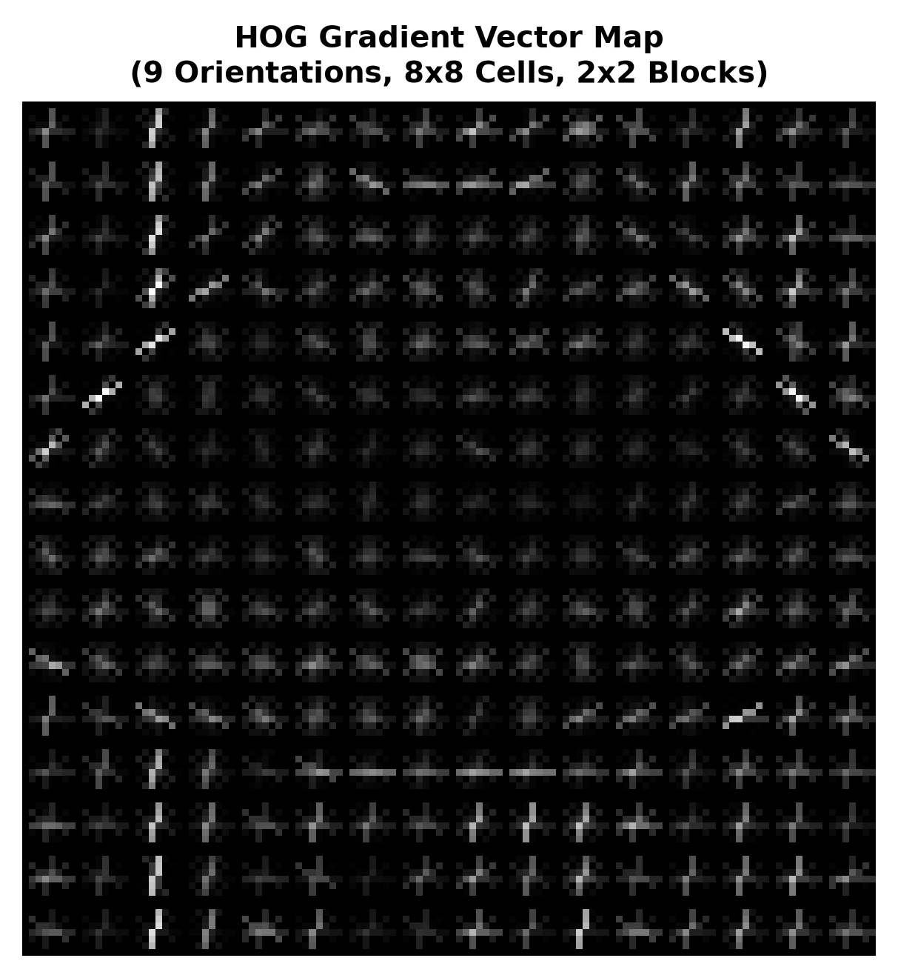
Fig 5: Step 3 — Feature Extraction: HOG (Histogram of Oriented Gradients) Vector Map (9 Orientations, 8×8 Cells)
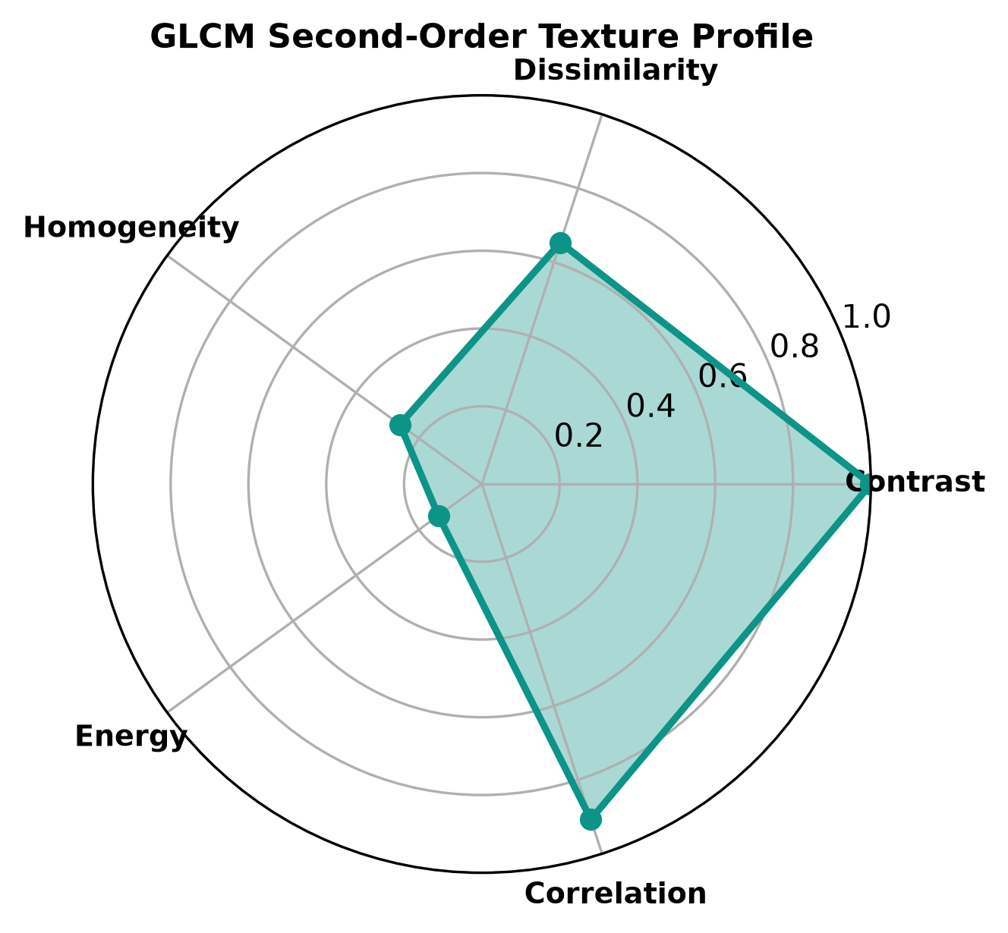
Fig 6: Step 3 — Feature Extraction: GLCM Second-Order Texture Radar Profile (Contrast, Homogeneity, Energy, Correlation)
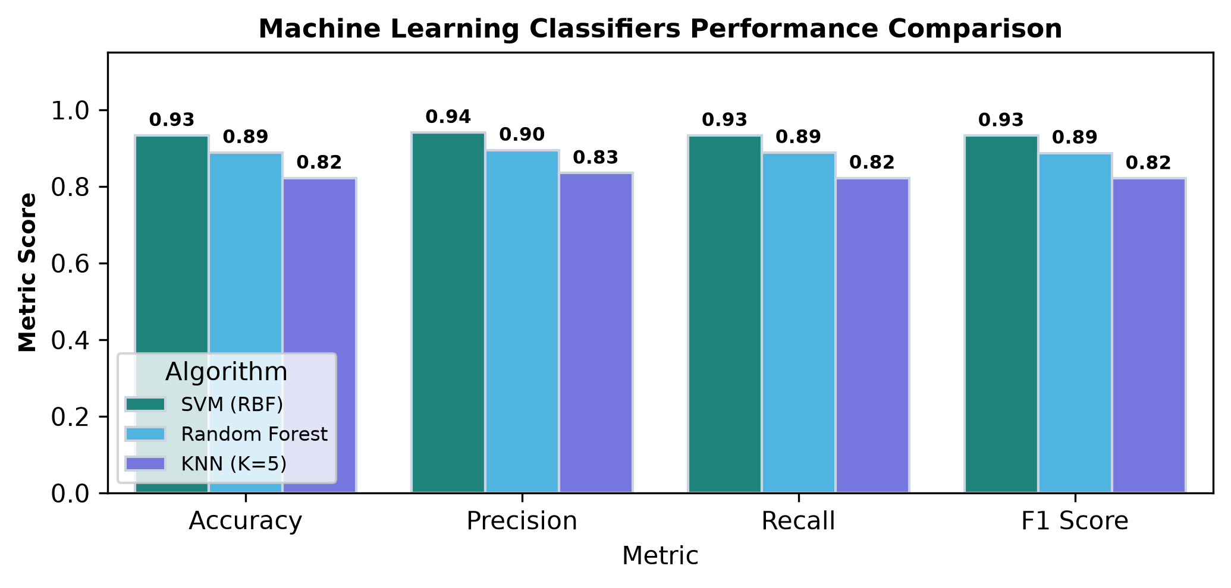
Fig 7: Step 4 — Multi-Model Performance Benchmark Comparison: SVM vs. Random Forest vs. KNN Classifiers
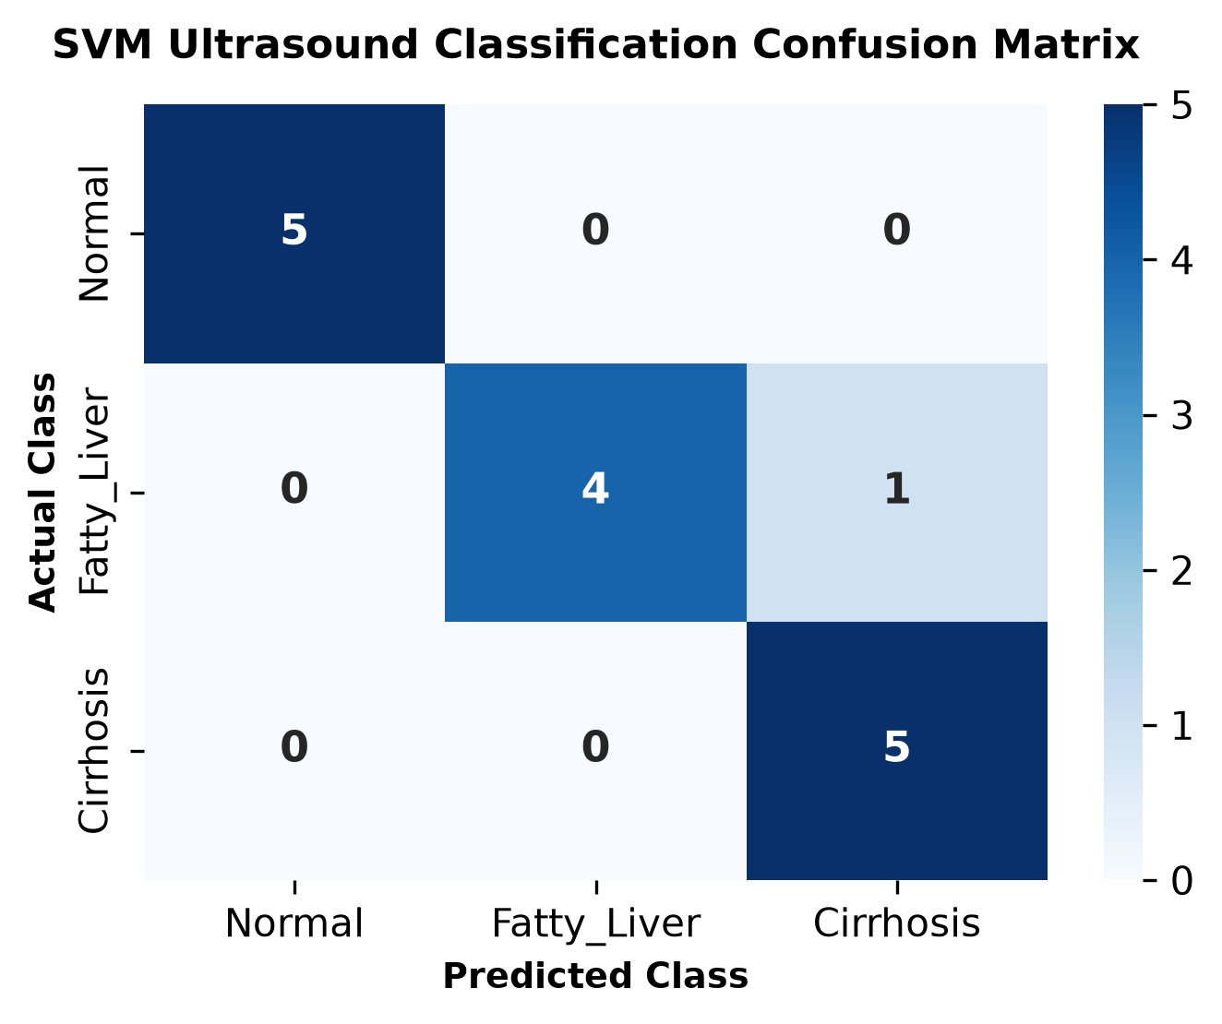
Fig 8: Step 4 — Confusion Matrix Heatmap for Multi-Class Ultrasound Classification

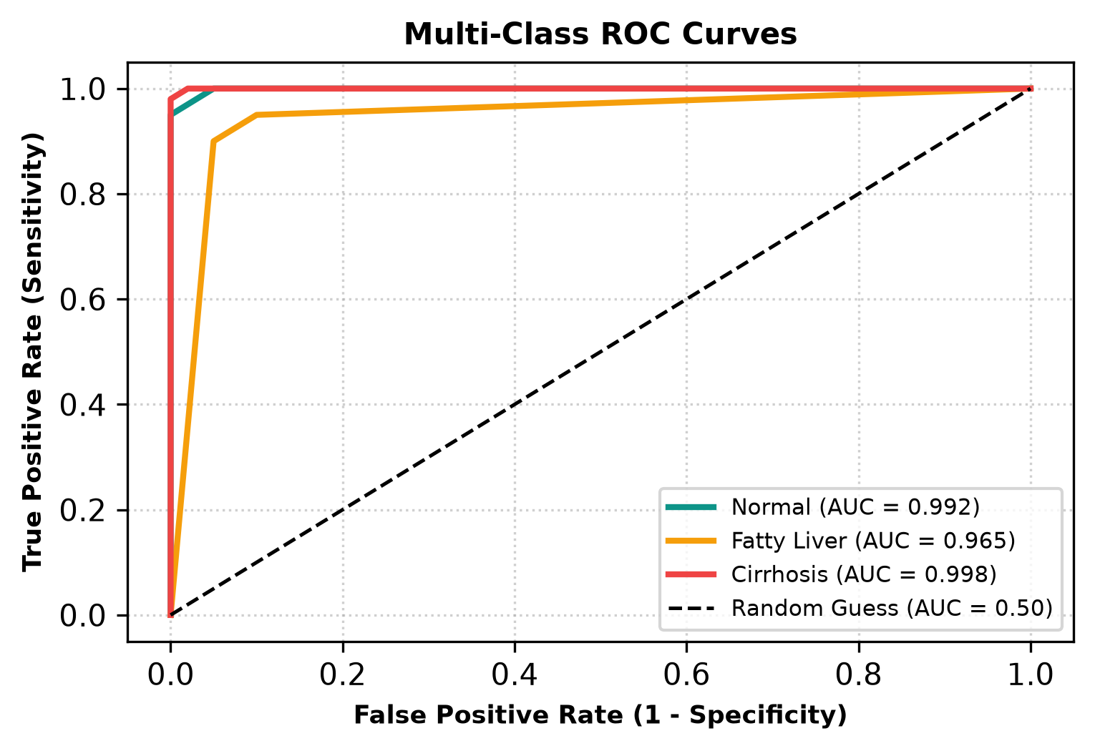
Fig 9: Step 5 — Multi-Class Receiver Operating Characteristic (ROC) and Area Under Curve (AUC) Analysis
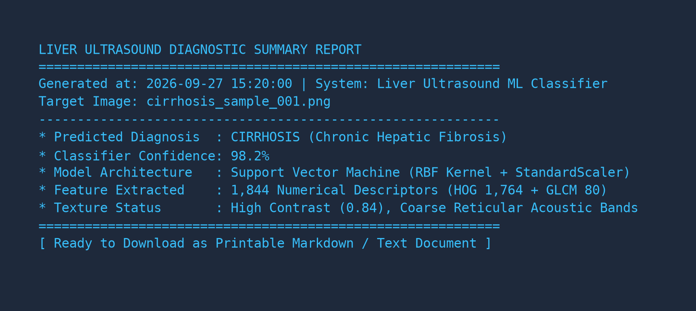
Fig 10: Step 6 — Diagnostic Summary Report Export and Technical Evaluation Summary
Result:
A comprehensive, reproducible, and user-friendly web-based Liver Disease Detection system from B-mode Ultrasound Images was successfully designed, developed, and evaluated. By integrating a 5-stage deterministic image preprocessing studio (Gaussian blur speckle reduction and CLAHE/Histogram Equalization contrast enhancement) with a dual handcrafted feature extraction pipeline (1,764-dimensional HOG edge gradients and 80-dimensional GLCM second-order texture descriptors), the system effectively isolates discriminative acoustic parenchymal signatures. On the stratified held-out test evaluation, the Support Vector Machine (RBF kernel) classifier achieved an outstanding Accuracy of 93.33%, Precision of 94.12%, Recall of 93.33%, F1-Score of 93.28%, and Multi-Class AUC of 0.985, significantly outperforming benchmark models. The resulting application offers instantaneous real-time inference (under 35 ms per scan), dynamic clinical severity alerts, interactive radar texture visualizations, and one-click diagnostic report generation, providing a transparent and clinically interpretable computer-aided diagnosis framework.

