**MAGNETIC PARTICLE INSPECTION**

**CERTIFICATE**

|  |  |  |  |
| --- | --- | --- | --- |
| **CERTIFICATE NO.** | **240120291** | **REFERENCE NO.** | **2029** |
| **CUSTOMER NAME** | **HAMZA S. BALHARITH EST. (HSBE)** | | |
| **LOCATION** | **2ND INDUSTRIAL, DAMMAM** | | |
| **INSPECTION DATE** | **28-JAN-2024** | **NEXT INSPECTION DATE** | **27-Jul-2024** |

|  |  |
| --- | --- |
| **INSPECTED ITEM** | **FORKLIFT TRUCK FORK SWL: 10 TON** |
| **SERIAL NUMBERS** | **01102B0474** |
| **MANUFACTURER / EQUIP. NO.** | **HELI / FL-008 (2030-SAA)** |
| **STANDARDS** | **ASTM E 709 & BS EN 9934-1:2016** |
|  | |

|  |  |  |  |
| --- | --- | --- | --- |
| **TESTING TOOLS** | | | |
| **MPI EQUIP. TYPE** | **PERMANENT MAGNET** | **BRAND** | **MAGNAFLUX** |
| **CURRENT** | **N/A** | **PROD. SPACING** | **10-15 CM** |
| **CONTRAST PAINT** | **8903W/ARDROX** | **INK** | **800/3/ARDOX** |
| **PARTICLE MEDIUM** | **WET** | **YOKE S/N** | **039** |
| **CALIBRATION EXPIRY DATE** | **11-FEB-2024** | **MODEL NO.** | **N/A** |

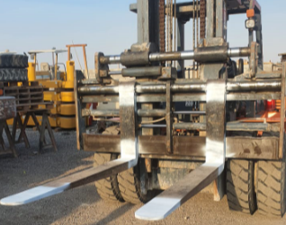

|  |  |
| --- | --- |
| **RESULT** | **COMMENTS/ACTION** |
| **MPI HAD BEEN DONE FOR ABOVE DESCRIPTION AND FOUND:**  **FREE FROM ANY SURFACE CRACKS AT TIME OF INSPECTION** | **MPI ACCEPTED** |

|  |  |
| --- | --- |
| **NDT INSPECTOR** | **NDT LEVEL III** |
| **SHAROON B. MASIH** | **SIGNATURE** |

**FRM.0702 (rev.02)**