MAGNETIC PARTICLE INSPECTION
CERTIFICATE

CERTIFICATE NO. | 240120291 | REFERENCE NO. | 2029
CUSTOMER NAME | HAMZA S. BALHARITH EST. (HSBE)
LOCATION | 2ND INDUSTRIAL, DAMMAM
INSPECTION DATE | 28-JAN-2024 | NEXT INSPECTION DATE | 27-Jul-2024

INSPECTED ITEM | FORKLIFT TRUCK FORK SWL: 10 TON
SERIAL NUMBERS | 01102B0474
MANUFACTURER / EQUIP. NO. | HELI / FL-008 (2030-SAA)
STANDARDS | ASTM E 709 & BS EN 9934-1:2016

TESTING TOOLS
MPI EQUIP. TYPE | PERMANENT MAGNET | BRAND | MAGNAFLUX
CURRENT | N/A | PROD. SPACING | 10-15 CM
CONTRAST PAINT | 8903W/ARDROX | INK | 800/3/ARDOX
PARTICLE MEDIUM | WET | YOKE S/N | 039
CALIBRATION EXPIRY DATE | 11-FEB-2024 | MODEL NO. | N/A

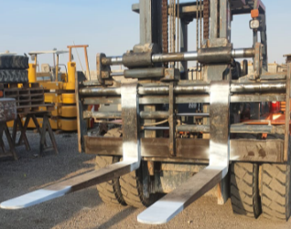

RESULT | COMMENTS/ACTION
MPI HAD BEEN DONE FOR ABOVE DESCRIPTION AND FOUND:  FREE FROM ANY SURFACE CRACKS AT TIME OF INSPECTION | MPI ACCEPTED

NDT INSPECTOR | NDT LEVEL III
SHAROON B. MASIH | SIGNATURE
FRM.0702 (rev.02)

