# RESUME

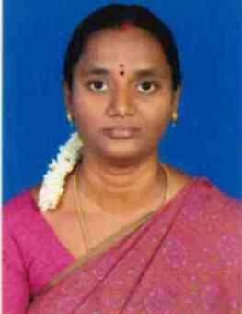

**J.JAYASUDHA**

No.14/41Kamaraj Road

M.K.Kottai

Trichy-620011.

Mobile: 8220569689

Ma[il: jayasudha](mailto:jayasudha179@gmail.com)[179@gmail.com](mailto:179@gmail.com)

**Objective:**

Seeking a position to utilize my skills and abilities in an educational institution that offers an opportunity for innovative and professional growth.

# Educational Qualifications

* P.hD (Doing) in UDC college.
* M.Phil(computer Science) with Distinction from Bharathidasan University
* M.C.A from Shrimati Indira Gandhi College, Tiruchirapalli
* B.Sc from Holy Cross College, Tiruchirapalli

# Academic Experience

* Working as an Assistant Professor, Department of Computer Science, **National College** from 07 October 2021 to 30 May 2023.
* Working as an Assistant Professor, Department of MCA**, M.I.E.T Arts &Science College** from June 2018 to 07 October 2021.
* Worked as a Lecturer in Department of Information Technology & Applications, at **Shrimati Indira Gandhi College** from July 2005 to March2014.

**Teaching Experience : 12 Years 8 months**

# Other Experience

* Approval in BDU
* Examiner in UG
* Member in Question paper setting

# Area Of Interested :

Cloud Computing, Data Mining & Network security

# Conferences, Refresher Courses, Staff Development Programme Attended

1. .Paper presented on “A review of Multicloud Security with Machine learning” International conference at Shrimati Indira Gandhi College on March 10th &11th 2023
2. Paper Presented on big data Analyties in health care, Kodaikanal Christian College19th September 2019.
3. Participated in a One-Day workshop on “”Rapid Manner – A Data Mining Tool”

at VIT Chennai on 5th October 2013

.

1. Attended a skill based Training Program on Dot Net Programming Organized by ICT academy 2012 on 21.03.2012 to 28.03.2012.
2. Atended a skill based Training Program on Dot Net Programming Organized by ICT Academy 2012 on 21.03.2012 to 28.03.2012.
3. Paper Presented on Cloud Computing, Jayaram Engineering College“HOT CLOUD- 10”8th August 2010.
4. Participated in the State Level conference on “Current Trends in Research Field Of Computer Science” organized by Shrimati Indira Gandhi College on13 &14th October 2007 .

# Personal Information

Husband’s Name : M. SivaGanesan

DateofBirth : 16th July1979

Gender : Female

MaritalStatus : Married

NativePlace : Trichy

**Declaration**

I hereby declare that the information furnished above is true to the best of my knowledge.

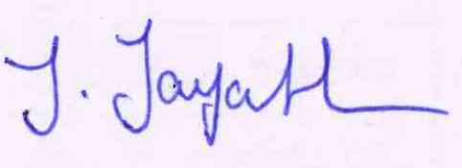

# (J.JAYASUDHA)