**Dependency Injection**

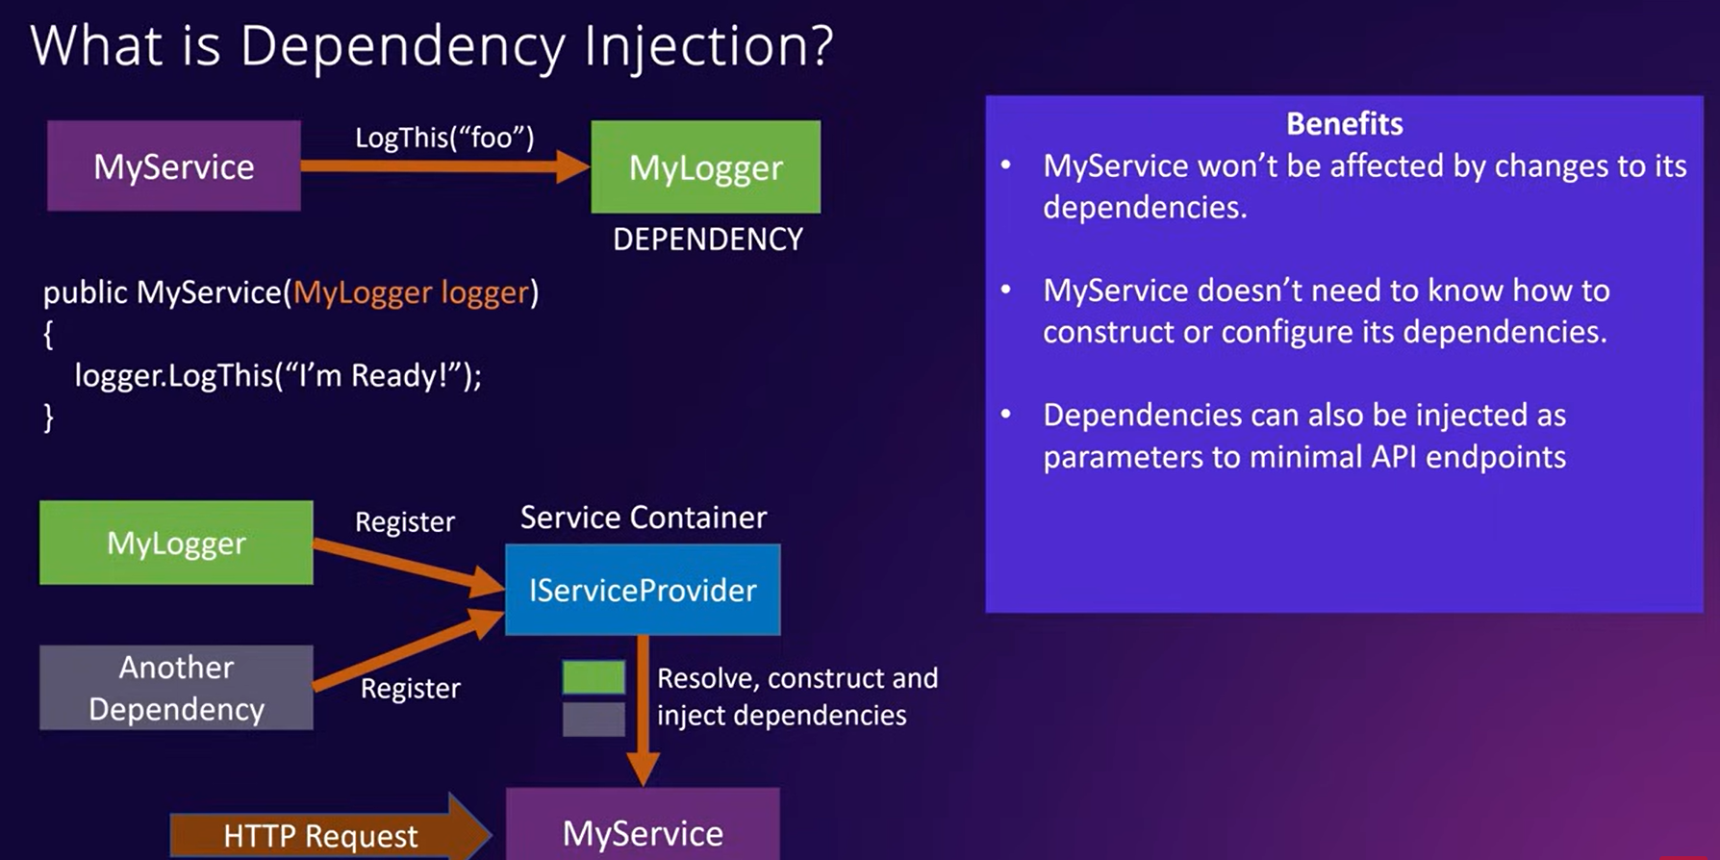

Benefit - service wont be affected by changes to its dependencies

**Dependency inversion**

Code should be depend on abstraction as opposed to concrete implementation

**Benefits**

easy to test

dependency can be swapped out for different implementation without modifying the service

code is cleaner, easier to modify

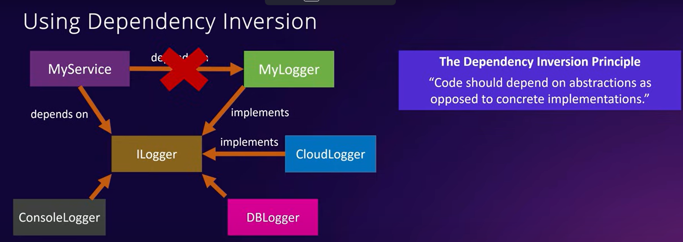

**Service Lifetime**

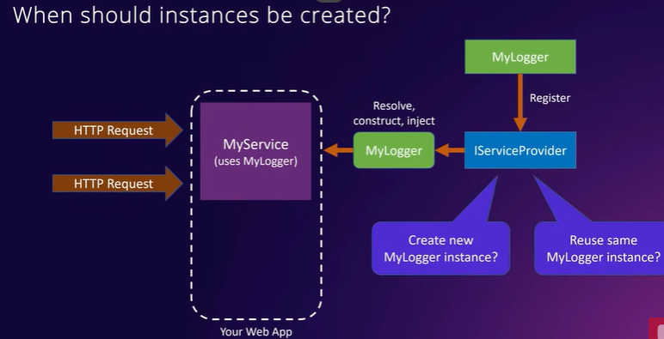

1. **Transient – creates instance every request**

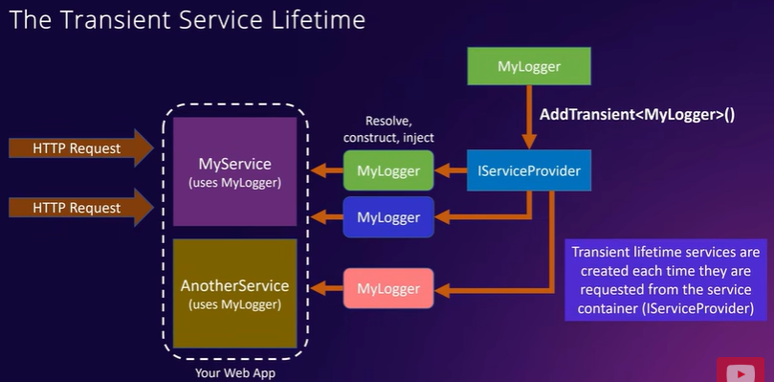

1. **Scoped –**

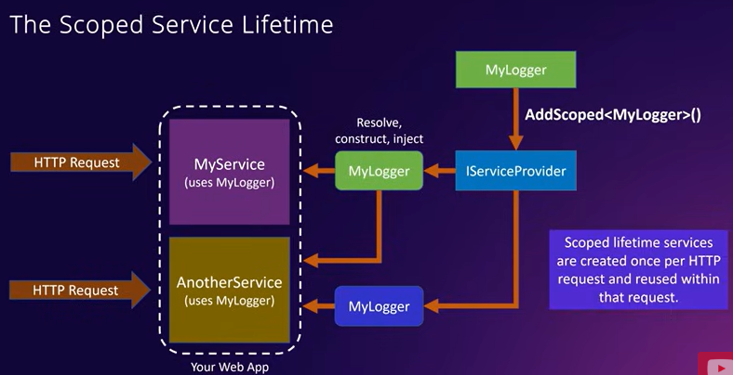

**3.Singleton -**

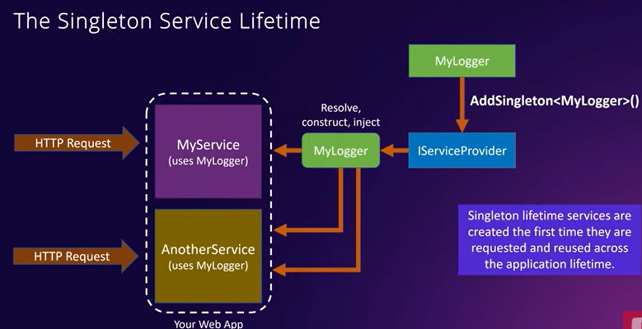

**Asynchronus Programming**

