RESTFUL Web API

From - [RESTful API with .NET Core (.NET 7) - Full Course for Beginners (youtube.com)](https://www.youtube.com/watch?v=_uZYOgzYheU)

Way to transfer data

Way for application to communicate with eachother

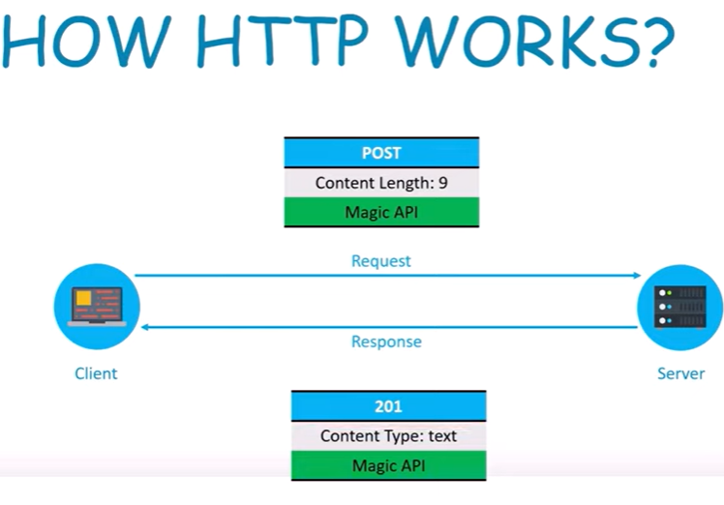

Stateless – will not remember the request