**Sprint Reviews**

**What is a Sprint?**

You may have heard of the term "Sprint" being used in the context of work that's happening with our database development and reporting tools. But what is a Sprint and why are we structuring our work this way? Essentially, sprints allow us to **apply our core value of continuous learning** to the work we're doing, and ensure that the data team remains responsive to the ever-changing needs of our organization. Watch the video at right and/or explore the links below.

[](https://www.atlassian.com/agile/scrum" \t "_blank)

[What is Scrum?](https://www.atlassian.com/agile/scrum" \t "_blank)

[](https://www.visual-paradigm.com/scrum/what-is-sprint-in-scrum/" \t "_blank)

[What is a Sprint?](https://www.visual-paradigm.com/scrum/what-is-sprint-in-scrum/" \t "_blank)

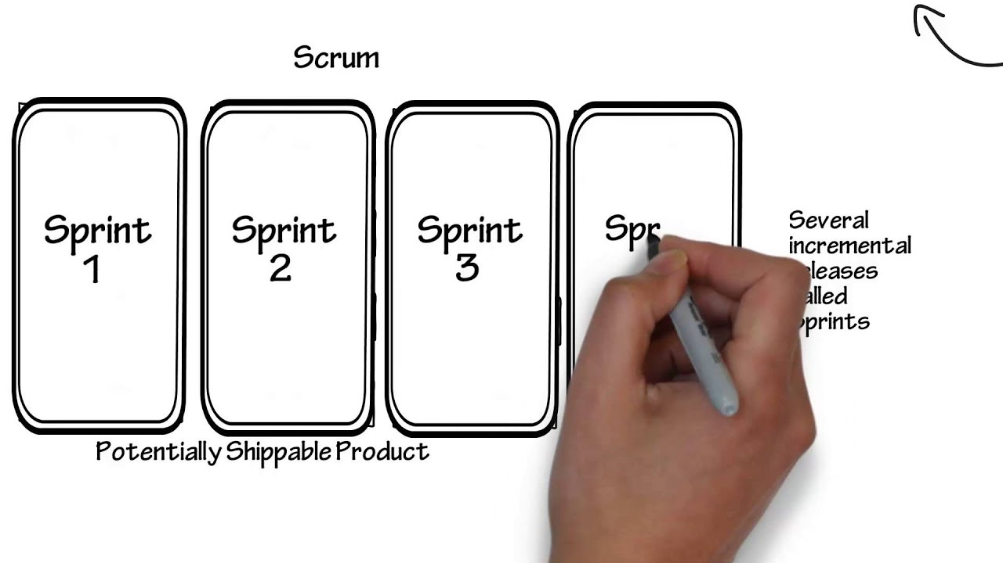

*See the bottom of this page for a visual representation of an entire sprint!*

**What is Sprint Review?**

Bottom Line is using two-week sprints, and every other Friday there is a Sprint Review meeting on the OBL calendar. These meetings give anyone in the organization a chance to see/demo the work that was completed in the previous sprint, give feedback on the new functionality, and to give input on the priorities that should be included in the next sprint.

[**Read more about Sprint Reviews**](https://www.scrum.org/resources/what-is-a-sprint-review)

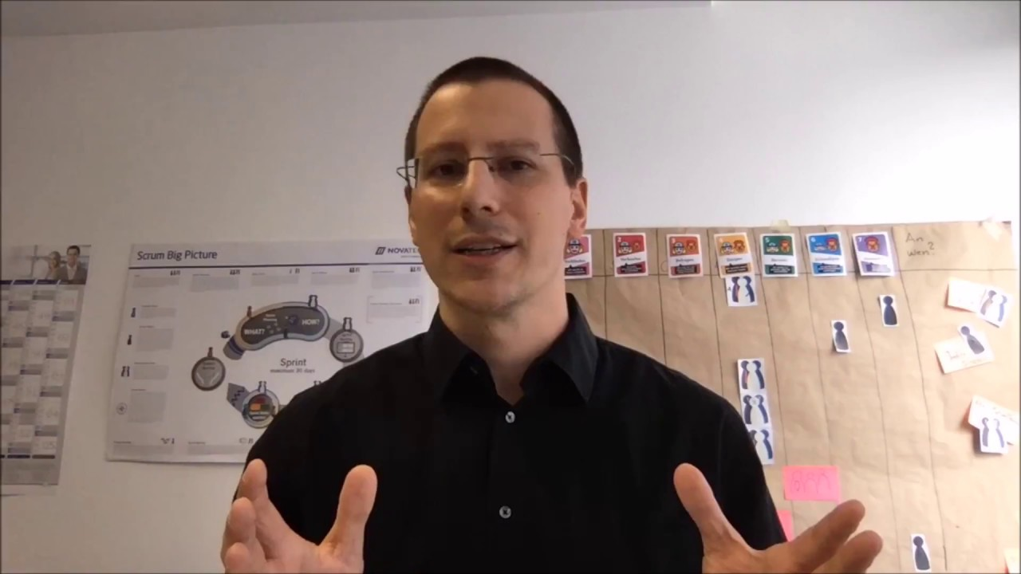



**Sprint Reviews at Bottom Line**

**Before the meeting:**

* The scrum team (currently Karla & Michelle) will make an announcement about what is on the docket to be discussed, as well as which projects/backlog items appear to be the most likely to be included in the following sprint given current knowledge of priorities
* Stakeholders will decide if they would like to attend that meeting (with some coordination in-region to ensure at least one representative is present)
* If a version of the product is ready for demo, that information will be included so that folx can play around with it before the meeting

**Meeting Agenda:** [meeting length will vary depending on how many items were completed in a given sprint, but will take no more than 2 hours]

* **Up to 20 min**: review the results of the sprint, inspect the increment(s)
* **Up to 1 hour**: stakeholders give feedback and ask questions
* **Up to 30 min**: stakeholders give input on the goal for the next sprint and what backlog items should be included
* **Up to 10 min**: everyone gives feedback about the process (communication, expectations, timelines, etc.)​​​​​​​

**When should I attend a sprint review?**

You should plan to attend if one of the following applies to you:

* I am responsible for making final decisions about this product
* I am the main user of this product; I would like to have input on functionality or design
* I am affected by these decisions and should have a voice in the process
* I would like to receive general updates/info about this product

*Note: at least one representative from each region (including National) needs to be present at each Sprint Review.*

](https://tbl500amory.sharepoint.com/sites/ReportingDocumentation/SitePages/Sprint-14.aspx" \t "_self)

[Sprint 14](https://tbl500amory.sharepoint.com/sites/ReportingDocumentation/SitePages/Sprint-14.aspx" \t "_self)