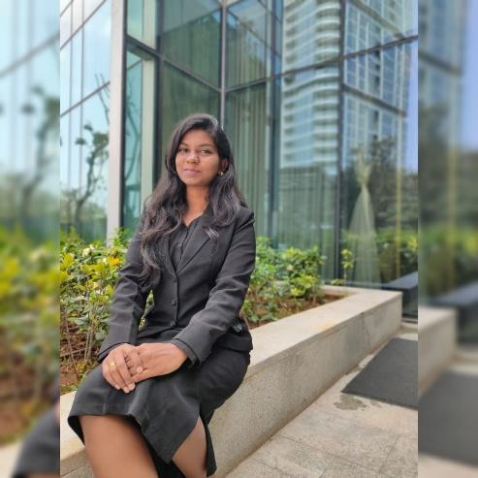

**Nomination Categories & Criteria:**

**1. eWIT Emerging Woman in IT Award**

**a. Eligibility: Women with 3 to 7 years work experience**

Jayathilaga Ramajayam is an Analyst-Data Analytics at Verizon India based out of Chennai. Her key responsibilities include building machine learning models and doing exploratory data analysis to improve the employee experience. Jayathilaga has been with Verizon since 2017 and has expertise in Text analytics and exploratory data analysis. She holds a B.E in Computer Science and Engineering and has won First Runner up - AI/ML hackathon con-ducted by Techgig Geek Goddess 2019.

**Work experience:** 2017 – Present (3 years of experience)

**b. Define your first success as an IT/ITES professional.**

I am the Runner up in **AMEX AI/ML Hackatho**n conducted by **Techgig Geek Goddess 2019.** Techgig Geek Goddess is a coding contest exclusively for women in technology. It aims at identifying and recognizing top female developers across India. Machine Learning emerged as the most popular theme among participants.

There were 3 rounds, 5175 registered for this hackathon. Top 15 team participated in the finale and presented their project to the jury members. I am really happy to be recognized at a national platform, where I am chosen as the first runner up. This gives me courage to strive hard and continue to give my best.

**Use case:** To build a predictive model for Credit card approval based on customers information. To remove manual intervention and provide accurate output in minimum time period.

In that event networked with other women in technology and got useful insights.

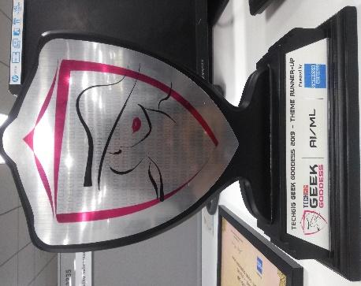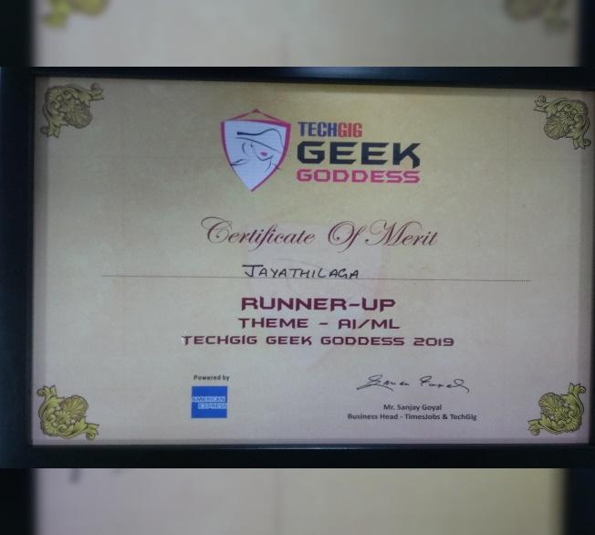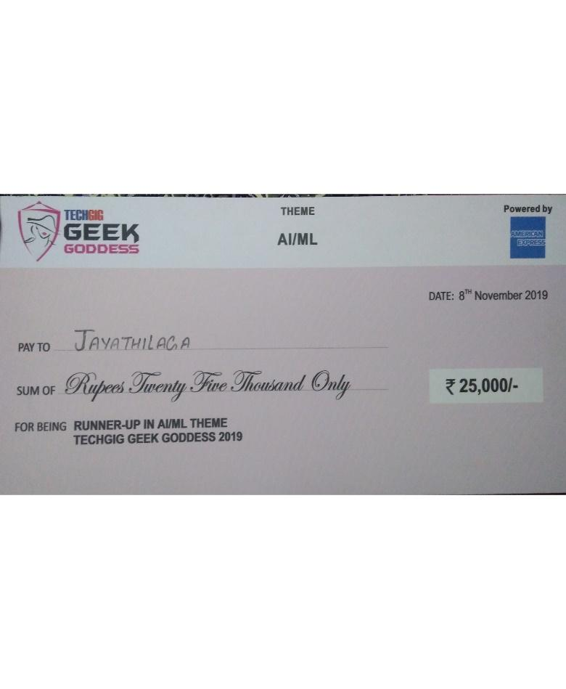

**c. Elaborate your readiness for Digital Transformation/Transition to new technologies**

**(Certifications/ Learnings/ Technical challenges and achievements).**

Submitted white paper for GHCI conference 2020. Title: **“Silvery: The Review Summarization Engine".**

In this paper, I develop a web based review summarization engine. This engine will take the review/feedback of any product and provide the summary of positive reviews and negative reviews. This will help people to identify the issue as well as improve the product based on the review. Here the review can be anything like tweets, Glass Door comments, YouTube comments, online shopping product review, movie review, online feedback, Instagram/ Face-book comment. This is achieved using sentiment classifier with BERT algorithm and visualization is presented in the form of word cloud and frequency table. Opinion mining approach is used where natural language processing (NLP) identifies the emotional tone behind a body of text. The review summarization engine is implemented in Apigee gateway and the code is hosted using AWS lambda architecture.

**YouTube link GHCI:** [https://youtu.be/aW8rC4mg_fk](https://urldefense.proofpoint.com/v2/url?u=https-3A__youtu.be_aW8rC4mg-5Ffk&d=DwMBaQ&c=udBTRvFvXC5Dhqg7UHpJlPps3mZ3LRxpb6__0PomBTQ&r=QxO7gzOwfV3T-RxCPSA5GOV_Us57-VtO59qi_g4ott4&m=36Z5_Q5Ifk116XCRPA2_NcY9yOhp0CiaBYuR43Keow8&s=pfgdzkLmAlXtpYta-6uToqaCgkG5g4Y2rEenz6oZ0jM&e=)

**d. List the Technical/ Operational/ Functional breakthroughs that you were part of.**

I was one of the speaker in VZ Tech Convene 2020. Topic: **“Step by Step process of building a ML Model”**

It feels amazing to present at this huge platform. It is imperative that we share the industry best practices and stay at par with the latest trends and market. I talked about the step-by-step process of building an ML model and how the power of machine learning can help us decipher the difference between two things using ML model, instead of using human judgement and manual rules. We can literally extrapolate the ideas to any problem domains.

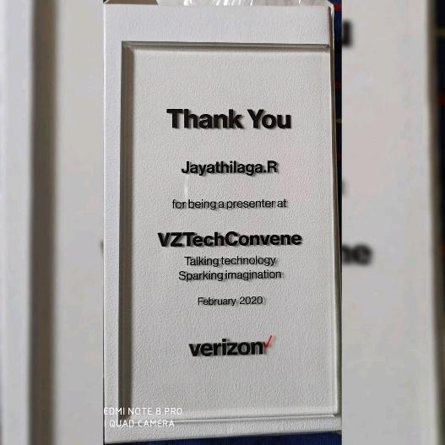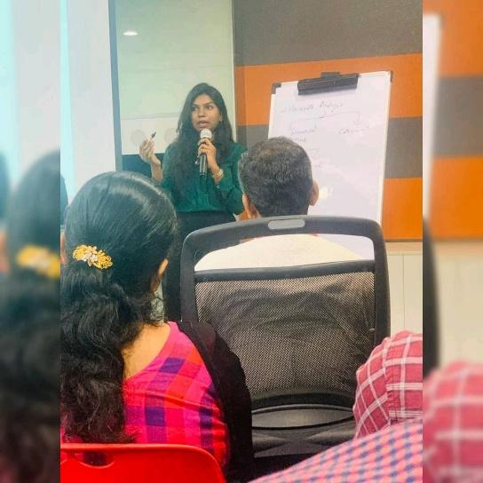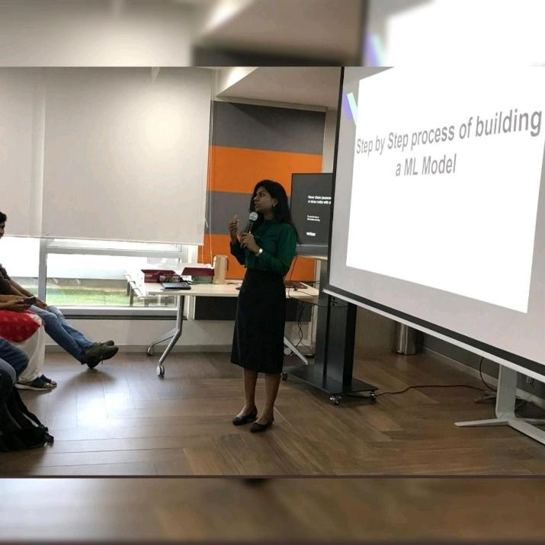

**e. Describe how you demonstrated Innovation or Entrepreneurship.**

Sometimes we feel what we are doing is good enough. But it's exciting to have a new goal and running towards it will give a lot of challenging experience and motivation to achieve more.

One of my innovation is to reduce the time spent on Exploratory Data Analysis (EDA) by automating the process. According to a survey in Forbes, data scientists spend 80% of their time on EDA. We do EDA to gain a sense of the relationship of the features with each other and the target variable.

EDA automation resulted in speeding up the model building and saved 16 hours in a week per employee.

As a sign off note, I want to share some insight based on my experience. Networking is important to grow in our career, and failure is an experience, learn and move on to achieve your goal.

I hope to aspire many and get inspired by our fellow colleagues in the upcoming eWIT excellence awards 2020.