**CO226 Project Description**

* **Group 9 -**

**Group members:**

*E/18/030 - ATHTHANAYAKA A.M.S.*

*E/18/282 - RANASINGHE R.A.N.S.*

*E/18/283 - RANASINGHE R.D.J.M.*

**Blood bank management system**

Each day, thousands of people, hospitals need donated blood and blood products to keep them in good health or allow them to stay alive.

In Sri Lanka, 100% of blood donors are voluntary non remunerated donors. But some blood banks may face a shortage of blood stocks sometimes. Therefore, sometimes people face so many difficulties to find blood for their requirements and go for illegally paid donors.

But there are so many donors around us who are willing to donate blood for the sake of others and do not expect any benefit. Even if the donor is available in the hospital, patients are unaware of it, and so are the donors due to lack of communication.

As a solution to this improper management of one of the most critical information in the country, we have designed a web-based blood bank management system to store, retrieve and share information among the general public.

The main objective of this is that the people who are in need of blood, can access this database and fulfill their requirements from the nearest located blood banks and the individuals who are willing to donate blood can donate them to the most needed blood bank at the moment so that it will be much beneficial.

Since the information about the blood stocks available in all the blood banks is stored in the database, hospitals also can easily access and order the needed blood requirements for the surgeries and other requirements.

Not only that, the organizations which are eager to conduct blood donation camps, can organize them, collect blood from the donors and donate them to the nearest blood banks for further tests and transfusion processes.

Once the blood is donated to the blood bank or retrieved from the blood bank, the records of the available stocks will be auto-updated.

While we are trying to manage all the data about the blood stocks in the country, we connect National blood banks, hospital blood banks, and cluster centers together and fulfill each other's requirements to keep the necessary bloodstock within the centers. The accounts of the donors are stored and updated by the National Blood Bank. The details about the blood stocks and the requirement information of the seekers will be updated by the particular regional or hospital blood banks. Seekers also can make direct requests from the National Blood Bank and the database will show them the available stocks.

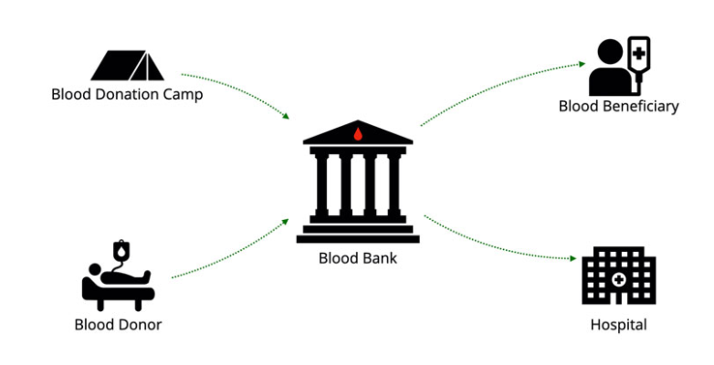Since this is a centralized database management system, the National blood bank can access to all the information about the other blood banks working under them, which will make the administration much more efficient.

Following users have the ability to use this web-based system with different functionalities.

Users of the Blood Bank Management System:

**Blood donor:**

The donor can register to the system by entering his/her data with a brief medical history. After checking the data of the donor, if all the requirements are fulfilled to become a donor, the donor registration will be approved by the system and a time for the donation will be booked according to the nearest blood banks or centers’ availability.

If the blood donor is willing to be a direct donor (donating for a specific patient's requirement), the donor will be registered into that category as well.

The attributes that are associated with the blood donor are name of the donor, date of birth, weight, NIC number, gender, address, and blood group. Once he has registered as a donor in the system, an account will be created with a distinct donor_id and a password for each user. The age and the nearest blood bank will be derived from the above provided information.

**Blood beneficiary:**

The most advantaged user from this database is the blood seeker. This blood bank management system will help the seekers to fulfill their blood requirements as quickly as possible.

When a person is logged to the system as a seeker the following details will be collected from him/her. Name of the seeker, NIC number of the seeker, name of the recipient, NIC number of the recipient, age of the recipient, blood group, number of blood units needed for the transfusion, address and contact number.

**Blood donation camp (Donors)**

**Organizations:**

Organizations can register to the system and book dates for their blood donation camps in collaboration with the nearest blood banks. Also, the registered donors in the area will be informed about the blood donation camps if they are available for donating.

Area, organization name, organizer name, contact number, affiliated blood bank, medical officer in charge, number of blood bags donated etc. are the details to be collected when a blood donation camp is held.

**Hospital:**

Doctors directly contact the blood banks to keep ready the required amount of blood before the surgeries are held. Since this is the most critical blood requirement, it will be prioritized.

**Laboratory:**

In the laboratories, all the blood specimens will be tested for HIV, HBV, HCV, and Syphilis infections, and the test results will be entered into the system and accepted blood specimen data will be sent to the relevant blood banks.

Name of the laboratory in charge, test details and a contact number will be stored in the database for the contacting purposes.

**Blood bank:**

The blood banks will store all the data about blood stocks that were tested and accepted by the laboratories. When there is a requirement, it will be fulfilled by the nearest and most suitable blood bank.

The blood stocks will be managed by the blood banks. Blood group, blood cells, blood bag id, blood bank are the details that will be recorded on blood stocks. Each stock is given a distinct stock_id.

In Sri Lanka, there is a National Blood Center located in Colombo while there are other Peripheral blood banks as hospital-based blood banks and cluster centers. All the bloodstock data in these blood banks are included in this system and easily managed by those centers.

* Blood house unit

* Blood Transfusion unit

* Blood distribution unit

The attributes of these users and their relationships will be subjected to changes according to the requirements and issues that we will have to face as the designing process continues.

Main Features of the Blood Bank Management System:

* This is a web-based database, which will assure easy accessibility for the general public, and insertion of their information into the database with less effort.
* Ability to manage the information of the donor by creating accounts for each donor which allows holding good documentation about the donor and their past blood donation activities as well.
* The blood donor can find out the nearest blood banks available according to his/her current location.
* Confirms that just in case of need, the blood is available to the patient, and this will support fast searching to find matching blood groups for the right person.
* If the blood stocks are unavailable to fulfill a particular requirement, the seeker can keep their request on hold for a certain period of time until a matching donor is found.
* The hospital/ Blood bank can update the status of their own blood inventory.
* List the availability or the shortage of any blood group at any given time.