**Digital Nurture 4.0 .NET FSE (Week-2 Report)**

By-Jayati Pal

**Module-3: Advanced SQL Using SQL Server**

Exercise 1: Ranking and Window Functions

Code and output for ROW_NUMBER():

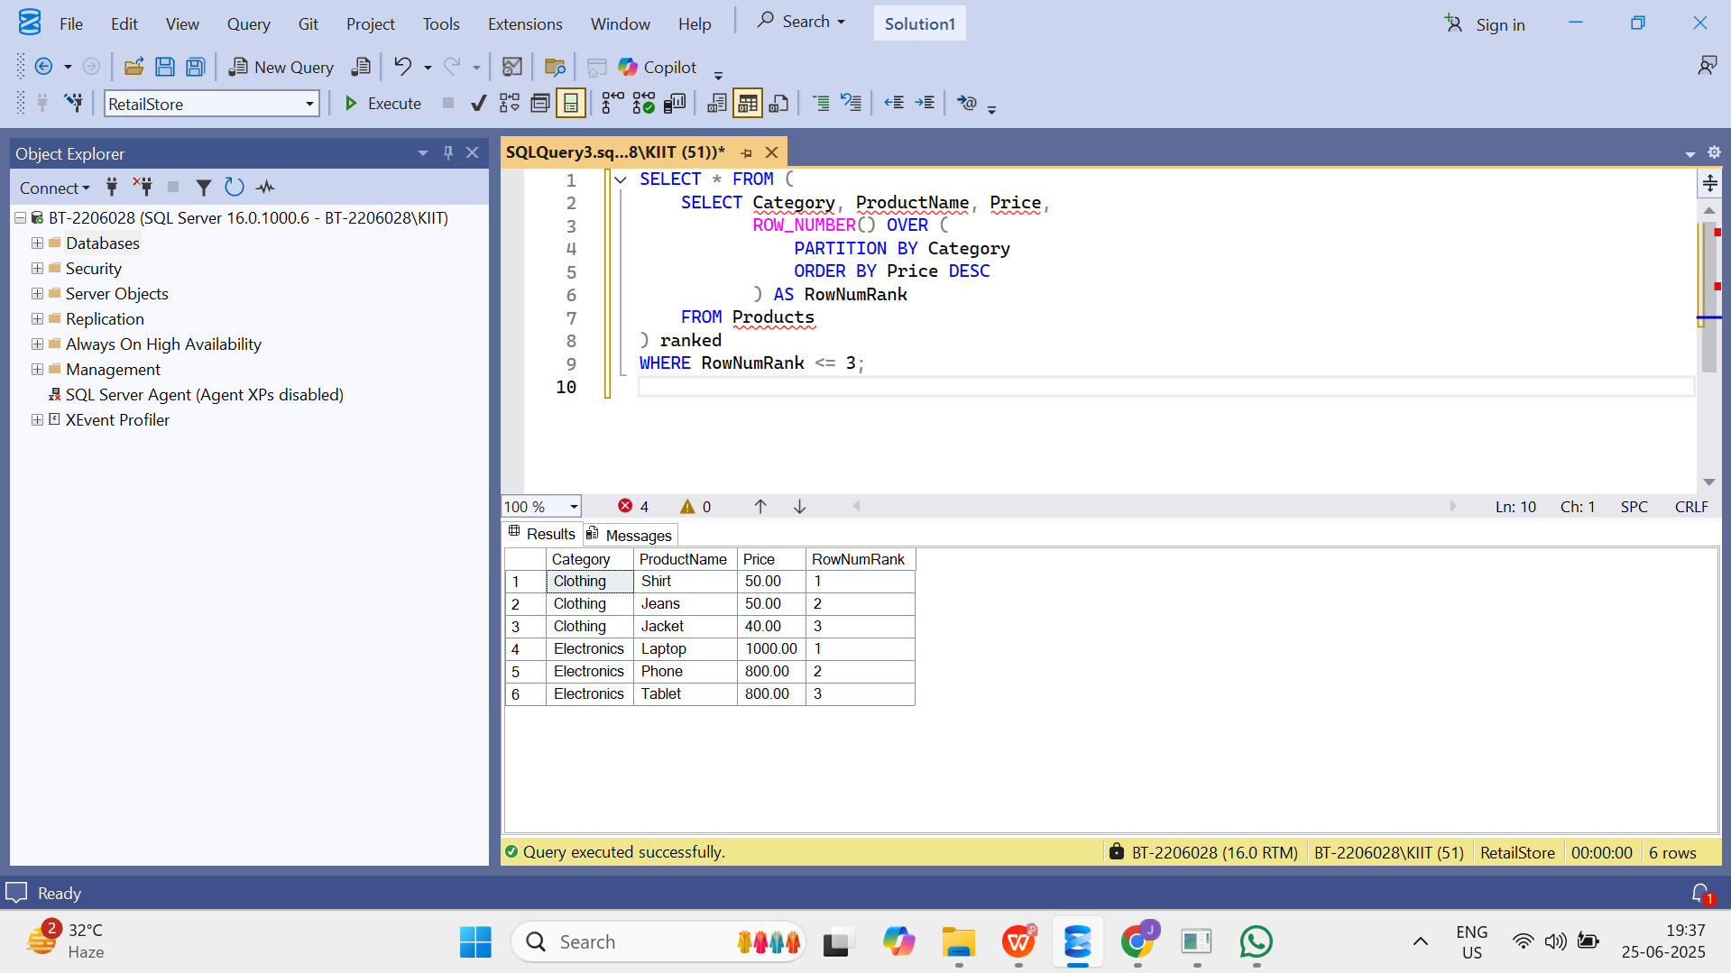

Code for RANK() and DENSE_RANK():

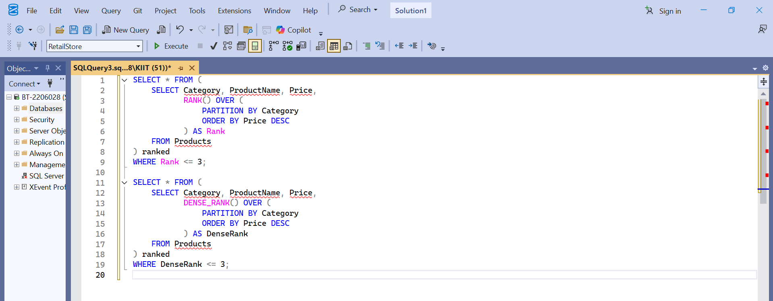

Output for RANK() and DENSE_RANK():

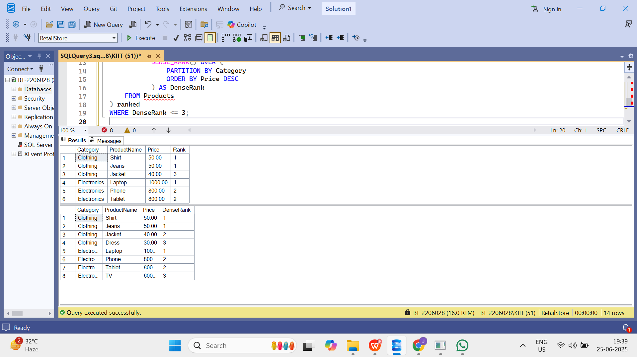

Exercise 1: Create a Stored Procedure

Code for defining the stored procedure with a parameter for DepartmentID and output to select employee details based on the DepartmentID :

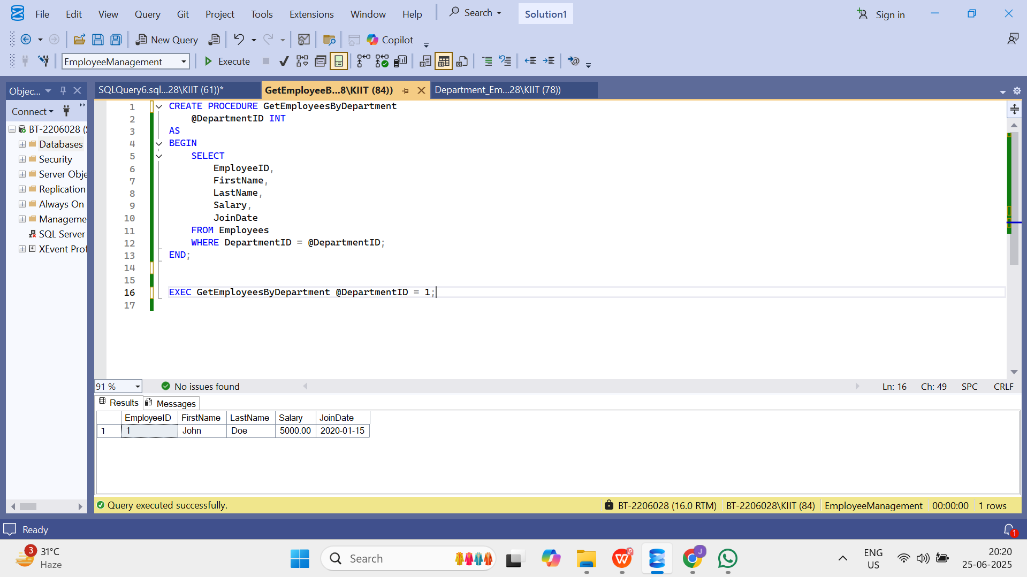

Code and output to create a stored procedure named `sp_InsertEmployee`:

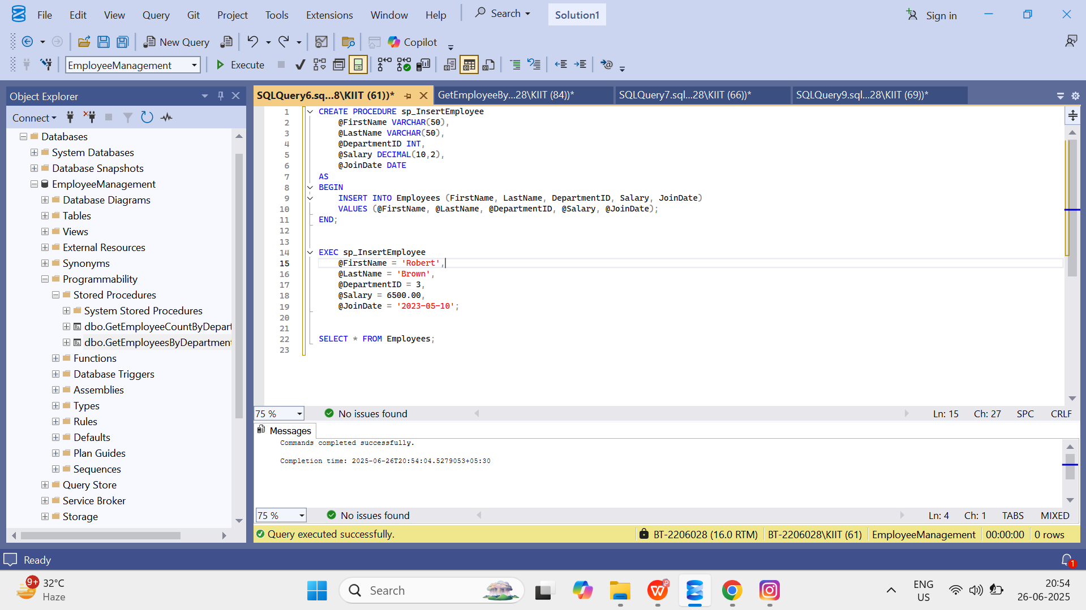

Exercise 5: Return Data from a Stored Procedure:

Code and output:

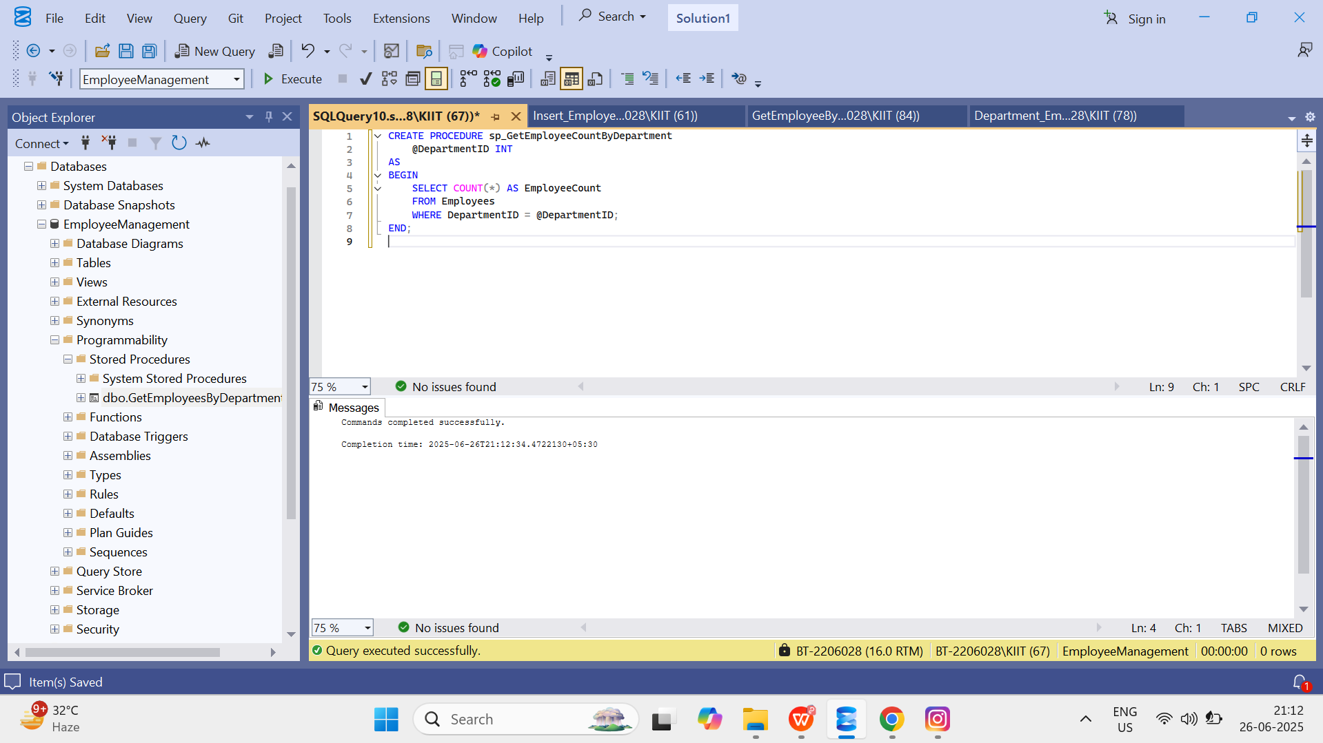

**Module 4 – NUnit and Moq**

Exercise 1: NUnit-Handson

Code:

using NUnit.Framework;

using CalcLibrary;

namespace CalcLibrary.Tests

{

[TestFixture]

public class CalculatorTests

{

SimpleCalculator calc;

[SetUp]

public void Setup()

{

calc = new SimpleCalculator();

}

[TearDown]

public void Teardown()

{

calc = null;

}

[Test]

[TestCase(2, 3, 5)]

[TestCase(0, 0, 0)]

[TestCase(-1, -2, -3)]

public void Add_WhenCalled_ReturnsExpected(int a, int b, int expected)

{

var result = calc.Addition(a, b);

Assert.That(result, Is.EqualTo(expected));

}

}

}

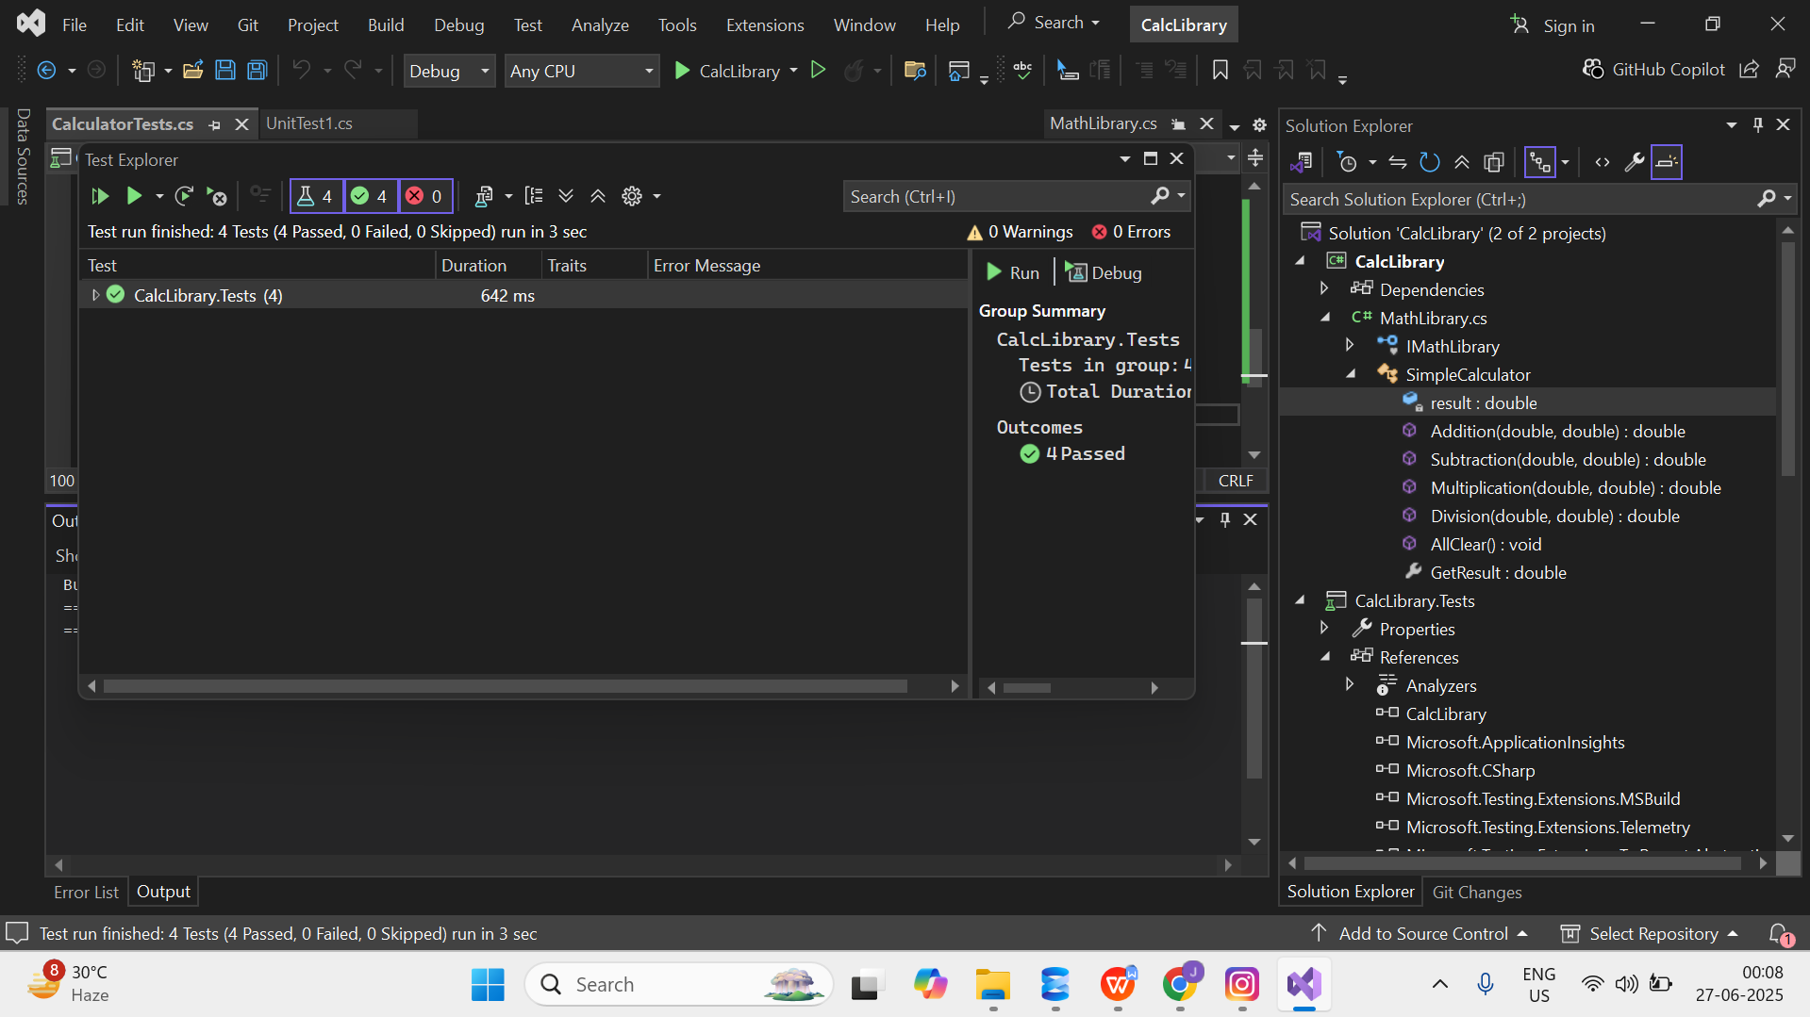

Exercise 1:Moq-Handson

Code:

