**Digital Nurture 4.0 .NET FSE (Week-3 Report)**

By-Jayati Pal

**Module 5 - Entity Framework Core 8.0**

Lab 1: Understanding ORM with a Retail Inventory System

Answer:

Object-Relational Mapping (ORM) is a programming technique that creates a bridge between object-oriented programming languages (like C#) and relational databases. Each C# class typically maps to a database table. Each property of a class maps to a column in the table. Each object instance represents a row in the table. Relationships (like one-to-many or many-to-many) are modeled using navigation properties and foreign keys

A new .NET Console App:

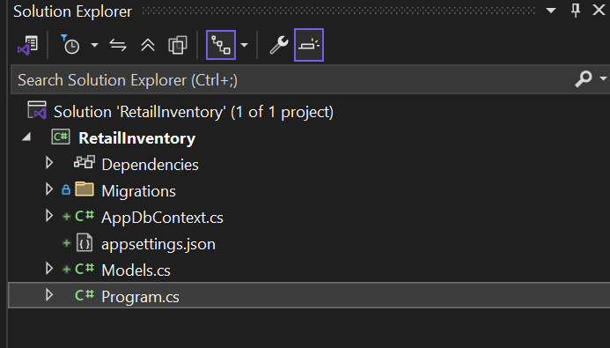

 EF Core Packages Installed:

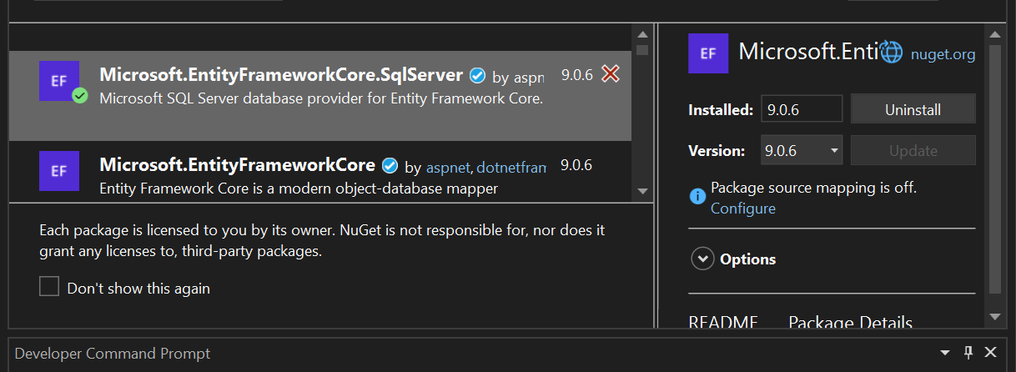

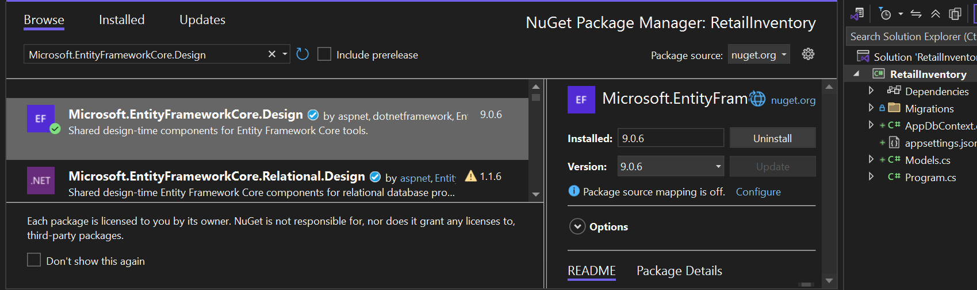

Lab 2: Setting Up the Database Context for a Retail Store

Code:

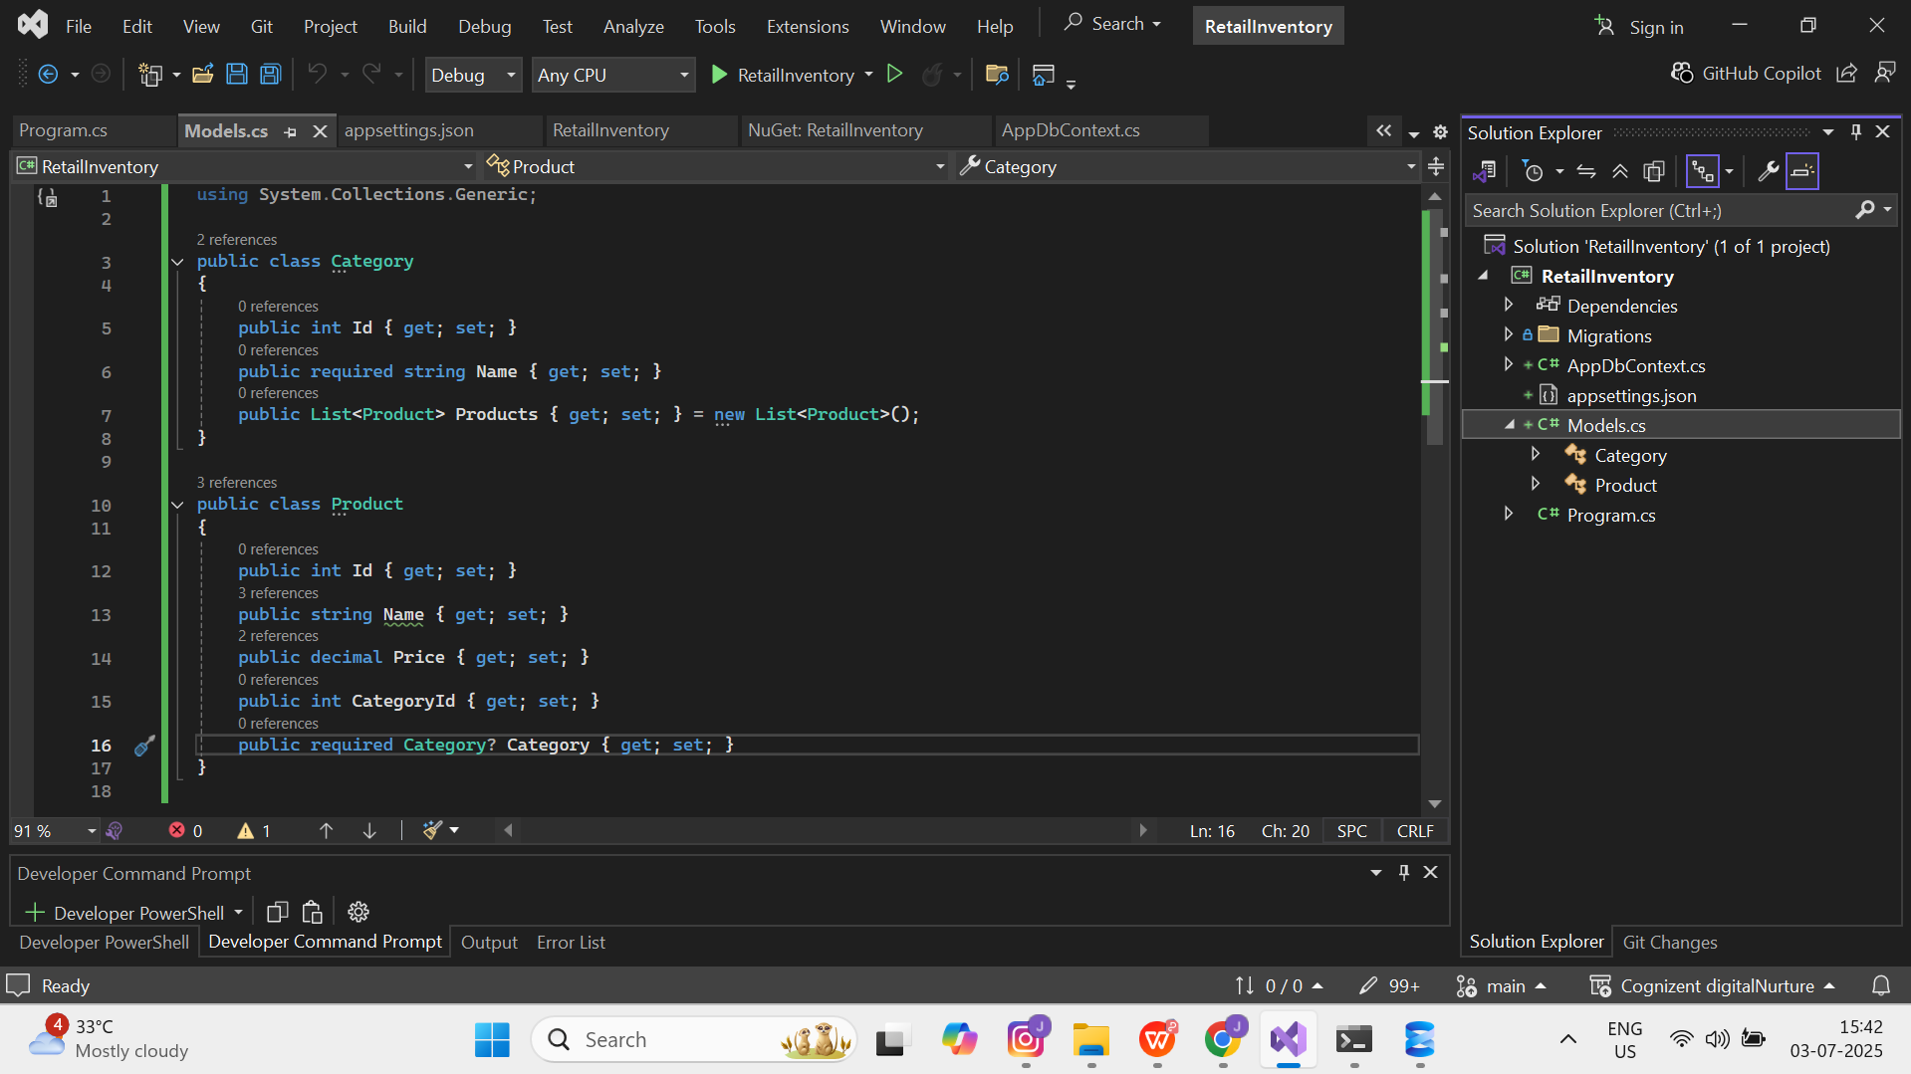

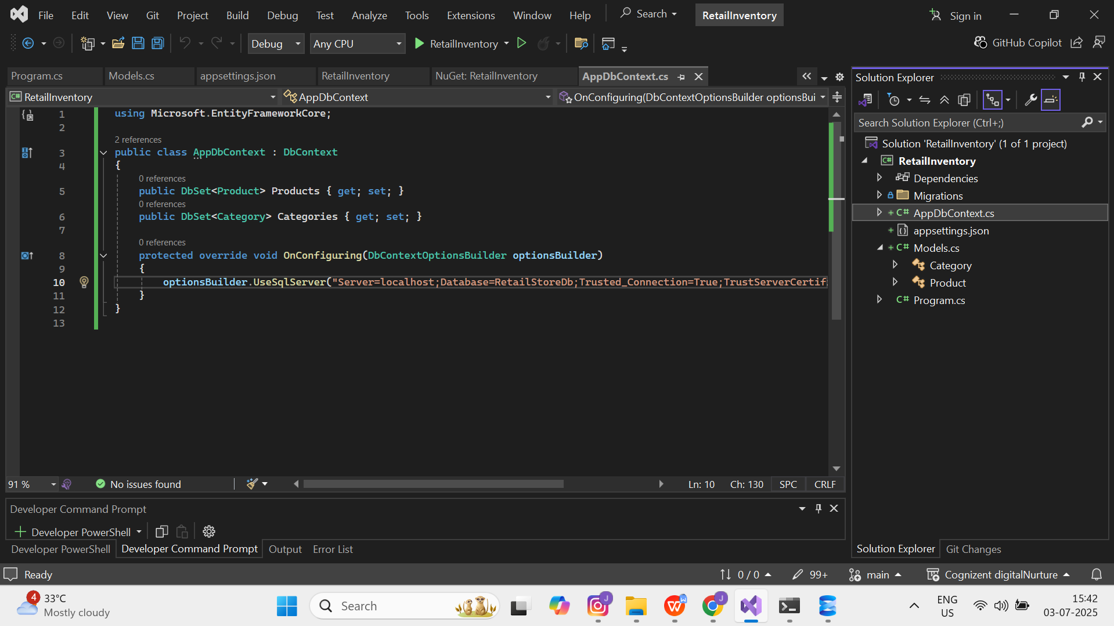

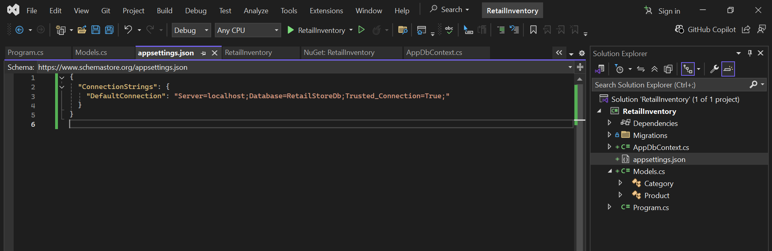

Lab 3: Using EF Core CLI to Create and Apply Migrations

Code and Output:

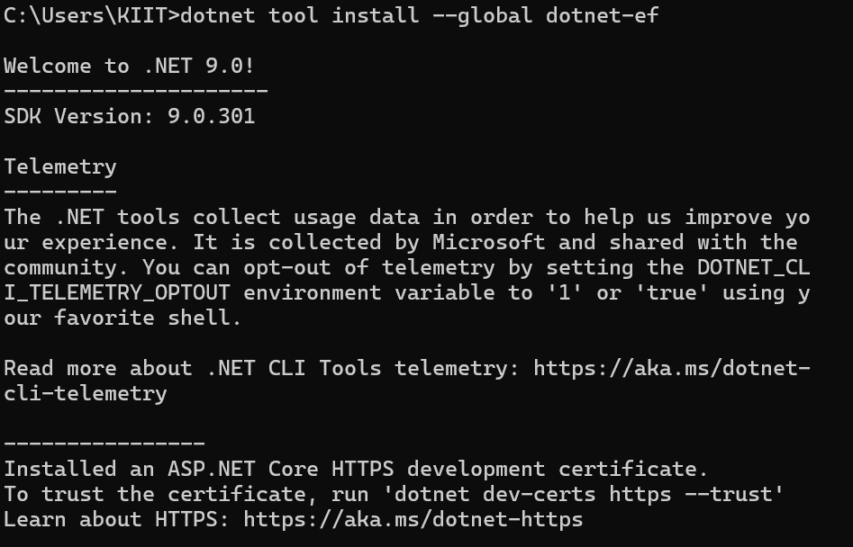

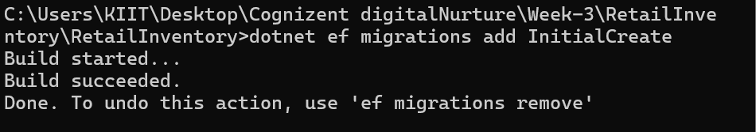

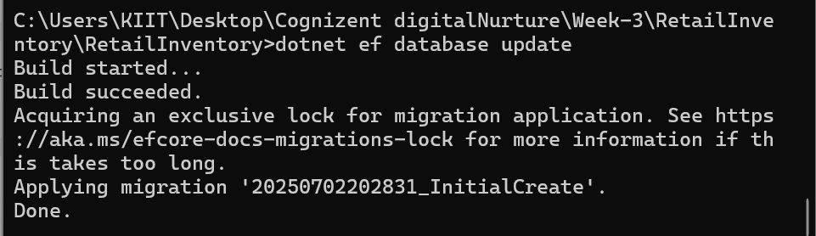

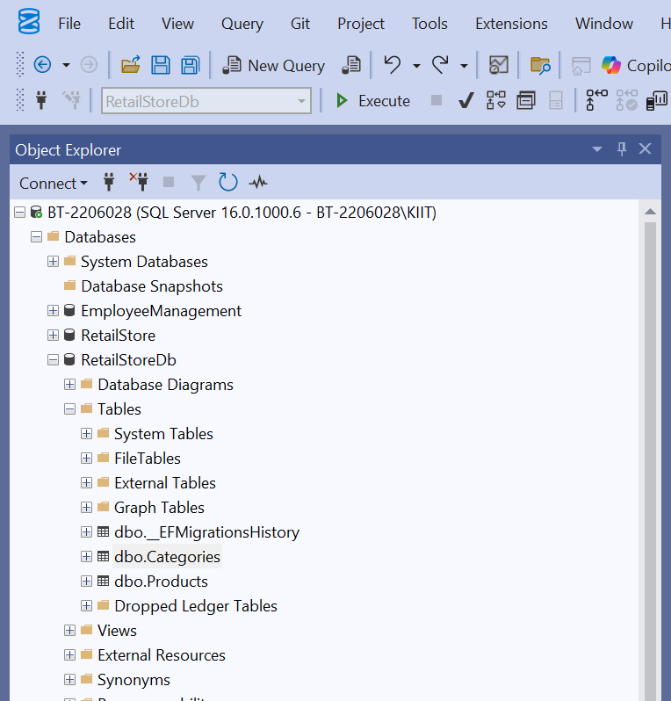

Lab 4: Inserting Initial Data into the Database

Code and Output:

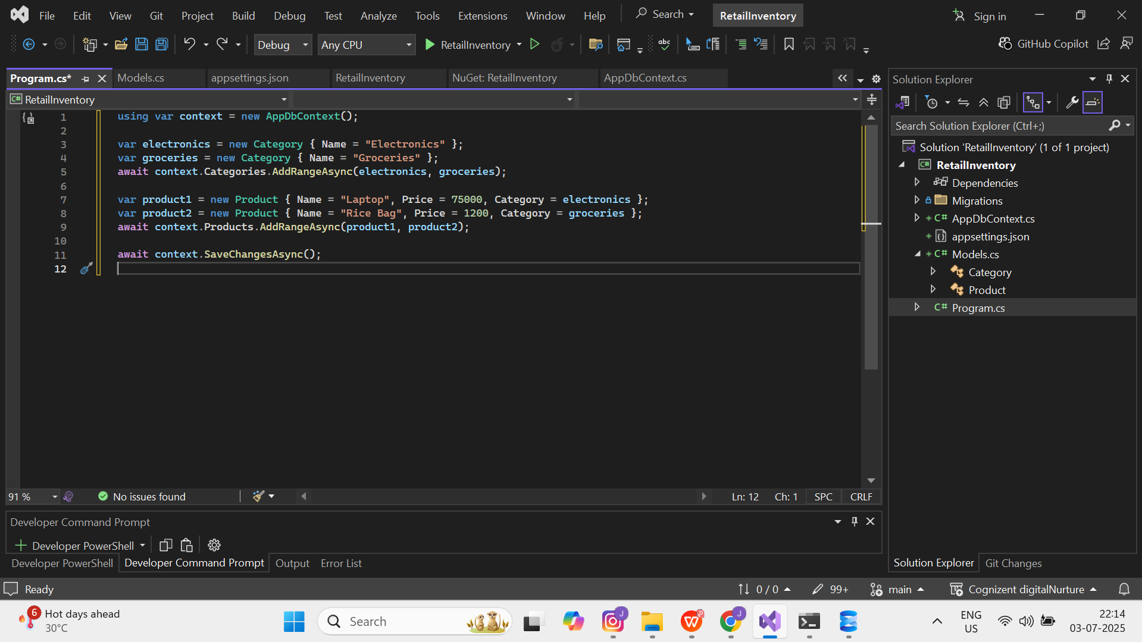

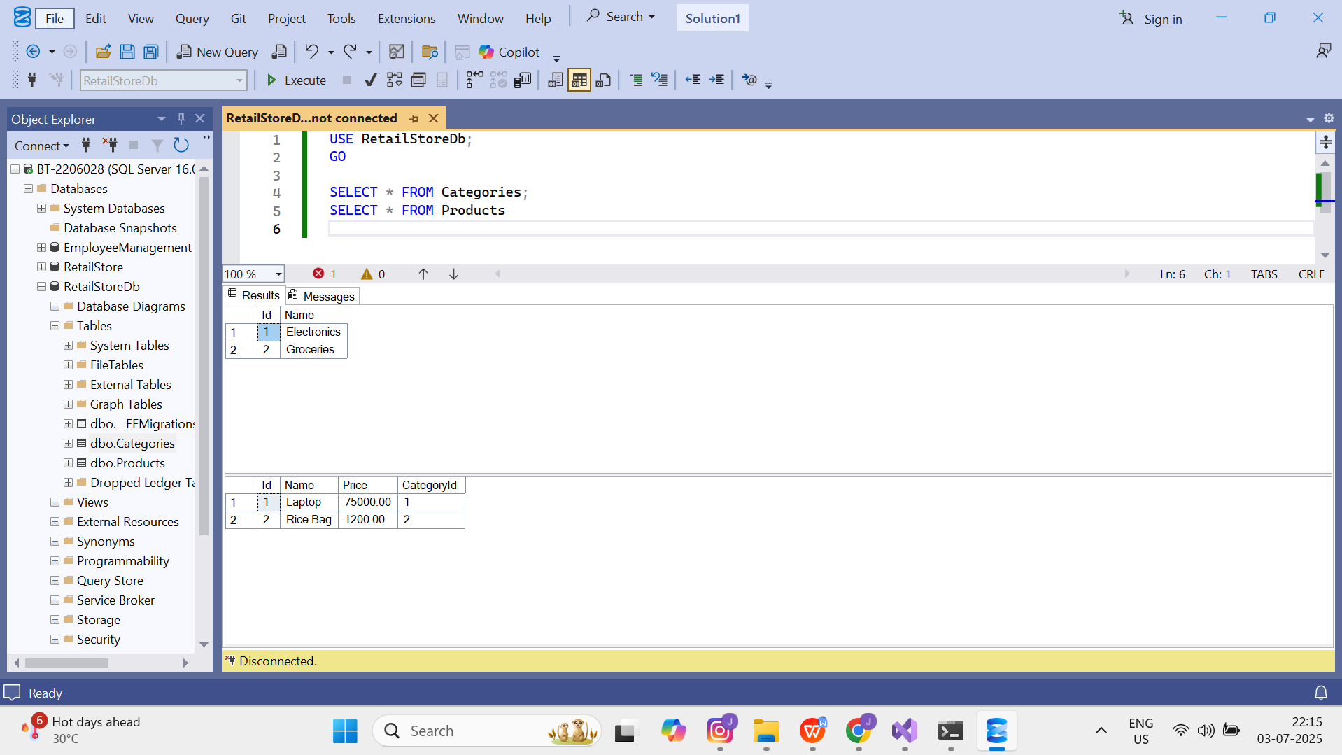

Lab 5: Retrieving Data from the Database

Code and Output:

