**Digital Nurture 4.0 .NET FSE (Week-5 Report)**

By-Jayati Pal

**Module 7 - Microservices Architecture using ASP.NET Core Web API**

Lab 6:

Code:

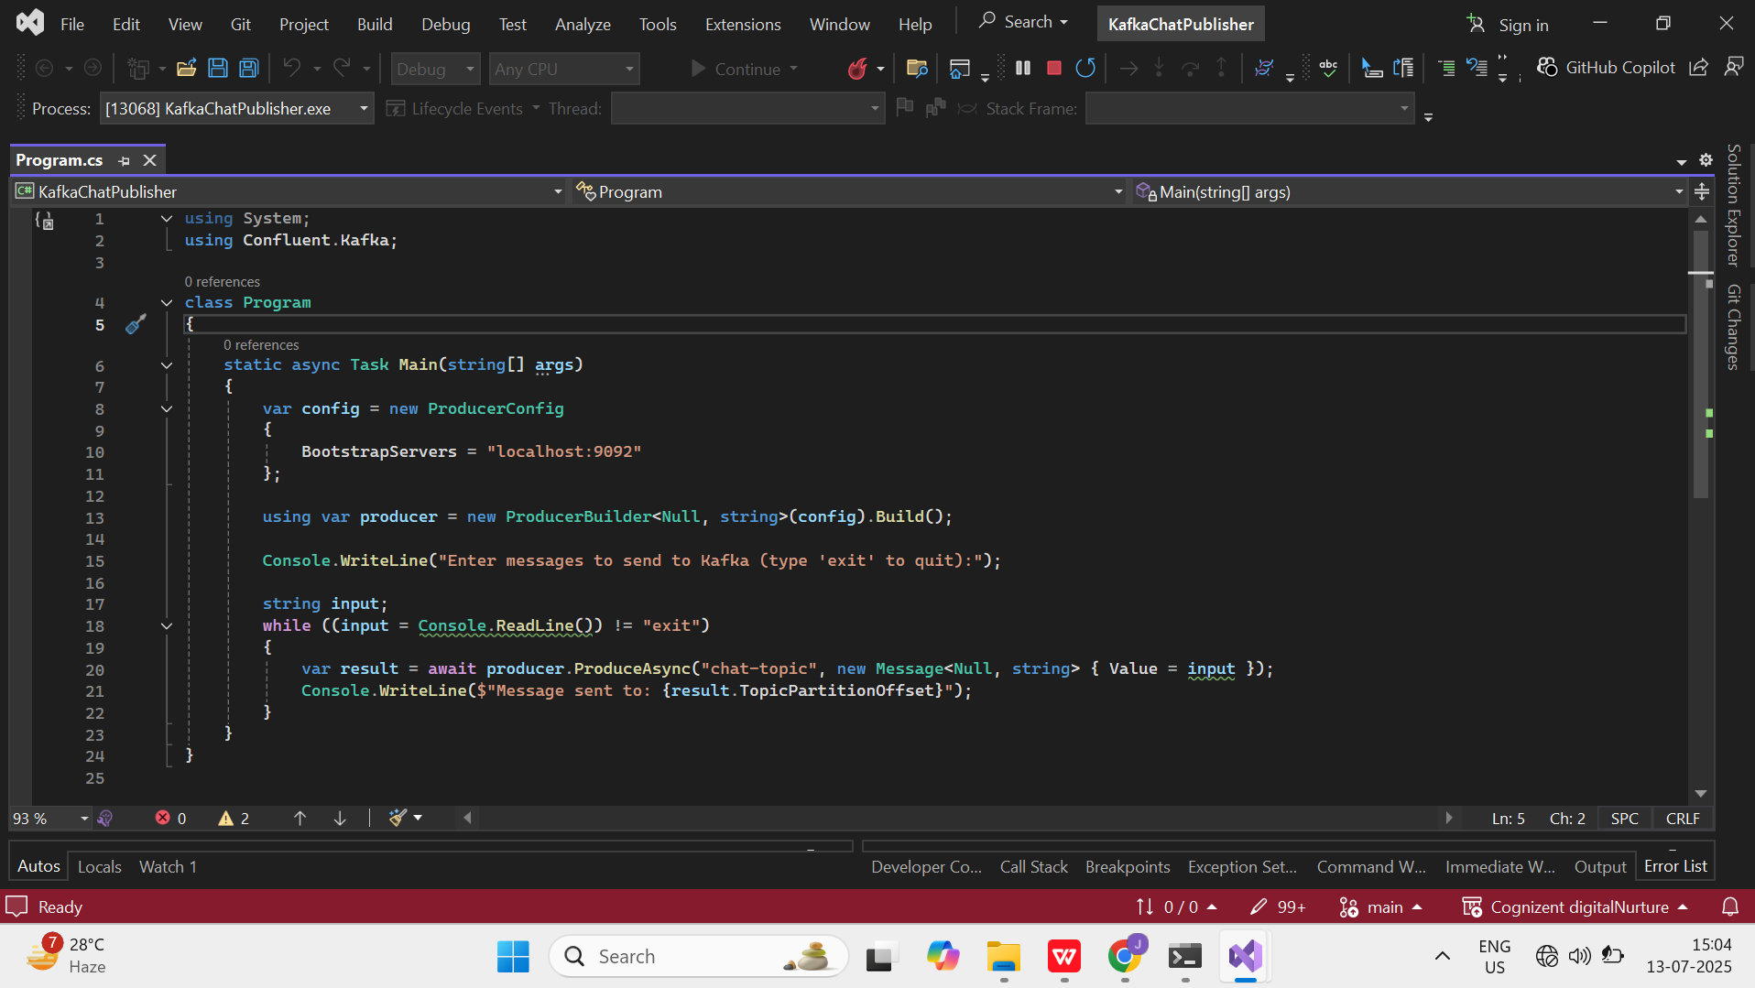

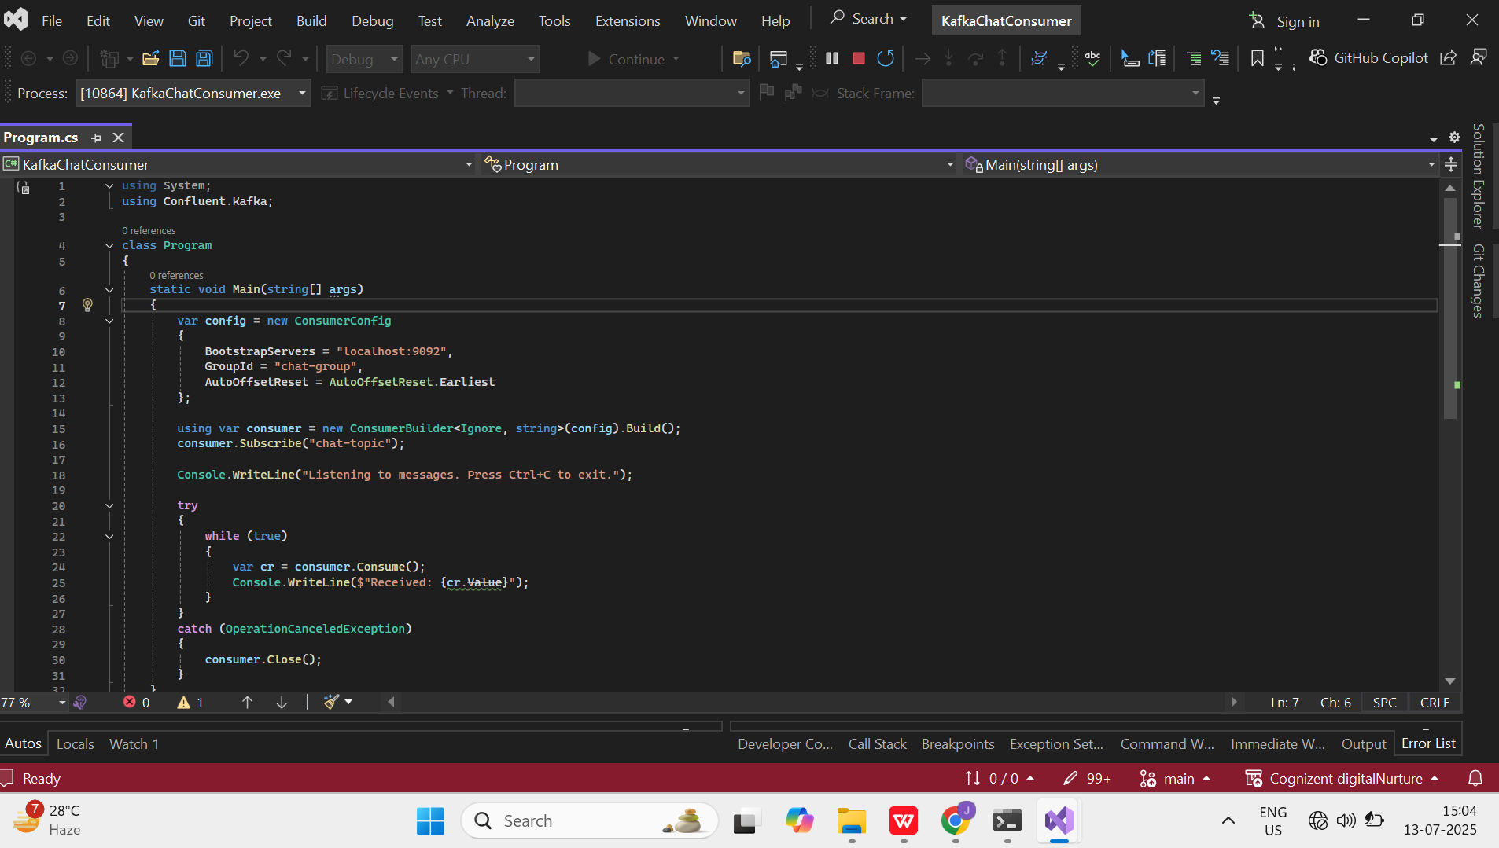

Output:

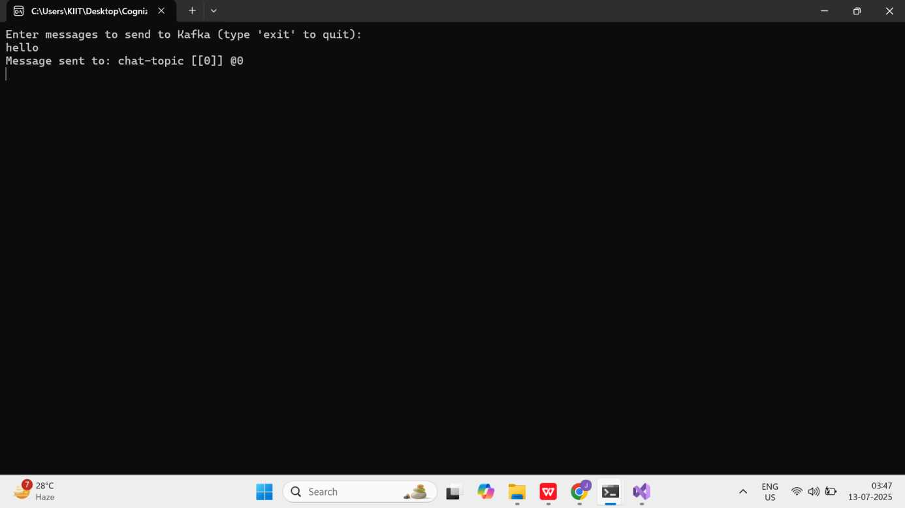

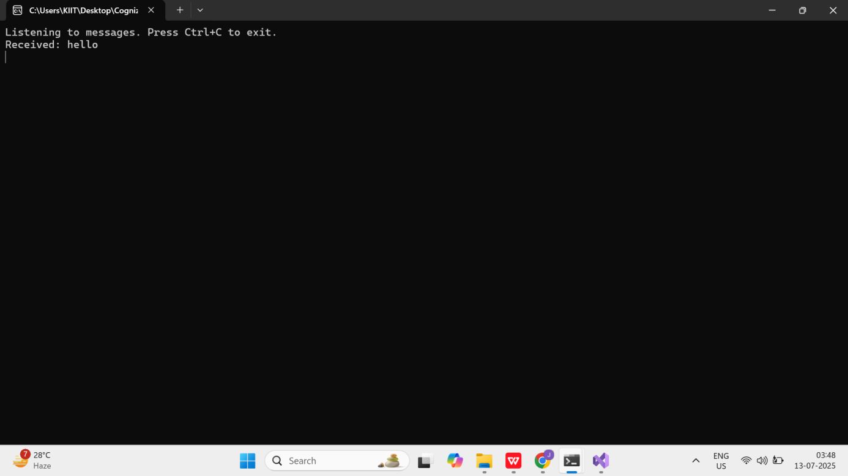

Question 1: Implement JWT Authentication in ASP.NET Core Web API:

Code:

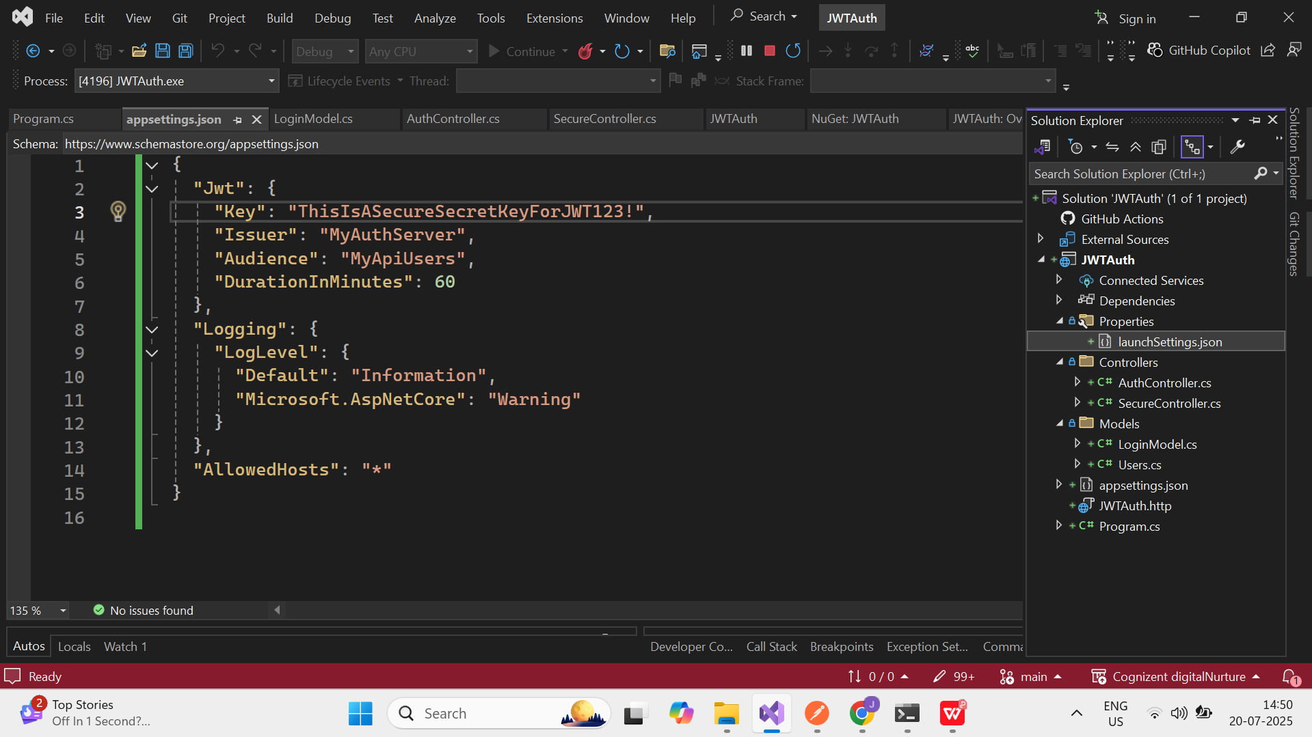

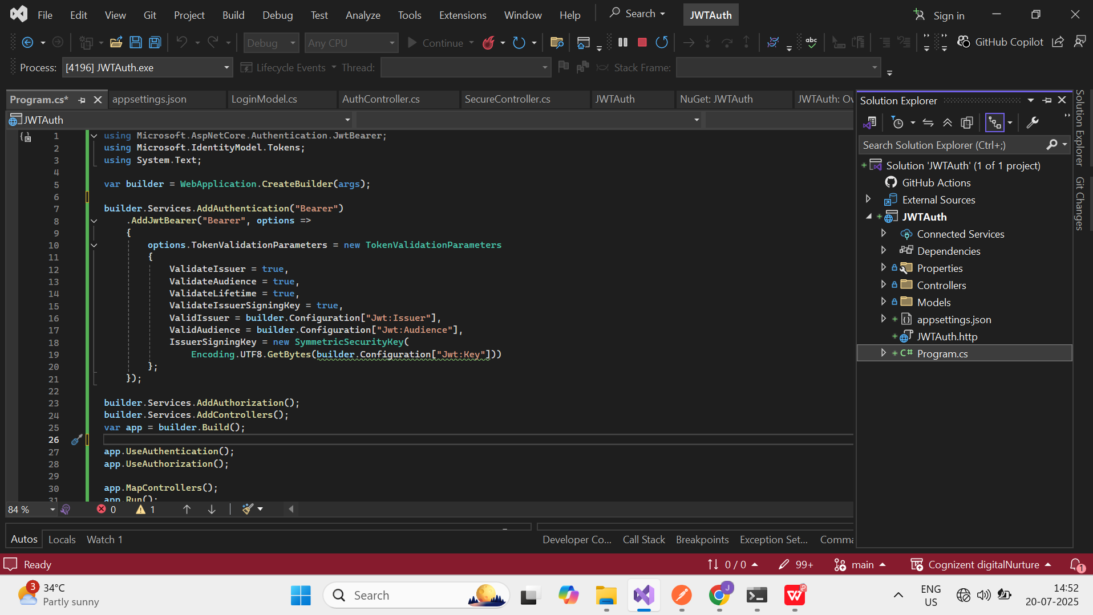

Output:

