Digital Nurture 4.0 .NET FSE (Week-7 Report)
By-Jayati Pal
- ReactJS-HOL
Code:
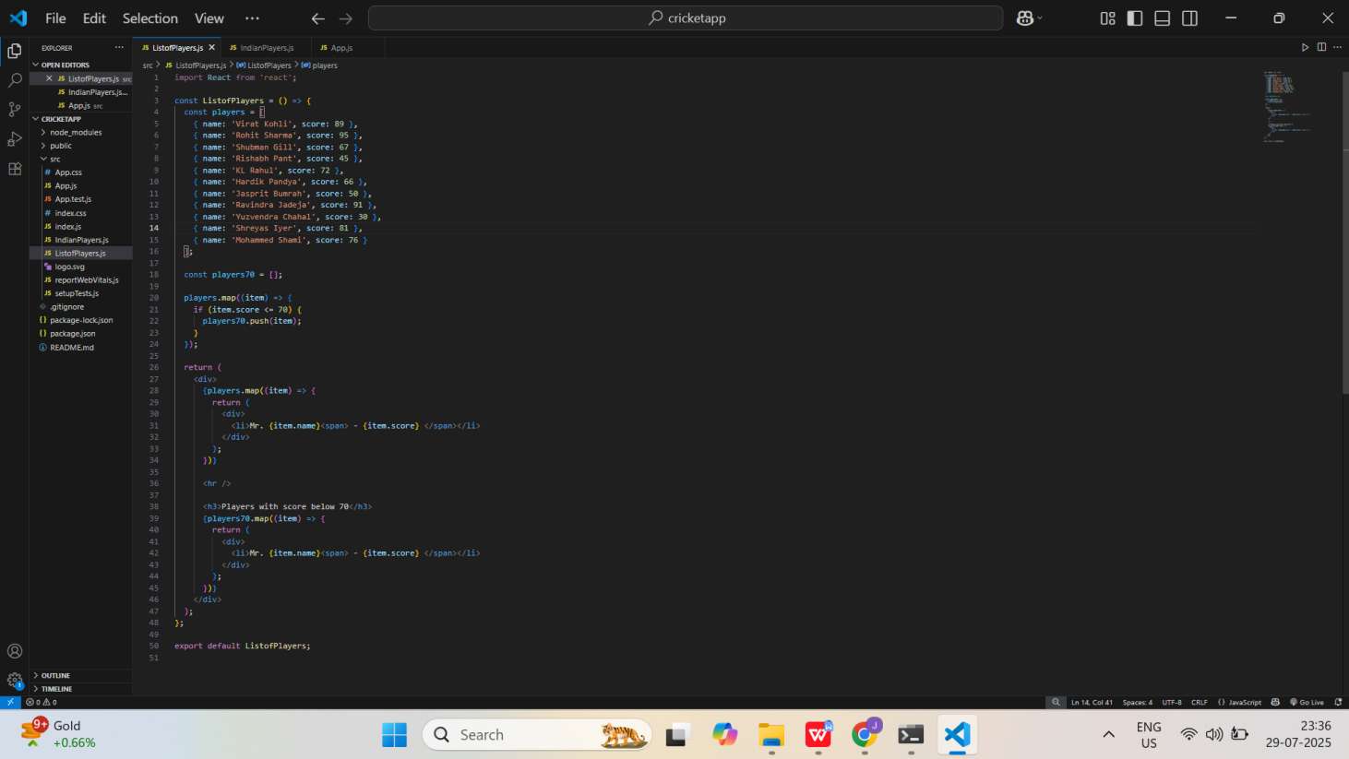
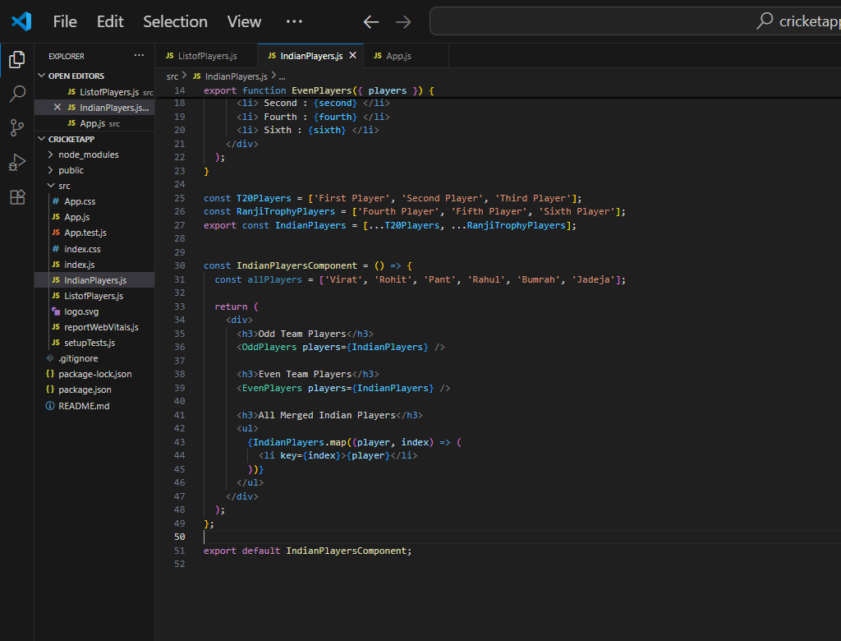
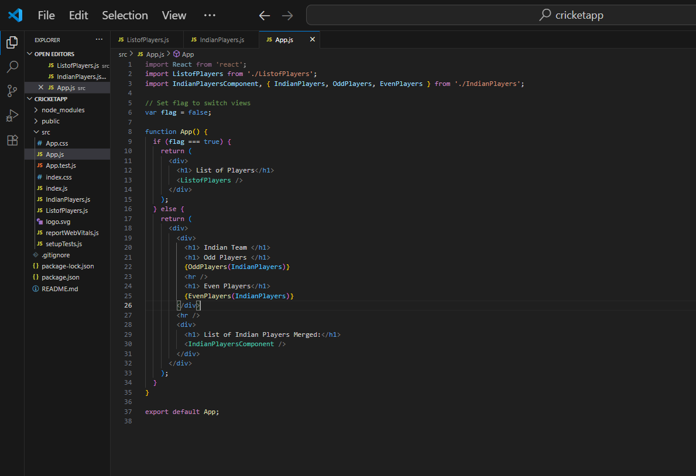

Output:
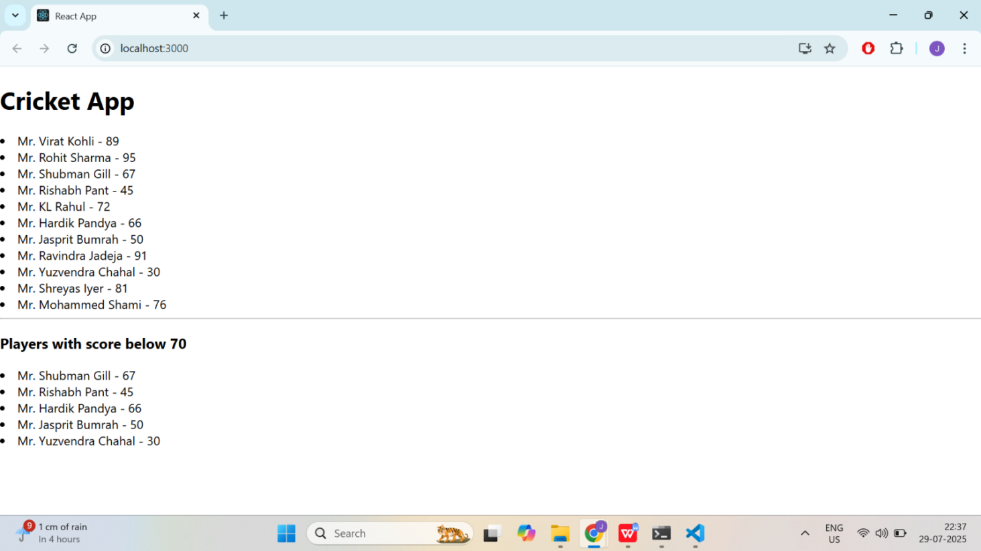
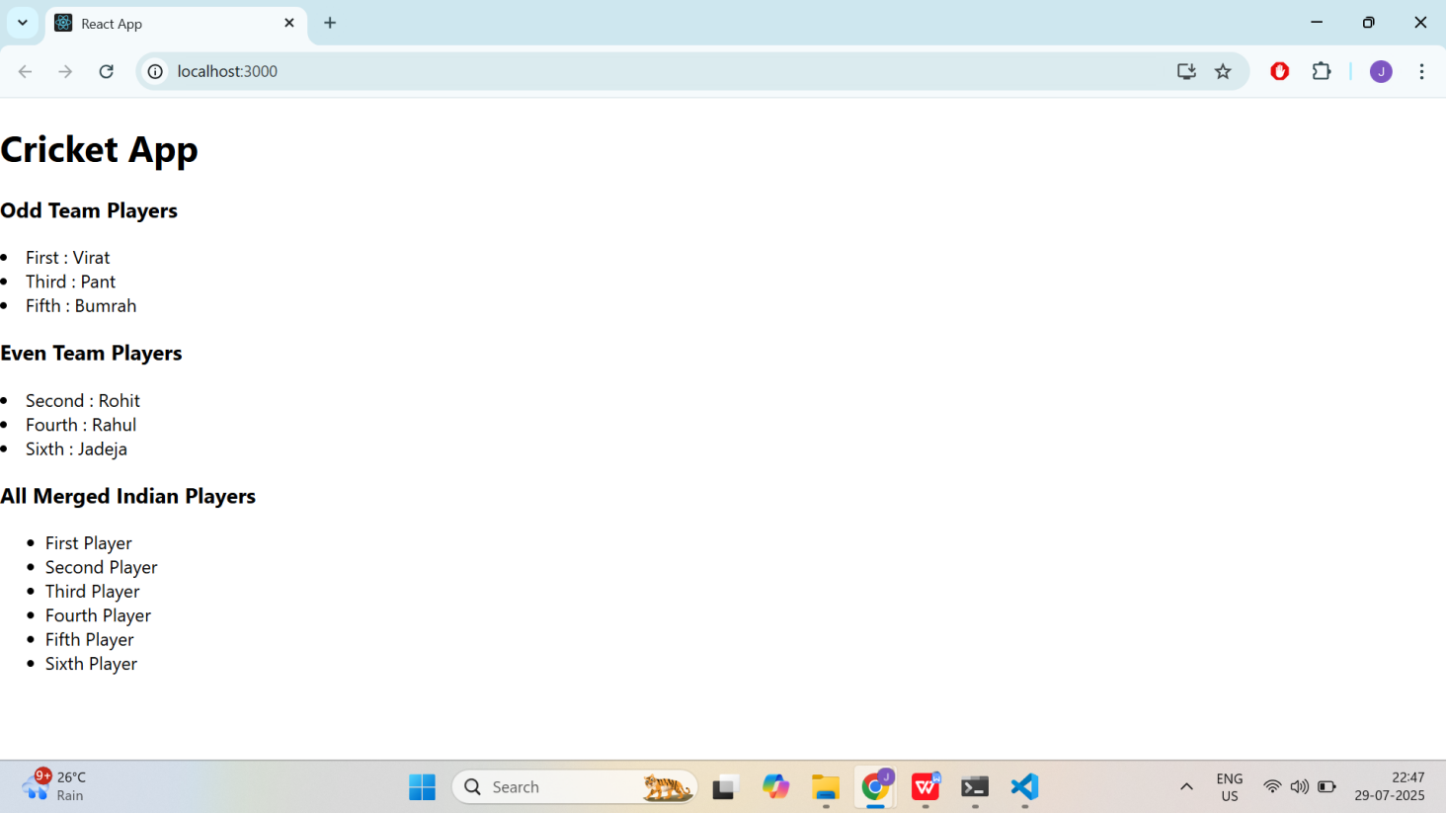

- ReactJS-HOL
Code:
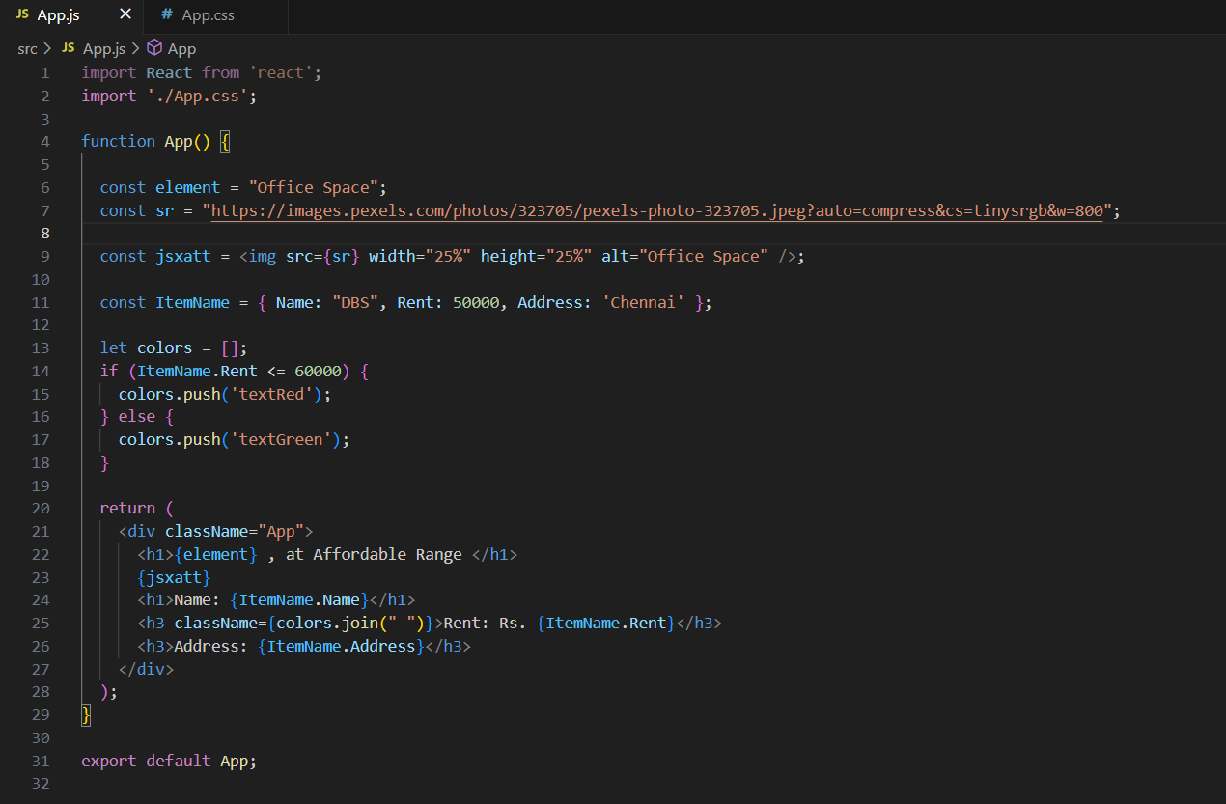

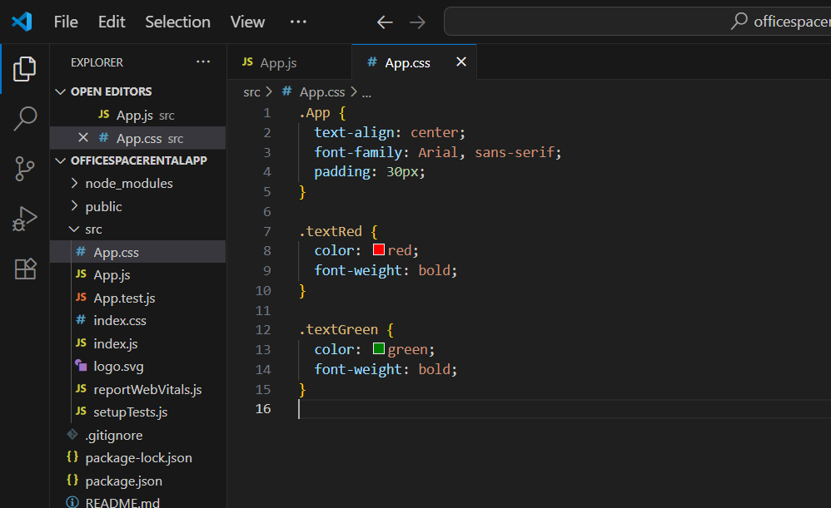

Output:
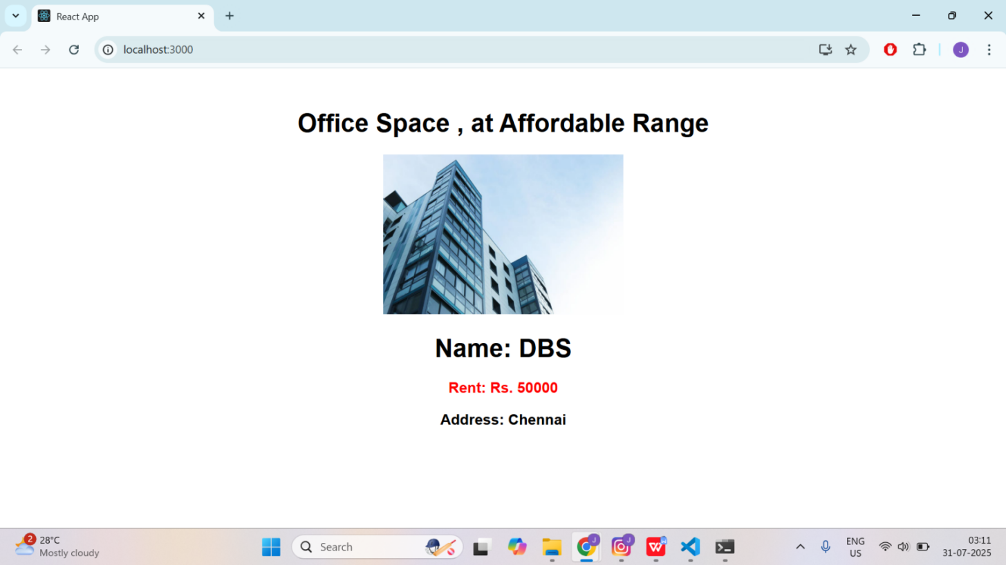
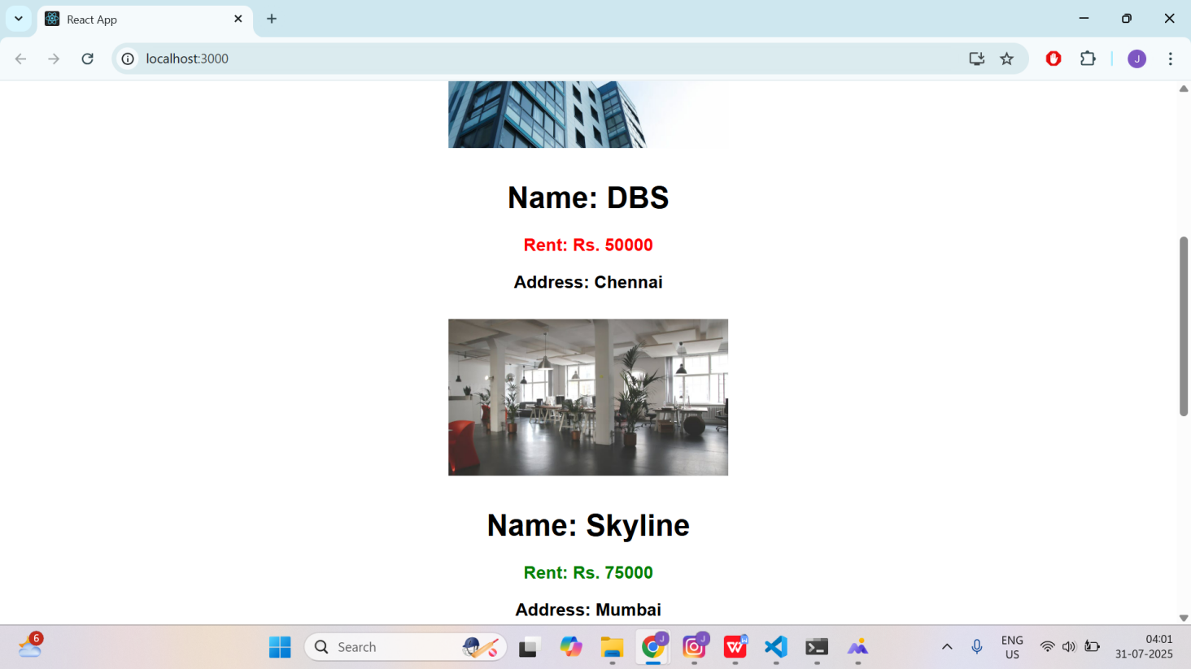

- ReactJS-HOL
Code:
import React, { useState } from "react";

function App() {
const [count, setCount] = useState(1);
const [amount, setAmount] = useState("");
const [currency, setCurrency] = useState("Euro");

const handleIncrement = () => {
setCount(count + 1);
sayHello();
};

const handleDecrement = () => {
setCount(count - 1);
};

const sayHello = () => {
alert("Hello! This is a static message.");
};

const sayWelcome = (msg) => {
alert(msg);
};

const handleClick = () => {
alert("I was clicked");
};

const handleSubmit = (e) => {
e.preventDefault();
const rate = 80;
const converted = amount * rate;
alert(`Converting to ${currency} Amount is ${converted}`);
};

return (
<div style={{ padding: "30px", fontFamily: "Arial" }}>
<div>
<p>{count}</p>
<button onClick={handleIncrement}>Increment</button>
<br />
<button onClick={handleDecrement}>Decrement</button>
<br /><br />
<button onClick={() => sayWelcome("Welcome")}>Say welcome</button>
<br /><br />
<button onClick={handleClick}>Click on me</button>
</div>

<br /><br />

<h2 style={{ color: "green", fontWeight: "bold" }}>Currency Convertor!!!</h2>

<form onSubmit={handleSubmit}>
<div style={{ marginBottom: "10px" }}>
<label>
Amount:&nbsp;
<input
type="number"
value={amount}
onChange={(e) => setAmount(e.target.value)}
style={{ width: "80px" }}
/>
</label>
</div>
<div style={{ marginBottom: "10px" }}>
<label>
Currency:&nbsp;
<select
value={currency}
onChange={(e) => setCurrency(e.target.value)}
style={{ width: "100px" }}
>
<option value="Euro">Euro</option>
</select>
</label>
</div>
<button type="submit">Submit</button>
</form>
</div>
);
}

export default App;

Output:
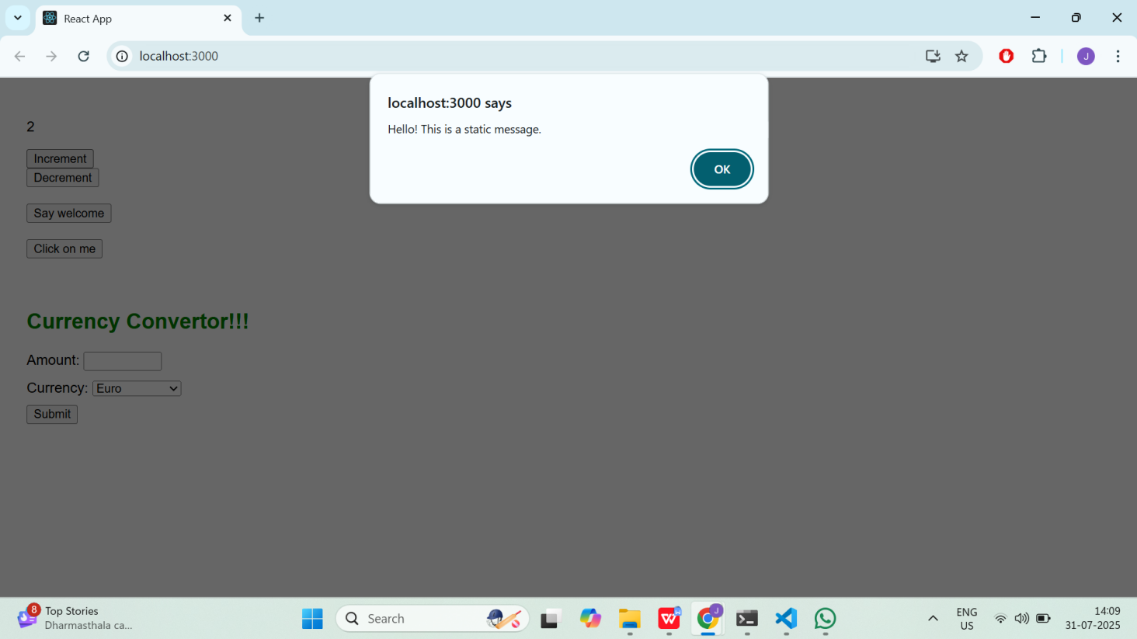

- ReactJS-HOL
Code:
import React, { useState } from "react";

function LoginButton(props) {
return (
<button onClick={props.onClick}>
Login
</button>
);
}

function LogoutButton(props) {
return (
<button onClick={props.onClick}>
Logout
</button>
);
}

function Greeting(props) {
const isLoggedIn = props.isLoggedIn;
if (isLoggedIn) {
return <UserGreeting />;
}
return <GuestGreeting />;
}

function UserGreeting() {
return <h1>Welcome back</h1>;
}

function GuestGreeting() {
return <h1>Please sign up.</h1>;
}

function App() {
const [isLoggedIn, setIsLoggedIn] = useState(false);

const handleLoginClick = () => setIsLoggedIn(true);
const handleLogoutClick = () => setIsLoggedIn(false);

return (
<div className="App">
<Greeting isLoggedIn={isLoggedIn} />
{isLoggedIn ? (
<LogoutButton onClick={handleLogoutClick} />
) : (
<LoginButton onClick={handleLoginClick} />
)}
</div>
);
}

export default App;

Output:
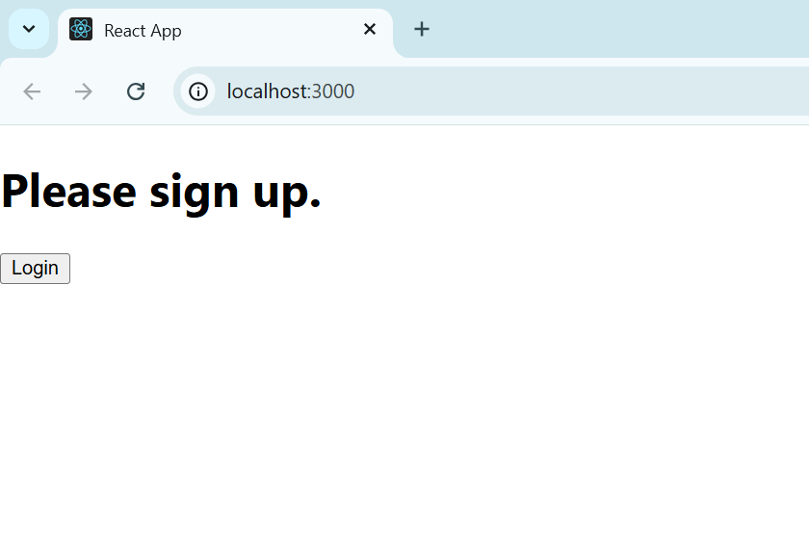

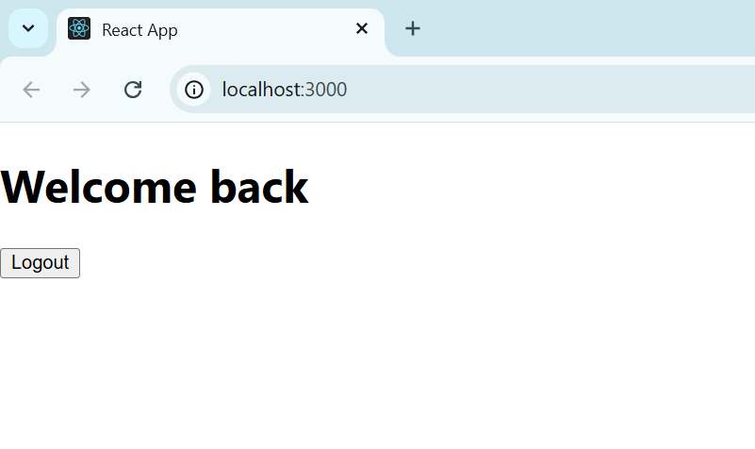

- ReactJS-HOL
Code:
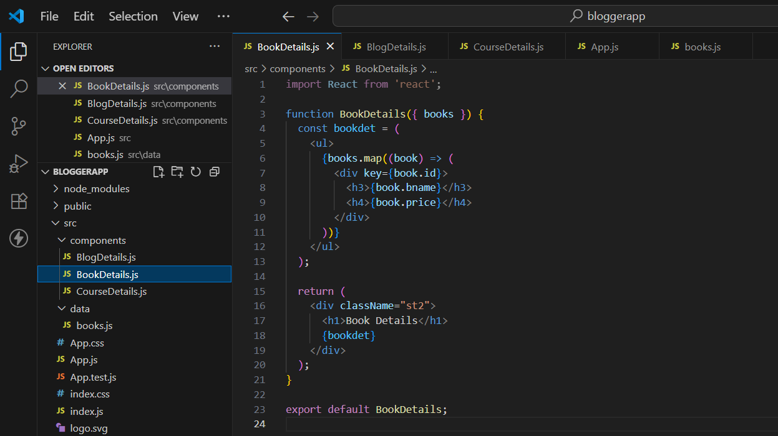
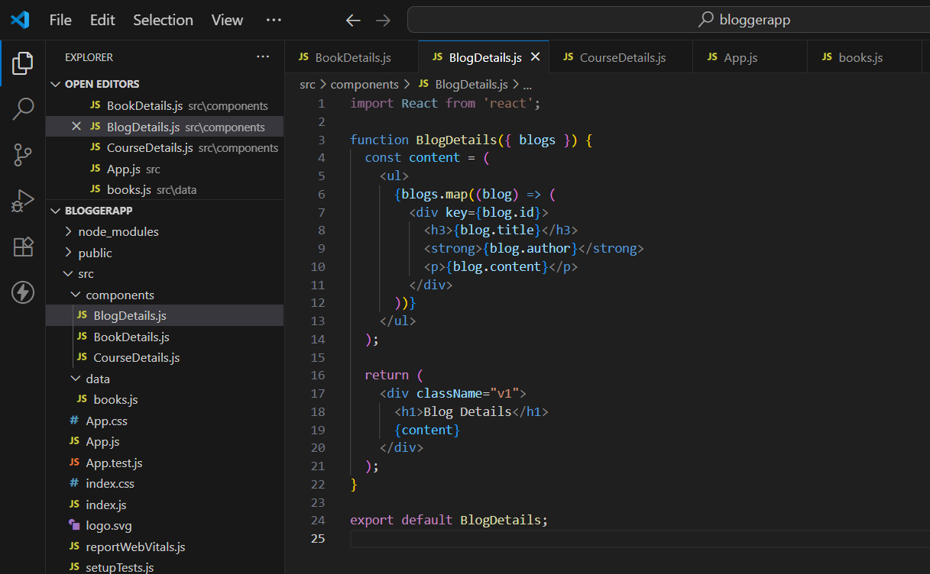
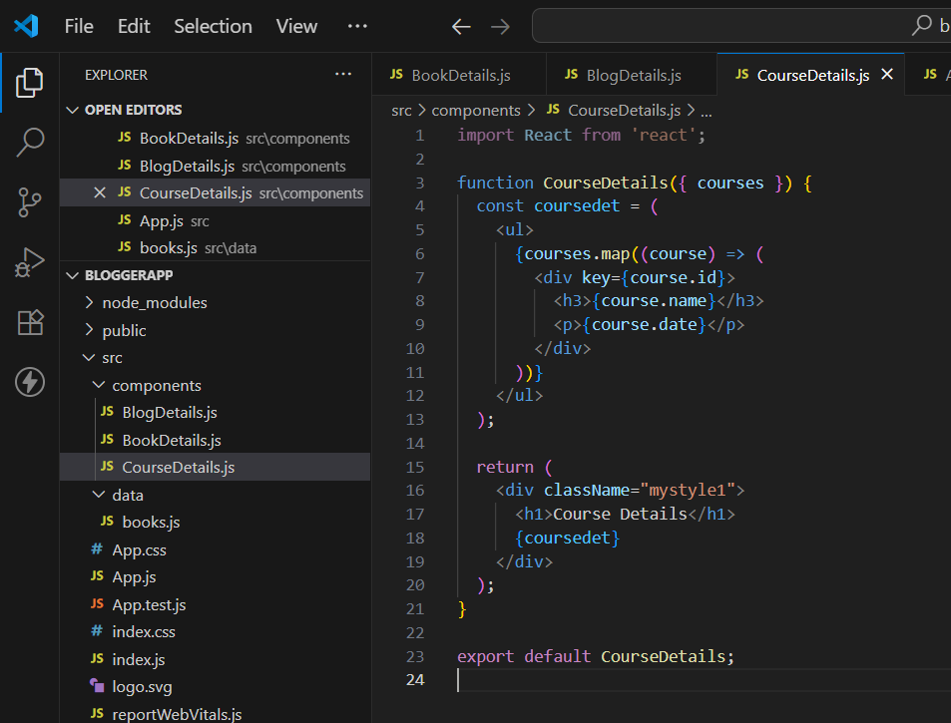
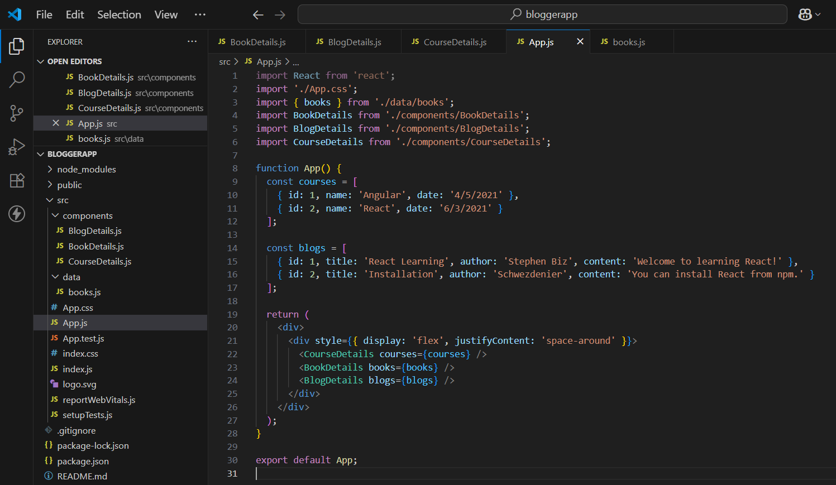
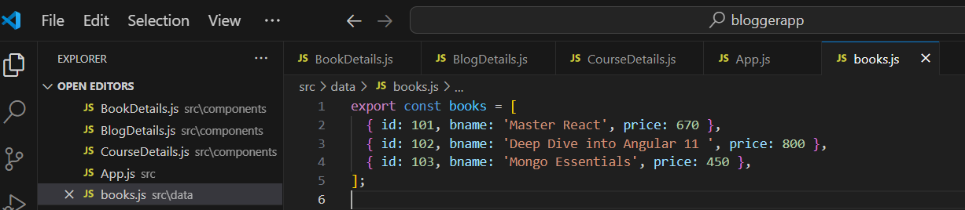

Output:
