Assignment -1
Linux
Name: T. Jayavardhan Reddy
Mail: jayavardhanreddythugu@gmail.com

1. Number Classification (if + function)
Write a shell script that uses a function to check whether a number is positive, negative, or zero using if.
Code:-
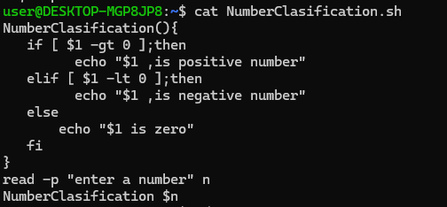
Outtput:-
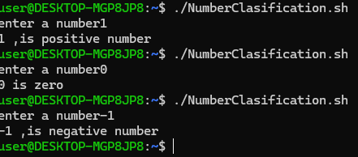
2. Factorial of a Number (while + function)
Write a shell script to calculate the factorial of a number using a while loop inside a function.

Code:-

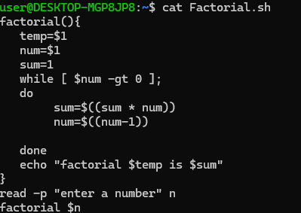
Output:-
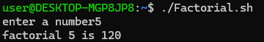

3. Sum of N Numbers (for + function
Write a shell script to calculate the sum of numbers from 1 to N using a for loop inside a function.

Code:-

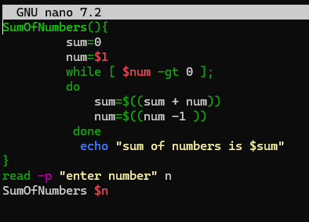
Output:-
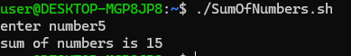

4. Prime Number Check (if + for + function)
Write a shell script that uses a function to check whether a given number is prime using if and for.

Code:-

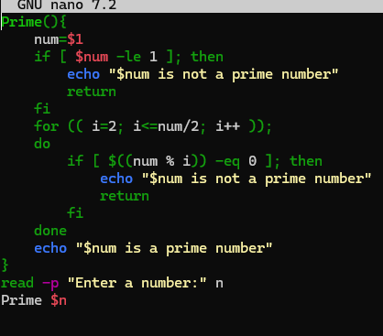
Output:-
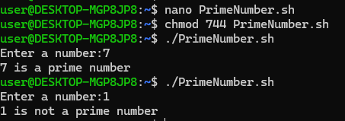
5. Reverse a Number (while + if)
Write a shell script to reverse a number using a while loop and if conditions where required.
Code:-
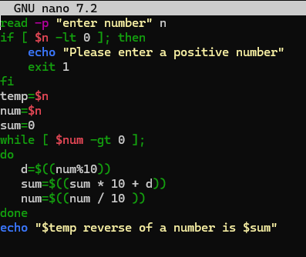
Output:-
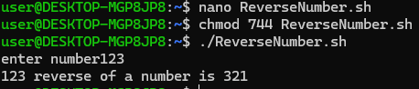

6. File Existence & Permission Check (if + function)
Write a shell script that uses a function to check if a file exists and whether it has read, write, and execute permissions.
Code:-
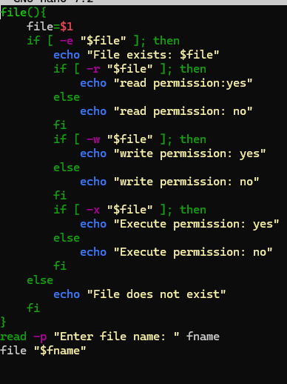
Output:-
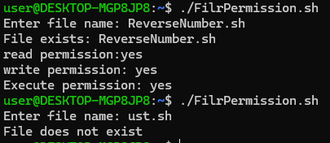

7. Menu-Driven Calculator (while + case + function)
Write a shell script that shows a menu in a while loop and performs add, subtract, multiply, divide using functions.
Code:-
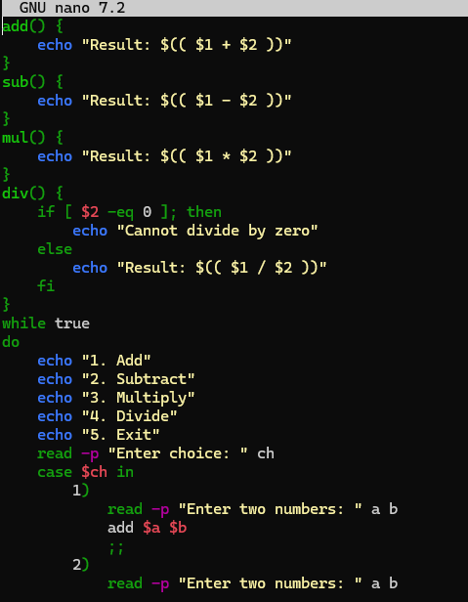
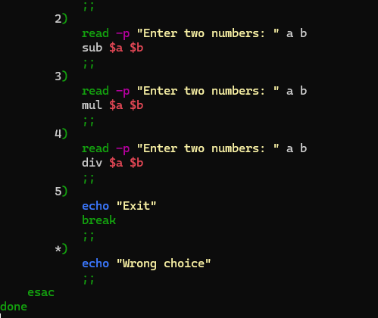
Output:-
