etl assignment

1.what is etl?
Etl is the process of collecting raw data,cleaning it,and storing it in a system where it can be analyzed.
2.what are three stages of etl?
transform
extraction
load
3.what is data transformation?
transformation means collect data and modify then implementation.
4.difference between and full load incremental load?
delete old dataset and load all data set with modify data.
load new records.
5.name two etl tools?
infarmatica,bi tool,cloud,bigdata,data injection tool
Mini project
1.extract data from csv
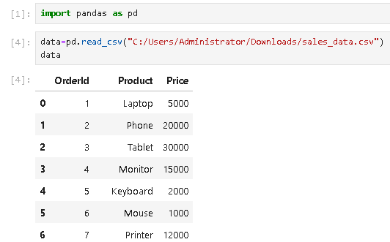
2.
remove null values
Calculate tax price
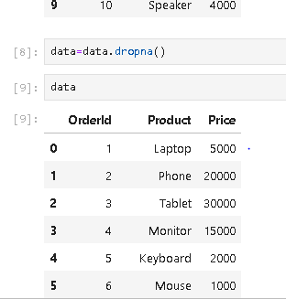
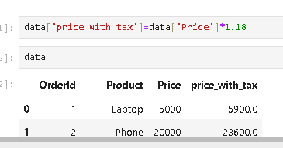
3.
load in to sql data base
To add into
