Conditional Split Transformation in SSIS

1. Introduction
In SQL Server Integration Services (SSIS), the Conditional Split transformation is used to separate data into different outputs based on conditions. It works similarly to an IF-ELSE statement in programming.
Conditional Split evaluates each row of data and sends it to different destinations depending on the condition specified.

Purpose
The main purpose of Conditional Split is to:
- Filter data based on conditions
- Route rows to different outputs
- Apply business rules during ETL processing
- Perform data validation
For example, sales records can be divided into high sales and low sales categories based on quantity.

Problem Statement
In this scenario, sales data is stored in a SQL Server table. The goal is to process the data using SSIS and split the records based on the quantity sold.

Condition
- If Quantity ≥ 3 → High Sales
- If Quantity < 3 → Low Sales
The high sales data will be used for aggregation, while low sales data will be stored in another table.

Source Table Structure
The source data is stored in the Sales_Source table.
CREATE TABLE Sales_Source (
SaleID INT,
ProductID INT,
Quantity INT,
Price VARCHAR(20),
Region VARCHAR(50)
);

Sample Data
SaleID | ProductID | Quantity | Price | Region
1 | 101 | 2 | 500 | South
2 | 102 | 1 | 1200 | North
3 | 103 | 5 | 300 | East
4 | 101 | 3 | 500 | South
5 | 104 | 4 | 700 | West

Destination Tables
Two destination tables are used.

1. Sales_Cleaned Table
Stores the records where Quantity < 3.
CREATE TABLE Sales_Cleaned (
SaleID INT,
ProductID INT,
Quantity INT,
Price DECIMAL(10,2),
Region VARCHAR(50)
);

2. High_Sales Table
Stores aggregated high sales data.
CREATE TABLE High_Sales (
ProductID INT,
TotalQuantity INT
);

Steps to Implement Conditional Split in SSIS

Step 1: Create SSIS Project
- Open SQL Server Data Tools (SSDT).
- Create a new project.
- Select Integration Services Project.
- Name the project SSIS_ETL_Practice.

Step 2: Add Data Flow Task
- Open the Control Flow tab.
- Drag Data Flow Task into the workspace.
- Rename it as Sales_ETL_Process.
Double click the task to open Data Flow.

Step 3: Add OLE DB Source
- Drag OLE DB Source into Data Flow.
- Create a SQL Server connection.
- Select the table Sales_Source.
This component reads data from the SQL Server table.

Step 4: Add Conditional Split Transformation
- Drag Conditional Split from the SSIS Toolbox.
- Connect the OLE DB Source to the Conditional Split.
Double click the Conditional Split component to configure it.

Step 5: Configure Conditional Split Condition
In the Conditional Split Editor, create the following condition.
Output Name:
HighSales

Condition:
Quantity >= 3

Rows satisfying this condition will go to the HighSales output.
Rows that do not satisfy the condition will automatically go to the Default Output, which represents Low Sales.

Connecting Outputs
After configuring Conditional Split, two outputs will appear:
- HighSales Output
- Default Output (LowSales)

HighSales Path
- Connect HighSales output to an Aggregate transformation.
- Aggregate the quantity by ProductID.
- Load the result into High_Sales table.

LowSales Path
- Connect Default Output to OLE DB Destination.
- Select the table Sales_Cleaned.
- Map the columns accordingly.

Data Flow Diagram
The ETL pipeline follows this structure:
OLE DB Source
|
Conditional Split
/ \
HighSales LowSales
| |
Aggregate OLE DB Destination
|
OLE DB Destination

Output Result
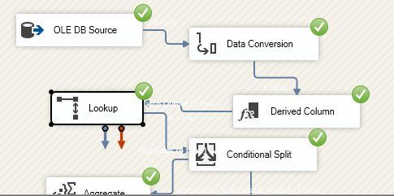

Output:

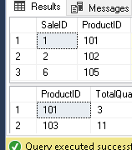
After executing the SSIS package:

High Sales Output
ProductID | TotalQuantity
103 | 11
101 | 3

Low Sales Output
SaleID | ProductID | Quantity
1 | 101 | 2
2 | 102 | 1

