Database Migration
Source
Legacy Customer DB
Destination
New Data Warehouse
Use:
● OLE DB Source
● Data Flow
● OLE DB Destination

1. Introduction
Database migration is the process of transferring data from one database to another database. It is usually done when organizations move from an old system (legacy database) to a new system such as a data warehouse for better storage, performance, and analysis.

- OLE DB Source – to extract data from the legacy database
- Data Flow Task – to control the movement of data
- OLE DB Destination – to load data into the data warehouse

Step 1: Create SSIS Project
First, an Integration Services Project is created in Visual Studio (SSDT). This project contains the SSIS package that performs the data migration process.

Step 2: Add Data Flow Task
Inside the Control Flow, a Data Flow Task is added. The Data Flow Task is responsible for moving data from the source database to the destination database.

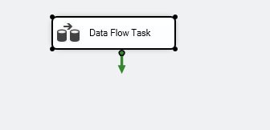

Step 3: Configure OLE DB Source
An OLE DB Source component is added in the Data Flow.
This component connects to the COMPANY_DB3 Database and extracts customer data from the source table.

Step 4: Configure OLE DB Destination
An OLE DB Destination component is added and connected to the OLE DB Source.
This component connects to the New Data Warehouse and loads the extracted data into the destination table.
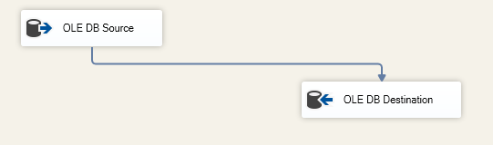

Step 5: Column Mapping
The columns from the source table are mapped to the corresponding columns in the destination table to ensure that the correct data is transferred.
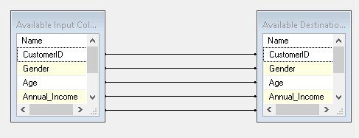

Step 6: Execute the Package
Finally, the SSIS package is executed. The system extracts data from the legacy database and loads it into the data warehouse successfully.

