Task 2 – Networking and Web Servers

Objective: Understand networking concepts and set up a basic web server.

Folder on VM: ~/Linux-Task2

Step 1: Prepare the VM

1. Make a Task 2 folder:
mkdir ~/Linux-Task2
cd ~/Linux-Task2

2. Update package lists:

sudo apt update
sudo apt upgrade -y
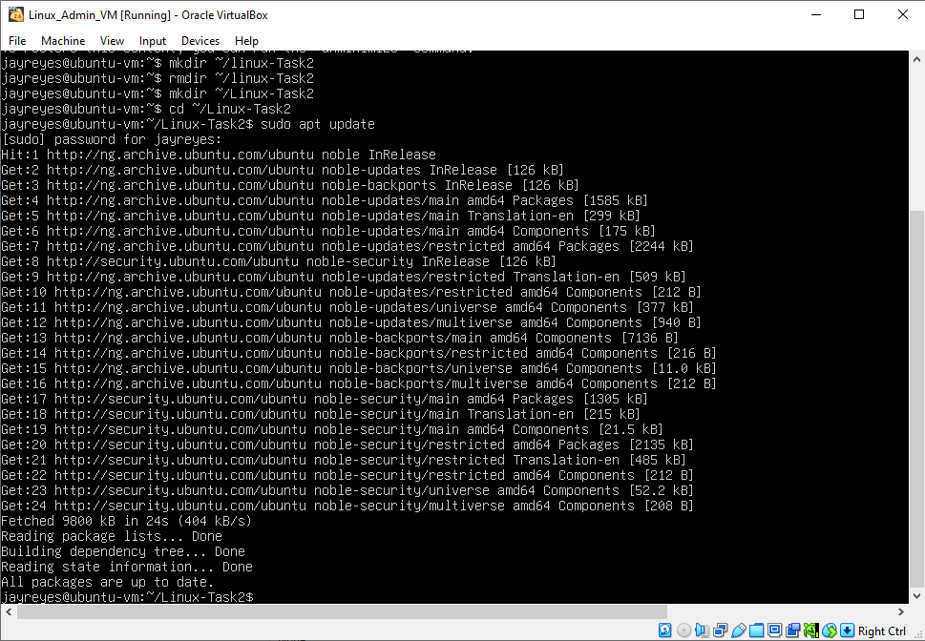
Screenshot placeholder: creation of Task 2 folder and sudo_upgrade.png

Step 2: Network Configuration

1. Check current network interfaces:

ip a

2. Assign a static IP

Edit netplan configuration:

sudo nano /etc/netplan/00-installer-config.yaml

Example configuration:

network:
version: 2
ethernets:
enp0s3:
dhcp4: no
addresses:
- 10.0.2.15/24
routes:
- to: default
via: 10.0.2.2
nameservers:
addresses:
- 8.8.8.8
- 8.8.4.4

Apply changes:

sudo netplan apply

Check connectivity:

ping -c 4 8.8.8.8
ping -c 4 google.com

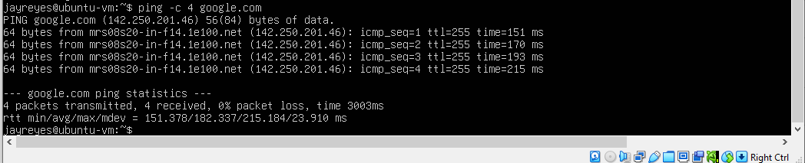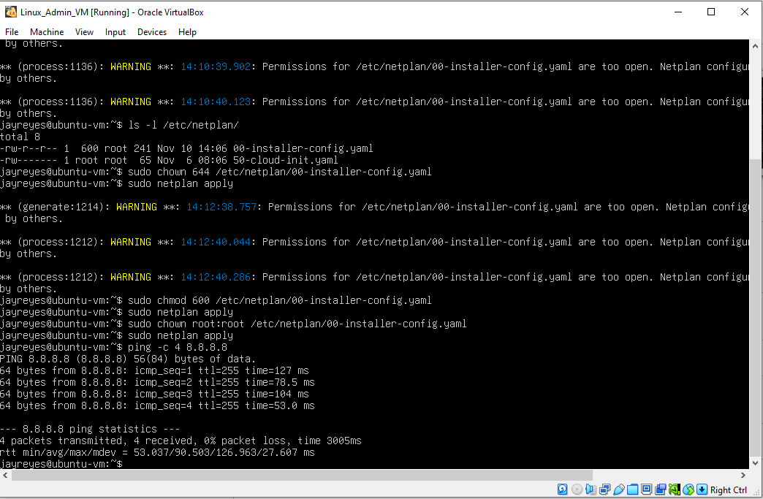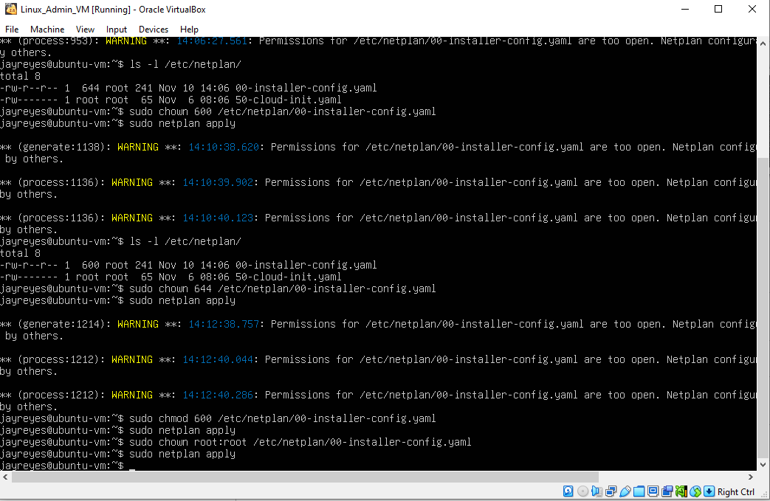
Screenshot placeholders: netplan.png and screenshot_ping.png

Step 2: Firewall Configuration

1. Install and enable UFW (Uncomplicated Firewall):

sudo apt install ufw -y
sudo ufw enable

2. Allow necessary services:

sudo ufw allow ssh
sudo ufw allow http
sudo ufw status

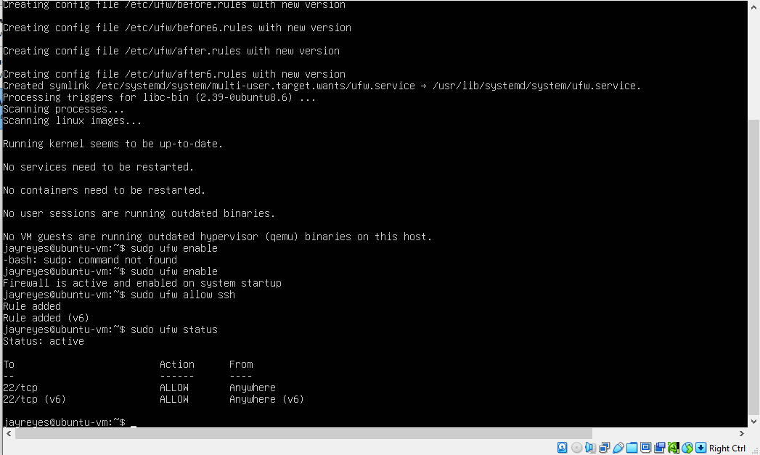
Screenshot placeholders: screenshot_ufw_status.png
Step 3: Install and Configure Nginx Web Server

1. Install Nginx:

sudo apt install nginx -y

2. Start and enable Nginx:

sudo systemctl start nginx
sudo systemctl enable nginx
sudo systemctl status nginx

3. Create a basic HTML page:

sudo nano /var/www/html/index.html

Add simple content, e.g.:

<h1>Hello from Task 2</h1>

4. Test in VM (or browser if using bridged/NAT network):

curl http://localhost

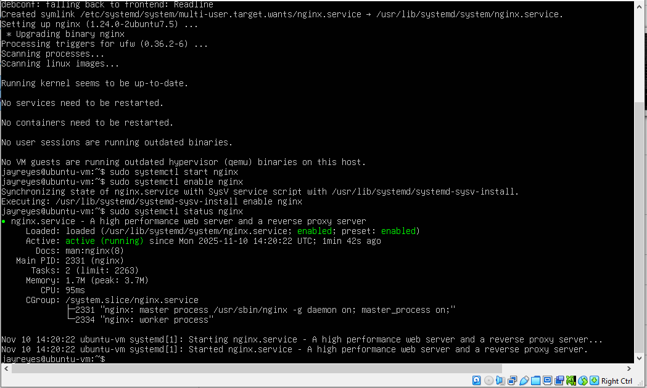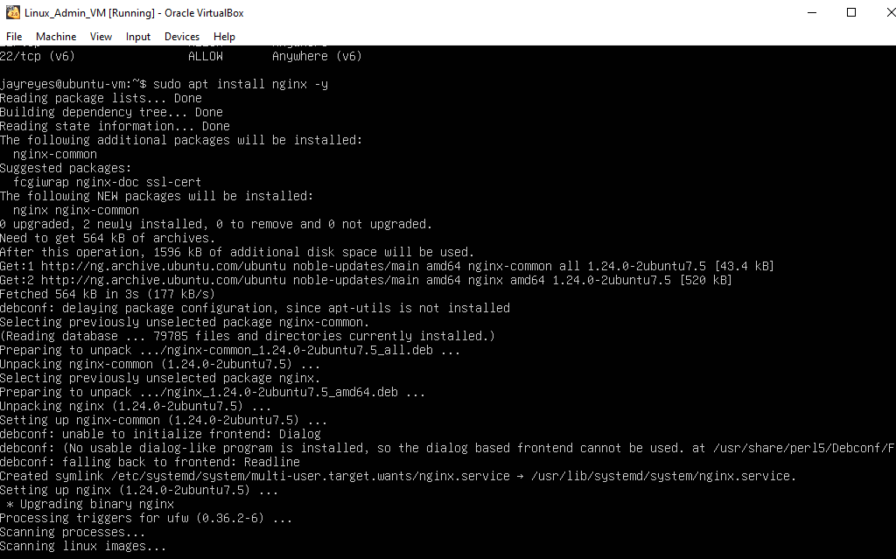
screenshot_nginx_status.png

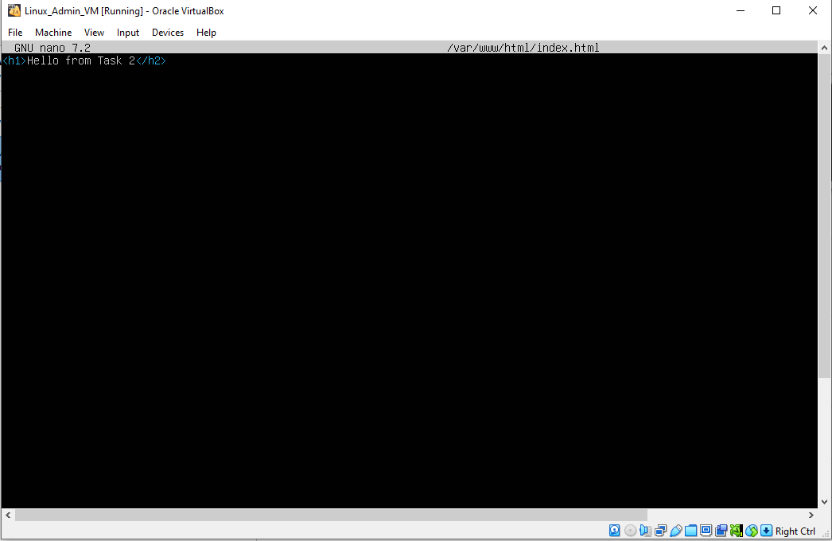
screenshot_html_page.png

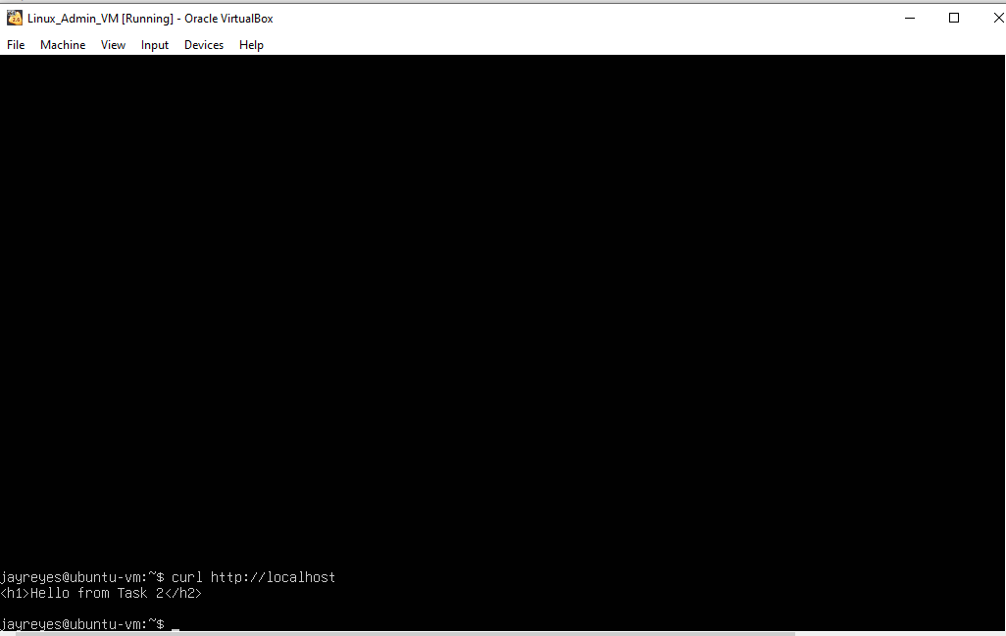
screenshot_curl_output.png

Step 4: DNS Exploration (Optional)

1. Test a public DNS resolver:

nslookup google.com

2. Configure local DNS resolver (optional, if needed for your lab).

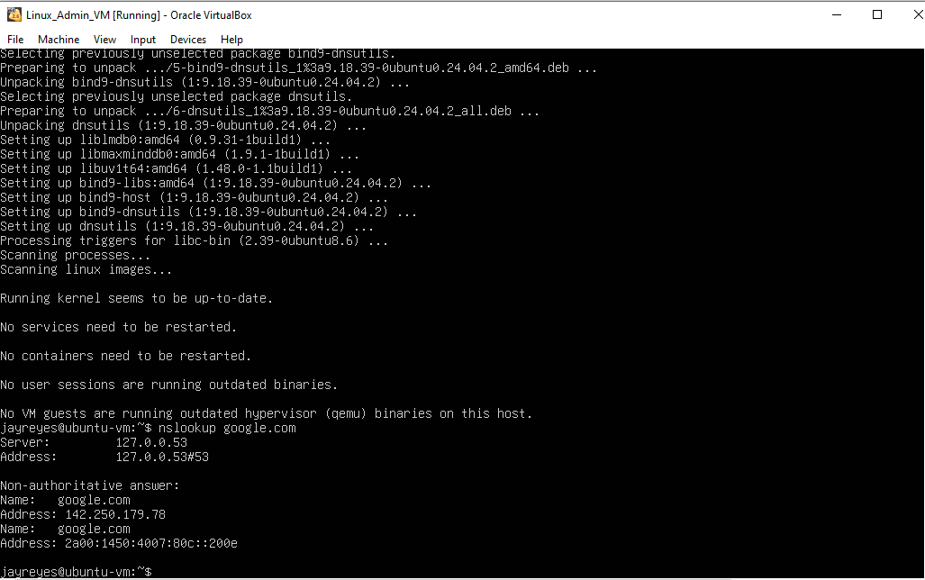

screenshot_nslookup.png

Step 6: Push Task 2 to GitHub

1. Initialize Git (if not already):

cd ~/Linux-Task2
git init
git add .
git commit -m "Task 2: Networking and basic web server setup"

2. Add GitHub remote and push:

git remote add origin https://github.com/<yourusername>/Linux-Task2.git
git branch -M main
git push -u origin main

Use Personal Access Token (PAT) if prompted.

Screenshot placeholder: screenshot_git_push.png

