Linux Task 1 – Basic Linux Administration

Step 1: Ubuntu Server Installation

> Boot the VM using Ubuntu Server ISO.
>Choose Ubuntu Server Minimal.
>Assign RAM and virtual hard disk.

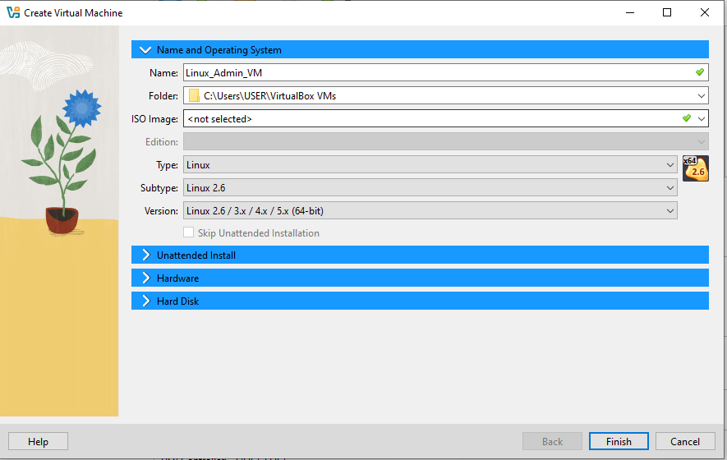
Screenshot: screenshot_vm_boot.png

2. Select language (English).

3. Network configuration

>DHCP or static IP.

4. Storage configuration

>Select detected virtual disk → Done.

5. User profile creation

>Full name: John
>Username: jayreyes
>Password: [your password]
>Sudo enabled by default

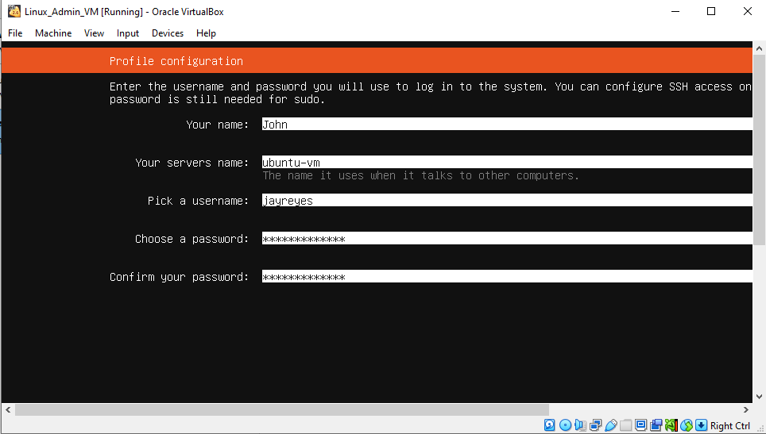

Screenshot: screenshot_user_profile.png

6. Optional SSH setup → Enabled OpenSSH server.

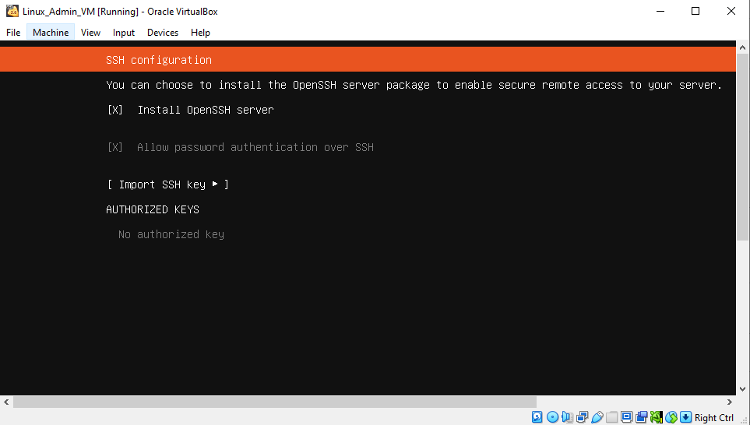
Screenshot: screenshot_ssh.png

7. Minimal updates → Selected minimal updates to speed up installation.
8. Installation progress → Wait until Ubuntu installs base system, kernel, and packages.

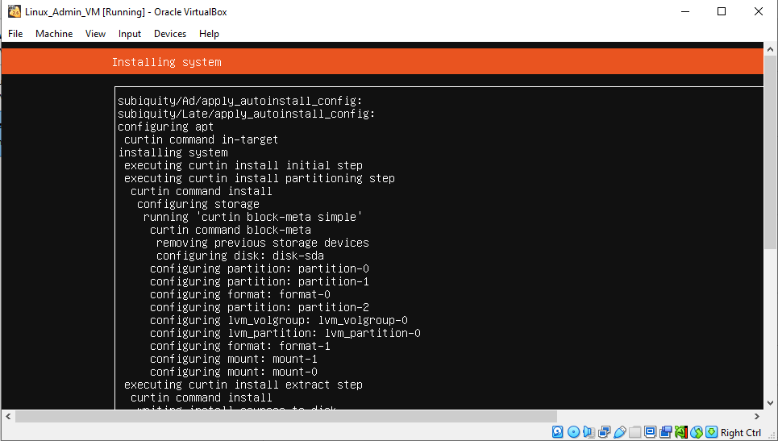
Screenshot: screenshot_install_progress.png
9. Reboot and first login

>Username: jayreyes
>Password: [your password]

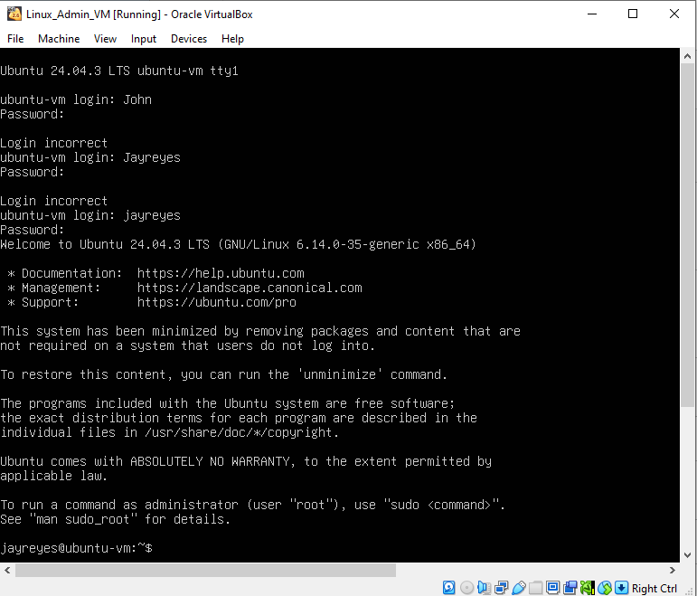
Screenshot: screenshot_first_login.png

10. Verify default users

cat /etc/passwd
Shows jayreyes and testuser

Step 2: User Management

1. Create testuser (if not created during install)

>sudo adduser testuser
>Full name: Jacob Isreal
>Set password
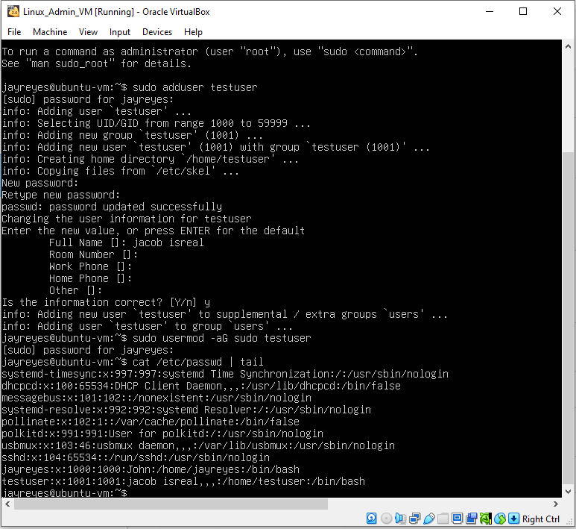
Screenshot: screenshot_adduser.png
2. Verify users

id testuser

>Should show only default primary group (testuser)

Step 3: File System Navigation and Permissions

1. Navigate to home directory

cd /home/jayreyes
pwd
ls -l

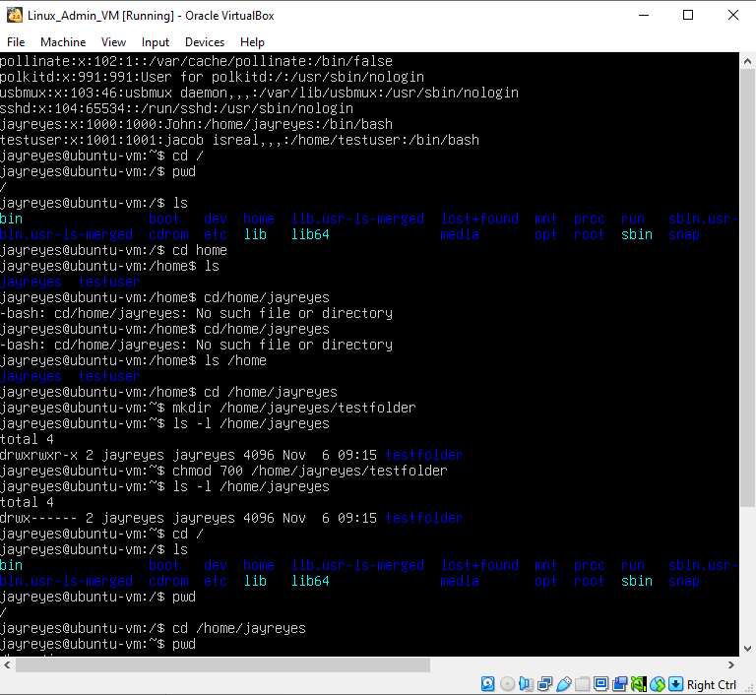
Screenshot: screenshot_home_ls.png

2. Create folder testfolder

mkdir testfolder
ls -l
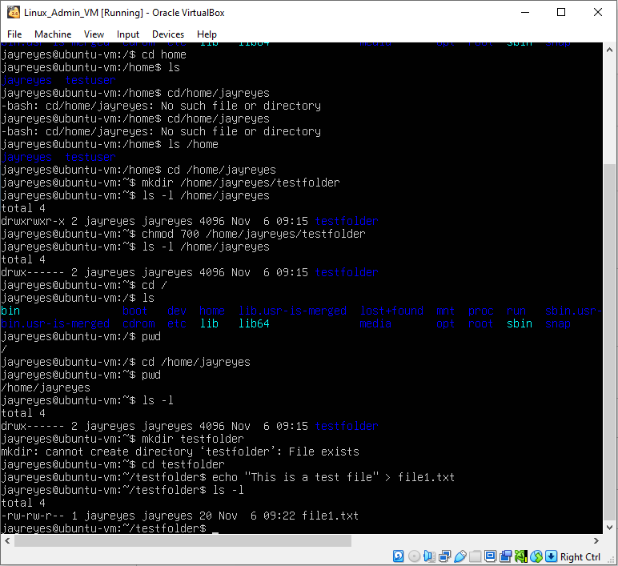
Screenshot: screenshot_create_folder.png

3. Set folder permissions

chmod 700 testfolder
ls -l

>Only jayreyes can access

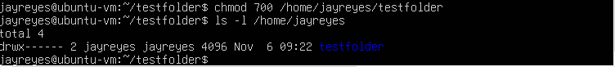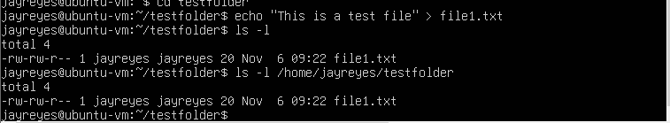

Screenshot: screenshot_chmod.png

4. Test folder access as testuser

su - testuser
cd /home/jayreyes/testfolder

>Should show Permission denied

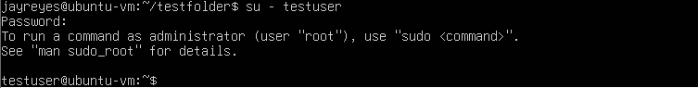

Screenshot: screenshot_permission_denied.png

5. Return to jayreyes

exit

Step 4: Package Management

1. Update and upgrade packages

sudo apt update
sudo apt upgrade -y

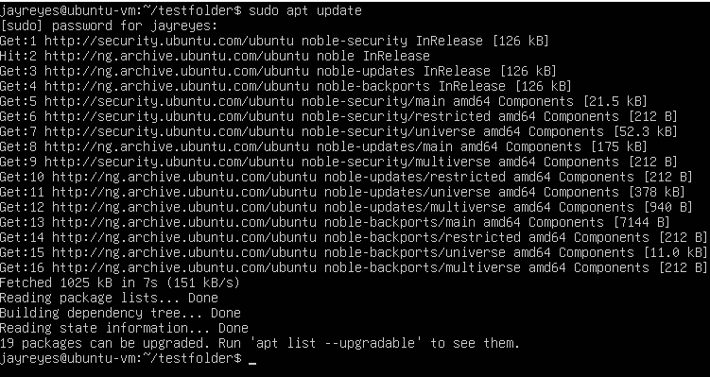

Screenshot: screenshot_update_upgrade.png

2. Install a test package

sudo apt install tree -y
tree --version

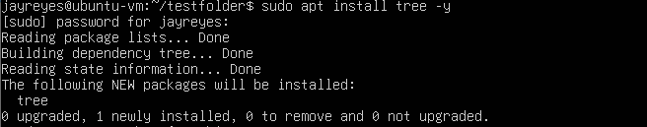
Screenshot: screenshot_install_tree.png
3. Test tree command

Tree

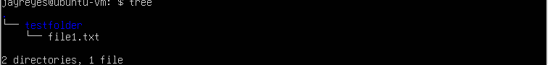

Screenshot: screenshot_tree_output.png

4. Remove package (optional)

sudo apt remove tree -y

Step 5: Bash Scripting

1. Create user_report.sh
nano user_report.sh

Paste the following script:

#!/bin/bash
echo "===== SYSTEM REPORT ====="
echo ""
echo "Number of users currently logged in:"
who | wc -l
echo ""
echo "Disk space available on the system:"
df -h / | awk 'NR==2{print $4}'
echo ""
echo "Report generated on: $(date)"
echo "==========================="

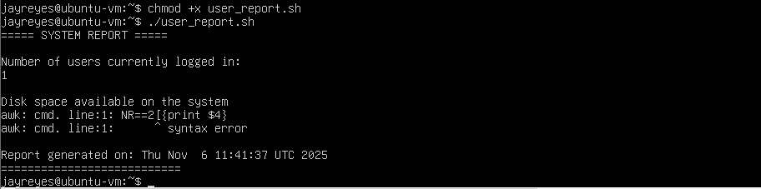
Screenshot: screenshot_create_script.png

2. Make script executable
chmod +x user_report.sh
ls -l

Screenshot: screenshot_chmod_script.png

3. Run the script

./user_report.sh

4. Move script to testfolder (optional)

mv user_report.sh testfolder/
cd testfolder
./user_report.sh

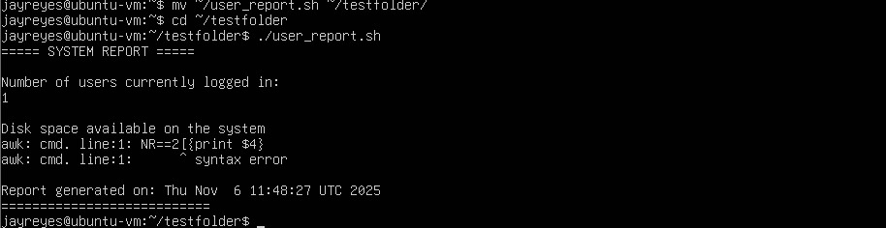

Screenshot: screenshot_script_in_testfolder.png

Step 6: GitHub Submission

1. Initialize Git repository

git init
git add .
git commit -m "Task 1 completed: Linux basics, users, permissions, package management, bash script"

Screenshot: screenshot_git_commit.png

2. Push to GitHub

git remote add origin https://github.com/<yourusername>/Linux-Task1-Basic-Administration.git
git branch -M main
git push -u origin main

Screenshot: screenshot_git_push.png

3. Verify online → All files and screenshots visible in GitHub repo.

