Task 3 – Advanced Linux Server Configuration

Objectives:

1. Set up SSH key authentication for secure remote access.

2. Harden your Nginx web server with SSL/TLS and security best practices.

3. Explore load balancing with Nginx.

4. Automate tasks using cron jobs.

Step 1: SSH Key Authentication

1. Generate SSH key pair on your VM:

ssh-keygen -t rsa -b 4096 -C "jayreyes@ubuntu-vm"

Press enter to accept default file location.

Optionally set a passphrase.

2. Add your public key to authorized keys:

cat ~/.ssh/id_rsa.pub >> ~/.ssh/authorized_keys
chmod 600 ~/.ssh/authorized_keys

3. Test login locally:

ssh localhost

You should connect without password.

4. Disable password authentication (optional but recommended):

sudo nano /etc/ssh/sshd_config

Set:

PasswordAuthentication no

Restart SSH:

sudo systemctl restart ssh

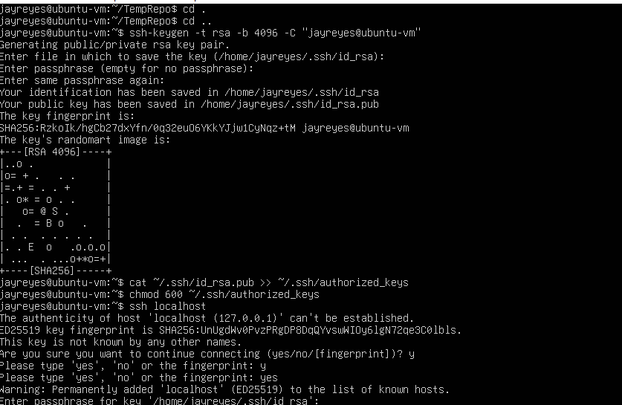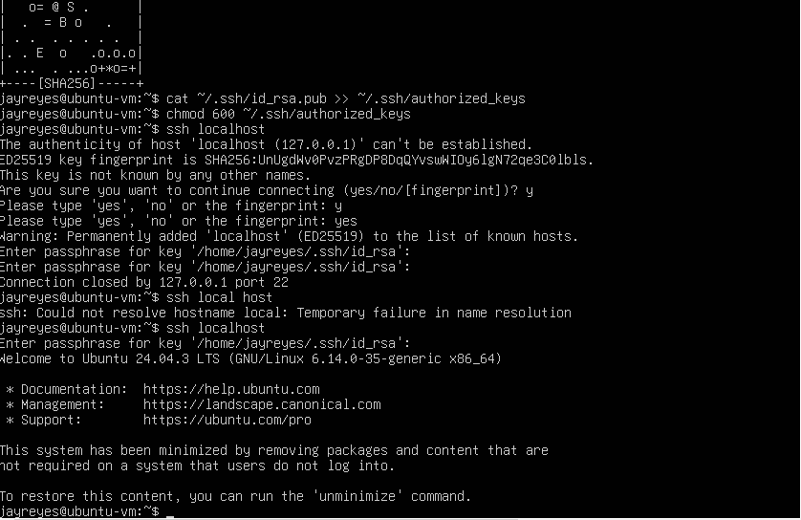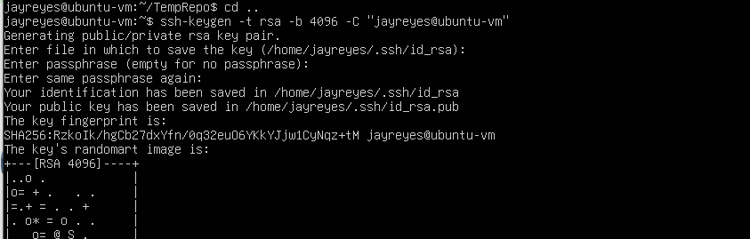

Step 2: Nginx Web Server Security

1. Install Nginx if not already installed:

sudo apt install nginx -y

2. Set up SSL/TLS (using self-signed certificate or Let’s Encrypt):

sudo openssl req -x509 -nodes -days 365 -newkey rsa:2048 -keyout /etc/ssl/private/nginx-selfsigned.key -out /etc/ssl/certs/nginx-selfsigned.crt

Configure Nginx to use the certificate.

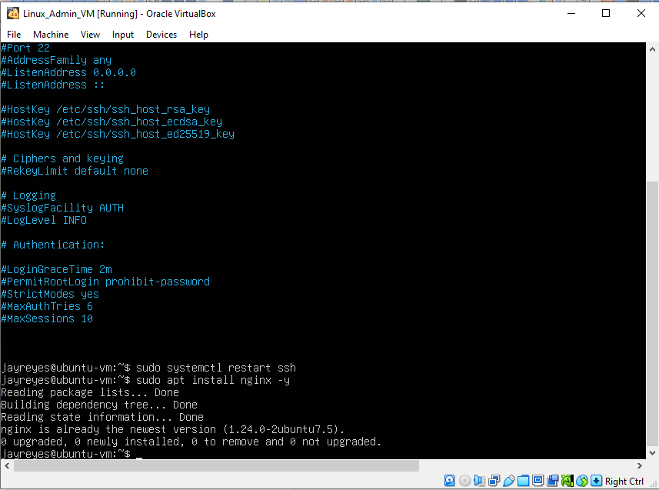

3. Harden Nginx security:

Disable server tokens:

Open the Nginx main config file

sudo nano /etc/nginx/nginx.conf

Look for the http { …} block inside add:

server_tokens off;

E.g

http {
include mime.types;
default_type application/octet-stream;

server_tokens off;

...
}

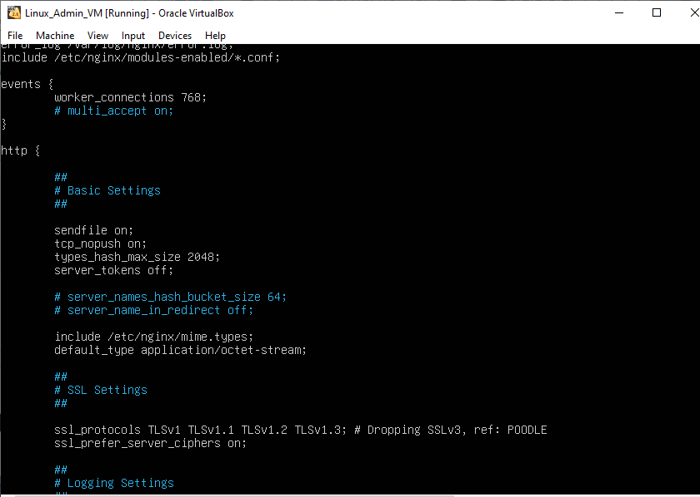

Enable firewall (ufw):

sudo ufw allow 'Nginx Full'
sudo ufw enable
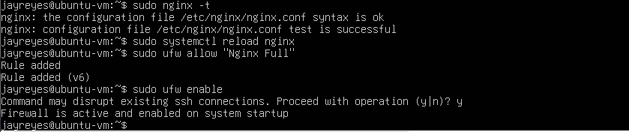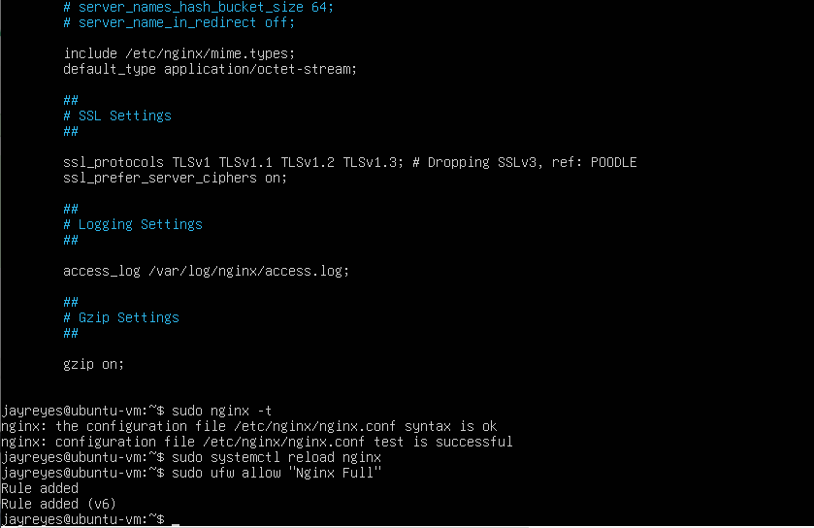

Step 3: Load Balancing (Basic)

1. Configure Nginx as a simple load balancer:

sudo nano /etc/nginx/sites-available/default

Replace everything with the below content

# Upstream backend servers
upstream backend {
server 127.0.0.1:8080;
server 127.0.0.1:8081;
}

# Main server block
server {
listen 80;
server_name localhost; # Must be here inside server block

location / {
proxy_pass http://backend;
proxy_set_header Host $host;
proxy_set_header X-Real-IP $remote_addr;
}
}

sudo nginx -t

syntax is ok test is successful

sudo systemctl reload nginx
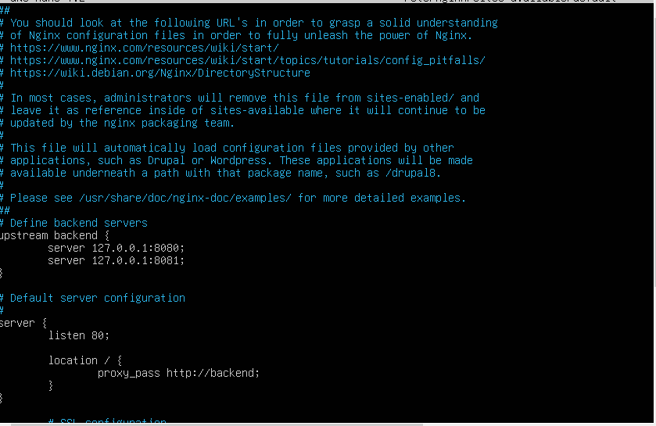
Screenshot: configuring nginx as a simple load balancer

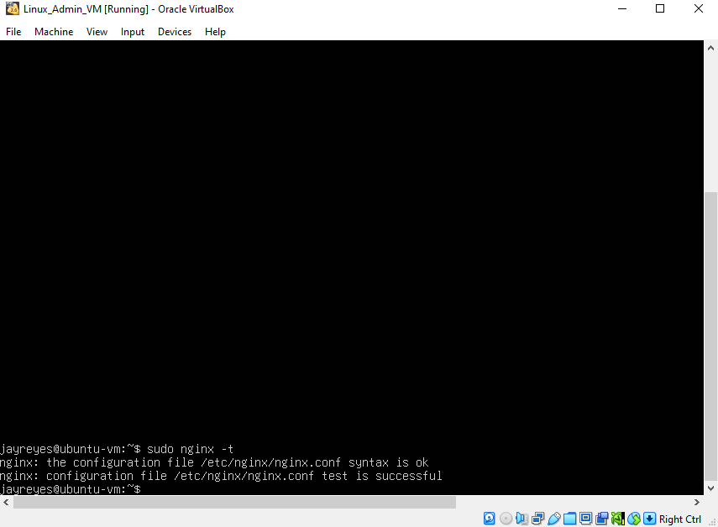
Screenshot: Test configuration

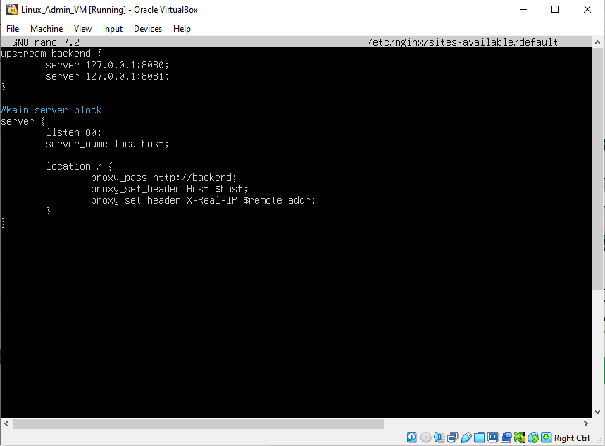
Screenshot: Configuration of load balancer(final)

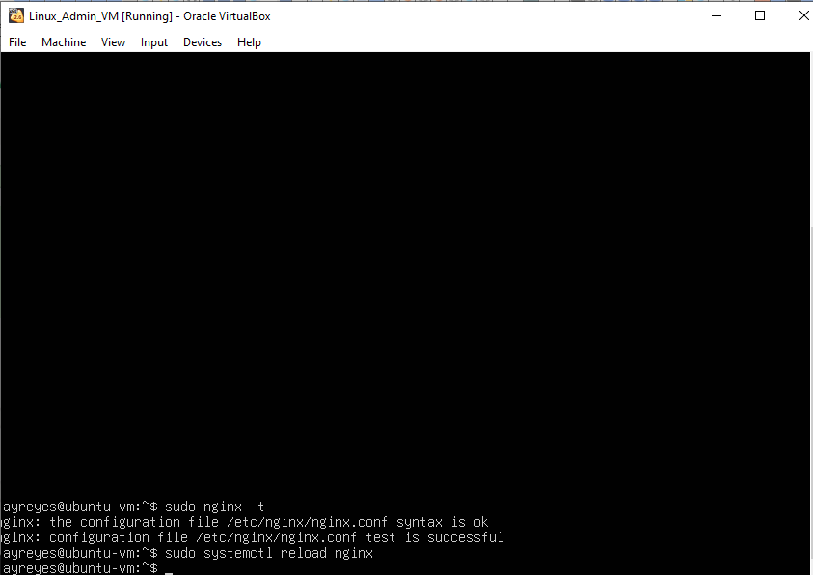
Screenshot: Test is successful

Step 4: Automating Tasks with Cron

1. Ensure Cron is Installed and Running

1. Install cron (if not already):

sudo apt update
sudo apt install cron -y

2. Enable and start the cron service:

sudo systemctl enable cron
sudo systemctl start cron

3. Check cron status:

sudo systemctl status cron

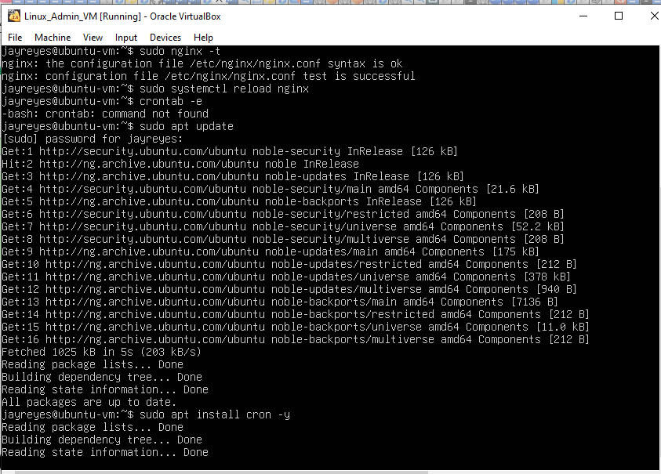
Screenshot: Install cron package

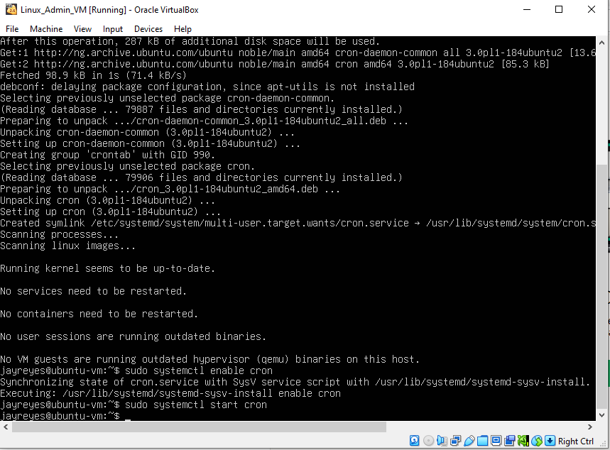
Screenshot: enabling and starting cron

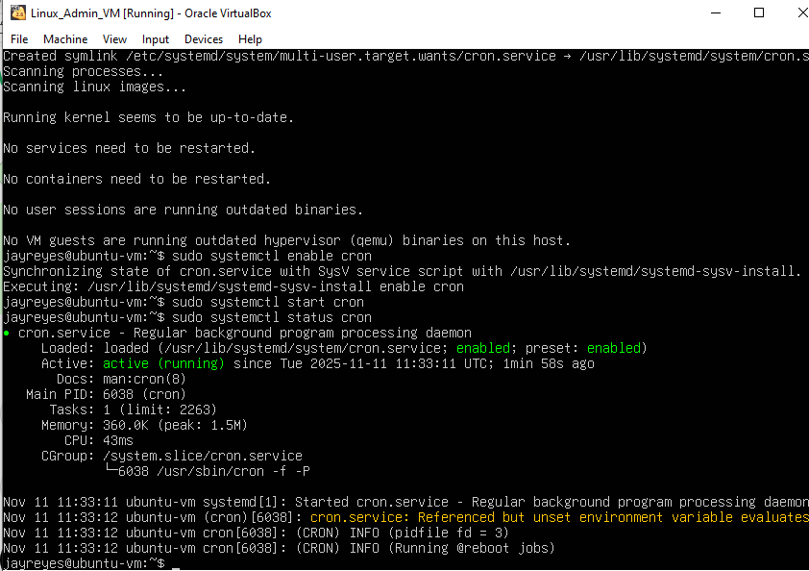
Screenshot: screenshot_cron_status.png

2. Edit Your User’s Crontab

1. Open crontab editor:

crontab -e

On first run, it may ask you to choose an editor (choose nano for simplicity).

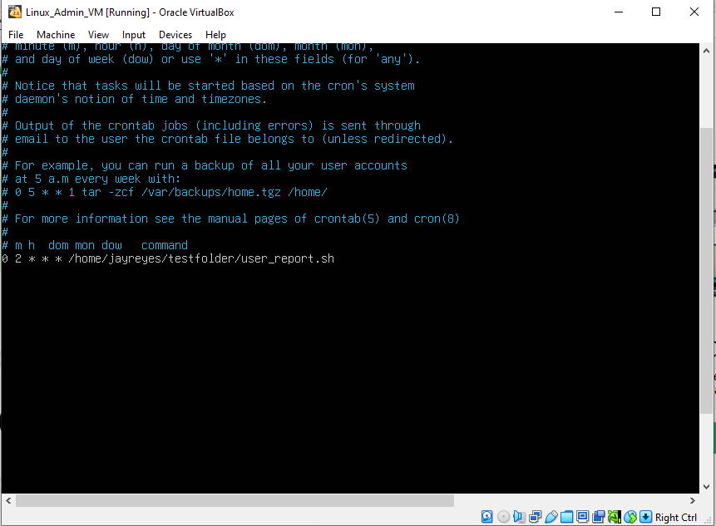
Screenshot: screenshot_crontab_open.png

3. Add a Cron Job

Example: run user_report.sh every day at 2:00 AM:

0 2 * * * /home/jayreyes/testfolder/user_report.sh

Cron format:

* * * * * command
| | | | |
| | | | +---- Day of week (0-7, Sunday=0 or 7)
| | | +------ Month (1-12)
| | +-------- Day of month (1-31)
| +---------- Hour (0-23)
+------------ Minute (0-59)

4 Save and Exit

In nano: Ctrl+O, Enter, Ctrl+X

Verify the cron job:

crontab -l

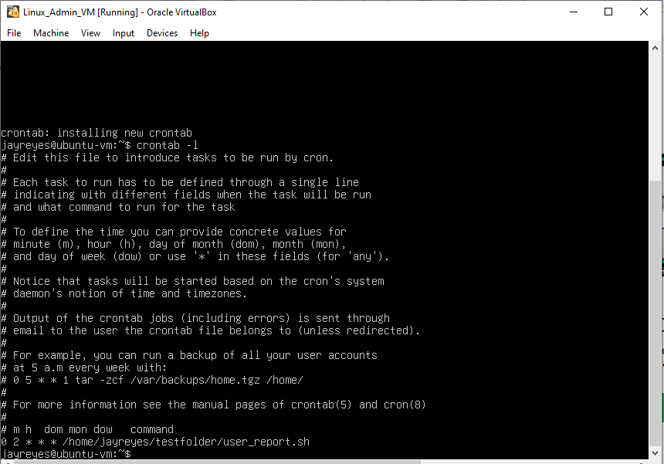
Screenshot: screenshot_cron_list.png

5. Test Cron Job Manually (Optional)

You can run your script manually to ensure it works:

/home/jayreyes/testfolder/user_report.sh

Output should show:

===== SYSTEM REPORT =====
Number of users currently logged in:
...
Disk space available on the system:
...
Report generated on: <date>
===========================

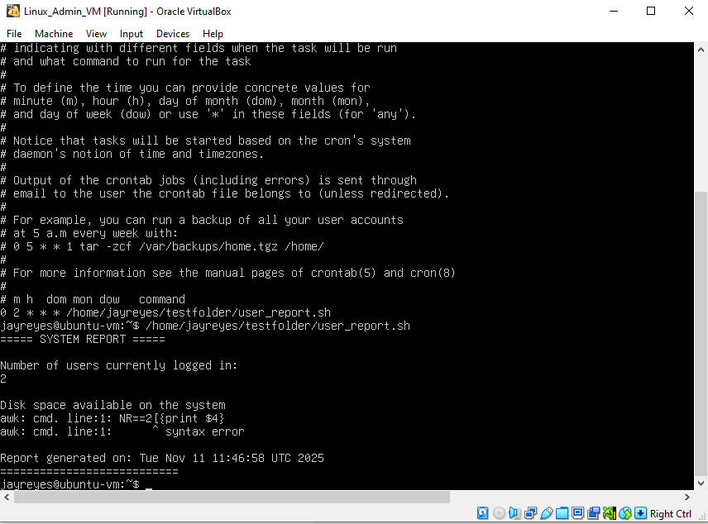
Screenshot: screenshot_cron_manual_test.png

6. Log Cron Activity

Cron logs are usually in:

sudo cat /var/log/syslog | grep CRON

