ECS Project

I. Overviews

1. Architecture
* Dev:
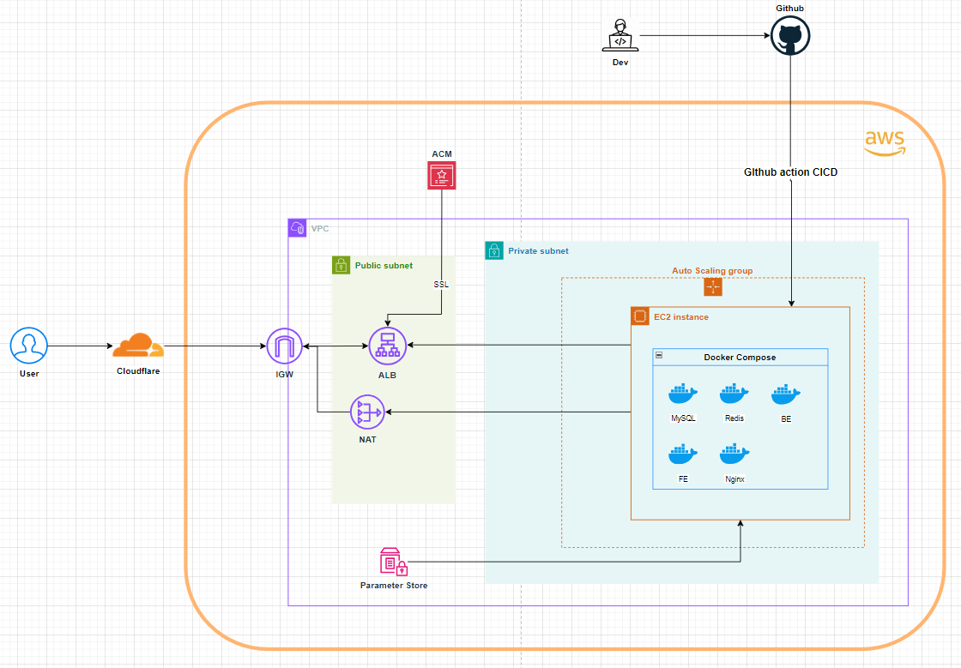
* Prod:
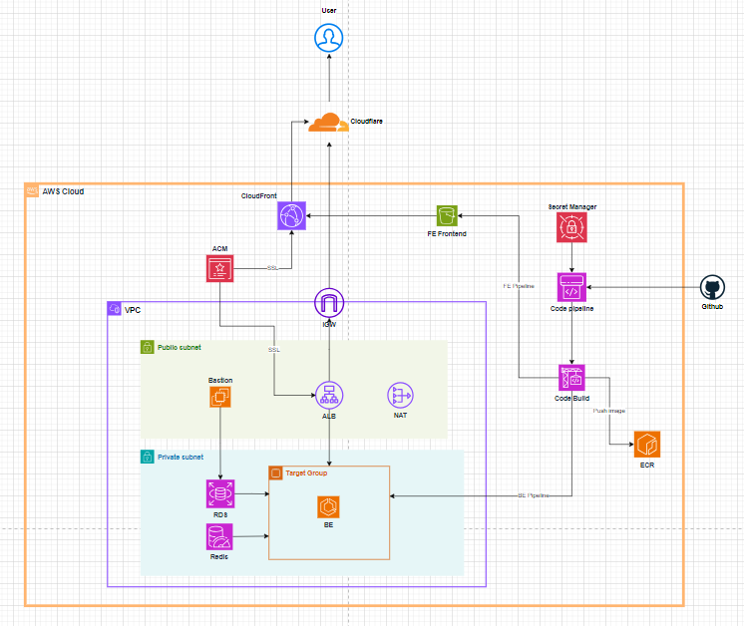

2. Deploy plans
* Dev:
- Step1: Prepare
- Step 2: Deploy AWS infrastructure using Terraform
- Step 3: In EC2 instance, install Docker then deploy application, webserver and database in containers using Docker-compose
- Step 4: Setup CICD

* Prod:
- Step 1: Prepare
- Step 2: Deploy infrastructure in each module in order: 1-network, 2-dependence, 3-application,4-cicd
- Step 3: Configure rds, services, secret, records, ... to make sure application are up
- Step 4: Setup CICD

3. Techstacks
* Dev:
- Applications: FE, BE, Database, Cache and Nginx run on docker container in EC2 instance
- Secret: Parameter Store
- CICD: Github action
- Monitor: Cloud Watch

* Prod:
- Frontend: S3-Cloudfront
- Backend: ECS
- Database: MySQL RDS
- Cache: Redis
- Secret: Secret Manager
- CICD: CodePipeline
- Monitor: Cloud Watch

II. Prepare

1. Github
* Generate a Github token for AWS CodePipeline: Github settings -> Developer settings -> Personal access tokens
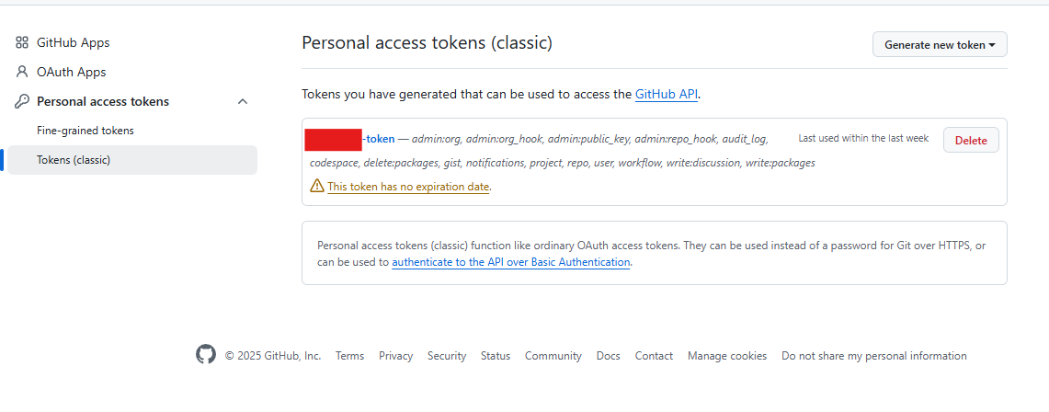
* Create a SSH Token in your local machine, server, bastion, etc,... and then paste the public key to Github:
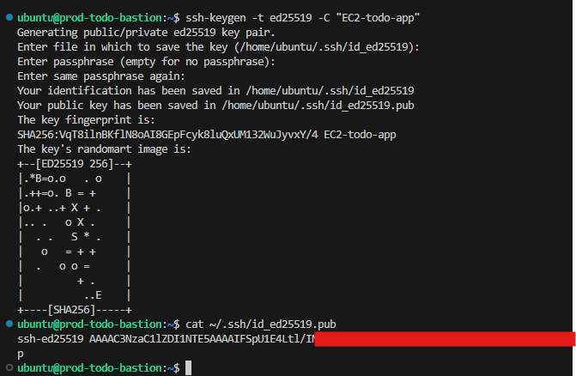
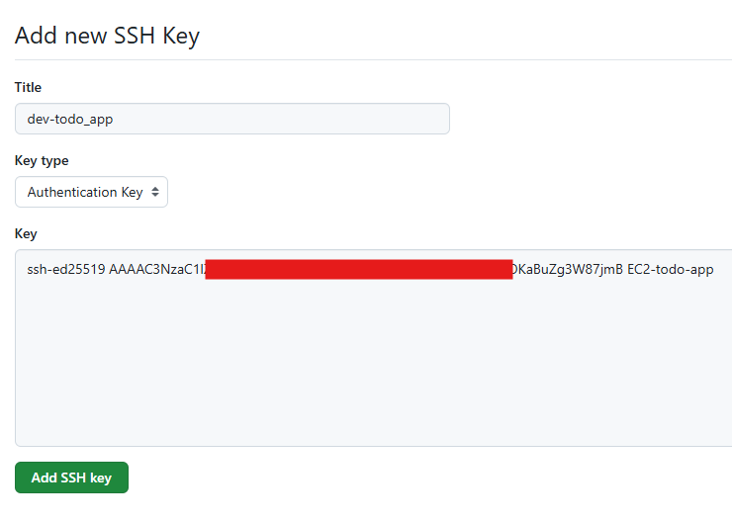

2. AWS CLI
* Create AWS CLI access key for Terraform in both AWS account (Dev and Prod)
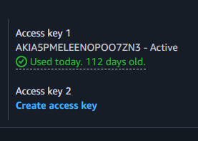

* AWS profile and credential configure for dev and prod:
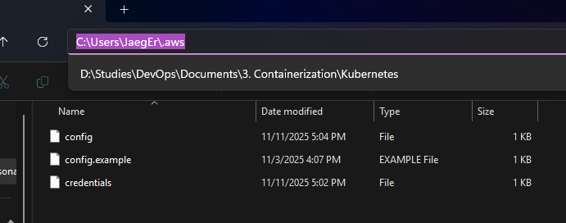
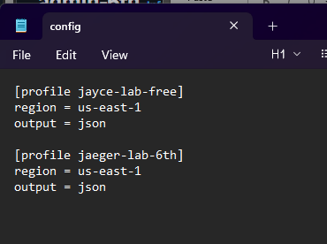
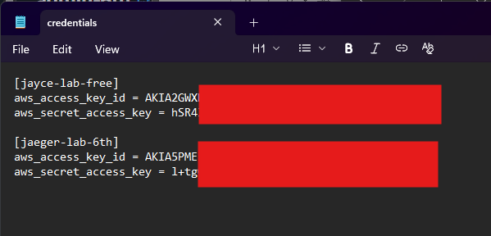

3. Domain
* Prepare your domain. Example: jayce-lab.work
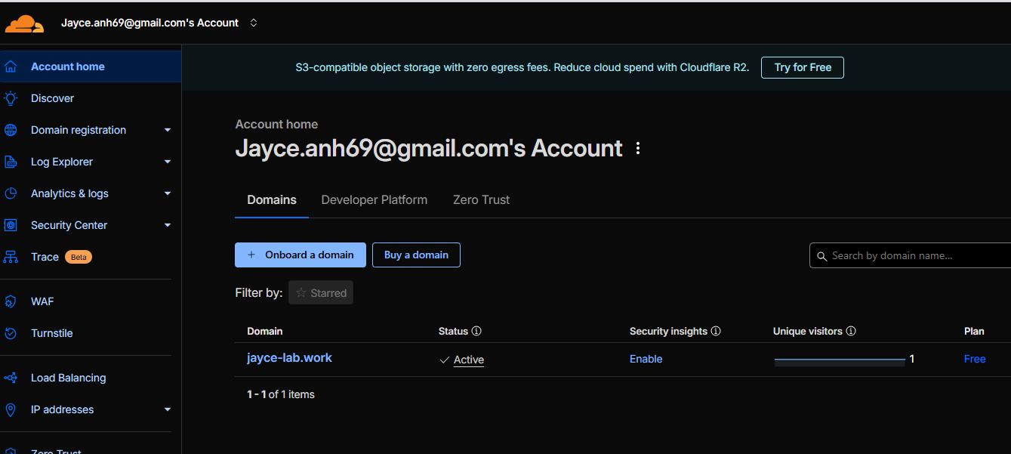

4. S3-backend
* Create S3-bucket backend in both account:
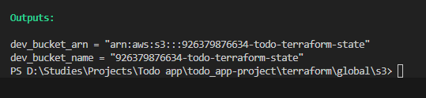
* Results:
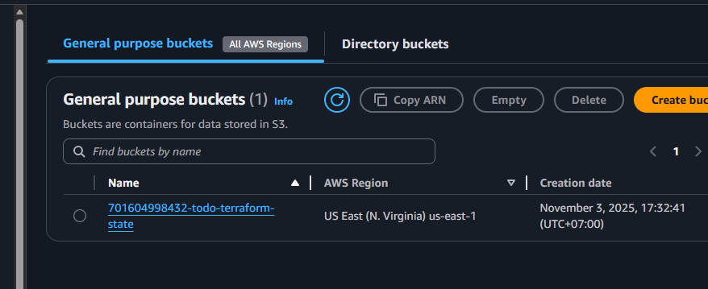
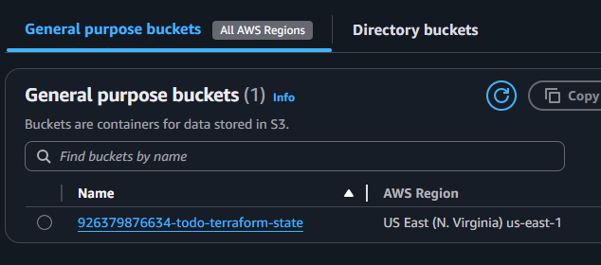

III. Dev

1. Network
* Deploy the VPC module first:
$ terraform apply –target=module.vpc
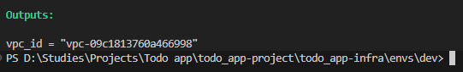
* Check config:
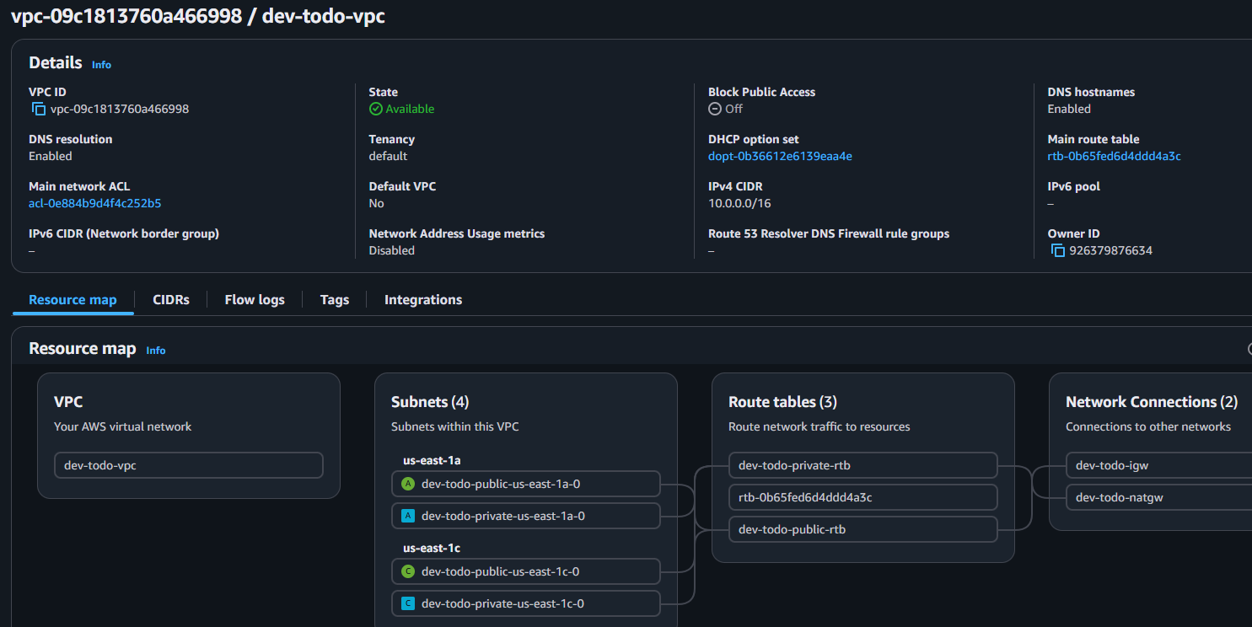

2. ACM
* Deploy the ACM module: $ terraform apply –target=module.acm
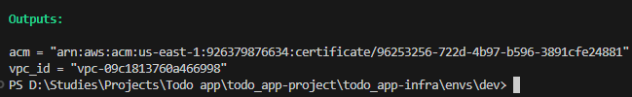
* Add CNAME records in your Domain management:
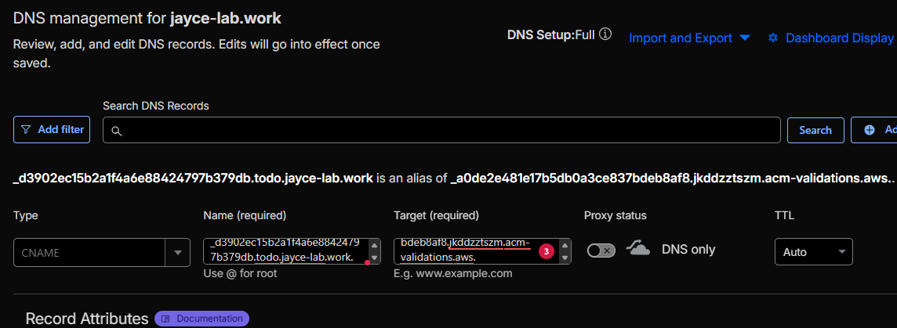
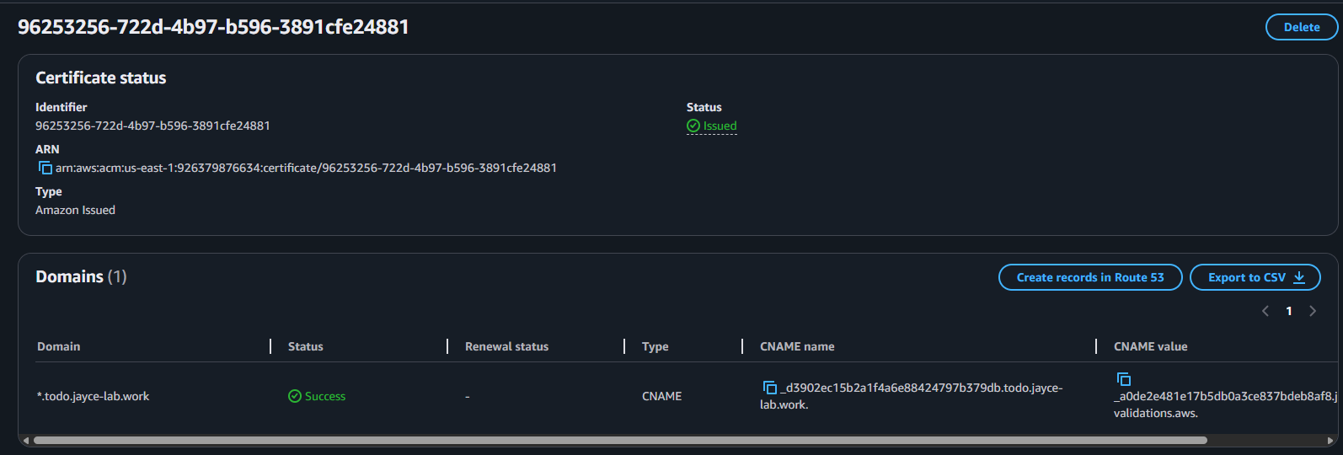

3. Parameter Store
* Deploy Parameter store: $ terraform apply –target=module.parameter_store
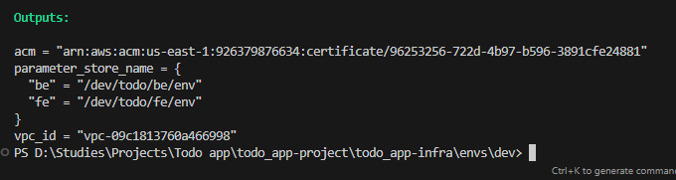
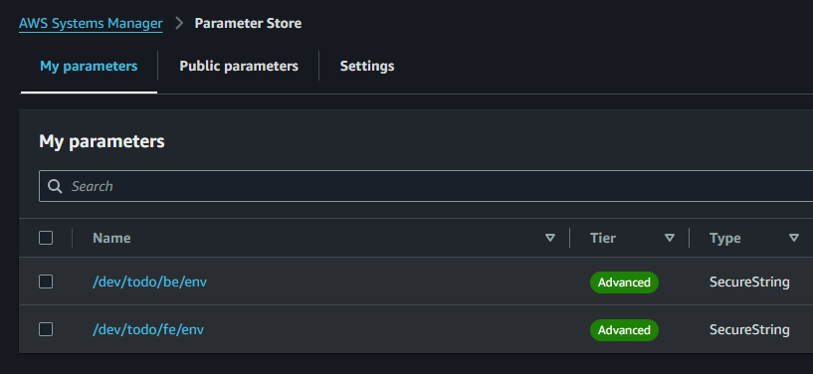
* Paste your env sercret content to Parameter store
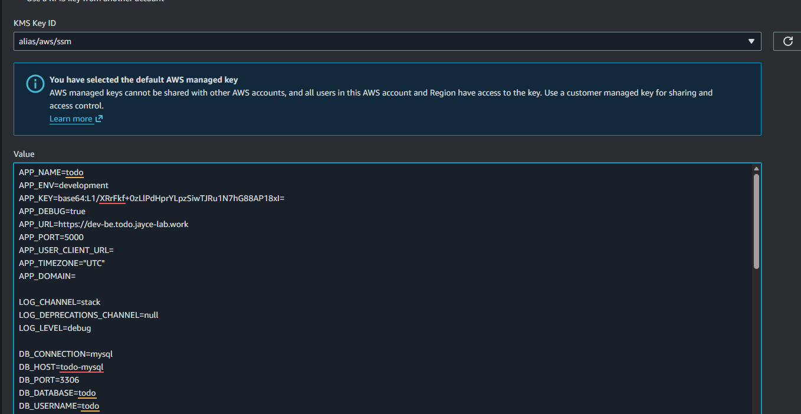

4. ALB
* Deploy ALB module: $ terraform apply –target=module.alb
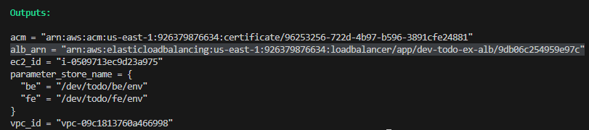
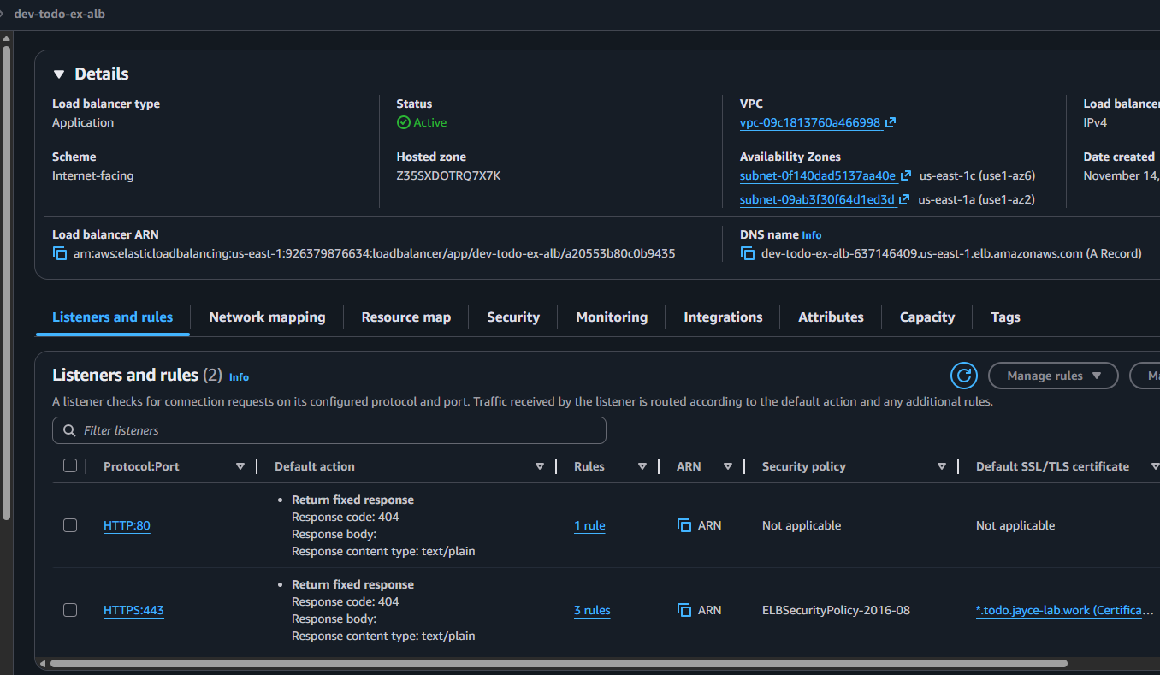
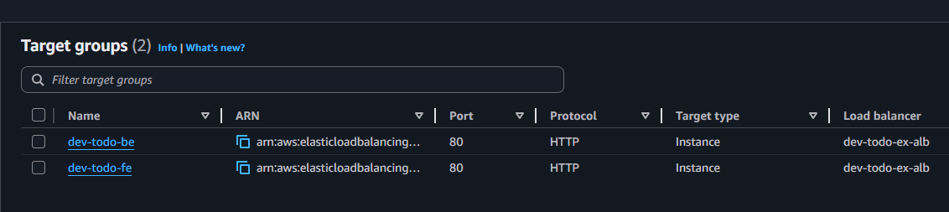
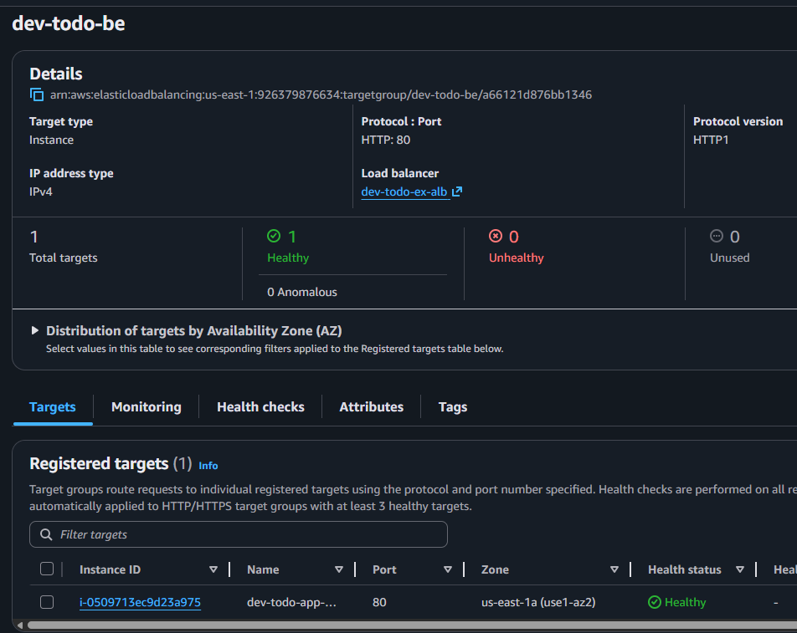
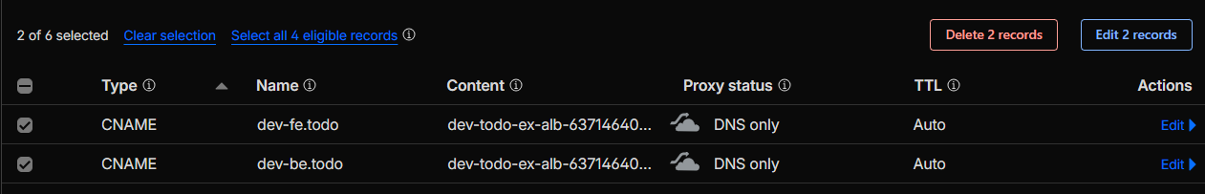

5. EC2 Instance
* Deploy EC2 Instance: $ terraform apply –target=module.ec2_instance
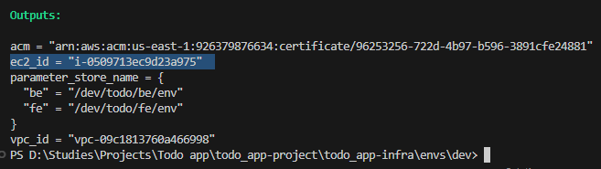
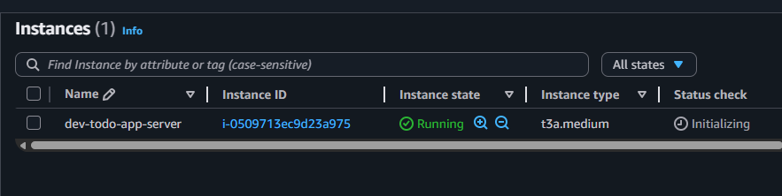

* Clone FE and BE source code
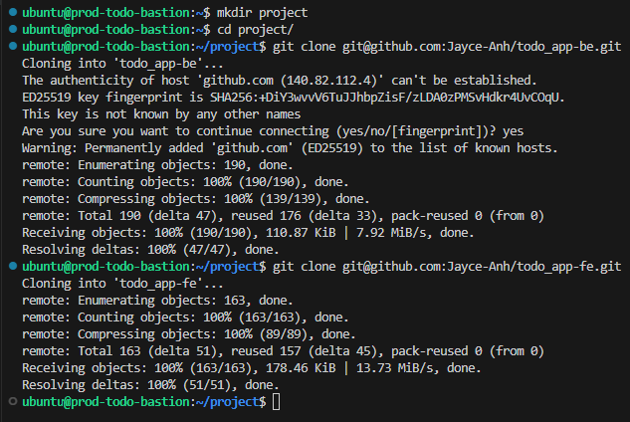
* Create docker-compose.yml and update env DB, Redis host, port, ...
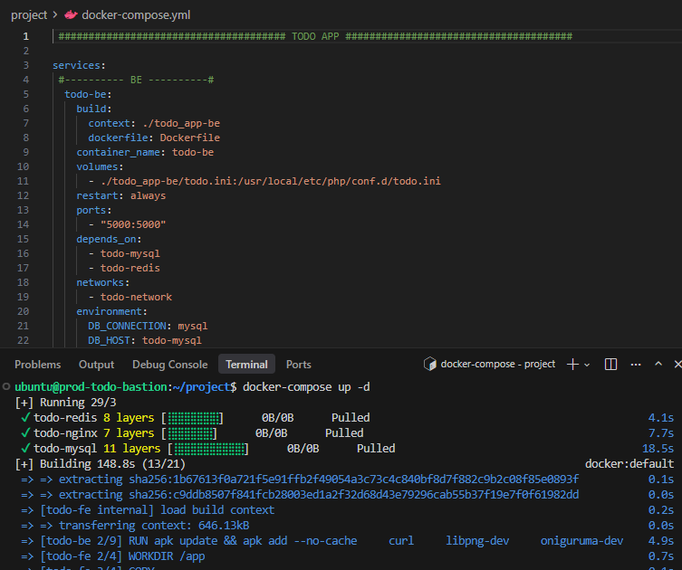
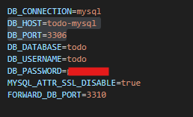
* Apply run docker-compose file
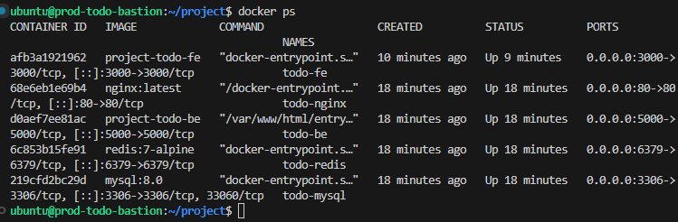

* Check service:
$’’’
curl -s -o /dev/null -w "Frontend: %{http_code}\n" http://localhost:3000
curl -s -o /dev/null -w "Backend: %{http_code}\n" http://localhost:5000
curl -s -o /dev/null -w "Nginx: %{http_code}\n" http://localhost:80
docker exec todo-mysql mysqladmin -utodo -p${password} ping 2>/dev/null && echo "MySQL: OK"
docker exec todo-redis redis-cli ping
$’’’
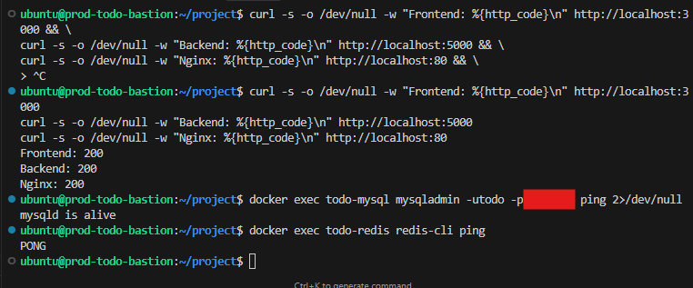
* Check service in web browser:
- Backend:
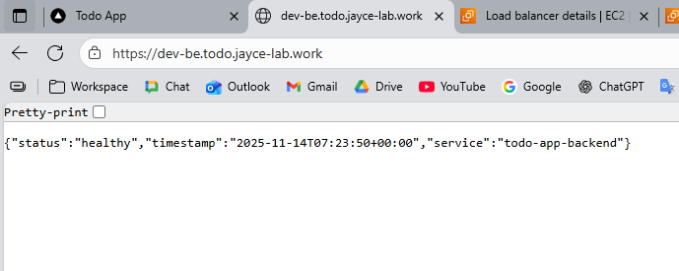
- Frontend:
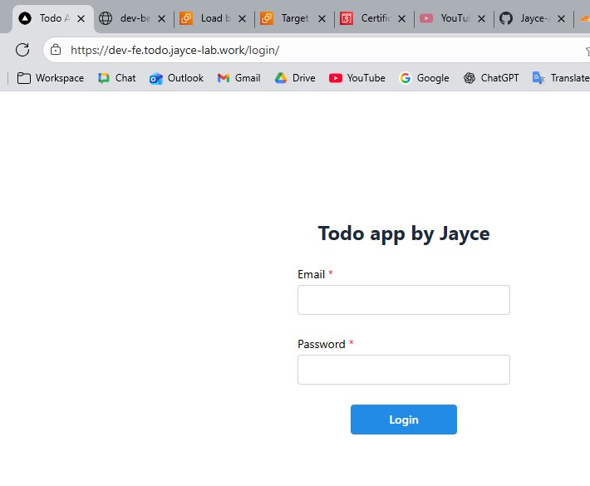

6. CICD
* Setup Runner:
- Go to each BE and FE github repo’s settings -> Action -> Runner -> Add new self-host runner
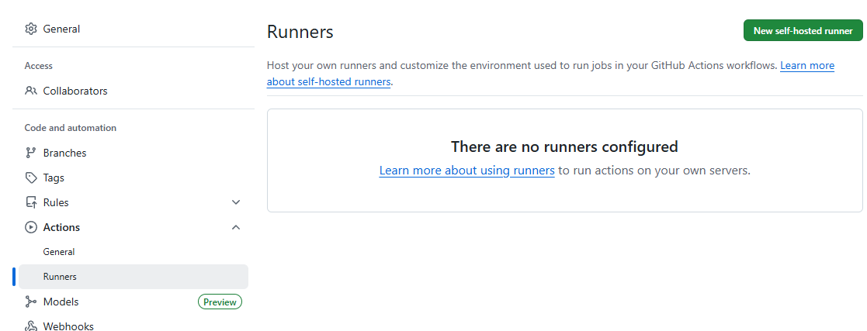

- Choose Runner Image and copy the Runner download package
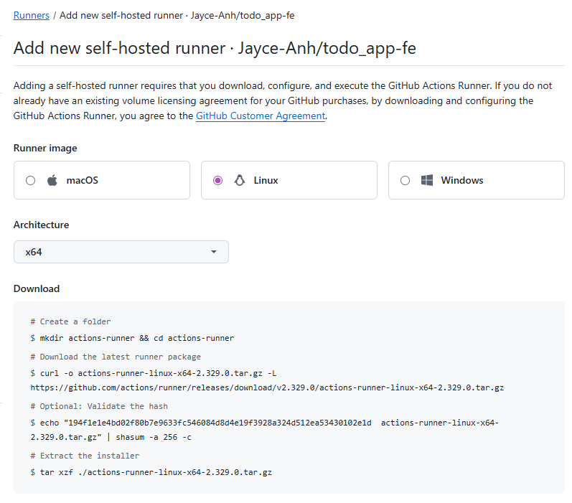
- Go to server and create runner directory for both FE and BE
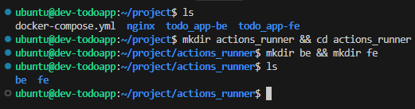
- In each directory, download the runner package:
$’’’
curl -o actions-runner-linux-x64-2.329.0.tar.gz -L https://github.com/actions/runner/releases/download/v2.329.0/actions-runner-linux-x64-2.329.0.tar.gz
tar xzf ./actions-runner-linux-x64-2.329.0.tar.gz
rm actions-runner-linux-x64-2.329.0.tar.gz
$’’’
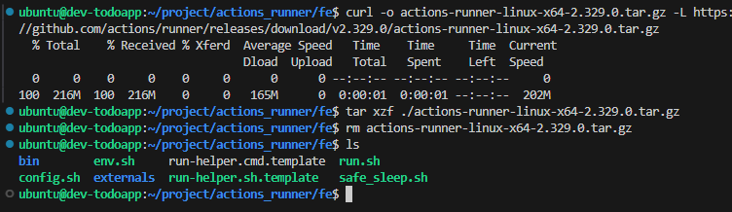
- Config the runner:
% ./config.sh --url https://github.com/Jayce-Anh/todo_app-fe –token BST7SAZKMABOV5HLTJYS6SDJDGG2A
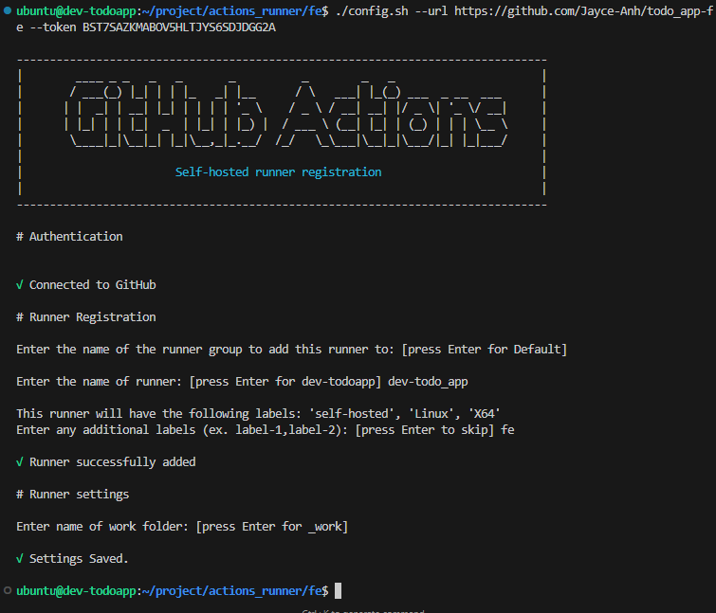
- Config runner as a service and make them run when restart server
$’’’
sudo ./svc.sh install
sudo ./svc.sh start
sudo ./svc.sh status
sudo systemctl enable actions.runner.<organization>-<repo name>.<runner name>.service
$’’’
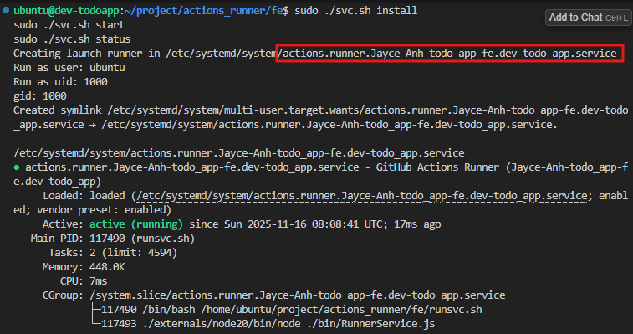

* Confirm runners installation: Github repos -> Settings -> Actions -> Runners
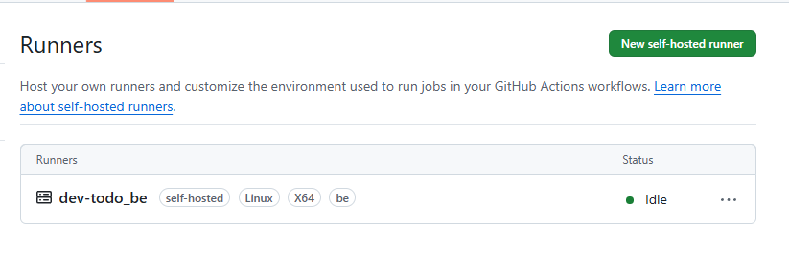
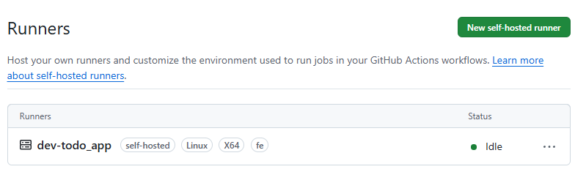
- After configure and install for both Fe and BE. Create a Workflow for both then save them to each project directory: .github\workflows\
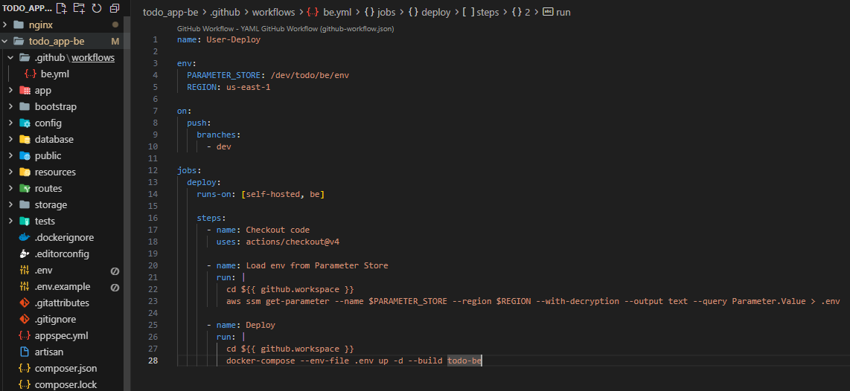

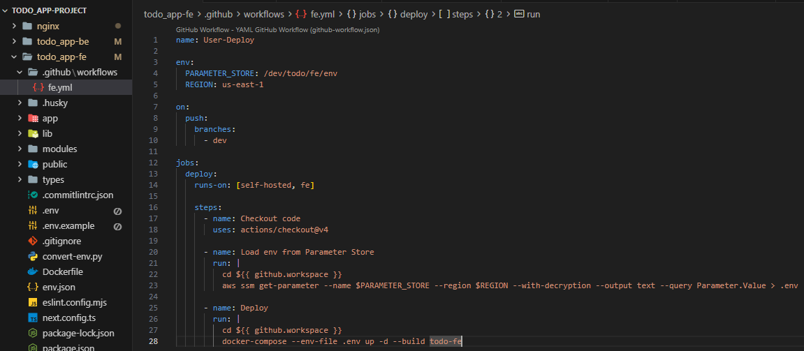
- Commit and push to Git and the branch:
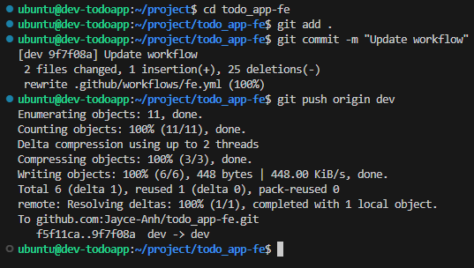
- Push test and verify the workflow results:
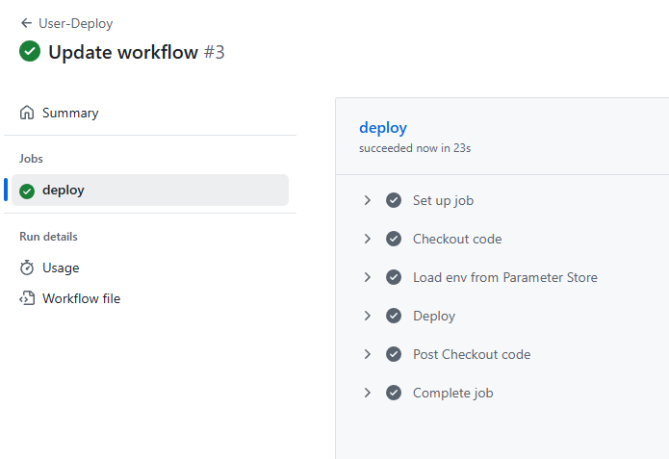

IV. Prod

1. Network
* Deploy Network module:
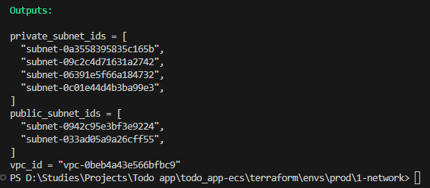
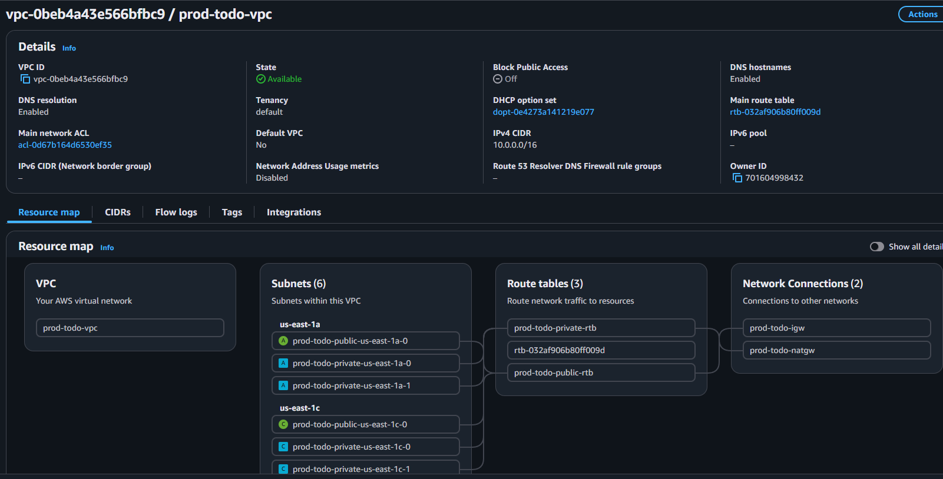

2. Dependence
* Deploy dependence module:
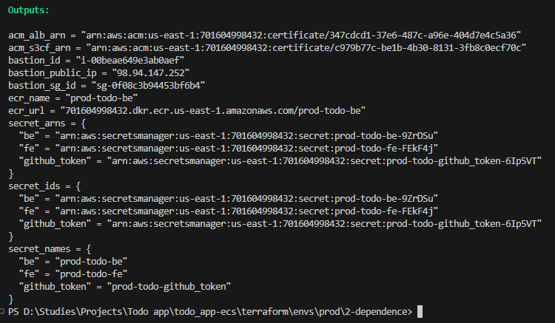
* ACM:
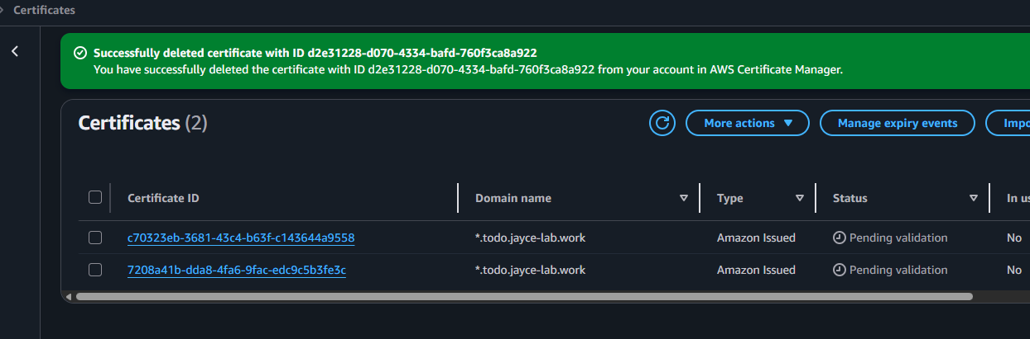
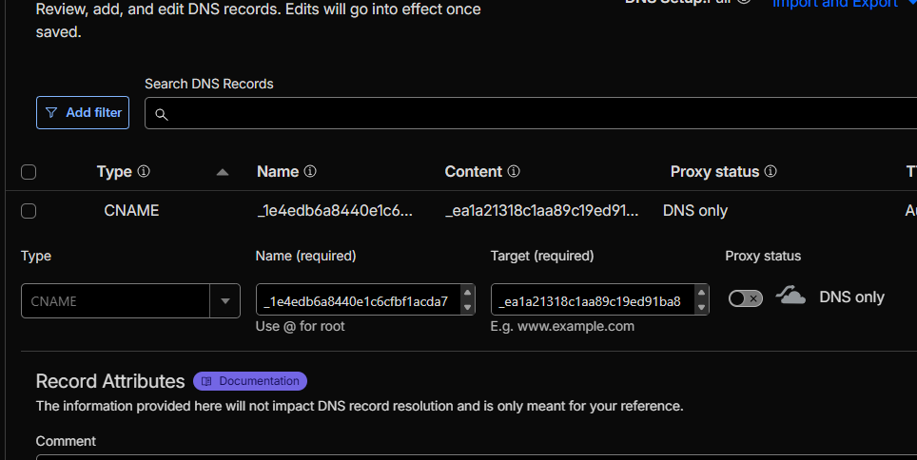
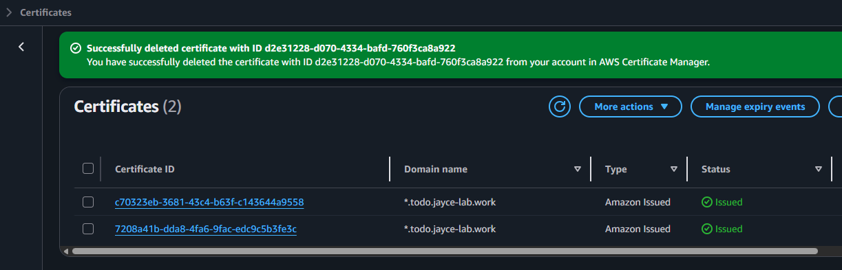

* ECR:
- Build backend docker image, then push to ECR
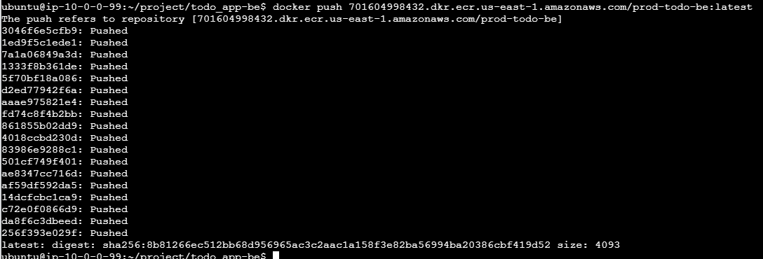
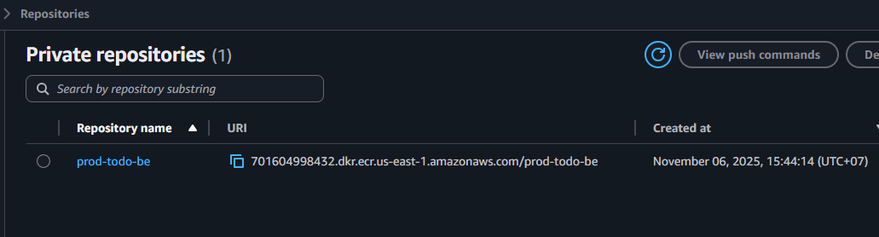

* Secret Manager:
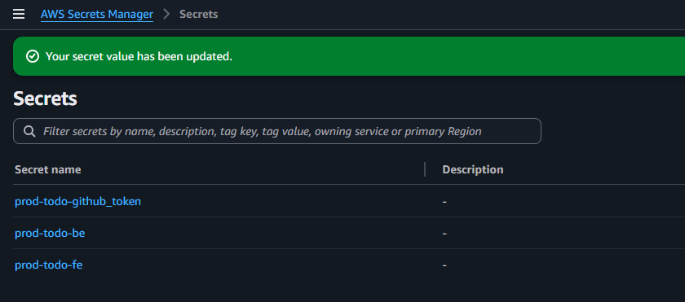
- Add your Github token to Github token secrets for CodePipeline:
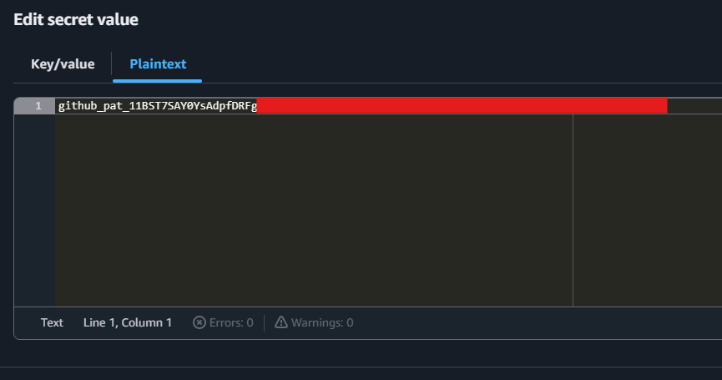
- Go to BE and FE codebase directory, convert .env to env.json:
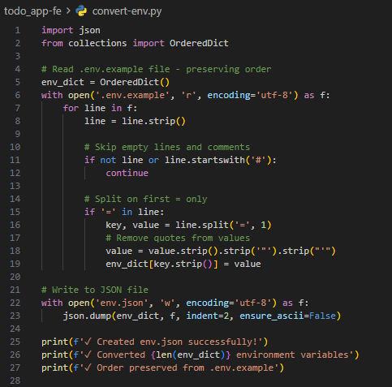
$ python .\convert-env.py
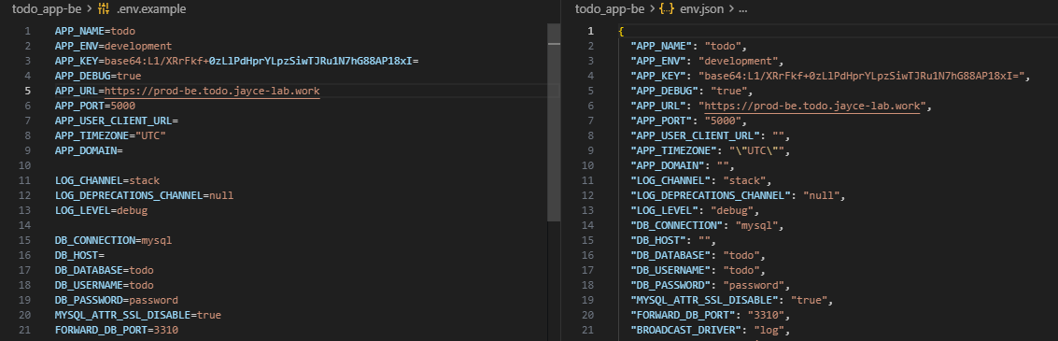
- Upload those env.json file to Secret manager:
$ aws secretsmanager put-secret-value --secret-id prod-todo-be --secret-string file://env.json
$ aws secretsmanager put-secret-value --secret-id prod-todo-fe --secret-string file://env.json
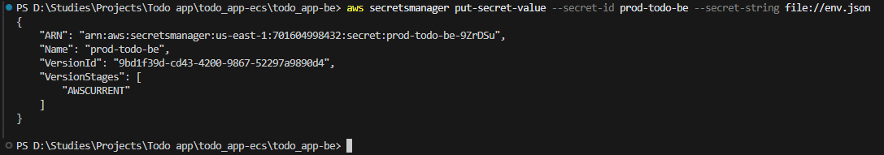
- Noted: For the Database and redis host env variable we can leave blank and update later after the RDS and Redis is deploy
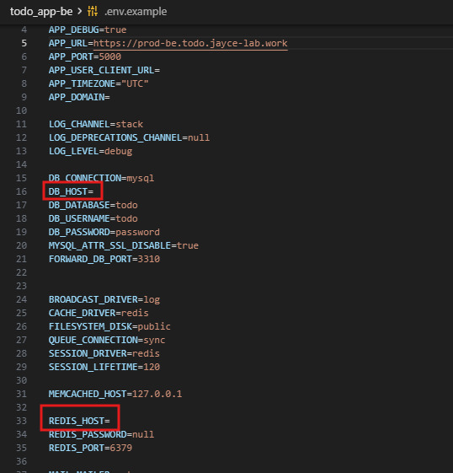
- Do this for both BE and FE secret
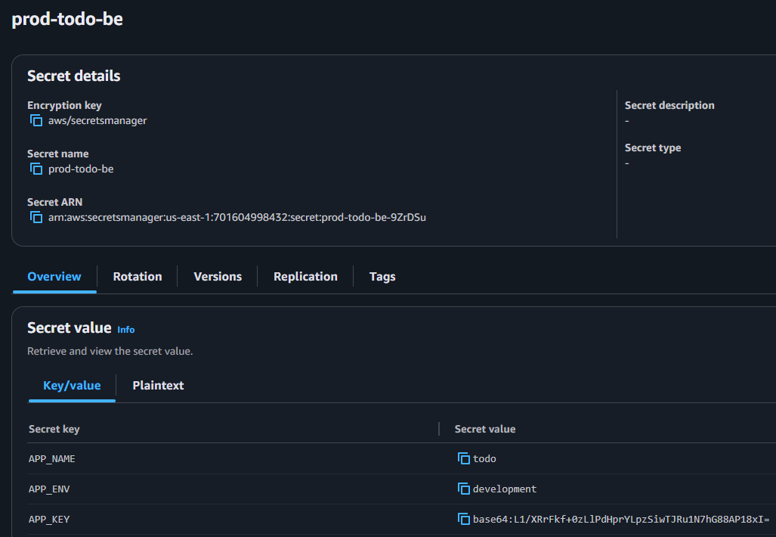

3. Application
* Deploy application module:
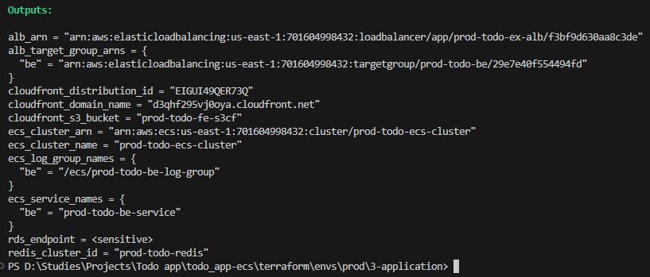
* Cloudfront
- Add CNAME record for Cloudfront:
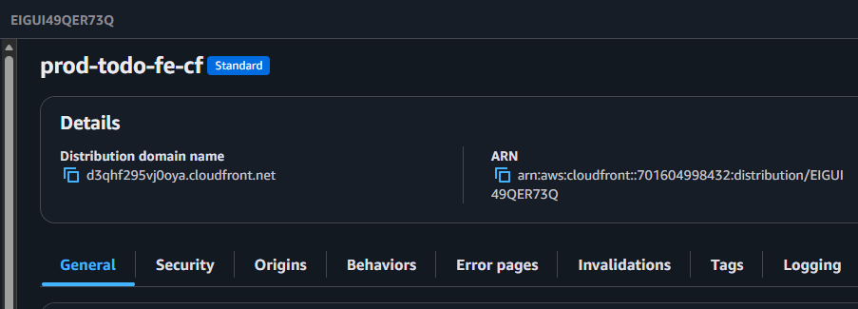
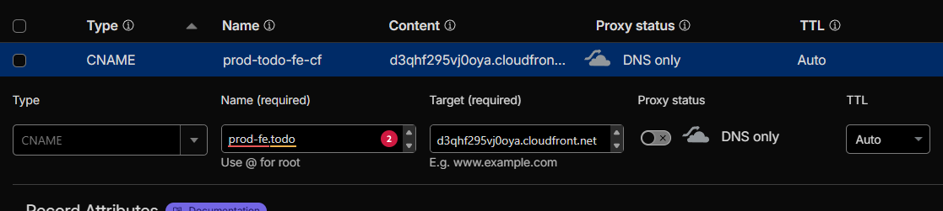
- Buiild the dist/ from the FE docker images

$’’’
cd ~/project/todo_app-fe

# Run container in background, copy, then stop
docker run -d --name temp-build prod-todo-fe tail -f /dev/null
docker cp temp-build:/app/dist ./dist
docker stop temp-build
docker rm temp-build

# Verify
ls -la dist/
$’’’
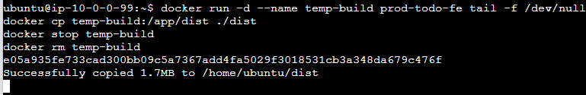
- Sync dist/ to S3 FE bucket
$ aws s3 sync dist/ s3://prod-todo-fe-s3cf --delete --exact-timestamps
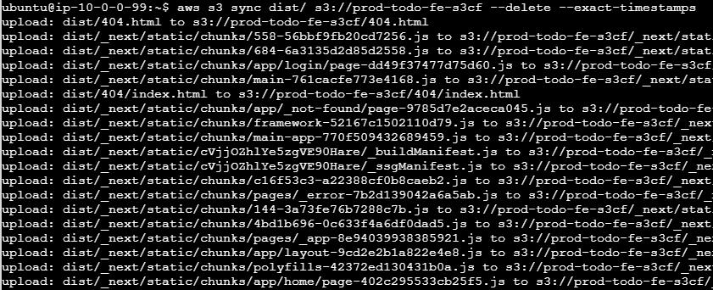
- Go to web browser and check FE service go live:
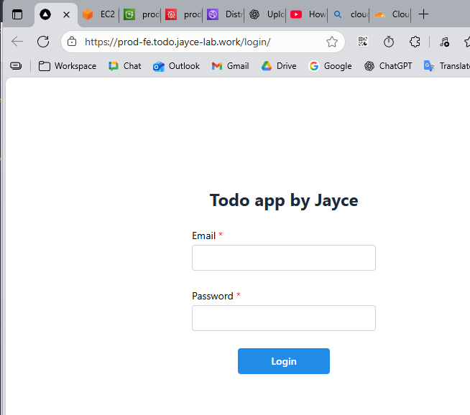

* Database:
- Copt endpoint of RDS and Redis ARN then update it to BE Secret Manager
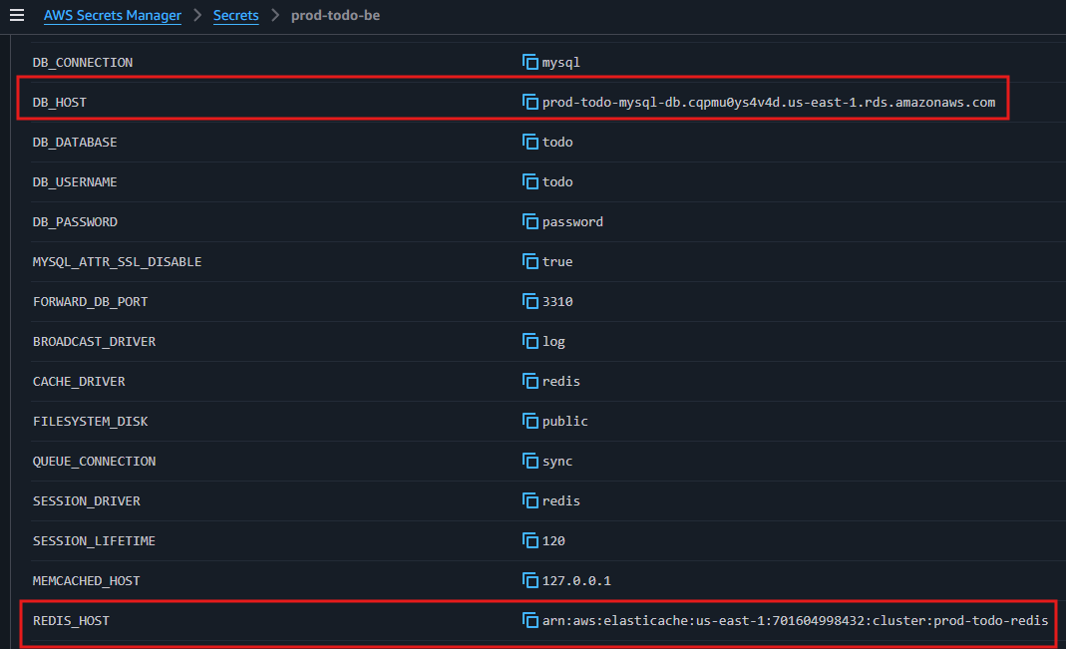
- Try to login mysql database in bastion:
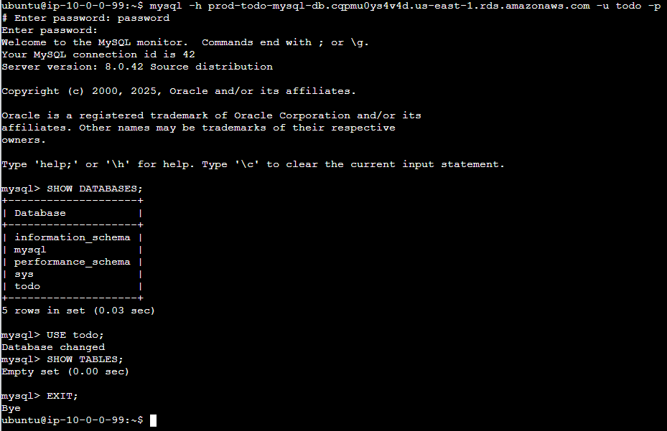

* ECS:
- Check service and container status:
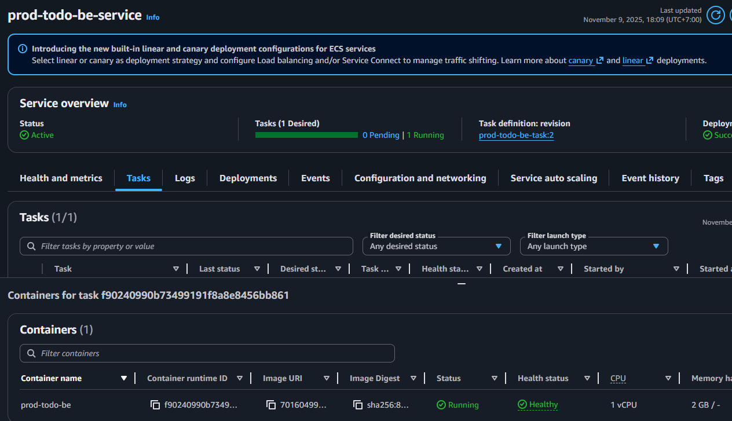
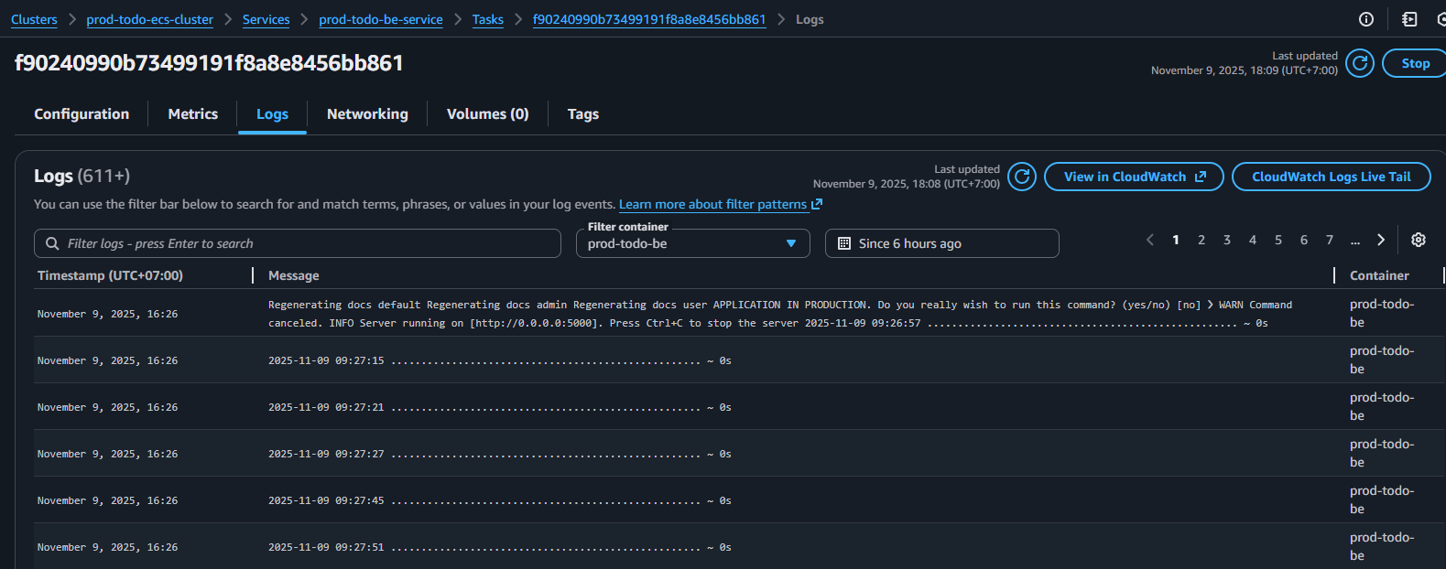

* ALB:
- Add CNAME record for ALB in Domain management
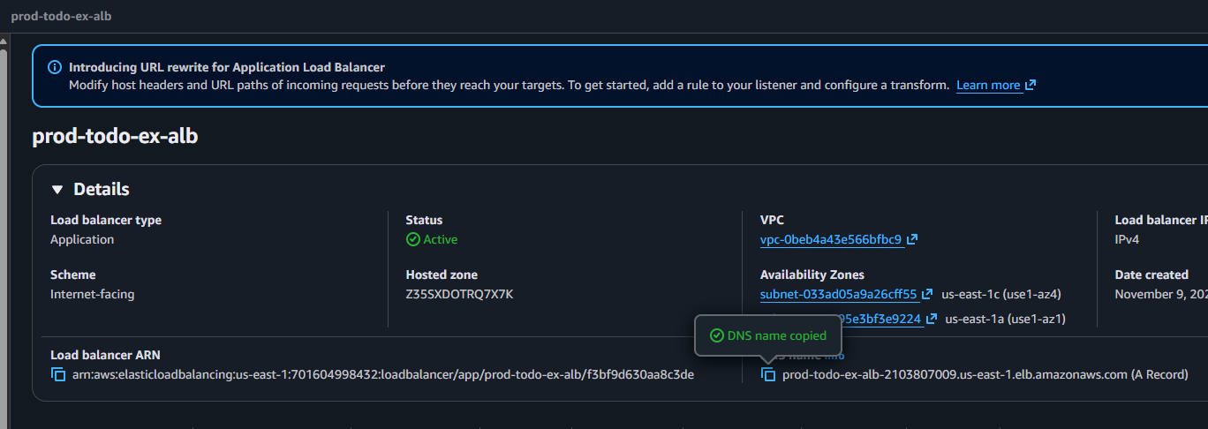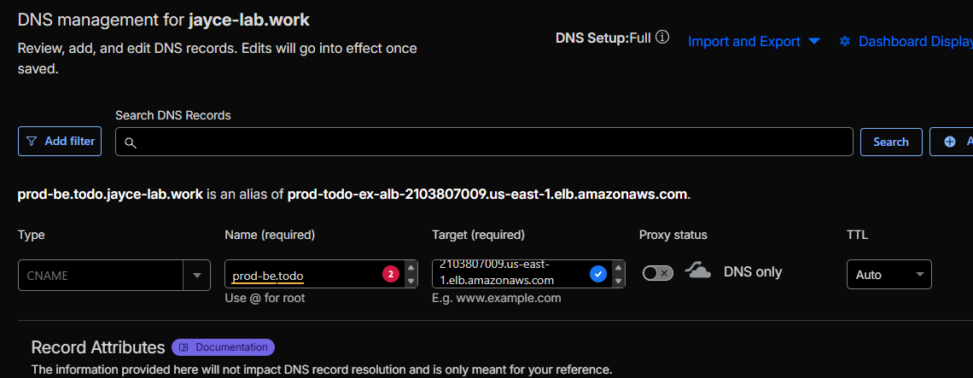

- Go to web browser and check BE api url :
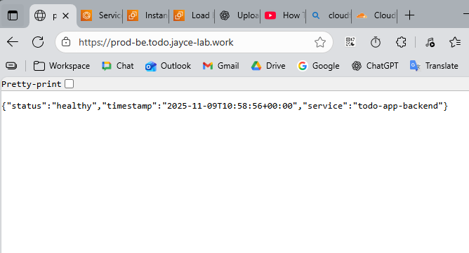

* Check CloudWatch Daskbroad and Alarms
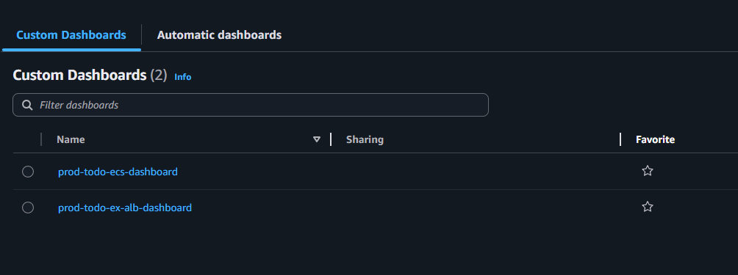
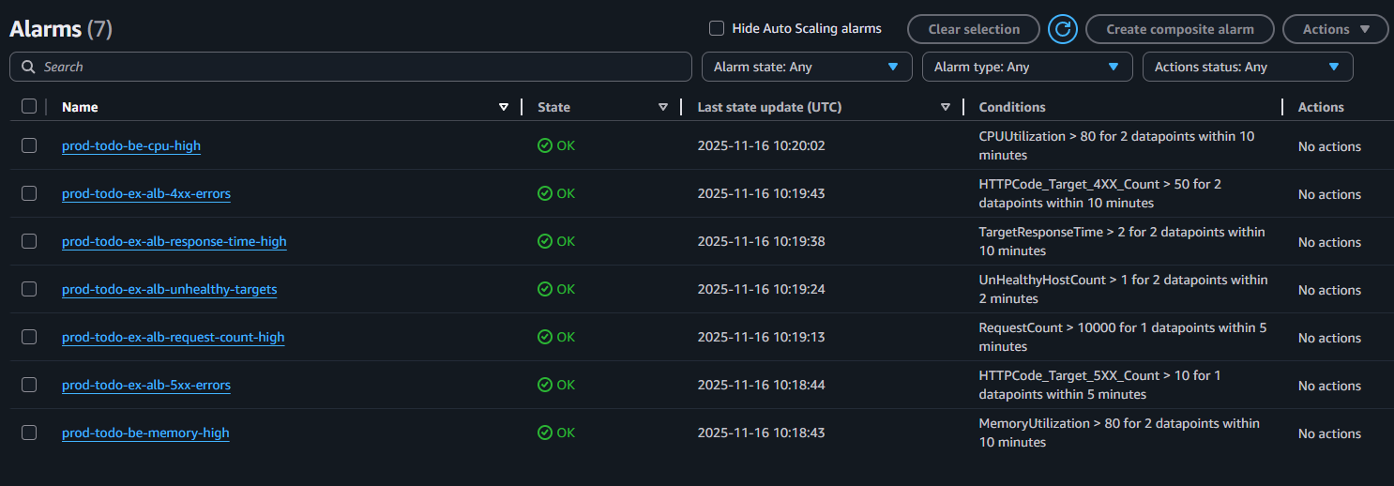

4. CICD
* Deploy CICD module:
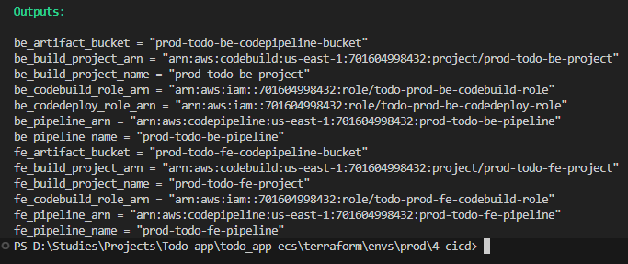

* Check result:
