# myblockly software :

### **Run the software**

The user double-clicks the software exe file, which requires administrator rights to run. After opening, the main interface of the software is displayed, as shown in Figure 3.1:

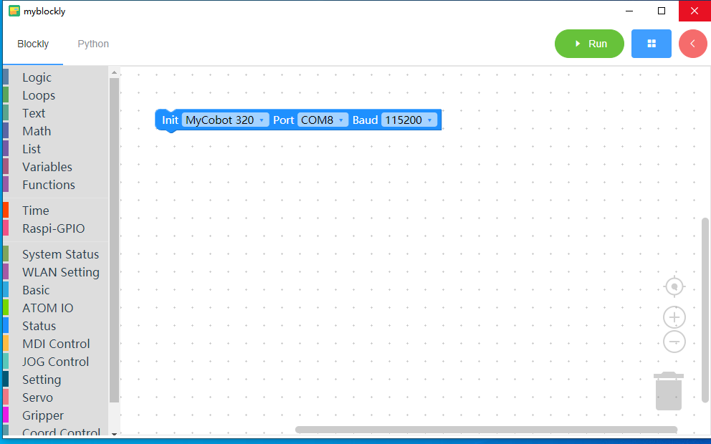

Figure 3.1 Software interface display

### **Blockly Programming**

#### Show building blocks

Click the left mouse button on the leftmost building block list to expand the corresponding building block:

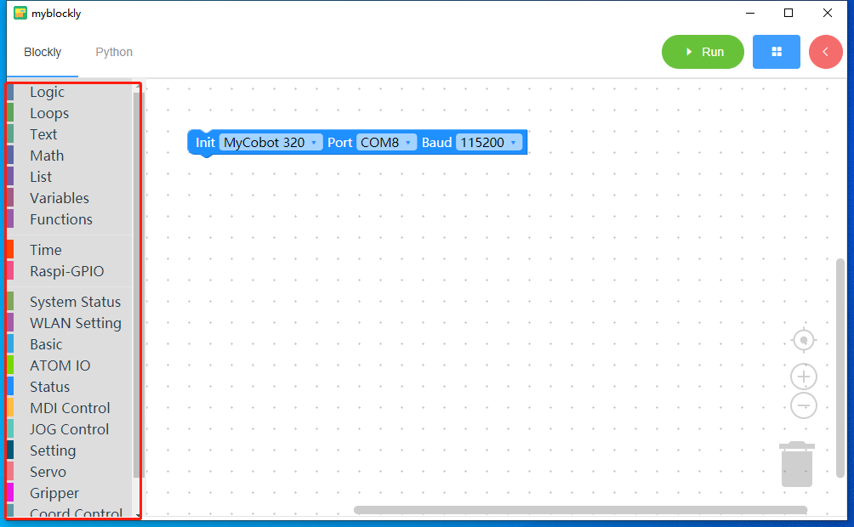

Figure 3.2 shows the list of blocks on the main interface of the software

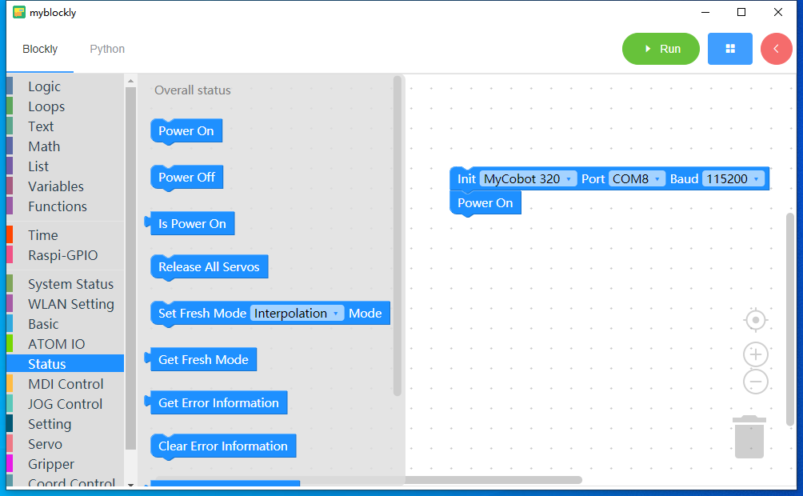

Figure 3.3 Building block list expanded

#### Drag and drop building blocks

Move the mouse over the corresponding building block, hold down the left mouse button, and drag the building block to the editing area.

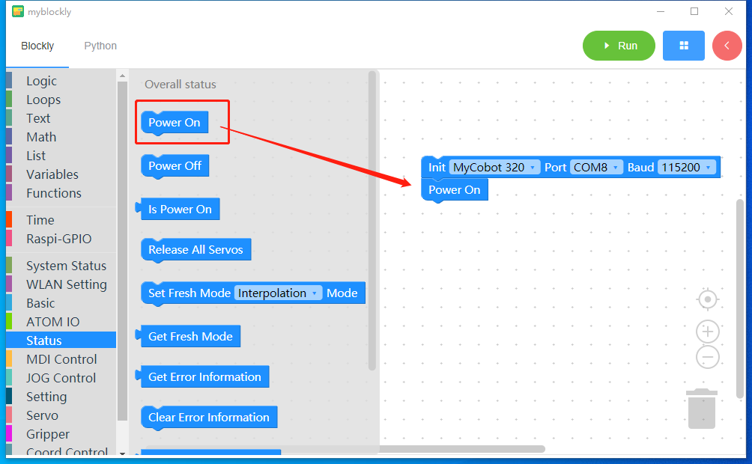

Figure 3.4 Dragging blocks

#### **Change building block parameters**

Double-click the parameters in the building blocks in the editing area to modify the parameters.

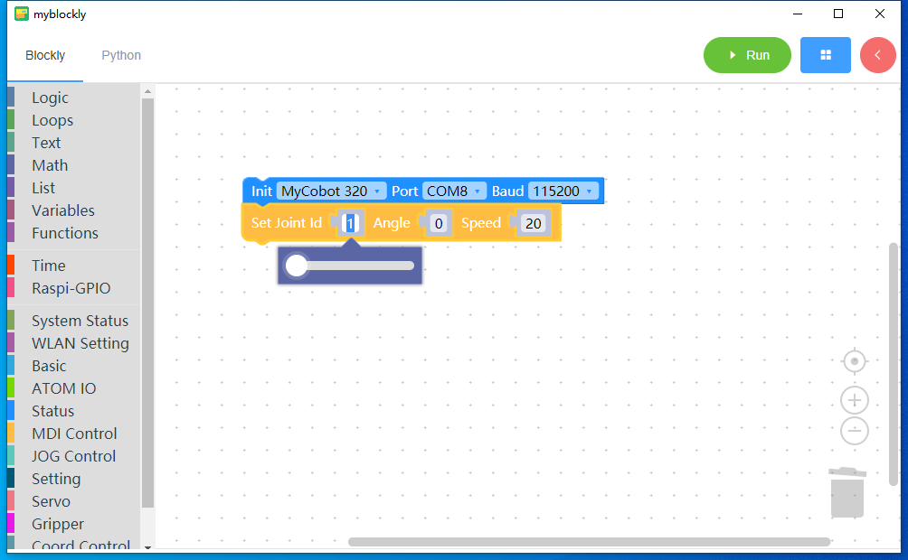

Figure 3.5 Changing building block parameters

#### **Duplicate building blocks**

Right-click the building block, then left-click and select "Copy" to copy the building block. After clicking "Copy", the same building block will appear in the editing area:

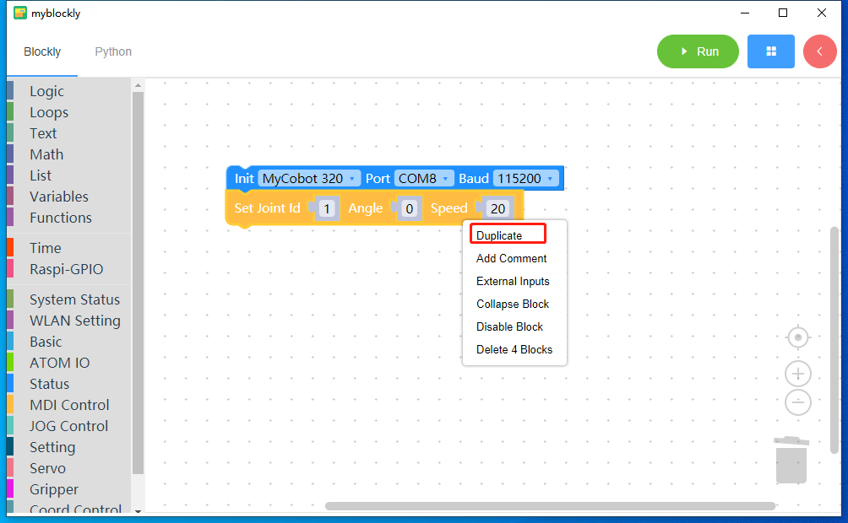

Figure 3.6 Copying the building blocks Figure 1

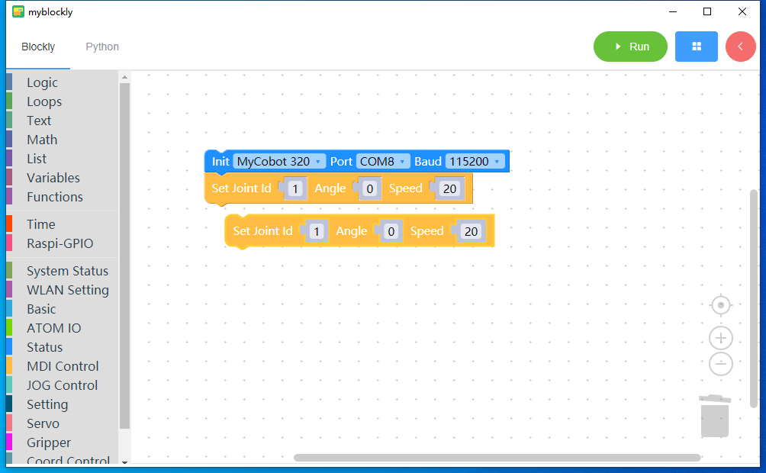

Figure 3.7 Copying building blocks Figure 2

#### **Add block annotations**

After right-clicking the building block and left-clicking "Add Comment", a '?' will appear on the left side of the building block. 'Sign, left mouse click'? 'sign, a comment input box will appear. You can enter the comment content in the input box and left-click again'? 'You can hide the input box.

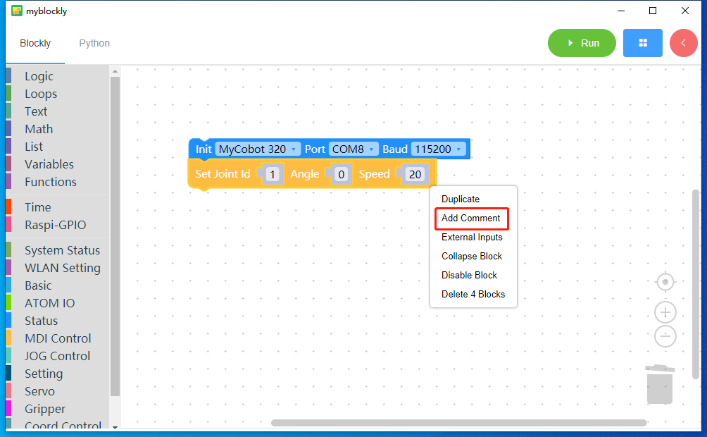

Figure 3.8 Adding building block annotation Figure 1

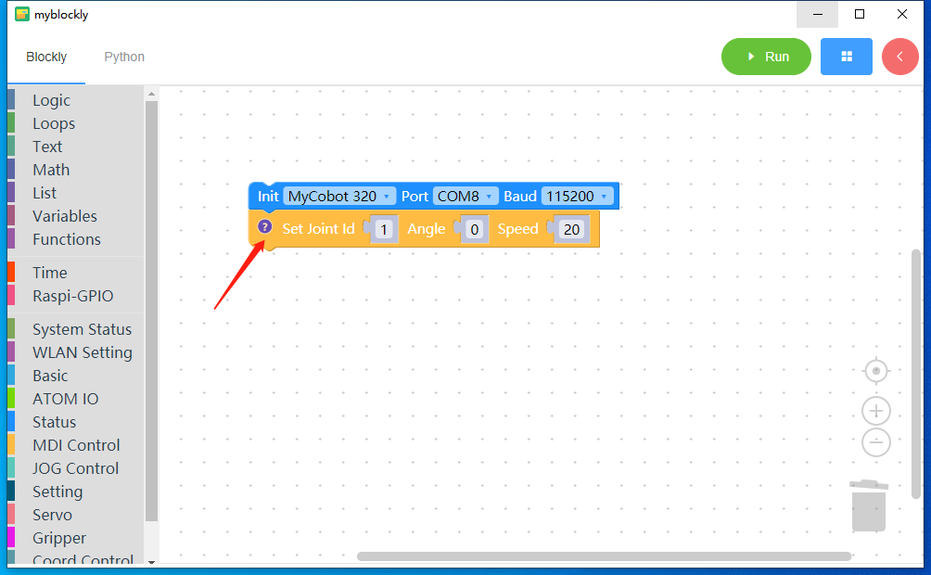

Figure 3.9 Adding building block annotation Figure 2

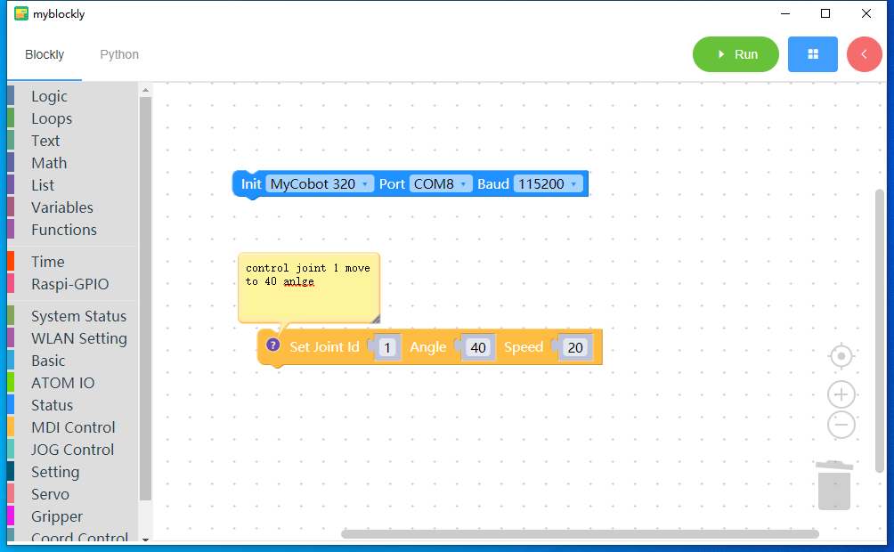

Figure 3.10 Adding building block annotation Figure 3

#### **Reduce/enlarge building blocks**

Use the mouse wheel or the left mouse button to click the '+' or '-' icon in the lower right corner of the blockly editing area to zoom in or out of the building blocks.

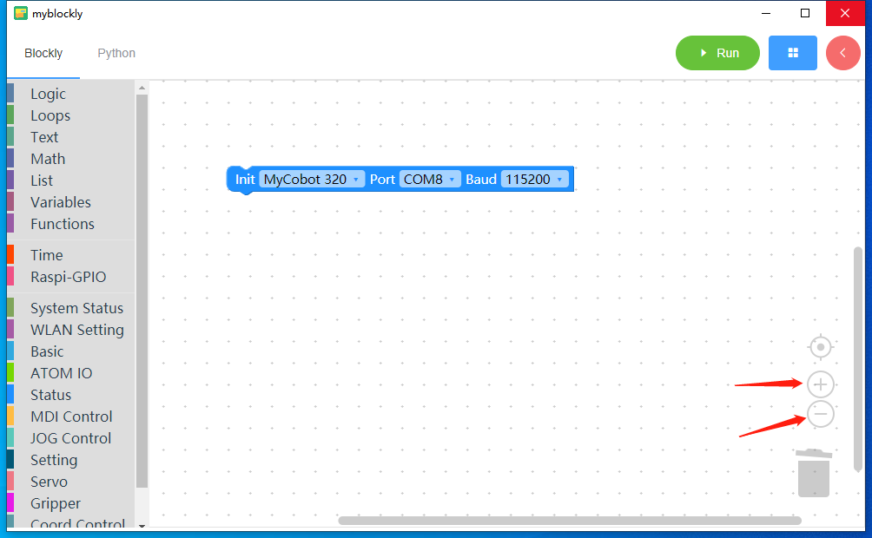

Figure 3.11 Zoom in/out the building blocks

#### **Display blocks in the center**

Left-click the 'center' icon in the lower right corner of the blockly editing area to center the blocks in the editing area.

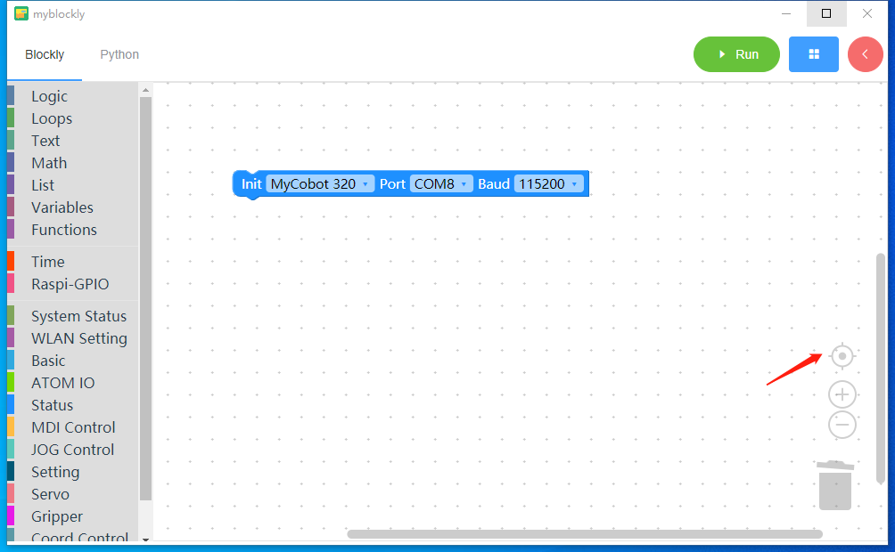

Figure 3.12 Display building blocks in the center

#### **Split building blocks**

For building blocks with multiple parameters, you can right-click the mouse and select 'External Input' to split them into multi-line building blocks; right-click the split building blocks and select 'Single Line Input' to restore the original line.

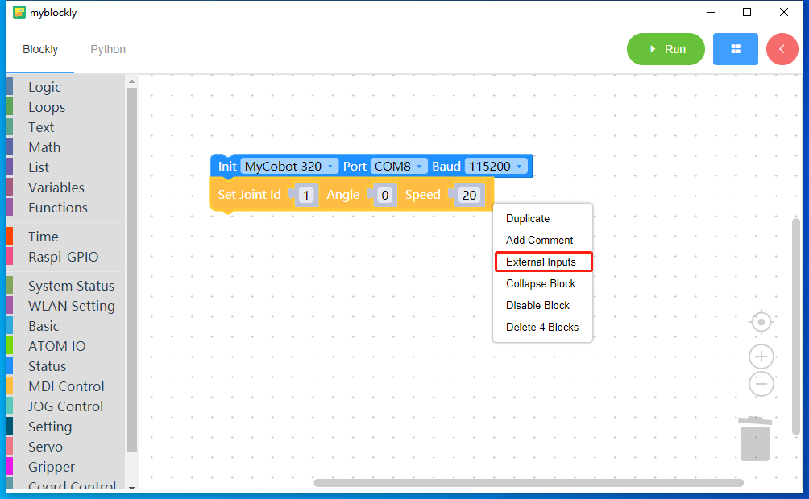

Figure 3.13 Splitting building blocks

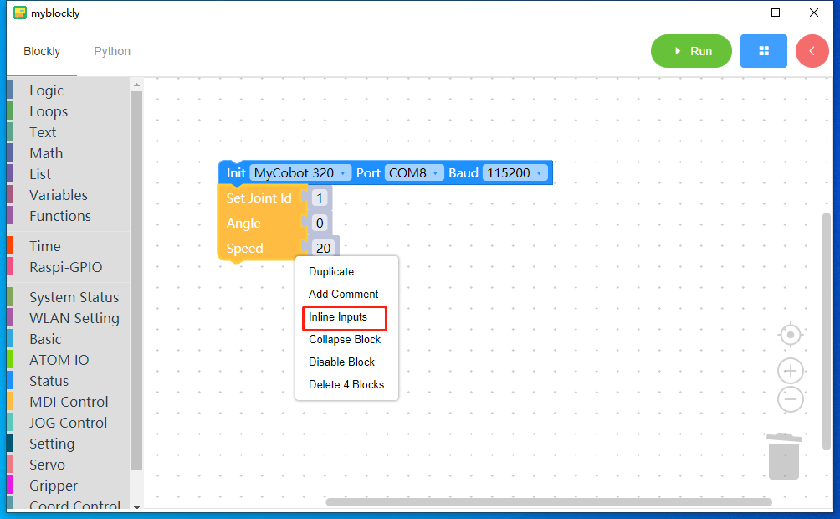

Figure 3.14 Merging building block diagram

#### **Collapse/expand building blocks**

Right-click the building blocks in the editing area and select "Collapse Blocks" to collapse the building blocks to make them look more beautiful. Similarly, right-click the building blocks in the editing area and select "Expand Blocks" to fold the building blocks. The block is restored to its original state.

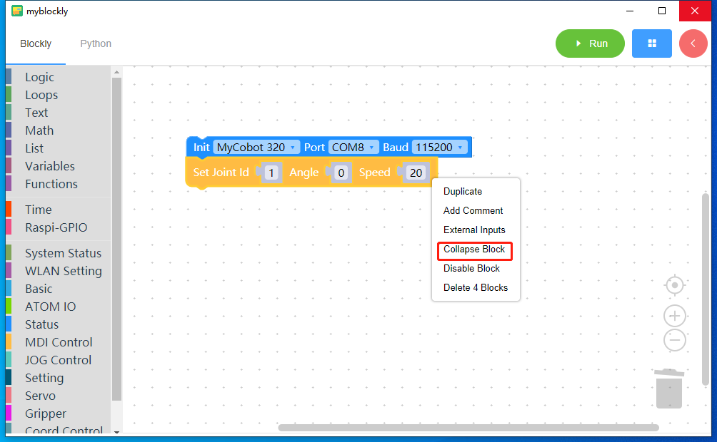

Figure 3.15 Folding building blocks

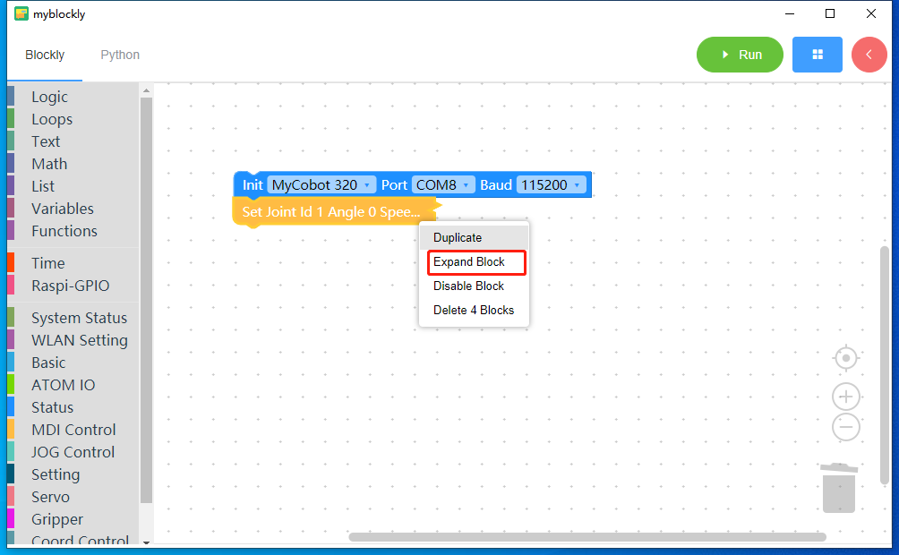

Figure 3.16 Expand the building blocks

#### **Disable blocks**

Right-click the selected building block in the editing area, then left-click and select "Disable Block". The disabled block cannot be converted into the corresponding Python code; right-click the disabled building block, then left-click and select "Enable Block". Restoring the original block can be automatically converted into the corresponding Python code.

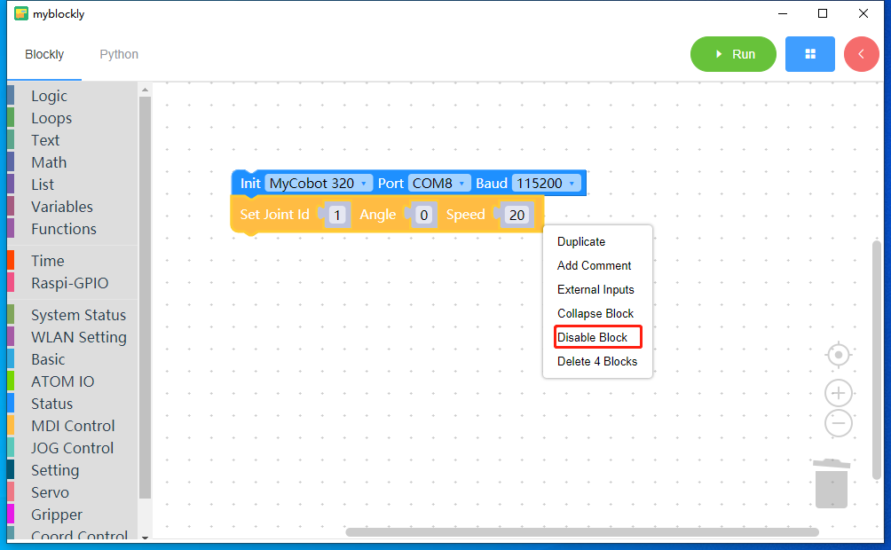

Figure 3.17 Disabling building blocks

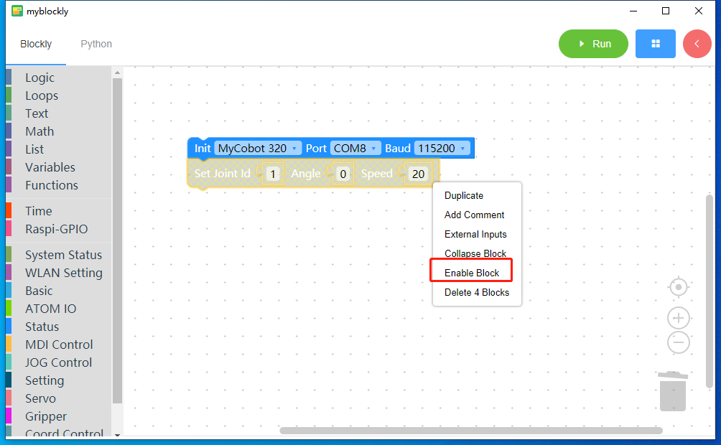

Figure 3.18 Enable building blocks

#### **Delete building blocks**

Right-click the building block, left-click and select "Delete x blocks" to delete the building block.

Hold down the left mouse button on the building block and drag the building block to the "trash can" icon in the lower right corner of the editing area. You can also delete the building block.

Right-click on a blank space in the blockly editing area and select "Delete x blocks" to delete all blocks in the editing area.

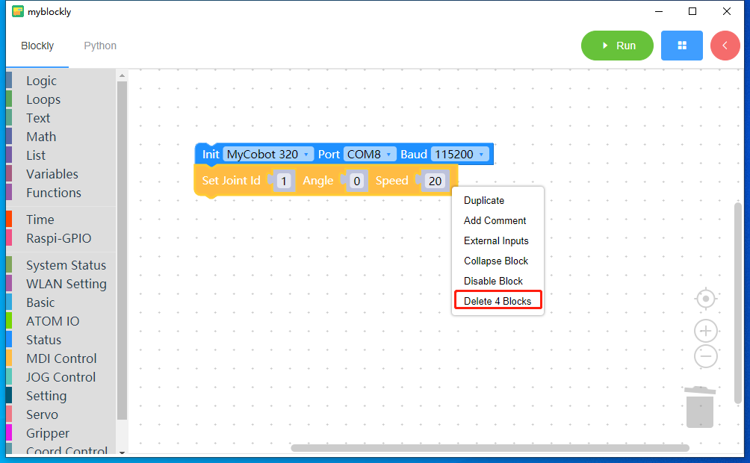

Figure 3.19 Delete building block 1

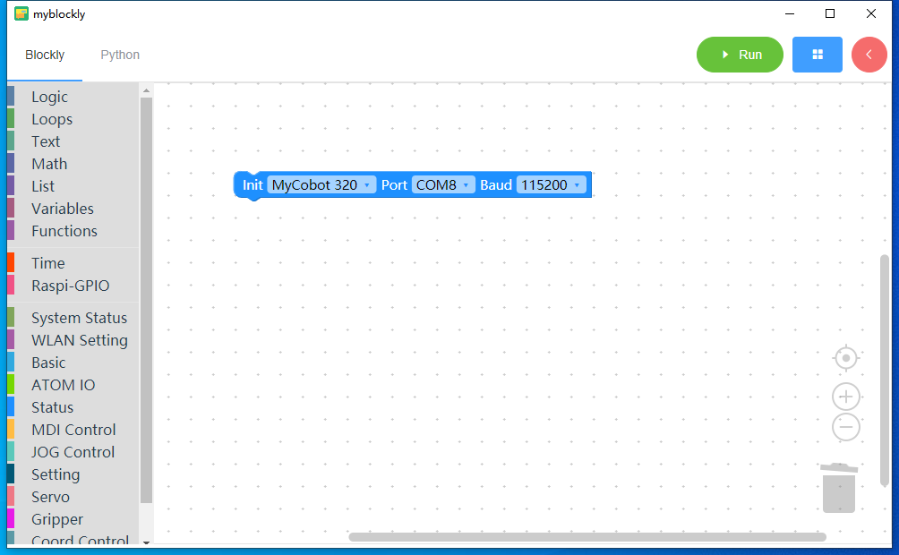

Figure 3.20 Delete building block 2

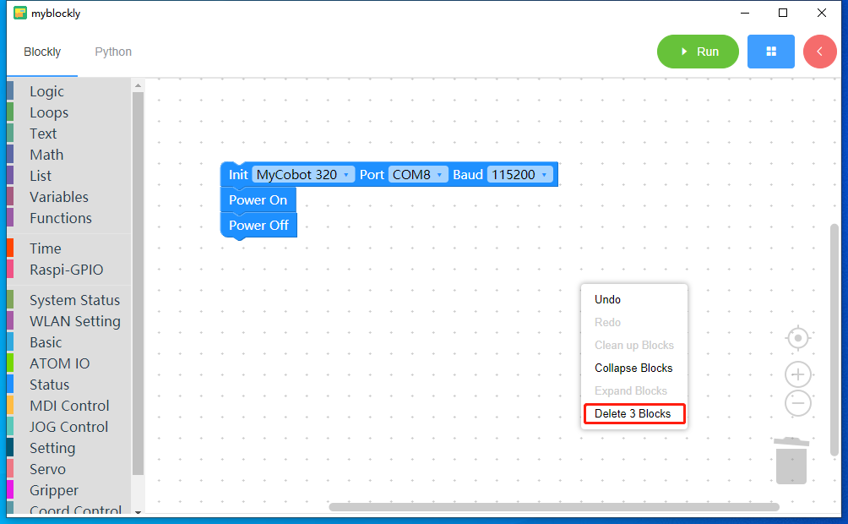

Figure 3.21 Delete building block 3

#### Restore deleted blocks

Left-click the "trash can" icon in the lower right corner of the main interface to display the deleted building blocks. Drag and drop the deletable building blocks into the blockly editing area.

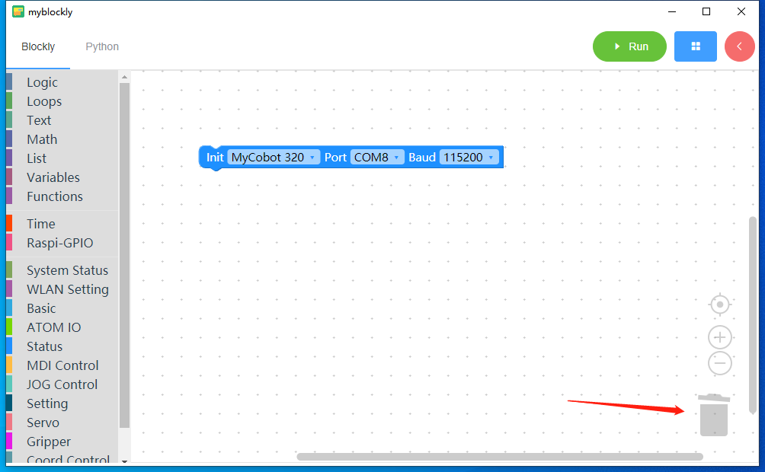

Figure 3.22 Restoring building block 1

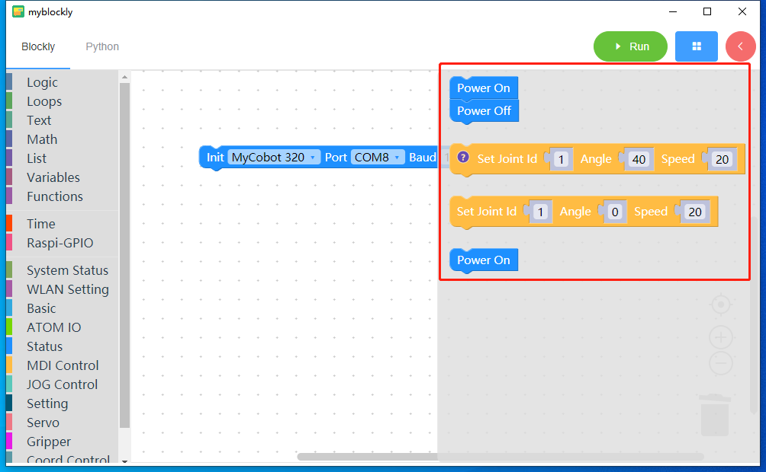

Figure 3.23 Restoring building block 2

### **View the converted Python code of the building blocks**

Left-clicking the "Python" button in the upper left corner of the main interface will automatically convert the building blocks in the blockly editing area into Python code. The added comments will also be displayed, and disabled blocks will not be displayed.

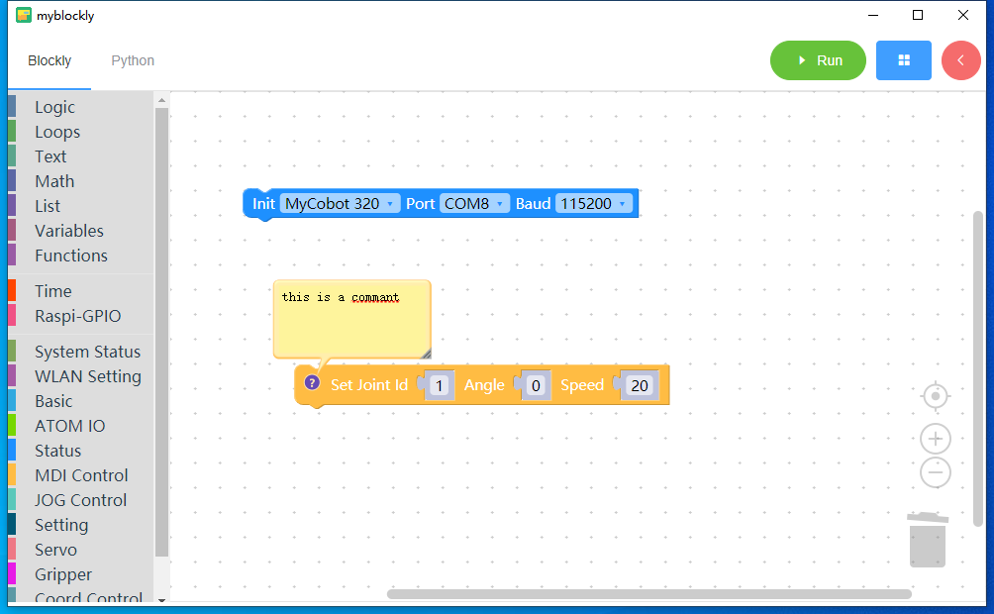

Figure 3.24 blockly editing area

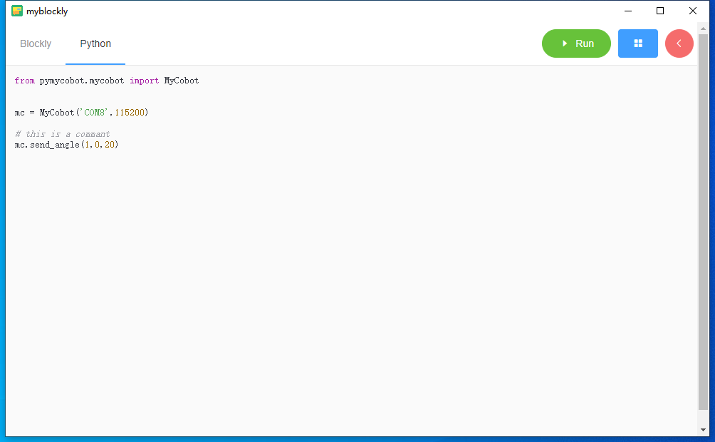

Figure 3.25 Converted Python code

### **run**

Click the "Run" button with the left mouse button to run the converted Python code of the building blocks in the blockly editing area, and display the running results.

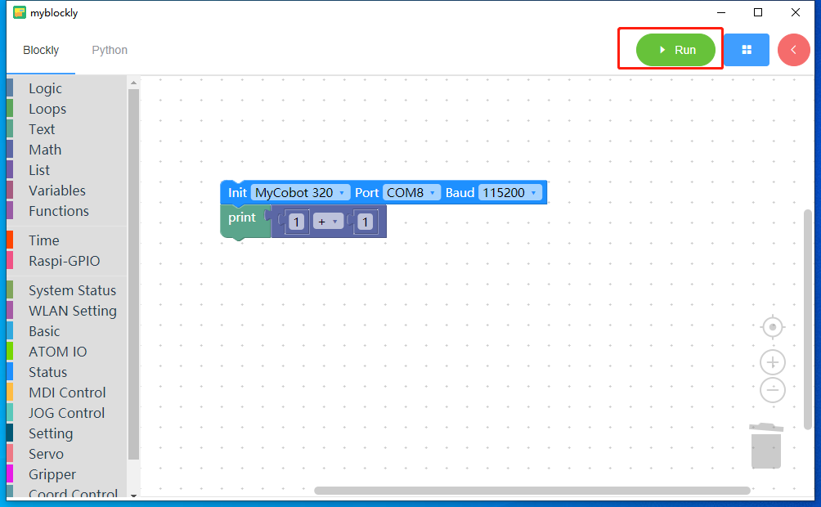

Figure 3.26 Run button

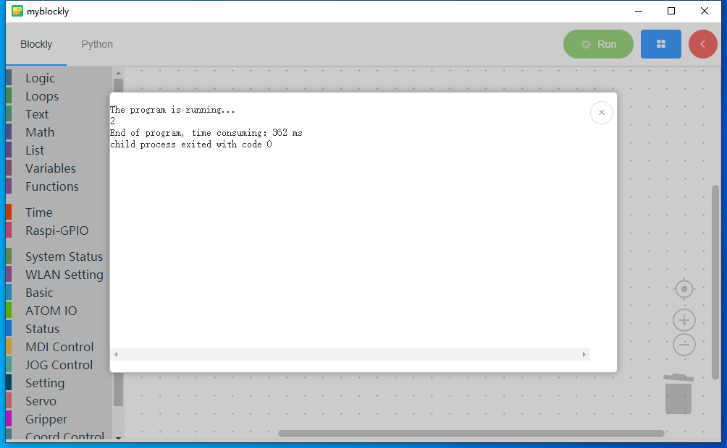

Figure 3.27 Display of running results

### **tool**

Left-click the "<" icon in the upper right corner of the software's main interface to expand the display tools. There are three drop-down boxes on the tool interface. The first one can select the model name, the second one can select the serial port number corresponding to the robot, and the third one can select the communication baud rate; there is also an "Open/Close" button, which can Open or close the communication connection between the software and the robot. In the "open" state, the "Run" button will not be available.

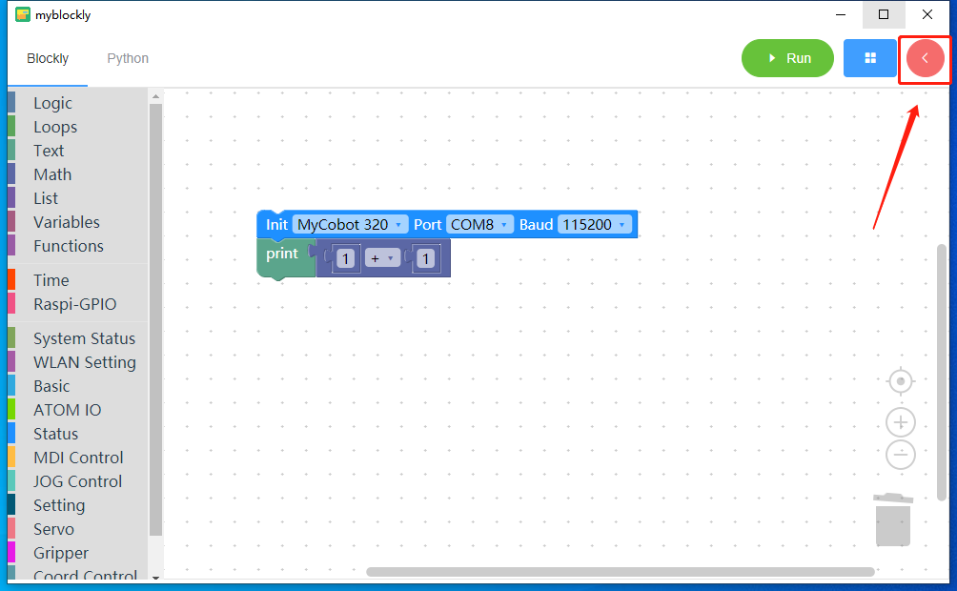

Figure 3.28 Display tool

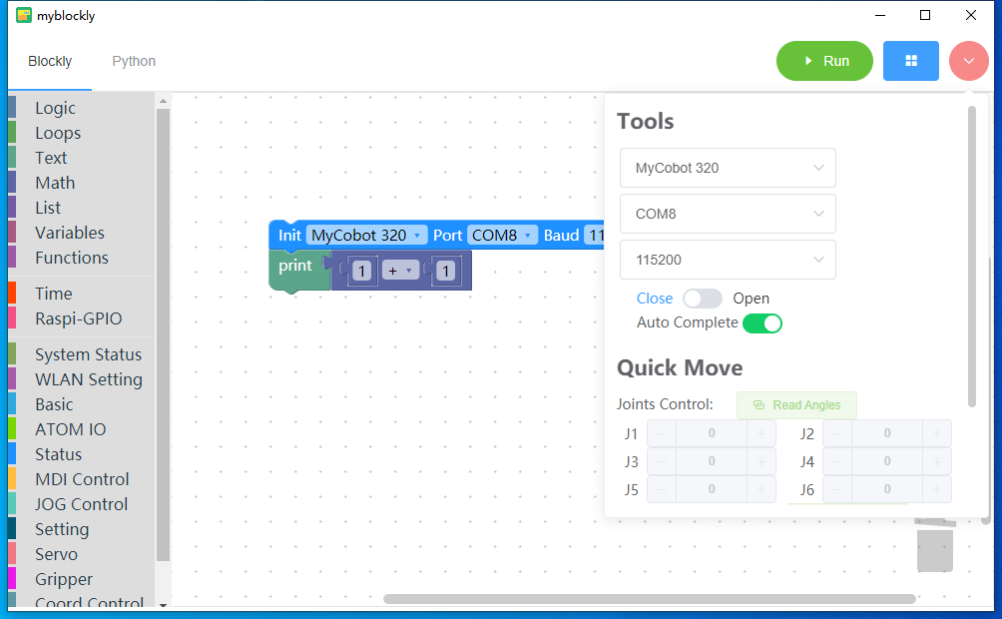

Figure 3.29 Tool interface

### **Fast-moving**

Left-click the "<" icon in the upper right corner of the software's main interface to expand and display quick movement.



Figure 3.30 shows fast movement

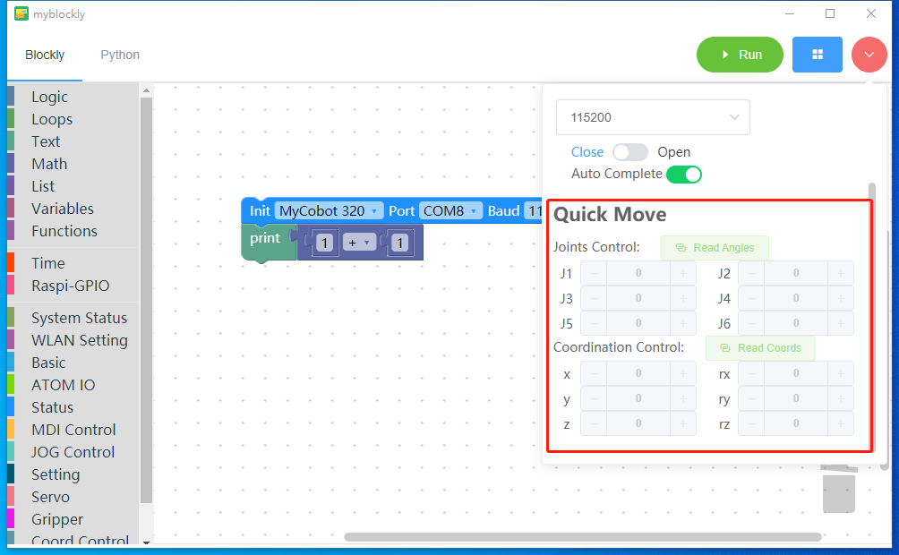

Figure 3.31 Quick movement interface 1

The use of fast movement requires connecting to machine communication, so you need to select the correct machine communication information in the toolbar and turn on the connection button before it can be used.

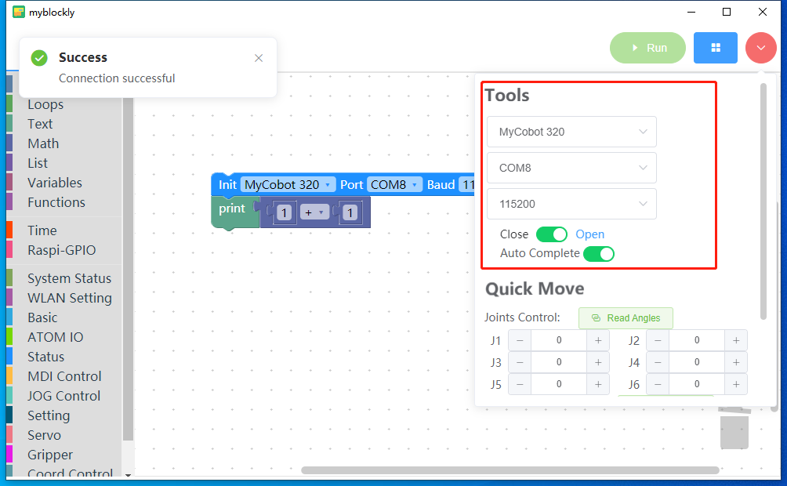

Figure 3.32 Connecting machine communication

After clicking the open button with the left mouse button, the software will automatically read the angle and coordinate information of the machine and display it:

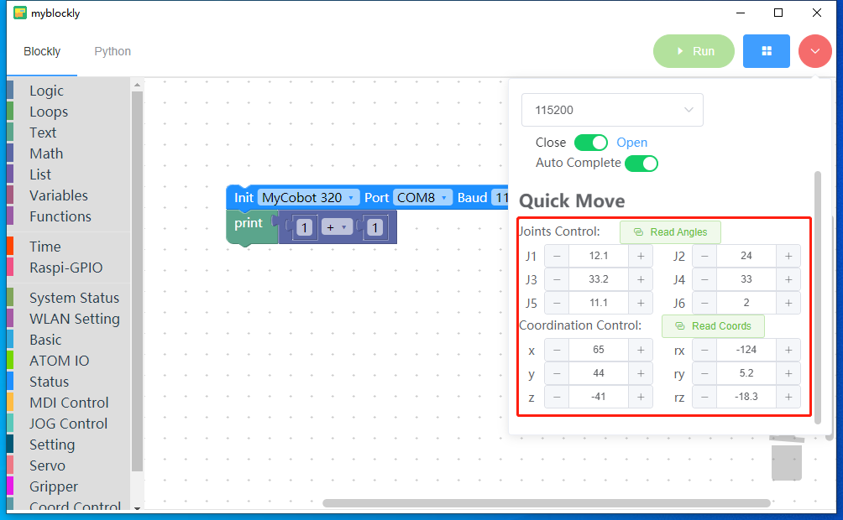

Figure 3.33 Display machine information

On the premise of turning on communication, left-click the "Read Angle" button on the fast movement interface to read the angle information of the machine once and update it to display it.

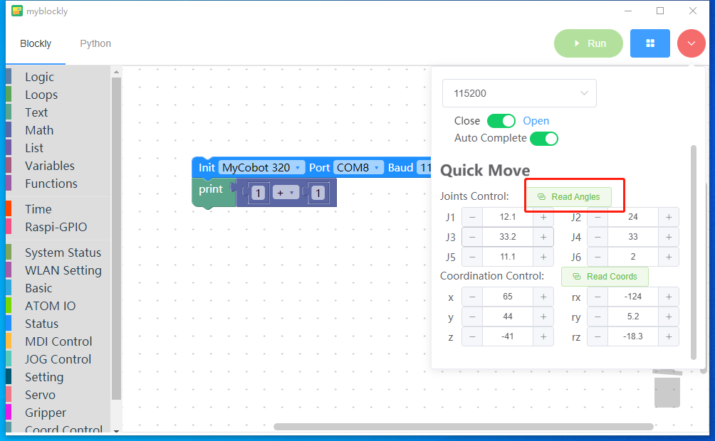

Figure 3.34 Reading machine angle information

On the premise of turning on communication, left-click the "Read Coordinates" button on the fast movement interface to read the coordinate information of the machine once and update it to display it.

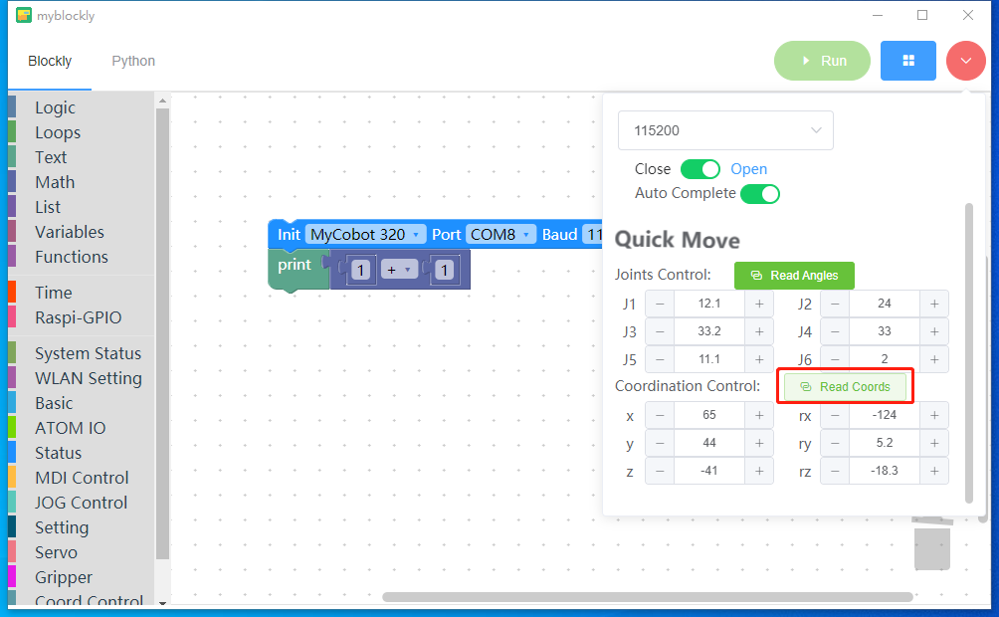

Figure 3.35 Reading machine coordinate information

On the premise of turning on communication, left-click the mouse or long press the "-" or "+" button to change the information of each joint or coordinate of the machine, and the changed data will be automatically sent to the machine itself to realize the modification. Machine motion control.

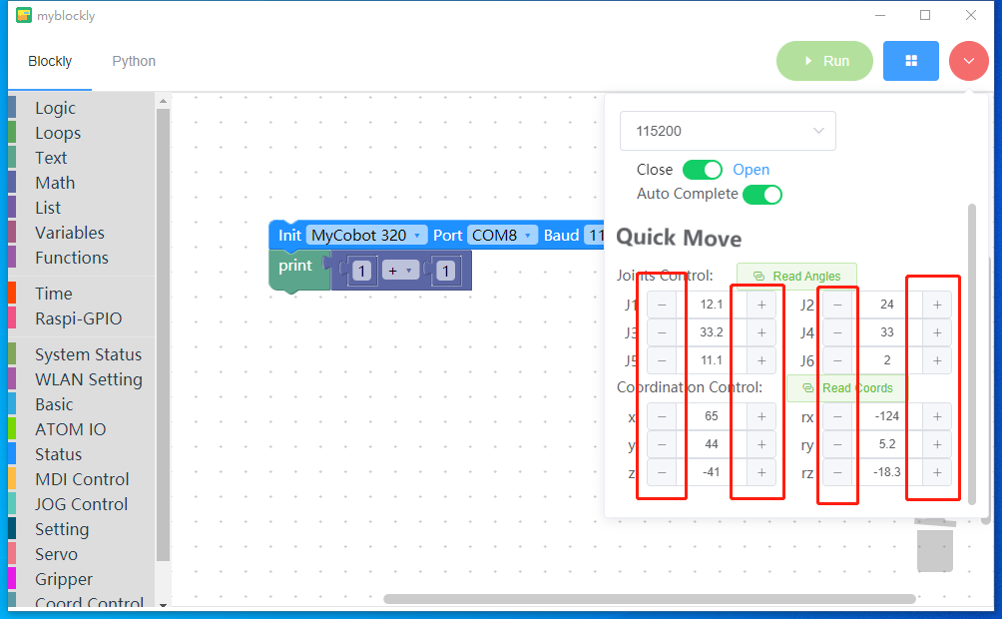

Figure 3.36 Modify and send machine information

### **load**

Hover the mouse pointer to the blue icon in the upper right corner of the software, and the "Load" button will appear.

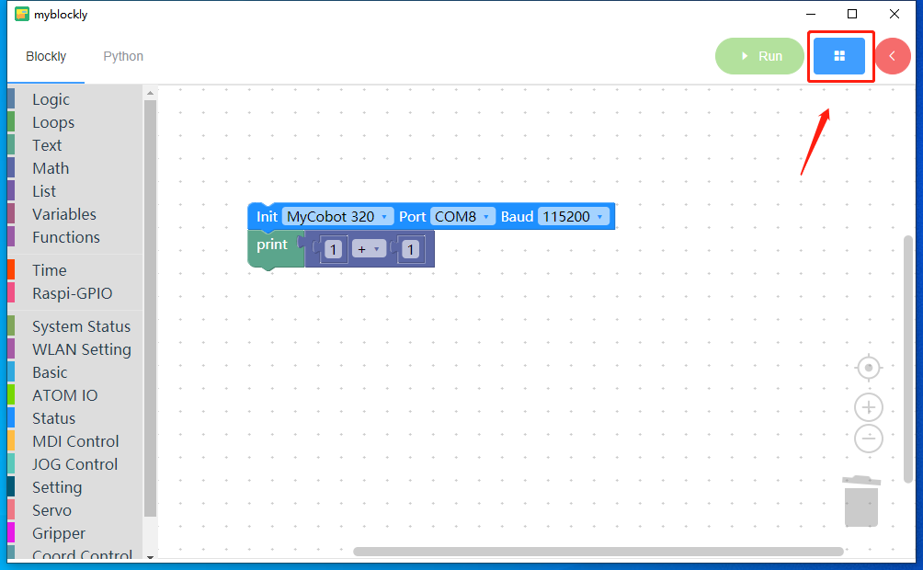

Figure 3.37 shows loading 1

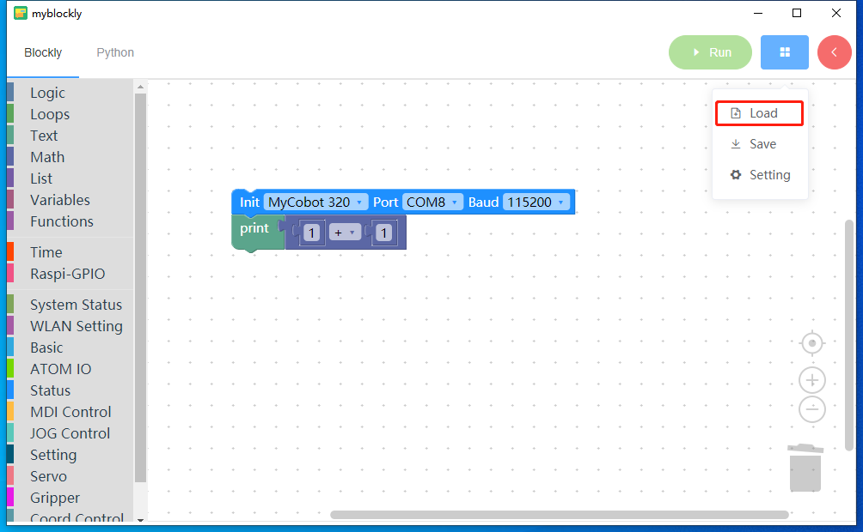

Figure 3.38 shows loading 2

Clicking the "Load" button will open the external file. You can select the Json format file that needs to be imported from the folder. This json file saves the building block information. By importing this file, you can quickly generate building blocks and overwrite the building blocks in the current editing area.

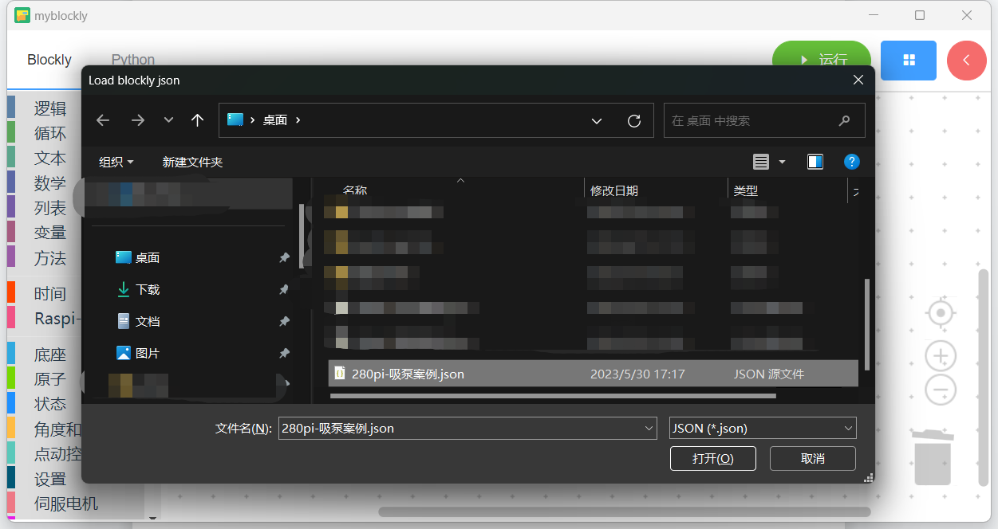

Figure 3.39 Loading Json file

### **save**

Hover the mouse pointer over the blue icon in the upper right corner of the application, and a "Save" button will appear.

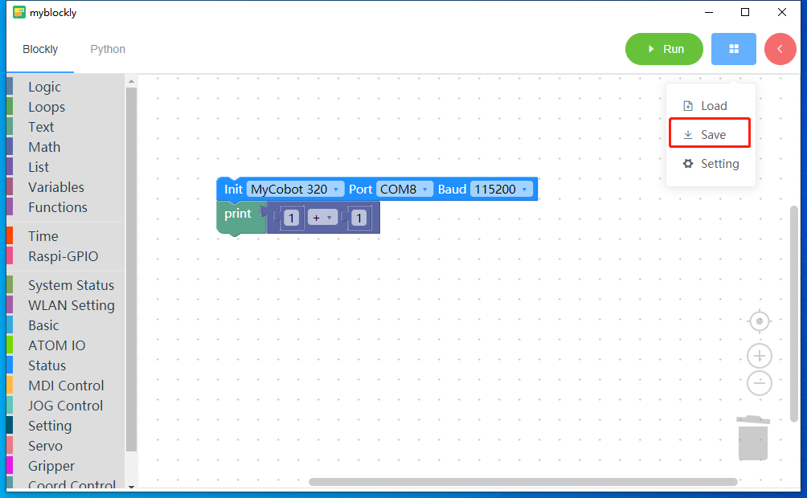

Figure 3.40 Saving building blocks

Clicking the "Save" button will open an external folder and save all the blocks in the current blockly editing area to a json file.

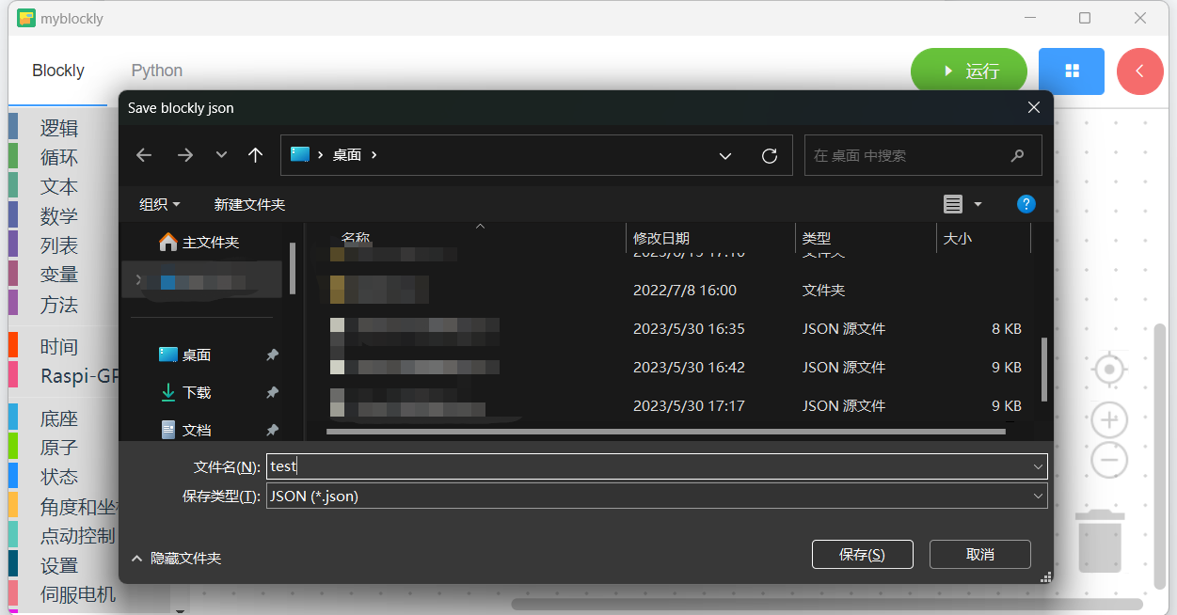

Figure 3.41 Save file

### set up

Hover the mouse pointer over the blue icon in the upper right corner of the application, and the "Settings" button will appear.

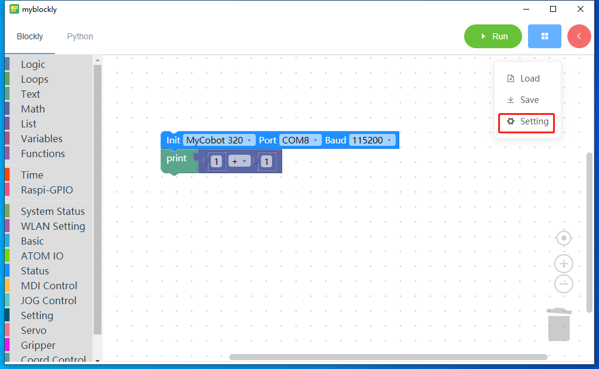

Figure 3.42 Setting button

Click the "Settings" button with the left mouse button, and a settings pop-up window will appear.

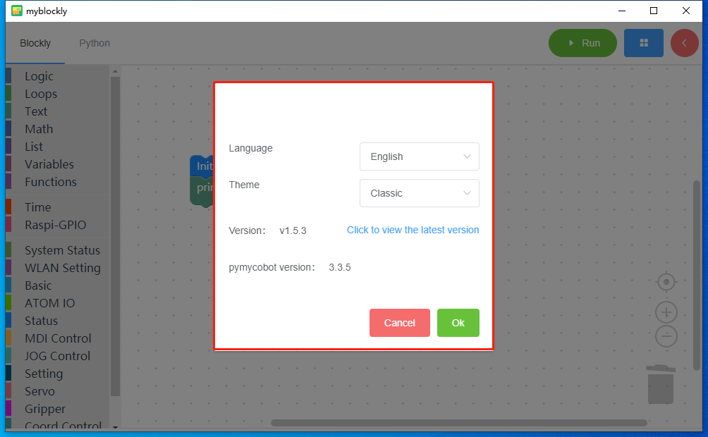

Figure 3.43 Setting pop-up window

The settings pop-up window includes setting the software's language, theme, current software version number, checking for version updates, and the version number of the Python library pymycobot used for robot communication.

Set the language: Click the language drop-down box with the left mouse button to select "Simplified Chinese" or "English" language, and then click "Confirm" to switch the software language.

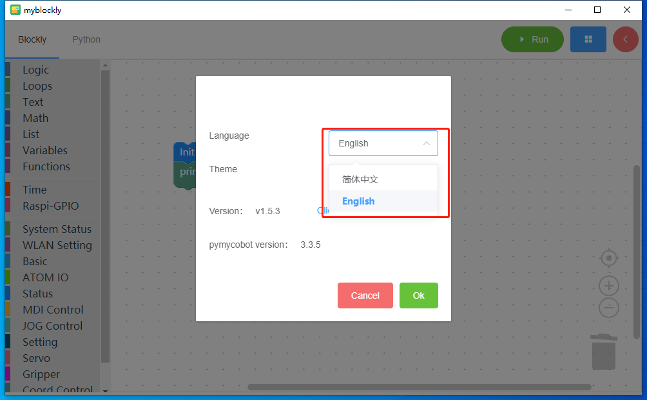

Figure 3.44 Set language

Set the theme: Left-click the theme drop-down box to select "Classic" or "Dark" theme, and then click "Confirm" to switch the software theme.

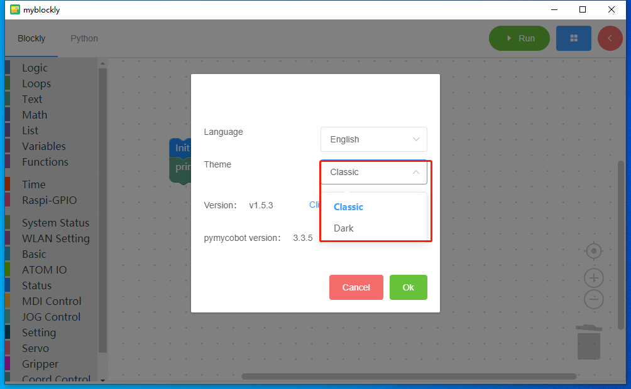

Figure 3.45 Setting the theme

Check for version updates: Click "Click to view the latest version" with the left mouse button. The browser will open and jump to the software download interface of the official website. Here you can check whether there is a new version of the software.

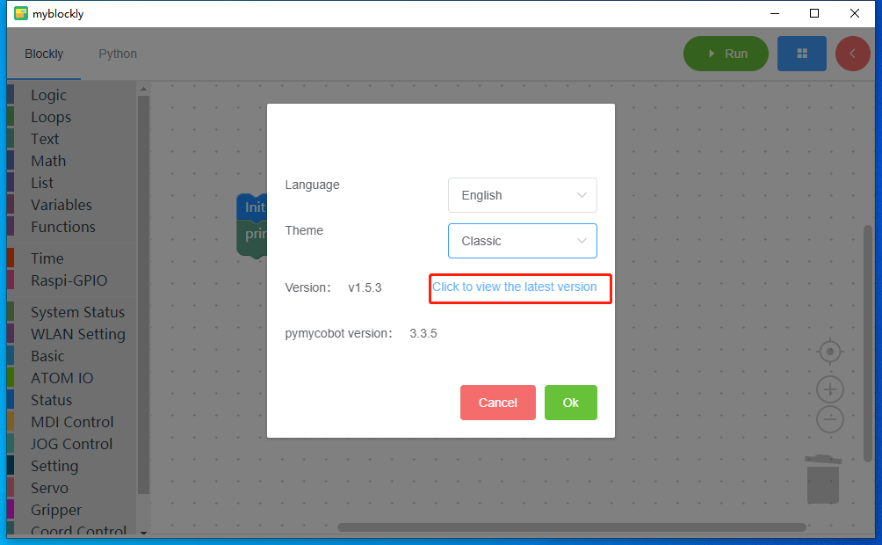

Figure 3.45 Check for updates