|  |
| --- |
| STEW Inc. presents |
| Fantasy Burgers Restaurant |
| “Where Wings Take Dream” |
| Version 0.1  All work Copyright © 2012 by STEW Inc.  All rights reserved. |
| **Thiago Andrade, Waynell Lovell, Sahil Mahajan, Anmol Sharma, Eddie Song** |
|  |

Version History: https://github.com/WaynellLovell/FinalGroupFantasyBurger

|  |
| --- |
|  |

**Table of Contents**

Table of Contents

I. Site Overview 3

II. Site Structure 3

III. Color and Font Scheme 3

IV. Technologies 3

V. Initial Design 4

VI. Live Site Preview 5

VII. Features In Development 8

# Site Overview

*This website servers as a cyber-portal of Fantasy Burgers Restaurant.*

# Site Structure

*Home page: Displays a carousel of images, and serves as the landing page.*

*About page: An introduction and a brief history of the restaurant.*

*Contact page: Contains location and contact information of the restaurant.*

*Menu page: Online menu that can be used to order food online.*

*Menu item page: Detailed description of menu item, and option to add to cart.*

*Register/Login page: User account management.*

*Shopping cart page: User can view his shopping cart and checkout.*

*Checkout page: User can enter his payment information and make a purchase.*

# Color and Font Scheme

*The site mainly uses apple green and white to create an atmosphere of freshness and healthiness.*

*The fonts used are Roboto and Open Sans, further accentuating the “crispy” look and feel of the site.*

# Technologies

* *ASP.NET MVC 5 as framework*
* *Microsoft Azure as web host*
* *Visual Studio 2015 as IDE*
* *Git for version control*
* *GitHub for team collaboration*

# Initial Design

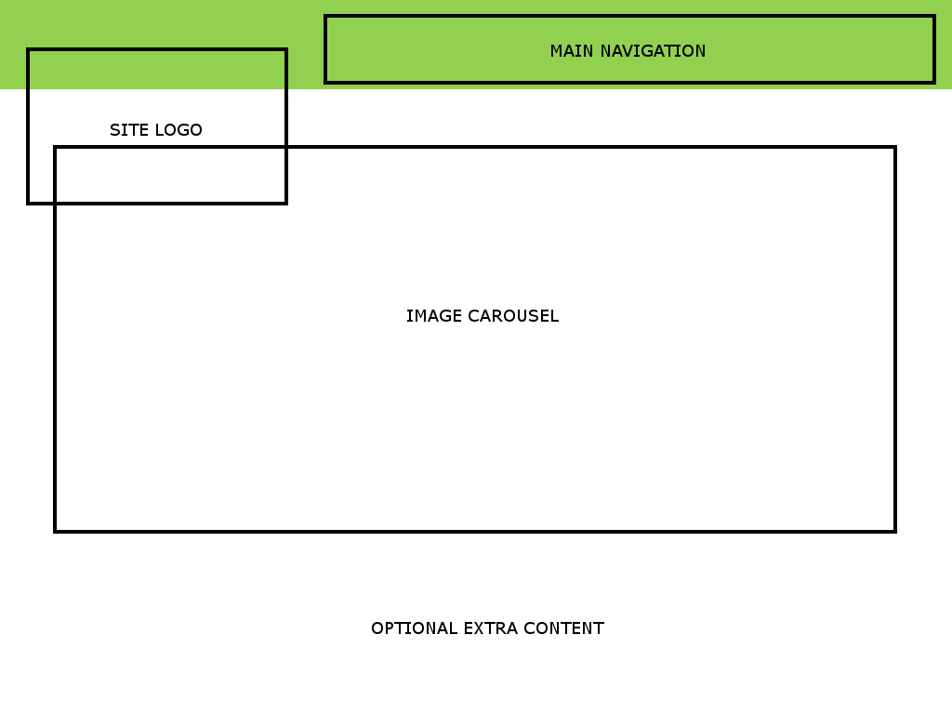

# Live Site Preview

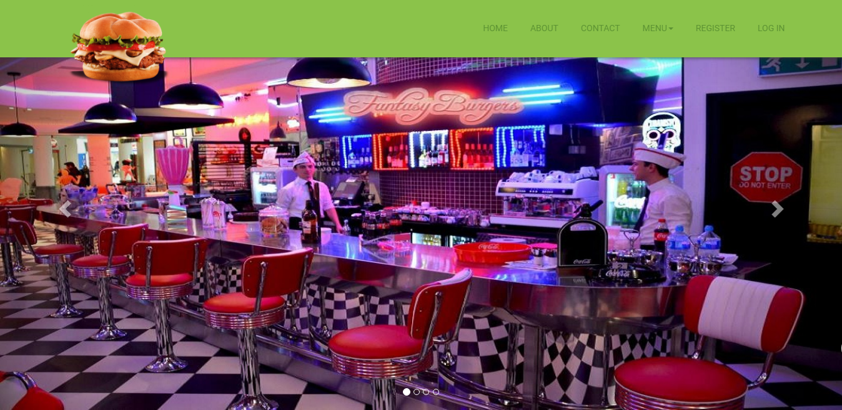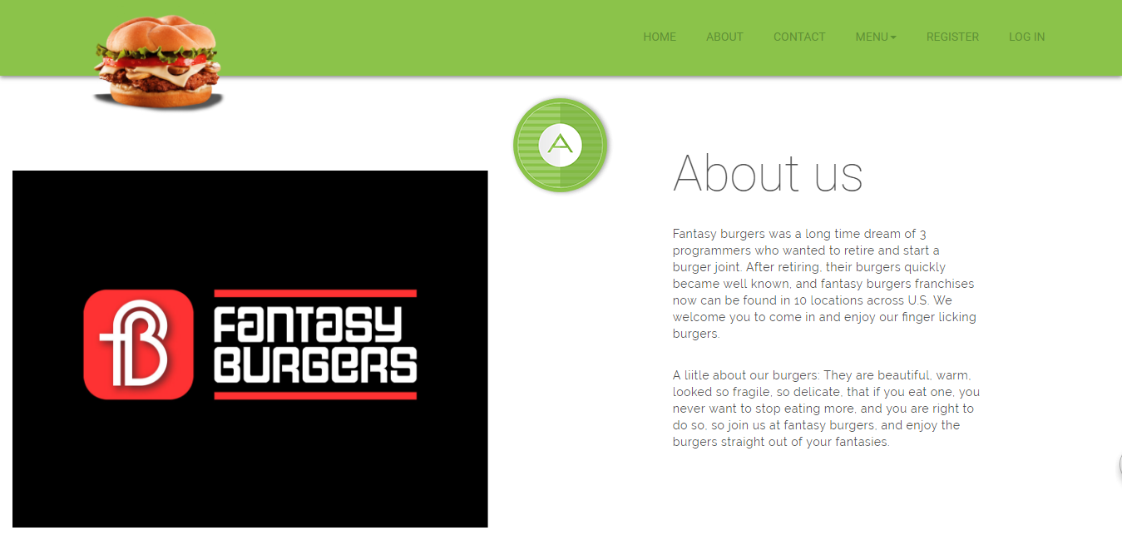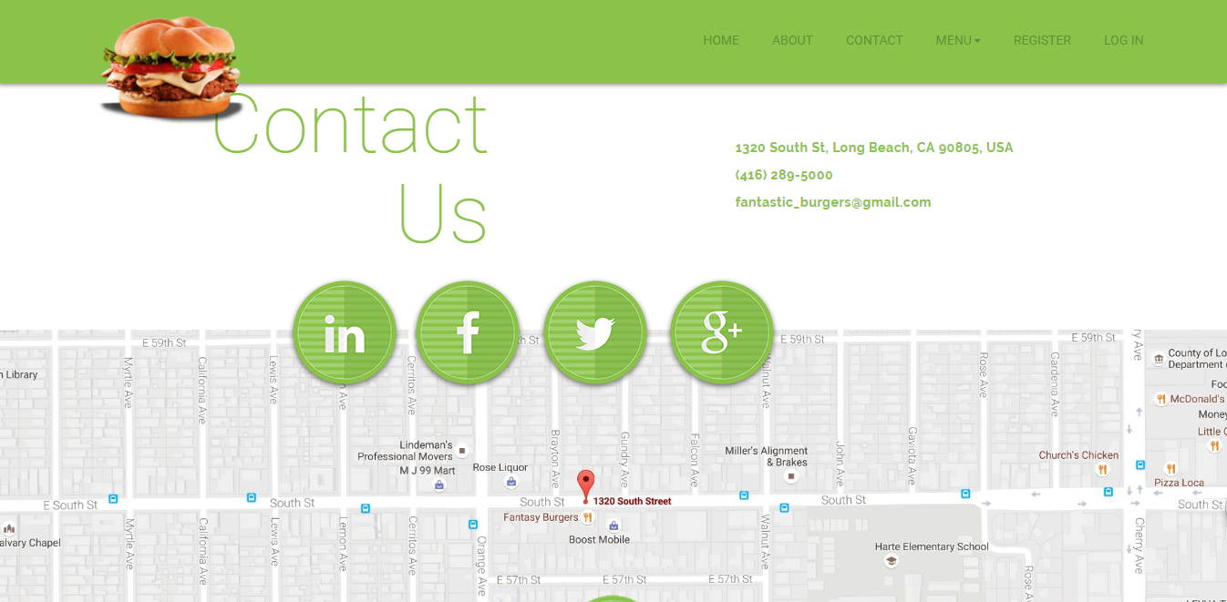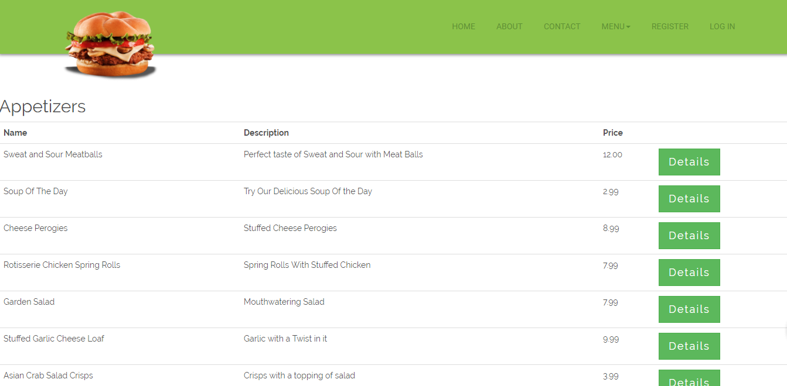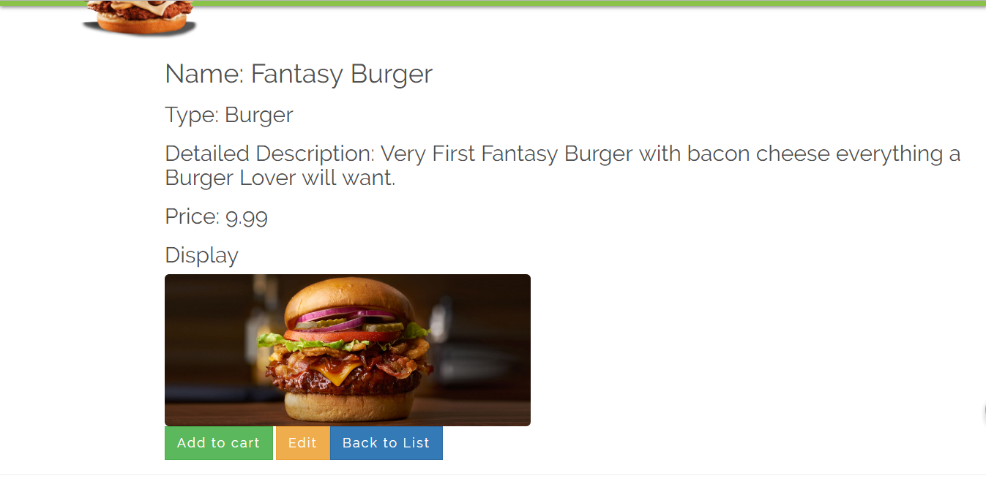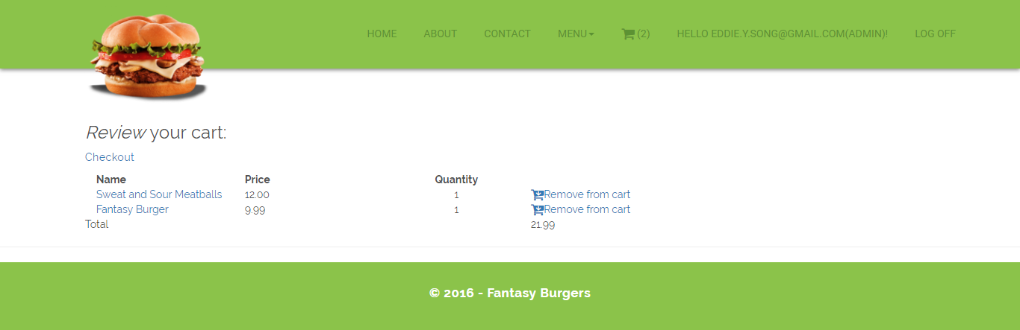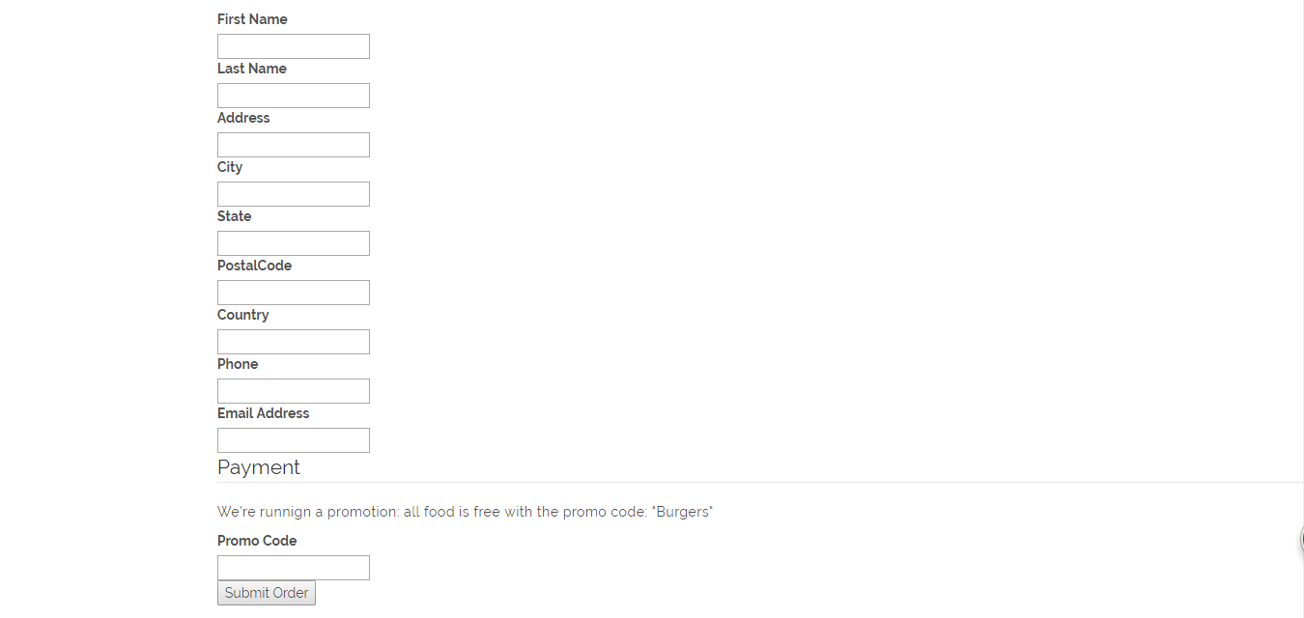

# Features In Development

* *More Customer Interactivity*
* *A comment/feedback section*