Report
Instructions: Please include server account information in each screenshot, as shown in the following three examples, and provide the following eight screenshots. Finally, when submitting the file, please delete all instructions and example images!
1.
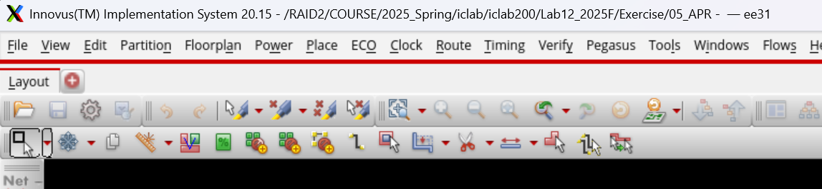
2.
3. 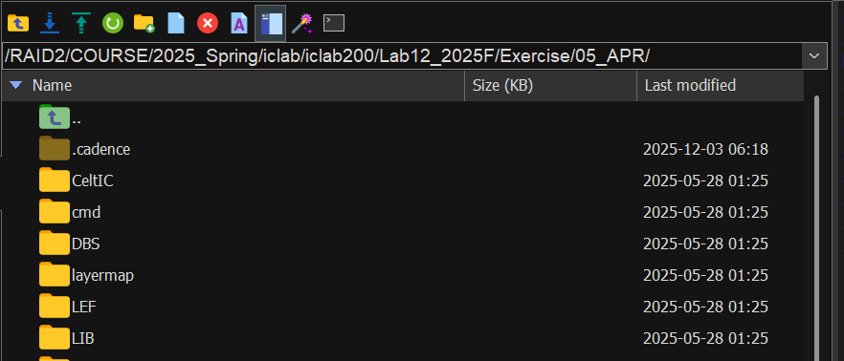
- Chip Layout View :
Instructions: After completing the final layout, capture a screenshot of the entire chip layout.
- Core to IO boundary :
Instructions: After completing the final layout, open Floorplan -> Specify Floorplan, and capture a screenshot.
- Core Ring :
Instructions: After completing the final layout, zoom in on the Power section (ensuring the entire power ring is visible), and use the K key to measure the width of a single power line.
- Post-Route setup time analysis :
Instructions: After completing the analysis, capture a screenshot of the results displayed in the terminal (including the timeDesign Summary).
- Post-Route hold time analysis :
Instructions: After completing the analysis, capture a screenshot of the results displayed in the terminal (including the timeDesign Summary).
- DRC result :
Instructions: After completing the final layout, run the analysis and capture a screenshot of the results displayed in the terminal (including the number of violations).
- LVS result :
Instructions: After completing the final layout, run the analysis and capture a screenshot of the results displayed in the terminal (including the number of violations).
- Post Layout simulation result :
Instructions: After completing the final layout, run the post-simulation in 06_POST and capture a screenshot of the results displayed in the terminal (including the "congratulation" message).
- Power result :
Instructions: After running the analysis, capture a screenshot of the results displayed in the terminal (including the Total Power).
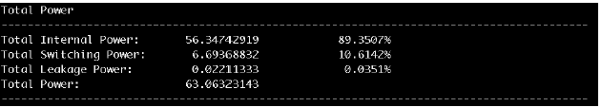
Example:
- IR Drop Results :
Instructions: After completing the analysis, capture a screenshot of the results in Innovus. Highlight the maximum value of the IR drop and provide a brief explanation of the method you used to mitigate the IR drop issue.
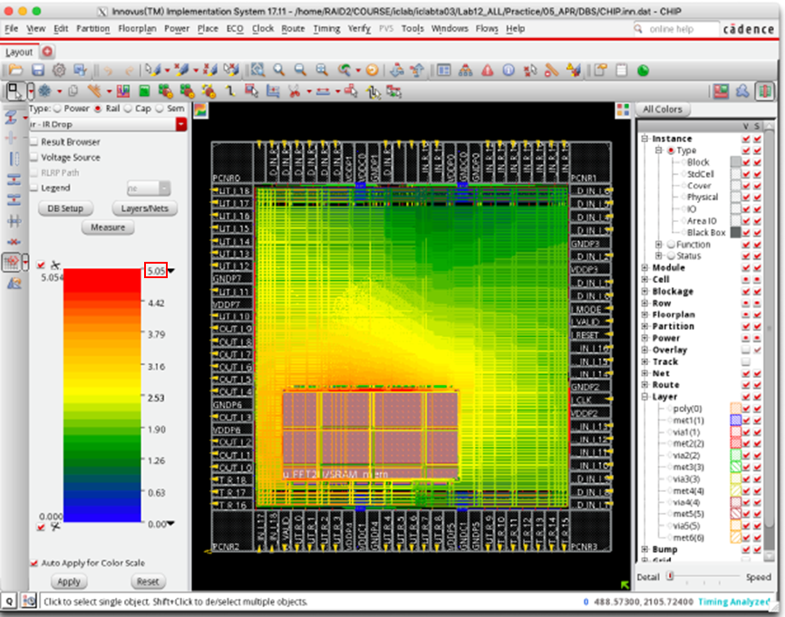
Example:

