Design Specification

For

IoT Countertop Oven

Prepared by:

Group Name: Table 14

James Jasinski | Jasinski.4@wright.edu
Austin Hunt  Tyler Rupert | Hunt.133@wright.edu  Rupert.33@wright.edu
John McKeny | Mckeny.3@wright.edu

For:
Project Sponsor Wright State University
Brian Rigling | Brian.Rigling@wright.edu
Erik Buck | Erik.buck@wright.edu

Document Tracking Information:
Document Version IoT Air Fryer ver. 1.0
Date 4/24/19
Final Approval Date <xxxx.xx.xx>
Final Appoval By: <Erik Buck> <Erik.Buck@wright.edu>
<Brian Rigling> <Brian.Rigling@gmail.com>

Table of Contents
1. Executive Summary 1
1.1 Purpose of this document 1
1.2 Design Scope 1
1.3 Intended Audience and Document Overview 2
1.4 Definitions, Acronymns, and Abbreviations 2
1.5 Document Conventions 2
1.6 References and Acknowledgments 2
2 Problem Statement 4
2.1 Historical Introduction 4
2.2 Market Analysis and Relevant Art 4
2.3 Alternative Approaches 4
2.4 Impact of Success 5
3 Context of Design Solution 6
3.1 Design Objectives 6
3.2 Design Assumptions 6
3.3 Design Requirements 6
3.4 Design Constraints 7
3.5 Design Standards 7
3.6 Design Functionality 7
3.7 User Characteristics 7
3.8 Operating Environment 8
3.9 User Documentation 8
4 Technical Approach 9
4.1 Hardware 9
4.2 Software 9
5 Appendix: Test and Evaluation Master Plan and Report 11

1. Executive Summary
This document outlines the proposed design for an IoT capable countertop Oven small home kitchen appliance, as designed to fulfill the requirements of the Wright State University group projects 1 2020 design challenge This document is based on the design specifications document template required as a capstone for the Group Projects 1 course.

Purpose of this document
This document describes the design for an IoT-enabled countertop Oven which would allow its user to control the device from anywhere. An countertop Oven will be purchased as the base item

Design Scope
The objective of the IoT countertop Oven is to reduce the amount of time the user must spend preparing food. It will safely keep food stored overnight. It will feature p2p password encryption for communication with an associated app and a mobile or network interface with a dedicated server. The app will provide control of the IoT countertop Oven, and the server will present optional recipes to the user through the app. The IoT countertop Oven will monitor for safety concerns within its systems and provide a user interface of its own for control without the app.

For this project, we are modifying a commercially available countertop Oven with sensor and control systems including: a camera, a display device for the user interface, a temperature sensor, a microcontroller, and an Android app compatible with Android 5.1 or higher that can control the system in addition to the user interface on the display device.

Intended Audience and Document Overview
The intended audience for this document consists of project sponsors, project clients, end users, project managers, marketing staff, and technical writers who will prepare documentation for end users. For project sponsors, marketing staff, and project clients, it’s recommended to read all of section 2 followed by section 3.1 and sections 3.6 through 3.10. For end users, it’s recommended to read section 3.6 followed by sections 3.8 through 3.10. For project managers, it’s recommended to read sections 3.1 through 3.6 followed by all of sections 4 and 5. For technical writers, it’s recommended to read all of sections 3 and 4.

Definitions, Acronymns, and Abbreviations
Height – Dimension of the appliance measured orthogonal to the mounting surface.
Depth – Dimension of the appliance measured front to back and parallel to the mounting surface.
Width – Dimension of the appliance measured parallel to the mounting surface and orthogonal to the appliance’s depth.
Front – Side of the appliance which features a user interface.
WAP – A wireless access point is a networking hardware device which allows other devices to connect to a network.
Smartphone – A mobile system for transmitting voices over a distance using wire or radio, by converting acoustic vibrations into electrical signals, that also performs many of the functions of a computer, typically having a touchscreen interface, Internet access, and an operating system capable of running downloaded applications.
Client – A piece of computer hardware or software which accesses a service made available by another device over a network.
FDA – Food and Drug Administration
Android – A mobile operating system based on a modified version of the Linux kernel and other open source software, designed primarily for touchscreen mobile devices such as smartphones.
IoT – Internet of Things, commonly defined as wirelessly connected everyday appliances.
Appliance-Heating element: The heating element(s) of the appliance, which will have to be directly controlled by microcontroller per feedback from the temperature sensor to finely control temperature inside the cooking compartment
Camera: A device to capture images within the cooking compartment in a digital format.
Microprocessor: A hardware device to provide simple computing functionality and control of attached sensing and actuating devices.
Temperature sensor: Hardware to detect temperature within the cooking compartment of the appliance.
User Interface display: An interactive interface on the physical appliance which allows access to functionality and information from the microcontroller.
WAP/Bluetooth Modem: This hardware enables wireless communications between either the microcontroller and a WLAN switch, or direct peer to peer connections from the microcontroller to a smartphone.
Electrical cutoff/safety switch: Hardware enables power cutoff to heating elements of appliance.
Signal conditioning circuits: Hardware possibly needed to properly interface various hardware components

Document Conventions

References and Acknowledgments
[1] J. Harris and R. Shiptsova, "Consumer Demand for Convenience Foods: Demographics and Expenditures", ResearchGate, 2007. [Online]. Available: https://www.researchgate.net/publication/23944115_Consumer_Demand_for_Convenience_Foods_Demographics_and_Expenditures. [Accessed: 24- Jan- 2020]
[2] "Nearly 37 percent of Americans regularly eat fast food, study shows", Safetyandhealthmagazine.com, 2020. [Online]. Available: https://www.safetyandhealthmagazine.com/articles/17784-nearly-37-percent-of-americans-regularly-eat-fast-food-study-shows. [Accessed: 29- Jan- 2020]
[3] Amazon.com, 2020. [Online]. Available: https://www.amazon.com/Panasonic-Programmable-Microwave-Black-NN-SU656B/dp/B008UUOGNE. [Accessed: 29- Jan- 2020]

Problem Statement
As technology improves, the daily lives of American citizens are becoming busier and faster paced. Convenience is king in today’s world and programmable appliances have automated many of the daily tasks we face. Programmable coffee makers are a great example of this [1].

While it’s cheap and easy to wake up to a hot pot of coffee, there’s a gap left when it comes to food! Save for fast food outlets and frozen pre-made meals there really isn’t a good way to wake up to a hot breakfast that’s already prepared for you, though the demand for this is high [2]. Even programmable microwaves don’t let you preset it [3].

Simply said, the issue is there isn’t a good way to wake up to hot food. Because this has to do with breakfast and no one is awake to prep the food, a technological solution is needed.

Historical Introduction
Historically the term Internet of Things (IoT) refers to a system of interrelated computing devices with the ability to transfer data over a network without requiring human to human or human to computer interaction. Here, and in the consumer market generally, IoT technology is most synonymous with products related to the concept of a smart home. The smart home system covers devices such as appliances, HVAC, home security and other systems accessible and controllable via devices associated with the home system, such as personal computers and smartphone devices. IoT is a strong and growing trend and will likely become more and more significant to future home appliance design, and is enabled by traditional computer science and computer engineering fields such as embedded systems, wireless sensor networks, control systems, and automation as well as further development from new and emerging fields such as real time analytics and machine learning. Working with and developing a product in this area is ideal for familiarization and demonstration of competence with the above and many other fields.

Market Analysis and Relevant Art
According to Morder Intelligence, the household appliance market is expected to grow from $174 billion in 2017 to $203 billion in 2023, following a compound annual growth rate (CAGR) or 2.6%. More specifically, the smart home appliances market is currently $38.35 billion in 2020 with a massive CAGR of 16.6%.

Other, similar, systems exist. Mostly focused on the convenience of providing recipes and some additional functionality such as pre-programmed cooking times. Our device is focused on the convenience of preparing food for the morning, offering functionality such as pre-programming cooking food more than 4 hours in advance and providing a warming function to ensure the food stays warm and can be kept overnight.

Alternative Approaches
Alternative approaches, discussed in the previous section, offer similar functionality but impose constraints that prevent the user from being able to use the countertop Oven to precook meals overnight. Our design offers this functionality to our customers

Impact of Success
- Cultural
  - People may become lax when it comes to preparing food; they won’t be as interested in traditional food prep methods like cooktops.
  - People will be able to eat better diets and have more time available in the morning. This could lead to large impacts of productivity across a broad range of industries, accelerating progress across the board.
- Economic
  - Save individuals money from alternative, more expensive, breakfast options or prepackaged meals.
  - Potentially contributes to the loss of jobs due to liquidation of fast food businesses, which can be mitigated limiting the appliance’s publicity.
  - As outlined above, causing an increase of productivity would support a much more active and successful economy, propelling us forward.
- Environmental
  - Fast food paper waste will be reduced, as fryer usage encourages reusable portable food containers.
  - This supports the effort to be more environmentally conscious and could help lead to a cleaner environment!
- Global
  - Increased ease of use in preparing common American foodstuffs may cause increased interest in these devices and cooking styles in other countries.
  - This would cause a ripple effect of healthier living and could help usher in a new period of global health and sustainability
- Public health
  - Encourage better eating habits which leads to increased public health.
  - Currently, the obesity epidemic is considered a threat to national security. Beyond just improving public health, this product can help to promote a more secure state overall.
- Public safety
  - Transport of hot foodstuffs within public domain presents a burn hazard, which can be mitigated by warning the user to securely close any containers used.
  - Implementation of maximum operation duration will reduce risk of fire in utilized locations.
- Public welfare
  - Apply for oven to be purchasable with SNAP or similar program funds
  - Apply for oven to be low cost option in government subsidized low-income housing programs.
  - Providing access to this product could make for a much higher quality of life and ability to eat higher quality foods among those living in underprivileged populations
- Social
  - Possible increased ease of use leads to more balanced eating habits, particularly breakfasts which can lead to less stress and reduced irritability in communal workplaces.

Context of Design Solution

Design Objectives
The goal in designing this device is to create an appliance that can cook food throughout the night and prepare it to be easily portable. This results in a reduction in the amount of overhead time put into making food during the day.
Objective 1: The appliance reduces the amount of time the user spends preparing food.
Lowers the time commitment of the user by enabling remote monitoring and control options.
Objective 2: The appliance safely keeps food stored overnight.
Food is kept warm (within maximum safe temperature) while stored.
Objective 3: The appliance communicates with a mobile or network interface.
This interface provides access to a catalog of suggested recipes that the user can choose from to aid in their cooking. Interface allows pre-scheduling of cook times and dynamic adjustments of device settings through cook time.
Objective 4: The appliance monitors for safety concerns
The appliance enforces a safe maximum operating period. The appliance enforces a maximum temperature of heating elements.
Objective 5: The appliance shall communicate with a server
Allows the user to retrieve information from an alternative device about the functionality of our device and allows the system to record user specific information.
Objective 6: The appliance shall use p2p encryption for passwords
Ensures protection to the user by ensuring that whenever the user sends their password on public channels, the password will be encrypted to make it as hard as possible for outsiders to get that password.
Objective 7: The appliance has an associated app to control it and presents optional recipes to the user.
This interface provides access to a catalog of suggested recipes that the user can choose from to aid in their cooking. Interface allows pre-scheduling of cook times and dynamic adjustments of device settings through cook time. The interface will also store recipes that the user records, and will have some example recipes for the user
Objective 8: The user interface of the appliance is easy to use
The user shall be able to control the device from both online, and physically at the device.

Design Assumptions
Assumption 1: There is a standard NEMA5 outlet within 10 ft’ of location of operation.
Assumption 2: Location of operation is National Electrical Code, NFPA70, compliant.
Assumption 3: The appliance is operated in an open-air environment with 1 ft’ clearance in all directions.
Assumption 4: The appliance runs in a temperature-controlled environment, kept within a typical commercial operating range of 10 to 40 degrees Celsius.
Assumption 5: A WLAN is in place at location of operation.
Assumption 6: The appliance receives the necessary network permissions to allow the appliance to communicate through the WLAN when prompted via mobile application.
Assumption 7: The user’s WLAN is IEEE 802.11g, and 802.11i compliant.
Assumption 8: The user has a mobile device running Android 5.1 or later which is connected to the internet.
Assumption 9: The application is installed on the user’s mobile device.

Design Requirements
Objective 1: The appliance reduces the amount of time the user spends preparing food.
Objective 2: The appliance safely keeps food stored overnight.
Objective 3: The appliance communicates with a mobile or network interface.
Objective 4: The appliance monitors for safety concerns
Objective 5: The appliance shall communicate with a server
Objective 6: The appliance shall use p2p encryption for passwords
Objective 7: The appliance has an associated app to control it and presents optional recipes to the user.
Objective 8: The user interface of the appliance is easy to use
Req No. | Obj No. | Requirement
1.1 | 1 | The appliance shall automate the process of cooking food; the user only has to put the food in/on the appliance and activate the appliance
2.1 | 2 | The appliance will keep food heated to at least 60 degrees Celsius internal temperature as noted by FDA for up to 6 hours
2.2 | 2, 4 | The appliance’s maximum ambient temperature will be 40 degrees Celsius.
2.3 | 2, 4 | The appliance’s minimum ambient temperature will be 10 degrees Celsius.
2.4 | 2 | The appliance shall have a food holding chamber.
2.5 | 2 | The chamber shall have a minimum width of 20 cm.
2.6 | 2 | The chamber shall have a maximum width of 55 cm.
2.7 | 2 | The chamber shall have a maximum depth of 20 cm.
2.8 | 2 | The chamber shall have a minimum depth of 40 cm.
2.9 | 2 | The chamber shall have a minimum height of 25.5 cm.
2.10 | 2 | The chamber shall have a maximum height of 55 cm.
3.1 | 3 | The appliance shall incorporate a WAP compatible with IEEE 802.11g/i.
3.2 | 3 | The appliance shall be able to send and receive data wirelessly.
4.2 | 4 | The appliance will power off upon reaching a maximum safe operating duration.
4.3 | 4 | The appliance shall comply with UL60335
4.4 | 4 | The appliance shall comply with NFPA 70
4.5 | 4 | The appliance shall receive power through a NEMA 5-15P connector.
5.1 | 5 | The server shall use either Windows or Linux
6.1 | 6 | Passwords shall be sent using an asymmetric encryption algorithm
7.1 | 3,7 | The appliance shall execute commands issued remotely via clients.
7.2 | 3,7 | The appliance shall associate and authenticate specific smartphone devices as clients.
7.3 | 7 | A partner application shall be developed for Android 5.1 or later smartphones.
7.4 | 7 | The application shall be accessible on desktop computers
7.5 | 7 | The application shall be accessible on tablet devices
7.6 | 7 | The application shall be accessible on mobile devices
7.7 | 7 | The application shall be supported for at least 3 years
7.8 | 3,7,5 | A client’s remote commands shall be sent through the web application hosted on the server
8.1 | 8 | The appliance shall have a touch screen user interface

Design Constraints
Const No. | Constraint
1.0 | Prototype budget shall not exceed $200.
1.1 | The appliance to be modified shall not exceed $50 in cost.
2.0 | The appliance shall be compatible with North American standard wall outlets NEMA 5-15P.
3.0 | The appliance’s height shall not exceed 45 cm.
3.1 | The appliance’s depth shall not exceed 45 cm.
3.2 | The appliance’s width shall not exceed 60 cm.
3.3 | The appliance’s weight shall not exceed 20 kg.
4.0 | The encryption key used to secure passwords shall have a minimum of 200 characters
5.0 | The server shall have a minimum of 6GB of Hard Drive Space
5.1 | The server shall have a minimum of 2GB of RAM
6.0 | The microcontroller shall have a minimum of 512MB of RAM

Design Standards
Stand. No | Standard
1 | NFPA 70 - National Electrical Code published by National Fire Protection Association
2 | UL60335 – Underwriters Laboratories: Safety of Household and Similar Appliances
3 | NEMA 5-15P - U.S. National Electrical Manufacturers Association Standard for Two Pole with Ground Plug wall outlet plugs
4 | IEEE 802.11g/i - IEEE Standard for information technology for local and metropolitan area networks

Design Functionality
- Cooks food
  - The user activates the cooking process or the scheduler activates cooking with a notification to the user through the peripheral application.
  - The appliance activates with the given job settings (time, temperature).
  - The food cooks.
  - Following the cook period, the appliance keeps food warmed to an appropriate temperature (see 2).
  - The appliance monitors the cook and warm periods for a safe maximum operation time and disconnects the heating element if the safe time is exceeded.
- Keeps food warm
  - The user selects the temperature to maintain and time to maintain it for.
  - The appliance stabilizes around the specified temperature.
  - The appliance ends the active job when the compartment is opened.
- Allows remote control from peripheral application.
  - The app user interface will have 4 different sections: Live camera feed, Scheduler, Recipe List, App Settings.
  - The recipe list will provide common recipes with the device and an enumerated ingredient list needed for each recipe. The list will have additional preparatory notes.
  - The app will have an options menu that lets the user change notifications, appearance, and network settings.
- Camera provides image of cooking in progress.
  - The user selects the camera in the peripheral application.
  - The application displays a live image.

Design Impact
- Cultural
  - People may become lax when it comes to preparing food; they won’t be as interested in traditional food prep methods like cooktops.
- Economic
  - Save individuals money from alternative, more expensive, breakfast options or prepackaged meals.
  - Potentially contributes to the loss of jobs due to liquidation of fast food businesses, which can be mitigated limiting the appliance’s publicity.
- Environmental
  - Fast food paper waste will be reduced, as fryer usage encourages reusable portable food containers.
- Global
  - Increased ease of use in preparing common American foodstuffs may cause increased interest in these devices and cooking styles in other countries.
- Public health
  - Encourage better eating habits which leads to increased public health.
- Public safety
  - Transport of hot foodstuffs within public domain presents a burn hazard, which can be mitigated by warning the user to securely close any containers used.
  - Implementation of maximum operation duration will reduce risk of fire in utilized locations.
- Public welfare
  - Apply for fryer to be purchasable with SNAP or similar program funds
  - Apply for fryer to be low cost option in government subsidized low-income housing programs.
- Social
  - Possible increased ease of use leads to more balanced eating habits, particularly breakfasts which can lead to less stress and reduced irritability in communal workplaces.

User Characteristics
The user is intended to be any busy person who doesn’t have enough time to make food for themselves, and thus would rather rely on another device to heat their food for a period that they specify. This device is only intended to be used to cook one meal at a time, and the load size can’t easily handle more meals.

Operating Environment
- Hardware
  - User needs a phone with Android 5.1 or newer
- Software
  - Device needs to be connected to WiFi internet at all times
- Environment
  - Device is intended to be used at the user’s home

User Documentation
None

Technical Approach
Hardware
4.11 Hardware Architecture
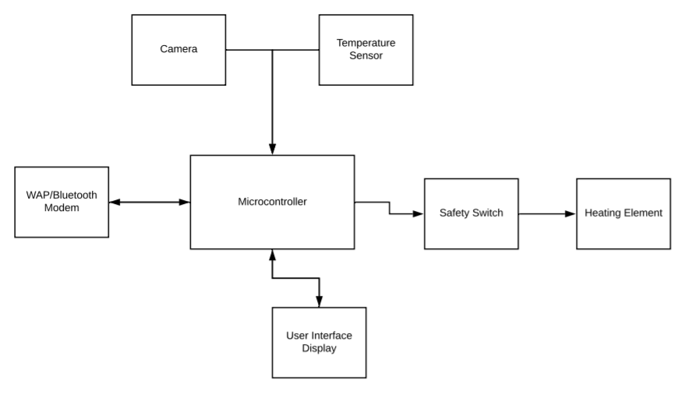
4.12 Hardware Definitions
- Appliance-Heating element: The heating element(s) of the appliance, which will have to be directly controlled by microcontroller per feedback from the temperature sensor to finely control temperature inside the cooking compartment
- Camera: A device to capture images within the cooking compartment in a digital format.
- Microprocessor: A hardware device to provide simple computing functionality and control of attached sensing and actuating devices.
- Temperature sensor: Hardware to detect temperature within the cooking compartment of the appliance.
- User Interface display: An interactive interface on the physical appliance which allows access to functionality and information from the microcontroller.
- WAP / WIFIModem: This hardware enables wireless communications between either the microcontroller and a WLAN switch, or direct peer to peer connections from the microcontroller to a smartphone.
- Electrical cutoff/safety switch: Hardware enables power cutoff to heating elements of appliance.
- Signal conditioning circuits: Hardware possibly needed to properly interface various hardware components

Software
4.21 Software Architecture
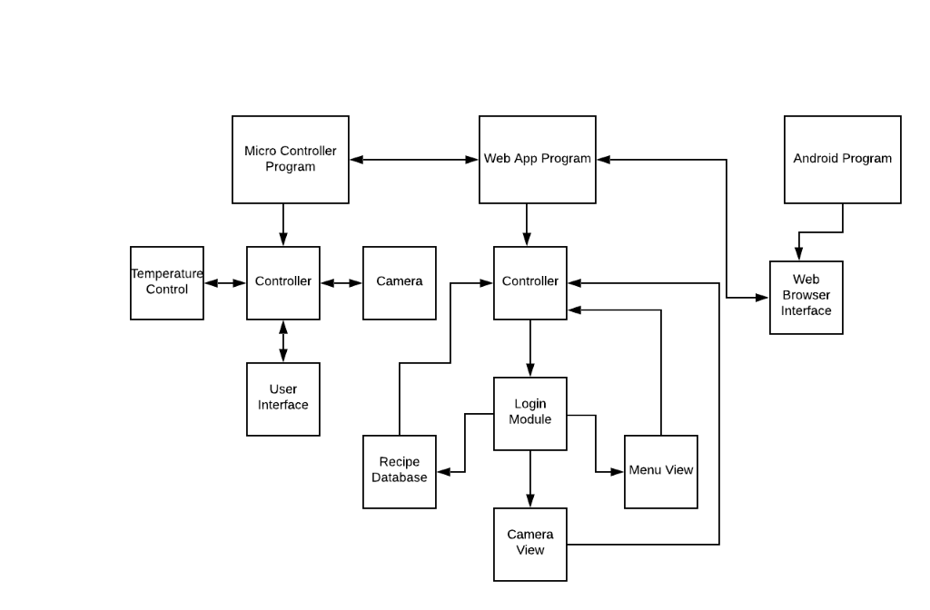
4.22 Software Definitions
Microprocessor Program
- Camera
  - Uploads a picture from the device
- Temperature Control
  - Read/Write Temp
  - Communicates with Temperature Sensor and Safety Switch
    - Safety Switch will set heating element temperature
- Controller
  - Receives input from sensors
  - Determines what actions need to be taken based on input
  - Sends signals to actuators
- User Interface (Main View)
  - Communicates with the controller to submit user input
Web App Program
- Controller
  - Manages what is displayed to the user, and computes incoming information.
- Menu View
  - Displays an interactive menu to the user. Input is received by the controller.
- Camera View
  - Displays an image that is taken from the camera on the device.
- Recipe Database
  - Online database that stores recipes that users have used before and preselected commonly used recipes.
- Module - Login
  - Passwords with encryption. Will connect to device
Android Program
- Web Browser Interface
  - Displays the website hosting the web app
4.23 Software Design Trades
- Wireless Communication Protocol
- Database Management Software
- Platform for the app
- UI Layout
- Password Encryption
- P2P Encryption

Use Case: Optimistic
Countertop Oven cooks food for user
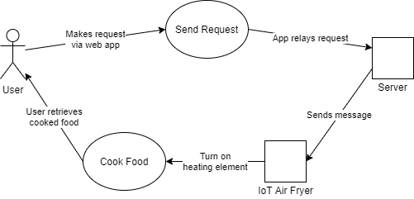

Use Case: Pessimistic
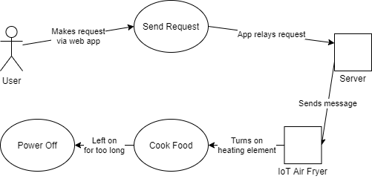

Appendix: Test and Evaluation Master Plan and Report

Hardware Design Trades
Camera | Design Options
Criteria | Pixy Smart Vision Sensor  Cmucam5 | Arducam Mini Shield Mini  5MP OV5642 | Arducam MT9M001 | Waveshare OV9655 | Raspberry Pi Camera Module  v1
Const. 1.0 (Cost) | ~$60 | $40 | ~$40 | $12 | $25
Const. 6.0, Req. 3.2 (Resolution) | 640x480 | 2592x1944,  1920x1080, 1280x720,  640x480, 320x240 | 1280x1024 | 1280x1024, 640x480, 352x240 | 1920x1080, 1280x720, 640x480
Const. 6.0, Req. 3.2 (FPS) | 50 | 15, 30, 60, 60, 120 | 30 | 15, 30, 30 | 30, 60, 60/90
Const. 1.0 (Power Consumption) | 140 mA | 390 mA | 100 mA | 30 mA | 250 mA
Req. 2.2-2.3 (Temperature Range) | Untested | -30 to 70 ℃ | 0 to 70 ℃ | -30 to 70 ℃ | -20 to 60 ℃
Const. 3.0-3.2 (Size) | 53.3x50.8x35.6 mm | 34x24 mm | 44x24 mm | 35.7x23.9 mm | 25x24x9 mm
Const. 3.3  (Weight) | 27g | 20g | 20g | 8.5g | 3g
Ease of use with selected microcontroller | no | no | no | no | yes
Raspberry Pi Camera Module because of its relatively low cost, small size, and especially its compatibility with the Raspberry Pi 1 B+

Temperature Sensor | Design Options
Criteria | SeeeD  Grove - I2C High Accuracy Temp&Humi Sensor (SHT35) | Tinkerforge  Temperature Bricklet TMP102 | AMS  AS6204-EK | National semiconductor LM34DZ
(Const 1.0)  cost | $13.90 | $11.44 | $18.75 | $3.25
(Req 2.1, 2.2, 2.3)  range | -40°C to +125°C | -40*C-125*C | -40*C-125*C | -45*C – 150*C
(Req 2.1, 2.2, 2.3)  precision | +/- .1*C | +/- .5*C | +/- .4*C | +/-0.5*C
(Req 2.1, 2.2, 2.3)  Humidity tracking | Yes | No | No | No
(Req. 4.3, 4.4)  Operating Voltage | 3.3V/5V | 3.6V | 1.8-3.6V | 5-30V
Choice: LM34DZ: We chose the sensor due to 5V which is optimal with the Raspberry Pi’s voltage output and acceptable range and precision at the lowest cost.

Microcontroller Device | Design Options
Criteria | Arduino Nano  33 IoT | Arduino UNO Rev3 SMD | Raspberry Pi 1  Model B+ | Raspberry Pi 3  Model A+ | Raspberry Pi Zero
Const. 1.0 (Cost) | ~$20 | ~$25 | $25-30 | $25-30 | $5
Const. 6.0 (RAM) | 32KB | 2KB | 512MB | 512MB | 512MB
USB connection | 1 | 1 | 3 | 4 | 1
Const. 1.0  (Idle Power Consumption) | 7mA | 50mA | 200mA | 230mA | 100mA
Req. 2.2-2.3 (Temperature Range) | Untested | -40 to 85 ℃ | -20 to 85 ℃ | -20 to 85 ℃ | -20 to 85 ℃
Const. 3.3  (Weight) | 5g | 25g | 50g | 29g | 9g
Choice: Raspberry Pi 1 B+; As the option with best RAM and enough USB connections for all planned sensing devices, as well as for compatibility with selected camera module this option was selected.

Display Device | Design Options
Criteria | Raspberry Pi 7Touch | GeeekPi EP-0085 | UCTRONICS 5-inch touch screen | Newsoul MDS-702 | Foxnovo FBA_1433311LMM45085
Req. 8.1 (Display Technology) | LCD | LCD | LCD | IPS LCD | LCD
Req. 8.1 (Touchscreen Capability) | Yes | Yes | Yes | Yes | Yes
Compatible Microcontrollers | All Raspberry Pis | Raspberry Pi 3 Model A+ | Raspberry Pi 3 Model B+ | Raspberry Pi 1  Raspberry Pi 3B+ | “Ideal for Arduino Board Module” - Will require some adaptation
Const. 3.0-3.2 (Size) | 7 Inch | 7 Inch | 5 Inch | 7 Inch | 2.8 Inch
Const. 6.0, Req. 3.2 (Resolution) | 800 x 480 | 1024 x 600 | 800 x 480 | 1024 x 600 | Not Listed
Const. 1.0 (Cost) | $64.00 | $49.99 | $47.99 | $79.99 | $17.29
Choice: Raspberry Pi 7Touch due to its compatibility with the Raspberry Pi Zero

Software Design Trades
User Interface | Design Options
Criteria | React | Vue.js | Angular | Ember | Raw HTML, CSS, and Javascript
Responsiveness | Fully Responsive | Fully Responsive | Fully Responsive | Fully Responsive | Fully Responsive
Extensibility | Fully Extensible | Fully Extensible | Fully Extensible | Fully Extensible | Fully Extensible
Type | Library | Library | Framework | Framework | Raw Code
Const. 1.0 (Cost) | Free | Free | Free | Free | Free
Team Familiarity | No | Yes | No | No | No
Choice: Vue.js; As all considered options met constraints, the main concern in this selection was team familiarity.

Wireless Communication Protocols | Design Options
Criteria | WiFi | Cellular 4G | Bluetooth
(Req. 3.1)  802.11 g/i compliant | Yes | Yes | Yes
(Req. 3.2)  Frequency bands | 2.4 GHz,  3.6 GHz and 4.9/5.0 GHz bands. | 700 MHz;  1700-2100 MHz; 2500-2700 MHz | 2.4GHz
(Req 3.2)  Range | 100+ meters | Up to 10M miles | 1-100 meters
(Re1 3.2)  Common usage | LAN | Cellular networks | PWAN  LoPWAN
Team Familiarity | Yes | No | No
Choice: WiFi ; With the most options for frequency bands, and an acceptable range for household use as well as team familiarity WiFi was a clear selection.

Database | Design Options
Criteria | Microsoft SQL Server | MySQL | Oracle RDBMS | IBM DB2
Req 5.1 (Compatible Operating Systems) | Windows, Linux | Linux,  Windows | Windows, Linux, Mac | Linux (Unix),  Windows,  Java
Const. 5.0 (Data Size) | 6GB in NTFS | Minimum of 1.5GB, Allocated Dynamically | 10GB | Minimum of 2GB, Allocated Dynamically.
Const. 5.1  (Recommended Ram) | 1GB | 512MB | 2GB | 1GB
Req. 1.0 (Price) | $931 Minimum, $0 if not used commercially | $2,000/year or  $0.18/hour | $5,800/Unit | $1.00/User
Team Familiarity | Yes | No | No | No
Choice: Microsoft SQL Server; We will be using Microsoft SQL Server as we are not developing the project to be used commercially, thus Microsoft SQL Server meets all of our server side requirements while being the only option that our team has experience with.

Password Encryption | Design Options
Criteria | Triple DES | RSA | Blowfish | Twofish | AES
Const. 4.0  (Average Key Length) | 3 keys, with average 56bit length totaling 168bits | 256bits | Dynamic Key Size, 32bits-448bits | 256bits | 192bit – 256bit for heavy duty encryption, otherwise 128bit
Req. 6.1  (Type of Encryption) | Symmetric | Asymmetric | Symmetric | Symmetric | Symmetric
Choice: RSA; RSA is suitable for our needs primarily because it supports having both a public key, and a private key, while also meeting our key size requirement. This will allow optimum security for our clients, as all passwords can be encrypted with the public key by the client, and decrypted with the private key by the server.

Testing and Evaluation Master Plan

Definition of terms:
Test: the act of inspecting or measuring a particular property or capability of the system.
Evaluation: the act of analyzing the results of a test to determine if a particular design requirement, constraint, or standard is satisfied.
Threshold: the minimal performance level for the design to satisfy a particular requirement, constraint, or standard.
Objective: the performance level goal, that is better than the performance Threshold value. In some cases, the sponsor pays a bonus when the design exceeds the Threshold

Test and Evaluation Methods
Requirements
Requirement | Test Method | Evaluation Method | Threshold | Objective
1.1 | Direct observation of time spent cooking with stopwatch | Demonstration of average time of activity with vs without appliance | XX average minutes fewer with appliance | YY average minutes fewer with appliance
2.1 | Direct observation of food internal temperature with handheld food thermometer after cooking in air fryer | Test that the air fryer can achieve an adequate internal temperature (at least 58° C) for the food it cooks | Food should not be below 58 degrees Celsius in temperature | Food should be at or above a temperature of 58 degrees  Celsius
2.2 | Indirect observation of ambient temperature with appliance settings at maximum heating setting by voltage mapping of temperature sensor | Testing of ambient temperature | There must be no measurements above 40 degrees Celsius in 10 out of 10 trials | N/A
2.3 | Indirect observation of ambient temperature with appliance settings at minimum heating setting by voltage mapping of temperature sensor | Testing of ambient temperature | There must be no measurements below 10 degrees Celsius in 10 out of 10 trials | N/A
2.4 | Direct observation of food holding chamber | Inspection of appliance | Must be present | N/A
2.5 | Direct observation with a measuring tool of chamber width. | Inspection of chamber width | Width must be at least 20 cm | N/A
2.6 | Direct observation with a measuring tool of chamber width | Inspection of chamber width | Width must be no more than 55 cm | N/A
2.7 | Direct observation with a measuring tool of chamber depth | Inspection of chamber depth | Depth must be at least 20 cm | N/A
2.8 | Direct observation with a measuring tool of chamber depth | Inspection of chamber depth | Depth must be no more than 40 cm | N/A
2.9 | Direct observation with a measuring tool of chamber height | Inspection of chamber height | Height must be at least 25.5 cm | N/A
2.10 | Direct observation with a measuring tool of chamber height | Inspection of chamber height | Height must be no more than 55 cm | N/A
3.1 | IEEE 802.11g/i standards | Test for IEEE 802.11 compliance | Must comply with standards | N/A
3.2 | Attempt connection and transmission of data to and from | Demonstration of multiple successful connections and transmissions | Must succeed in at least 9 out of 10 attempted connections and transmissions | N/A
4.2 | Direct observation of time before air fryer powers itself off when left on, with cutoff at XX hours | Test that air fryer consistently turns off before XX hours | Air fryer stays on no more than XX hours for 10 out of 10 trials | N/A
4.3 | UL60335 standards | Test for compliance | Must comply with standards | N/A
4.4 | NFPA 70 standards | Test for compliance | Must comply with standards | N/A
4.5 | Direct observation of a NEMA 5-15p connector used to power the appliance | Inspection of a connector and testing of compliance to NEMA 5-15p | Must be present and comply with standard | N/A
5.1 | Check the operating system running on the server | Inspection of operating system present | Must be Windows or Linux | N/A
6.1 | Observation of asymmetric encryption for sending passwords between appliance, server, and user’s smartphone | Demonstration of asymmetric encryption | Must use asymmetric encryption for sending passwords | Appliance encrypts with public key, Server decrypts with private key
7.1 | Direct observation of appliance responding to wireless input from user’s smartphone | Demonstration of response | Must respond in 9 out of 10 trials | N/A
7.2 | Direct observation of attempts to connect to appliance with a device before and after the device is authorized | Demonstration of failed connection attempts by unauthorized device and successful connection with authorized device | Appliance must deny access until device is authorized | Appliance allows connection once device is authorized
7.3 | Direct observation of an Android 5.1+ compatible partner application | Demonstration of partner application running on Android 5.1 | Must be present | N/A
7.4 | Direct observation of using the web application on a desktop computer | Demonstration of | Must be present | N/A
7.5 | Direct observation of using the web application on a tablet device | Presence or absence | Must be present | N/A
7.6 | Direct observation of using the web application on a mobile device | Presence or absence | Must be present | N/A
7.7 | Direct observation of updates to the web and partner applications | Demonstration of released updates | Must be within X months apart from each other | Updates continue for at least 3 years from product release date
7.8 | Direct observation of wireless input forwarded from the user through the server to the appliance | Demonstration of sending information from the user’s device to the server and subsequently receiving information from the server to the air fryer | Must be present | N/A
8.1 | Direct observation of a touch screen used to interface with the appliance | Demonstration of interfacing with air fryer with its attached touch screen | Must be present | N/A

Constraints
Constraint | Test Method | Evaluation Method | Threshold | Objective
1.0 | Itemized cost of all needed components from source | Inspection of bill of materials | Total cost will not exceed $200 | N/A
1.1 | Cost of appliance from source | Comparison of cost against budget limit | Total appliance cost will not exceed $50 | N/A
2.0 | Direct observation with a measuring tool of appliance power connector | Comparison of measurements against provided values of NEMA 5-15R | Connector will be in compliance with NEMA 5-15R | N/A
3.0 | Meterstick | Inspection of appliance height | Height must be within 0.5 cm of 45 cm | N/A
3.1 | Meterstick | Inspection of appliance depth | Depth must be within 0.5 cm of 45 cm | N/A
3.2 | Meterstick | Inspection of appliance width | Height must be within 0.5 cm of 60 cm | N/A
3.3 | Mass scale | Inspection of appliance weight | Weight must be within 0.5 kg of 20 kg | N/A
4.0 | Direct observation of encryption keys | Demonstration of encrypting password using 200+ character key | Key must not contain fewer than 200 characters | N/A
5.0 | System report | Demonstration of server Hard drive capacity | Capacity will not be below 6 GB | N/A
5.1 | System report | Demonstration of server RAM capacity | Capacity will not be below 2 GB | N/A
6.0 | System report | Demonstration of microcontroller RAM capacity | Capacity will not be below 512 MB | N/A

Standards
Standard | Test Method | Evaluation Method | Threshold | Objective
1 | Collection of data relevant to NFPA 70 | Analysis of data against specifications of standard | Compliance with standard | N/A
2 | Collection of data relevant to UL60335 | Analysis of data against specifications of standard | Compliance with standard | N/A
3 | Collection of data relevant to NEMA 5-15P | Analysis of data against specifications of standard | Compliance with standard | N/A
⁞4 | Collection of data relevant to IEEE 802.11g/i | Analysis of data against specifications of standard | Compliance with standard | N/A

