Computer Architecture Course
LAB 1
Running Assembly Code on the
Arm Education Core
INSTRUCTOR’S VERSION
Issue 1.0

Contents
1 Introduction 1
1.1 Lab overview 1
2 Requirements 1
3 What is the Arm Education Core? 1
4 Coding in Arm Assembly 2
5 String copy in Arm Assembly 3
5.1 Exercise: Initializing content in memory 3
5.2 Exercise: Assembling instructions and generate Verilog memory model file 5
5.3 Task: Generate Verilog memory model file from ELF file 7
5.4 Testbench for Arm Education Core 8
5.4.1 Task: Using Arm Education Core’s testbench for simulation 10
5.5 Task: Verifying Assembly code on Arm Education Core 11
5.6 Exercise: Creating a string copy operation 14
6 Summary 16
7 Additional references 17

Introduction

Lab overview
At the end of this lab, you will be able to:

- Create and modify an assembly source file that uses Armv8-A AArch64 instructions.
- Use the GCC compiler to assemble AArch64 instructions.
- Generate a hexadecimal Verilog memory model file from an ELF file to load onto the Arm Education Core.
- Compile and simulate Assembly code on a single-cycle processor (Arm Education Core) with a testbench file provided.
- Verify Assembly code using the Arm Education Core.
- Write a string copy operation using Armv8-A AArch64 instructions.

Text and diagrams outlined in red are for instructors only.

Requirements
Before attempting Lab 1, ensure that you have already completed the installation instructions in the Getting Started Guide provided with this course.
The prerequisites for this lab are:
- Familiarity with Arm assembly
- Verilog (2005)
Lab 1 exercise comes with supporting files provided in Educore-SingleCycle.zip.

What is the Arm Education Core?
Arm Education Core is an educational processor that implements a subset of the Armv8-A ISA. It is one implementation of the Armv8-A architecture and has limited functionality. It was developed purely for educational purposes and to demonstrate some computer architecture concepts. See the Introduction to Arm Education Core document provided in the Getting Started folder for more information. Please refer to the Arm Education Introduction to Computer Architecture Education Kit End User License Agreement for terms of usage of Arm Education Core.
In this lab, we will run a simple Arm Assembly code on the Arm Education Core. The Arm Education Core that is provided with this lab is a single-cycle processor, where an instruction is processed in a single clock cycle.

Coding in Arm Assembly
An Arm Assembly source file typically contains a sequence of statements. Each statement has three optional parts in the following order:
label statement // comment
For example:
mylabel MOVZ X0, #1 // move 1 to register X0
MOVZ X1, #2 // move 2 to register X1

- A label identifies the address of the instruction. It can be used as a target for branch instructions, or for certain load and store instructions. If the line has no label, a space or tab delimiter can be used to start the line.

- A statement can either be an assembly instruction, assembler directive, or a macro. An assembler directive tells the assembler to do certain things, and these directives do not generate machine language instructions. A macro is a text substitution representation.

- In the above example, the # symbol specifies the immediate value. An assembly instruction is encoded in terms of 1s and 0s, which a processor will have to decode to interpret the instruction. An immediate value is value or data stored as part of the instruction encoding itself. More information on instruction encodings will be covered in the next lab manual.

- The MOVZ instruction moves a 16-bit immediate value to a register. For more information, see MOVZ instruction in Additional references.

In this course lab, we will be introducing several assembly directives:
.text | Executable code is typically specified in the .text section.
.global symbol | Tells the assembler that the symbol or label is to be made globally visible to other source files and to the linker.
.data | Data for the code is typically placed in the .data section, which are used in the test cases for the final lab.

For more information on the Armv8-A A64 Instruction Set, see The A64 Instruction Set in Additional references.

String copy in Arm Assembly
In this exercise, we will write an Assembly source file that performs a string copy function. A C-program-equivalent function would be something like strcpy(const char *src, char *dst). This function will load a character from memory, save it to the destination pointer, and increment both pointers until the end of the string.
For the exercises in the lab, we assume that:
- The source pointer *src is to be stored in register X0 and that it is pointing to address 0x0050.
- The destination pointer *dst is to be stored in register X1 and that it is pointing to address 0x013C.
- The characters “e” (ASCII 0x65) and “f” (ASCII 0x66) are stored in memory.

Exercise: Initializing content in memory
In the Getting Started Guide, we have created a workspace for the labs (C:\Workspace). We will now create the string copy Assembly source file.
- In your working directory, create a folder called Lab_1 (C:\Workspace\Lab_1).

- In Lab_1 folder, create an empty text file called test_STRCPY.s and type the following code in the created file:
.global _start
.text
_start:
Note: It is not a fixed rule that all label names must begin with an underscore. Underscores are typically used when it has to integrate with a higher level language like C, where some C compiler uses this convention to be able to be callable from a C code.

- Under the _start label:
  - Use the MOVZ instructions to initialize the source address (0x0050) in register X0 and destination address (0x013C) in register X1, respectively.
MOVZ X0, #0x0050
MOVZ X1, #0x013C
  - Then, use the MOVZ instructions to shift value 0x65 in register X5 and value 0x66 in register X6.
MOVZ X5, #0x65
MOVZ X6, #0x66
- Next, copy the following code to use the STURB instruction to load the values into memory:
STURB X5, [X0]
STURB X6, [X0, #1]
STURB WZR, [X0, #2]

Your code should look similar to the following snapshot:

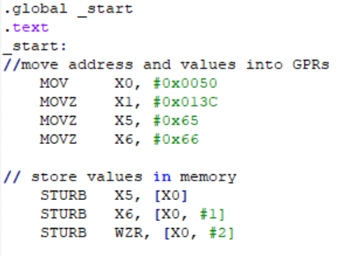

Note:
- Arm Education Core has limited functionality and only supports a limited subset of the Armv8-A ISA. The Arm Education Core does not currently support the store instruction variant STR <Xt>, [Xn] as this instruction can be assembled in many ways of which the opcode is unsupported by the Arm Education Core. However, the Arm Education Core supports the STUR (Store Register Unscaled) instruction, which can give the same outcome. There are also specific STUR instructions depending on the data size to store, such as STURB and STURH.
- The difference between STR and STUR is that the STUR is the Store (unscaled) Register instruction that allows accessing 32/64-bit values that are not aligned to the size of the operand. This is unlike the STR operation, which requires the immediate offset to be in multiples of 4 or 8. However, STR and STUR instructions in this case gives the same result; therefore, we will be using STUR for the Arm Education Core instead.
- For more information on STR and STUR instructions, see the A64 Base Instructions in Additional references.

- Save the file.

Answer the following question:

- What does the STURB instruction do? How is STURB different from STUR? (Hint: See the A64 Base Instructions in Additional references)
STURB—Store Register Byte (unscaled) calculates an address from a base register value (X2) and an immediate offset (if specified with instruction) and stores a byte to the calculated address, from a 32-bit register. STUR would store a word (32 bits) rather than a byte.

- What is WZR and how many bits wide is WZR? (Hint: Read about Zero register in Additional references)
WZR is a zero register, whereby all bits are zeros. WZR is a 32-bit register. On the other hand, XZR is 64-bit. The zero register reads as zero when used as a source register and discards the result when used as a destination register. You can use the zero register in most, but not all, instructions.

- What does instruction STURB WZR, [X0, #2] do?
Stores a byte of zeros to address 0x52 (0x50+2).

- What location address is the value of register X6 intended to be stored to?
(0x0050 + 1 = 0x0051).

Exercise: Assembling instructions and generate Verilog memory model file
To assemble test_STRCPY.s using the GNU C compiler (GCC) that is included in the GNU Toolchain for the A-profile Architecture, follow these steps:
- Ensure that you are in the same directory as test_STRCPY.s.

- Run the following command:
aarch64-none-elf-gcc -nostdlib -nodefaultlibs -lgcc -gdwarf-4 -Wa,-march=armv8-a -Wl,-Ttext=0x0 -Wl,-N -o test_STRCPY.elf test_STRCPY.s
Note: In the Getting Started Guide, you have downloaded the GNU Toolchain for the A-profile Architecture that contains the GNU C Compiler (GCC). GCC recognizes the assembly file as an input and automatically invokes the GNU assembler and GNU linker. Running this command will generate an ELF file that contains the object code. The following table describes the switches used.
Command/switch | Description
aarch64-none-elf-gcc usage | aarch64-none-elf-gcc [option switches] [input file]
-nostdlib  -nodefaultlibts  -lgcc | Specify to not use standard system startup files or libraries when linking. Bypass libgcc.a, a library of internal subroutines GCC. Example of internal subroutine is __main. The -lgcc option ensures that you have no unresolved references to internal GCC library subroutines.
-gdwarf-4 | Produce debugging information in DWARF version 4 format. DWARF is a debugging file format used by the compiler to support source-level debugging. It is also the format of debugging information within an object file.
-Wa,-march=armv8-a | Target architecture is Armv8-A; this setting is passed to the assembler with the -Wa switch.
-Wl, -Ttext=0x0 | -Ttext=0x0 specifies starting address (0x0) for the output file; this setting is passed to the linker with the -Wl switch.
-Wl, -N | -N sets the text and data sections to be readable and writable. Also do not page-align the data segment. This setting is passed to the linker with the -Wl switch.
-o | Specify the output filename

You would have observed the following error:
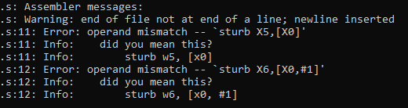
  - What is a W register and how does it differ from an X register? For example, how is register W5 different from register X5? (Hint: Read the A64 General-Purpose Registers in Additional references)
The X registers are 64-bit wide, and the W register is 32-bit wide. The W register maps to the lower half of the corresponding X register. For example, W0 maps to the lower word (32-bits) of X0, and W1 maps to the lower word of X1.

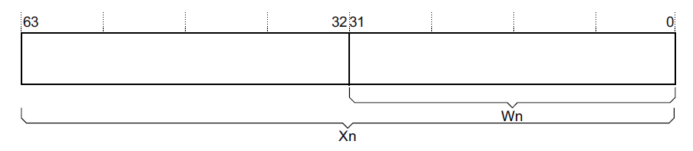

  - Why should the first operand STURB be a W register instead of an X register? (Hint: See the A64 Base Instructions in Additional references)
The syntax for these instructions is specified in the Arm Architecture Reference Manual.
In terms of instruction usage, since these instructions are transferring data in terms of byte size, it does not need the usage of X registers, i.e., W registers would suffice given that the instruction encoding also allows space for a signed immediate offset in the range of −255 to 255.

- Fix the above error and rerun the command to assemble test_STRCPY.s. Ensure that there are no errors and an ELF file is generated.
Replace STURB X5, [X0] with STURB W5, [X0].
Replace STURB X6, [X0, #1] with STURB W6, [X0, #1].

- What is the default endian setting for the GCC compiler if no specific endian switches are specified?
Little-endian. This means that the least significant byte of the data is placed at the lowest address. Subsequent bytes are stored subsequently in order.

Task: Generate Verilog memory model file from ELF file
To convert the generated ELF file into encodings arranged in Verilog Memory Model format so that Arm Education Core can read it easily, follow these steps:
- Ensure that you are in the same directory as test_STRCPY.elf.

- Run the following command:
aarch64-none-elf-objcopy -O verilog test_STRCPY.elf test_STRCPY.mem
Command/switch | Description
aarch64-none-elf-objcopy | aarch64-none-elf-objcopy [option switches] [input file] [output file]
-O verilog | Set output target as Verilog Memory Model hexadecimal format, which is suitable for loading memory models of HDL simulators.

Observation: The contents of the generated .mem file should look like this:

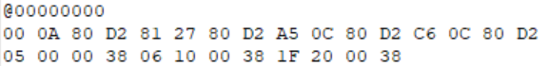
We will take a closer look at the meaning of these encodings in the next lab manual.

Testbench for Arm Education Core
Arm Education Core comes along with a testbench Verilog file called test_Educore.v. This testbench file instantiates the processor core module named Educore and defines the unified data and instruction memory called memory, as shown in Figure 1.
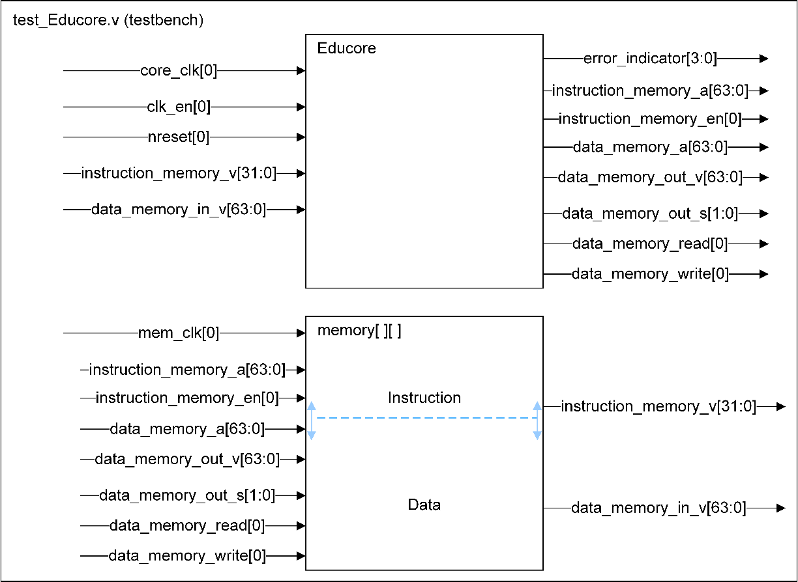
Figure 1: High-level view of the testbench and module Educore. The testbench contains a unified memory containing both instruction and data. Note that the instructions are always at the top of the memory.
We will learn more about these signals in Task: Verifying Assembly code on Arm Education Core.

Clock and ratios
The testbench defines 3 different clocks:
- main_clk: This is the main clock running at simulation tick.
- core_clk: This is the clock feeding into the module Educore (Arm Education Core).
- mem_clk: This is the clock feeding into memory in the testbench.
To simplify the memory implementation for Arm Education Core in this lab without requiring the need for asynchronous bridges between Educore and memory, we have set core_clk to never be faster than mem_clk to prevent data loss. If the mem_clk is too slow relatively to core_clk, the memory may miss events coming from Educore. For now, do not change the clock ratios in the testbench file unless instructed in the labs. Changing the clock ratios may produce unpredictable results.

Memory
Although Arm Education Core has separate busses for instruction and data accesses, the testbench uses a unified memory. This means both instruction and data are stored in a 64KByte 2D array (8 bit by 2^16) called memory. The unified memory has no memory protection or hard boundary to separate instruction and data; therefore, your Assembly code must not cause an overlap between instructions and data (see Figure 2)—especially since the array is 8 bit wide and so a 32-bit instruction will easily take up 4 entries.
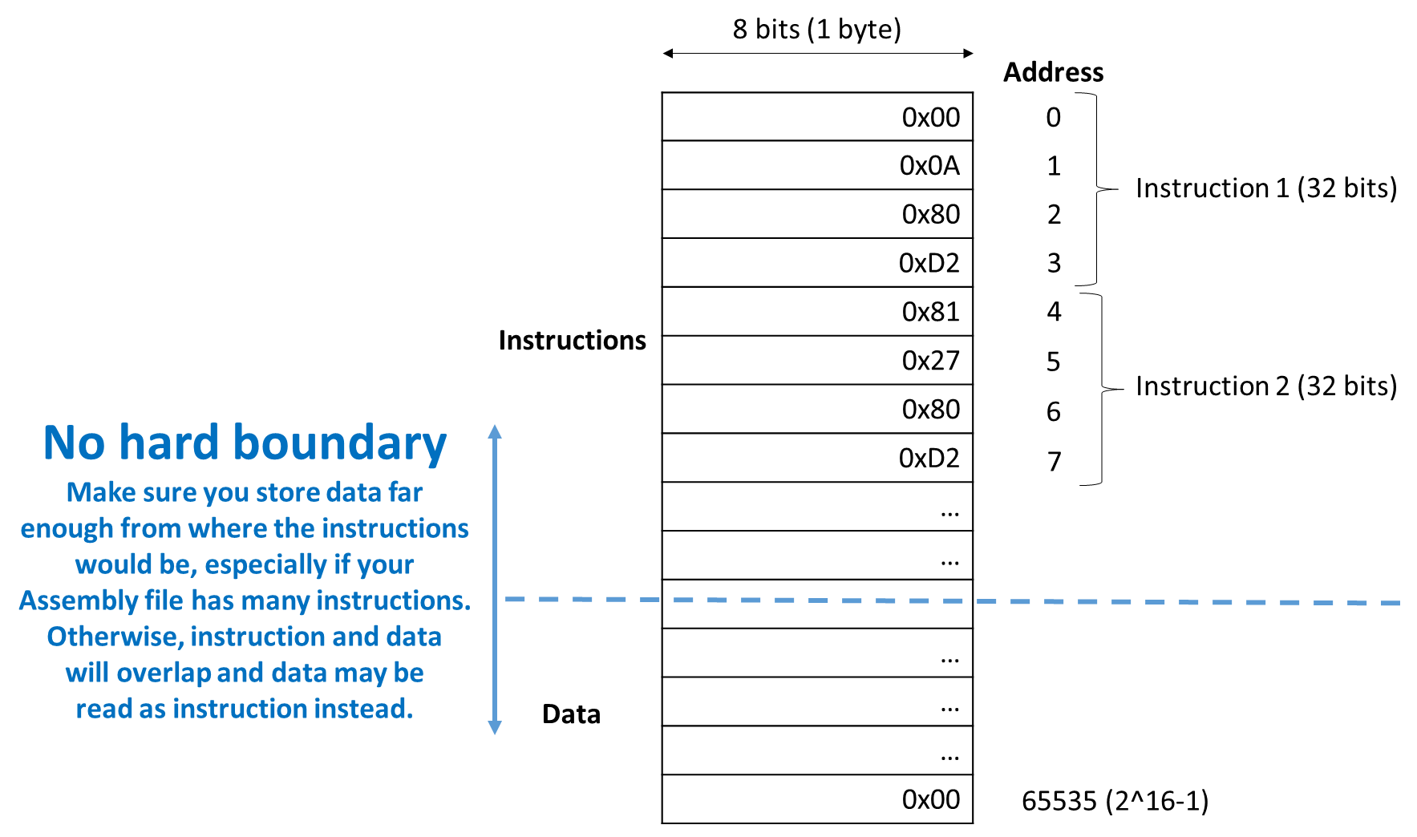
Figure 2: Unified memory in test_Educore.v file. The instructions are always at the top of the memory. The data can be placed at any location specified by the user. The light blue dashed line in memory indicates that there is no fixed boundary between instruction and data in the unified memory. Therefore, the user needs to ensure that any data stored (using the STURB instruction, for example) is placed in a far enough location from the instructions so that the instructions and data do not overlap.

Instruction read and data read/write are synchronized to the positive edge of mem_clk.
Note:
- The testbench loads the Assembly instructions .mem file using $readmemh.
- When nreset=0, instruction value in the testbench is assigned a NOP instruction to prevent Xs from being read into the single-cycle Arm Education Core.

Error indicator
The testbench also waits for an error indicator from the Arm Education Core:
- If error_indicator = 0, the simulation will not finish.
- If error_indicator = 1, there is an undefined error (e.g., an instruction that Arm Education Core does not support)
- If error_indicator= 2, Arm Education Core detected a YIELD instruction. You can place a YIELD instruction as the end of your Assembly source file to indicate that all instructions have been processed. The testbench will halt simulation automatically when a YIELD instruction is detected.

Task: Using Arm Education Core’s testbench for simulation
To run an assembly code on Arm Education Core, you will first need to indicate to the testbench to finish simulation once all your instructions have been processed:
- Modify test_STRCPY.s to add the YIELD instruction at the end of your Assembly code.
// store values in memory
STURB W5, [X0]
STURB W6, [X0, #1]
STURB WZR, [X0, #2]
YIELD

- Save the file. Recompile the Assembly source file and convert the ELF file into encodings, similar to what was done in the previous exercise:
aarch64-none-elf-gcc -nostdlib -nodefaultlibs -lgcc -gdwarf-4 -Wa,-march=armv8-a -Wl,-Ttext=0x0 -Wl,-N -o test_STRCPY.elf test_STRCPY.s
aarch64-none-elf-objcopy -O verilog test_STRCPY.elf test_STRCPY.mem

Task: Verifying Assembly code on Arm Education Core
To run an Assembly code on Arm Education Core, you first need to compile and simulate the Arm Education Core using Icarus Verilog. Follow these instructions:
- Copy and extract Educore-SingleCycle.zip into your Lab_1 folder.

- Open a Windows terminal and change directory into the unzipped Educore-SingleCycle folder.
cd Educore-SingleCycle
Note: In Educore-SingleCycle folder, there are 3 folders:
- src\ contains the Verilog source files
- head\ contains the Verilog header file
- tests\ contains the testbench for the Arm Education Core.

- Compile the Arm Education Core using the following command:
iverilog -Wall -Wno-timescale -Wno-implicit-dimensions -I head/ -t vvp -y src/ -s test_Educore src/* tests/* -o test_Educore.vvp
Command/switch | Description
iverilog | iverilog [option switches] [sourcefile]
-Wall | Enable all warnings
-Wno-timescale | Disable warnings for inconsistent use of timescale directive
-Wno-implicit-dimensions | Disable warnings for creation of implicit declarations
-I | Specify include directory for header file
-t | Specify target (vvp)
-y | Append directory to module search path
-s | Specify top-level module
-o | Specify output file name

- Simulate Arm Education Core using the following command, noting that test_STRCPY.mem is in the directory hierarchy 1 level above:
vvp test_Educore.vvp -lx2 +TEST_CASE=../test_STRCPY.mem

Command/switch | Description
vvp | vvp [option switches] inputfile [extendedargs]
-lx2 | Dumps out waveforms in lx2 (LXT2) format
+TEST_CASE=../test_STRCPY.mem | The + operator passes the arguments to the vvp file, which would be picked up by $value$plusargs in the testbench file.

- When the simulation is complete, a dump.lx2 file is created, and you should get the following message in the windows terminal:
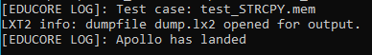
Note: If you are getting the message [EDUCORE ERR]: Houston, we got a problem instead, ensure that you have inserted the YIELD instruction and recompiled and generated the correct .mem file.

- Use GTKWave to check contents on the waveform by using the following command:
gtkwave dump.lx2
Note: If you want to run GTKWave in the background (similar to Unix command “&”), use the start "" gtkwave dump.lx2 command in your Windows terminal.

- Add the following signals to view the waveform:

<module name>/<signal name> | Description
test_Educore/core_clk | Clock signal for Arm Education Core
test_Educore/mem_clk | Clock signal for memory in testbench
test_Educore/nreset | Active-LOW asynchronous reset signal in Arm Education Core
Educore/nreset_sync | Synchronizes nreset to next rising edge of core_clk
Educore/instruction_memory_en | Instruction memory read enable signal
Educore/instruction_memory_a | Instruction memory address
Educore/aligned_pc | 64-bit Program Counter of Educore
Educore/instruction_memory_v | Instruction value
Educore/instruction | Instruction fetched
register_file/rX00, rX01, rX05, rX06 | Registers X0, X1, X5, and X6
test_Educore/data_memory_write | Data memory write control. Set to 1 to write data.
test_Educore/data_memory_out_v | Data memory write value
test_Educore/data_memory_a | Data memory address
test_Educore/error_indicator | 0—no error (no halt)  1—undefined error  2—YIELD instruction detected

- In the GTKWave window, select File > Write Save File As and save as the name debug.gtkw. This will save the signal filters that you can reuse in other simulations, instead of dragging the signals manually again. Ensure that this file is in the same folder location as dump.lx2. Then, click OK (we will be using this file in the next exercise).

- Verify that the register contents are as expected, as shown in the snapshot below.
Note: You can right-click on the signal and select Data Format to Decimal or Hexadecimal.

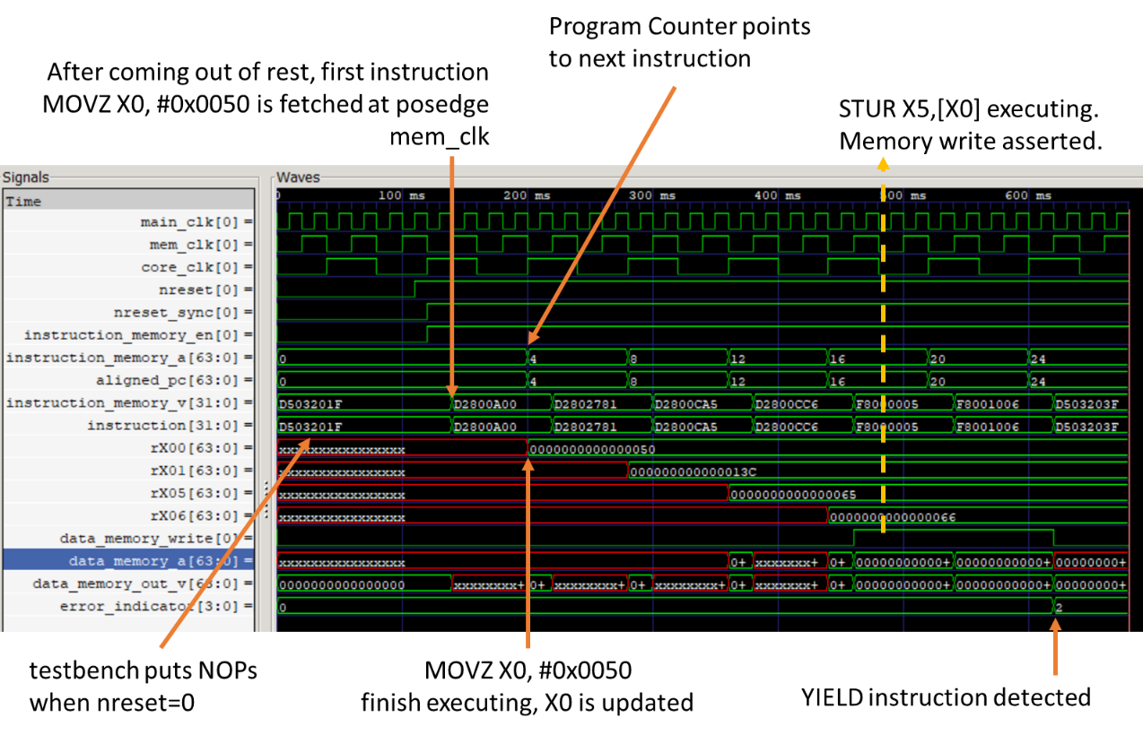

Observations:
- When nreset=0, the testbench puts NOPs into instruction_memory_v—this was a workaround to prevent Arm Education Core from reading in Xs briefly after coming out of reset.
- Arm Education Core’s program counter (aligned_pc) points to the address of the instruction to be fetched. aligned_pc increments in a multiple of 4. This is because the instruction width is 4 bytes (32 bits).
- At the rising edge of core_clk, register X0 (rX00) has already been updated by value 0x50, corresponding to the first instruction (MOVZ X0, #0x0050). At the end of the second cycle, register X1 has been updated.
- When STURB X5, [X0] is executing, the data_memory_write signal is asserted:
  - data_memory_out_v = 0x65
  - data_memory_out_a = 0x50

Exercise: Creating a string copy operation
In this exercise, we will create a string copy operation.

- Copy the following code for _strcpyloop (shown in blue below) into test_STRCPY.s file so that the contents of the file are as shown below. Ensure that the YIELD instruction is the last in the file.
.global _start
.text
_start:
//place move instructions here
MOVZ X0, #0x0050
MOVZ X1, #0x013C
MOVZ X5, #0x65
MOVZ X6, #0x66

// store values in memory
STURB W5, [X0]
STURB W6, [X0, #1]
STURB WZR, [X0, #2]

//strcpy operation
_strcpyloop:
LDURB W2, [X0] // Load byte into X2 from memory pointed to by X0 (*src)
ADD X0, X0, #1 // Increment src pointer
STURB W2, [X1] // Store byte in X2 into memory pointed to by X2 (*dst)
ADD X1, X1, #1 // Increment dst pointer
CMP X2, #0 // Was the byte 0?
BNE _strcpyloop // If not, repeat the _strcpyloop
YIELD
The string copy operation first loads a byte from memory address pointed by the source pointer. It then increments the source pointer by 1 and then stores the loaded byte into the memory at an address pointed by the destination pointer. The destination pointer is then incremented by 1. This whole operation repeats and only ends after the byte loaded and stored has the value 0.

Note:
- Arm Education Core only has limited functionality and only supports a limited subset of the Armv8-A ISA. Arm Education Core does not currently support the LDR <Xt>, [Xn] instruction as this can be assembled in many ways of which the opcode is unsupported by Arm Education Core. However, Arm Education Core supports the LDUR (Store Register Unscaled) instruction, which can give the same outcome. There are also specific LDUR instructions depending on the data size to store, such as LDURB and LDURH.
- The difference between LDR and LDUR is that the LDUR is the Load (unscaled) Register instruction that allows accessing 32/64-bit values that are not aligned to the size of the operand. This is unlike the LDR operation, which requires the immediate offset to be in multiples of 4 or 8. However, LDR and LDUR pre-index instructions in this case gives the same result; therefore, we will be using LDUR for Arm Education Core instead.

  - What does the LDURB instruction do? How is LDURB different from LDUR? (Hint: See the A64 Base Instructions in Additional references)
Load Register Byte (unscaled) calculates an address from a base register ([X0]) and an immediate offset (if specified with instruction), loads a byte from memory, zero-extends it, and writes it to a register.

- Save the file and recompile using aarch64-none-elf-gcc and the switches shown in the previous exercise.
cd Lab_1
aarch64-none-elf-gcc -nostdlib -nodefaultlibs -lgcc -gdwarf-4 -Wa,-march=armv8-a -Wl,-Ttext=0x0 -Wl,-N -o test_STRCPY.elf test_STRCPY.s
aarch64-none-elf-objcopy -O verilog test_STRCPY.elf test_STRCPY.mem

- Provide a snapshot of its register content (including Register X2) waveforms below to show that it is working.
cd Educore-SingleCycle
vvp test_Educore.vvp -lx2 +TEST_CASE=../test_STRCPY.mem
gtkwave dump.lx2 debug.gtkw

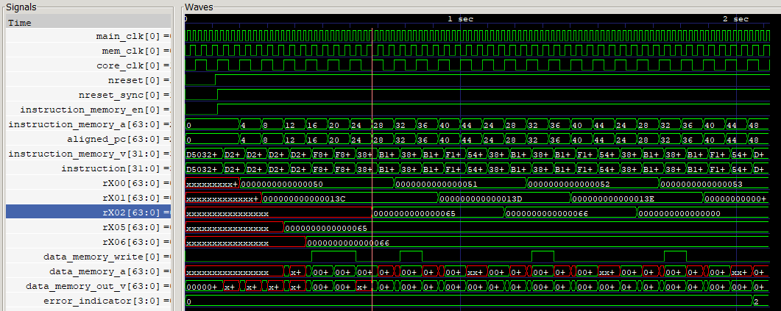
Students should notice that the contents of register X2 have the value 0x65, followed by 0x66 and 0x0.

- Reduce the number of instructions in _strcpyloop so that it does not require the use of ADD to increment the pointers. Recompile the Assembly code, generate .mem file, and re-simulate on Arm Education Core to verify correct behavior. (Hint: Arm Education Core supports the post-index increment variant for LDRB and STRB instructions as the load/store post-index instruction type has a distinct encoding, and therefore do not get assembled in various ways. See A64 Base Instructions in Additional references.)

_strcpyloop:
LDRB W2, [X0], #1
STRB W2, [X1], #1
CMP X2, #0 // Was the byte 0?
BNE _strcpyloop // If not, repeat the _strcpyloop
When simulating, students should also notice what the post-index increment would also change (increment) the register values of X0 and X1.

Summary
In this lab, we have run an Assembly code on the single-cycle Arm Education Core. We did a simple string copy operation using Armv8-A instructions. However, how does Arm Education Core recognize these instructions in order to process them? Each instruction is encoded, as we have seen in the generated .mem file. In the next lab, we will interpret these encodings and observe how immediate values are encoded in the instruction itself.

Additional references
A64 Base Instructions
- https://developer.arm.com/docs/ddi0596/g/base-instructions-alphabetic-order

The A64 instruction set
- https://developer.arm.com/docs/den0024/a/the-a64-instruction-set

A64 General-Purpose Registers
- https://developer.arm.com/architectures/learn-the-architecture/armv8-a-instruction-set-architecture/registers-in-aarch64-general-purpose-registers

Zero register
- https://developer.arm.com/docs/den0024/a/armv8-registers/aarch64-special-registers/zero-register
- https://developer.arm.com/docs/den0024/latest/an-introduction-to-the-armv8-instruction-sets/the-armv8-instruction-sets/registers
- https://developer.arm.com/docs/den0024/latest/armv8-registers

MOVZ instruction
- https://developer.arm.com/docs/100076/0100/instruction-set-reference/a64-general-instructions/movz

Icarus Verilog User Guide, commands, and arguments
- https://iverilog.fandom.com/wiki/User_Guide
- https://iverilog.fandom.com/wiki/Iverilog_Flags

VVP commands and arguments
- https://iverilog.fandom.com/wiki/Vvp_Flags

Simulation
- https://iverilog.fandom.com/wiki/Simulation

GTKWave manual
- http://gtkwave.sourceforge.net/gtkwave.pdf

arm-none-eabi-as command
- https://manned.org/arm-none-eabi-as/a7ae4940

Arm Cortex-A Series Programmer’s Guide for Armv8-A
- https://developer.arm.com/docs/den0024/a/preface

GNU manual
- https://gcc.gnu.org/onlinedocs/gcc/Option-Summary.html

Arm Education Core
- Introduction to Arm Education Core document (provided in the Getting Started folder)

