**Project Plan Documentation**

**Jade Gorton - 7100288111**

**Project Management**

**Project Plan**

Contents

Introduction 3

Project Scope 4

Software Development Methodology Analysis 6

Software Management Tools 9

Project Methodology Email 11

Sign off 12

Bibliography 13

Understanding and Selecting Systems Development Life Cycle (SDLC) Methodologies 13

Microsoft Project vs. SmartSheet vs. OpenProj 13

OpenSource: OpenProj vs Microsoft Project 13

OpenProj v. Microsoft Project 2007 13

Git hub features 13

# Introduction

This project plan will, include process and research phase of the project.  
It will outline best suited strategies for managing this specific project.

Once software development methodology has been selected reasons why it’s best suited for project be explained and listed why it’s best for this project. Project plan be made reflect chosen methodology.

Comments on Code source Control & Collaboration management will be provided and also how I would handle project if I had additional staff in project collaborate with

# Project Scope

After sending few emails regarding requirements this program needs to meet and specifications for the program. I managed put together script of appointments we had and what I view as requirements.

“Mister Sparkly” is a company that manufactures and sells laundry detergent.

The company started its operations in 2009 and has been growing rapidly and now has several employees that work in various departments namely: Administration, Sales, Purchasing, Production, and Logistics.

Mister Sparkly purchases raw materials from a variety of suppliers by sending them with a purchase order. The raw materials go through a series of process to produce laundry detergent that gets bottled in to different popular brands.

The sales agents sell the detergents to the increasing number of retailers in their allocated area in various states and a retailer is assigned to one sales agent. The retailers can **only** place their orders with the sales agents and the agents forward the orders to the Administration department to be processed by creating a Sales Order.

With Mister Sparkly’s growth, the company would like to have an integrated system that would handle the company’s sales and purchasing, as well as managing its products, raw materials, suppliers, customers, and employees.

Mister Sparkly would like the system to do the following:

* Ability to manage the growing list of suppliers
* Ability to manage the list of materials
* Manage the purchasing of raw materials from suppliers
* Ability to manage the growing list of retailers
* Ability to manage the list of different brands of detergents
* Handle the sales of detergent to the retailers by the company’s sales agents
* Ability to manage the growing list of employees including the sales agents.

The security of the system is paramount and so they would like to assign different access rights to different users. Some users may have limited access to the features of the application. For example, users in Purchasing may enter new materials but cannot enter new products; some users in Sales are able to enter sales but can only read the product details; or some users may have administration rights where they can access every feature of the application. Each user will have their own user logins and one user will only be allocated with one login; there will be no cases where one user will have multiple access rights.

Mister Sparkly wants the Ordering / Sales system done in the first stage of the project and wants it to start immediately. The Purchasing system will be done in the second stage of the project and will start upon advice by Mister Sparkly.

This Document will outline and explain chosen methodology, code management and collaboration management tools.

# Software Development Methodology Analysis

A methodology is clearly defined process. A methodology is collection of practices, procedures and rules that follow set procedure of rules to be utilized to achieve smooth development and implementation of requirements for the developed software.

Required process to achieve successful project many refer to Software Development Life Cycle or (SDLC) the goal of SDLC is to define steps and process from beginning of project through until its successful completion. Process of SDLC is cycle in which projects have beginning and end. End of project can be used continue legacy for birth of new projects.

Typical industry used SDLC have five steps. Requirement analysis, Design, Development, Testing and Implementation. Other methodologies have sprang up with different ways implementing five steps above as alternative to traditional methods of software development.

Researching methodologies that could be applicable for Mr Sparkly Program Development following methodologies. Discussing different methodologies that can be utilised for this project with pros and cons using within this project requirements and project structure. Determining requirements for project prior to selecting appropriate methodology is crucial.

Waterfall

This was first formal methodology for controlling process for software development, this methodology is also ground foundation for all other SDLC methodologies. They simply change order of steps are achieved. What defines waterfall method is that each Process steps falls in downward style that once step is achieved never go back to previous step. Hence name for waterfall as never saw waterrise in nature. Each phase has dependency on previous phase that it requires process be completely finished before continuing.

This phase breaks down everything based on prerequisite requirements and everything can be finished in cascading fashion each phase needs approval and have requirements defined & designed before developing the application. Once development is finished and functionality is made testing the product for if it meets requirements is then done. Once it meets requirements from testing move to implementing solution to business environment.

Then there is ongoing machine and operation phase.

Spiral

Spiral method closely follows waterfall besides repeating analysis and design phases that repeat in quick succession to produce prototypes of product.

The spiral method follows cascading approach of waterfall however includes repeating requirements and design phase for designing Prototypes. Each prototype cycle produces closer product to requirements needed. When you define scope & start analysing requirements you create prototypes operation requirements and then move onto design prototype. Once have finished prototype you go onto development and continue normally like waterfall.

Agile/Extreme

Agile programming is departure to typical SDLC methodologies and has focus in compressing time within scope. Focused on using time driven approach instead requirements driven, Agile seeks use process that included with creating application reduce writing documentation to increase speed at where project can be compressed into. How it achieves this is by during design phase utilities stories, scenarios and use cases to replace formal documentation. This seeks reduce development process to reach implementation in days rather than months or years.

Analysing needs for the software I determined best software development methodology using waterfall methodology.

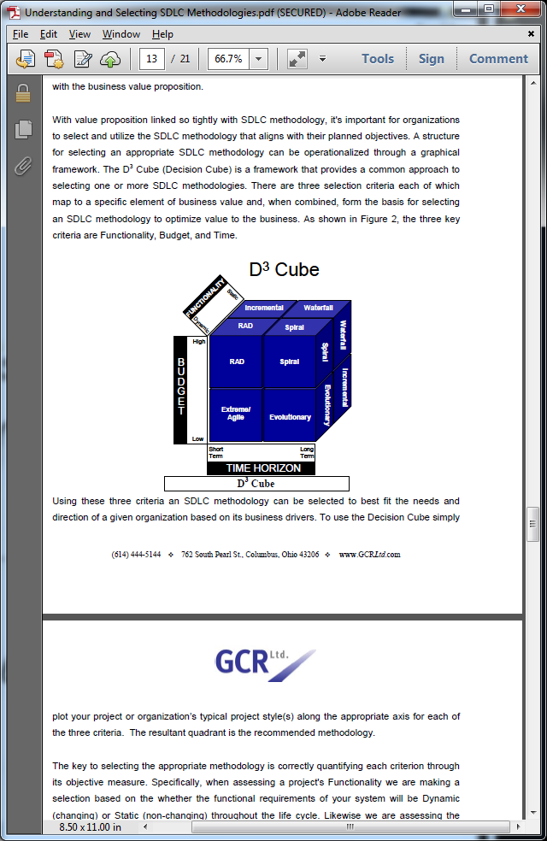

(Understanding and Selecting SDLC Methodologies)

Using D3 Cube can determine based on requirements of project which methodology you should use.  
D3 cube is common approach on how to select one more or more methodologies.

|  |  |  |
| --- | --- | --- |
| Methodology & Criteria | Advantages | Disadvantages |
| Waterfall | Clearly Defined and Attainable goals with well documented process & results | Developed Resistance to any change.  Minimal means for measuring progress within phases. |
| Big Project over long period of time,  Where functionality decided at start. |
| Spiral | Able support changing requirements over lifetime of the project and scale for enhancements. | Increase management complexity and risk for not knowing when project ends due to possible introduction of scope creep |
| Big project over long period of time, Where functionality can change over time based on different requirements. |
| Agile | Rapid demonstration of functionality with minimal uses for resources and supports fixed or changing requirements. | Increase risk requirements for project management & dependencies. Risks are increased maintenance requirements. |
| Small Project over short period of time, Where Functionality decided at start or functionality can change over time based on different requirements. |

# Software Management Tools

Tools available for software management first obvious choice would be project management tool. If you already have Microsoft office products you be more familiar with using Microsoft Project. Microsoft project has tools in managing projects and allocating resources and time according.

Alternative to Microsoft project is OpenProj an open source product and is free to download and use. It has same basic functionality

Choosing appropriate Between MS Project and OpenProj,

Reasoning for not looking for other alternatives because familiarity to software UI design & Critical Path as important requirement.

Similarities between programs not anything major both are project management tools.   
One offers many of same features as other however it’s free. With that being said Microsoft project clearly has more features when comes to reporting. Be that reporting is more direct than OpenProj where outputs files as excel spread sheet. While MS Project uses PDF exports of reports.  
  
If you familiarly with Microsoft products & willing purchase Microsoft office or already have it clearly MS Project perfect choice. OpenProj supports exporting, saving and opening of files for MS project.

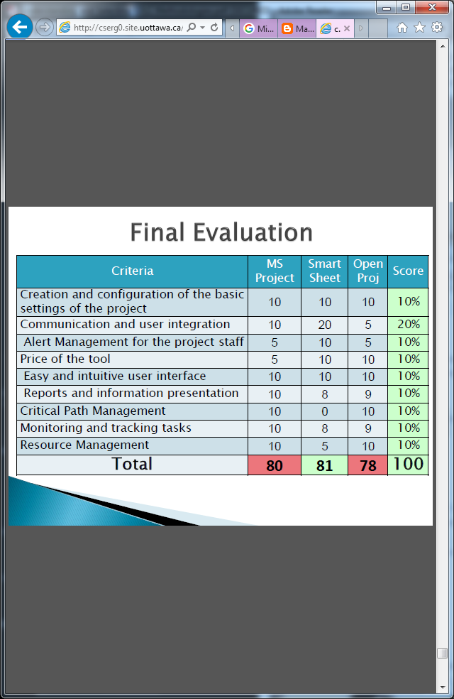

(Microsoft Project vs. SmartSheet vs. OpenProj)

# Project Methodology Email

Dear Project Management,

I gone through possible methodologies to use for this project and selected most suitable for requirements project needs. When doing research and analysing requirements of project I have decided that most suitable methodology is Waterfall slightly modified meet suite requirements of Mr Sparkly.

Source control software for collaboration between projects members we be using GIT HUB. Reasoning for choosing git hub is familiarity and is common source control. Has flexible usage for control over who uses project. Git hub allows you create private repositories where people with sufficient permissions can view and contribute to project. Able organize members into groups that can view & change source control. Includes Issue Tracker used for tracking bugs & features mark with various flags to communicate with rest project team.

Also allows creation of branches that don’t change main code. But allow you test & create additional features before implementing them into main project. Main, features of git is ability to create comments for all code changes and implementations. So Git & Git hub be source version control software we be using for the project.

Ideal project management software is MS Project as company computers already have Microsoft products ready. However, I don’t have MS Project so I be using OpenProj then exporting it for use with MS Project.

From Jade Lead Programmer.

## Sign off

Manager approves methodology research and appropriate methodology chosen for the project. Source control product chosen is appropriate and project plan meets client’s requirements.

Signature: ___________ date: ___/___/_____

# Bibliography

###### Understanding and Selecting Systems Development Life Cycle (SDLC) Methodologies

<http://www.menyaltd.com/Portals/7/Understanding%20and%20Selecting%20SDLC%20Methodologies.pdf>

###### Microsoft Project vs. SmartSheet vs. OpenProj

http://cserg0.site.uottawa.ca/seg/pub/CSI5112/PresentationSchedule/FinalProjectGHS.pdf

###### OpenSource: OpenProj vs Microsoft Project

<http://marikaneshimacs100w.blogspot.com/2013/10/opensource-openproj-vs-microsoft-project.html>

###### OpenProj v. Microsoft Project 2007

<http://mmis-621.blogspot.com/>

###### Git hub features

https://github.com/features