Software Testing Report (IEEE 829 standard)
Contents
Executive Summary: 1
Test Scope: 2
Test Environment: 2
Test Execution Summary: 3
Defect Summary: 4
Defect Analysis: 7
Coverage Report: 8
Risk Assessment Update: 8
Test Conclusion: 10
Recommendations: 10
Lessons Learned: 11
Appendices: 11
PMT Formula Research: 11
Appendix A: Test Plan 11
Appendix B: Test Cases 11
Appendix C: Test Execution Results: 12
Appendix D: Traceability Matrix: 12
Appendix F: Defect Log 12
Appendix G: Risk Register: 12

Executive Summary:
This report confirms that the BankCore Enterprise Management System has been thoroughly tested through an extensive, and detailed testing cycle which included both manual and automated testing. All of the BankCore Enterprise Management System’s modules where tested through multiple different tests to ensure that the application meets business requirements, and that it is ready for deployment.
During the testing phase, multiple tests where conducted which highlighted 17 bugs, which impacted the programs readiness for deployment. It should also be noted that these defects have been rectified to ensure that the BankCore Enterprise Management System meets business requirements, and that it is ready to be deployed.

Test Scope:
During the testing phase of the BankCore Enterprise Management System, the following where tested:
- Account Management module
- Transaction Engine module
- Interest Calculator module
- Loan Processing module
- Reporting Engine module
- Authentication module
- Validation Library module
It should also be noted that the following aspects where not tested:
- Front end UI
- External database connections
- Third-Party API integrations

Test Environment:
Testing workstations:
- Main Testing Workstation:
  - CPU: AMD Ryzen 7 5800X3D
  - GPU: AMD Radeon RX9060XT
  - RAM: 32GB RAM
  - ROM: 1TB Nvme M.3 SSD
  - OS: Windows 11 Pro 25H2
  - Tools:
    - .NET SDK 8.0
  - IDE: Visual Studio 2026
- Secondary Testing Workstation:
  - CPU: AMD Ryzen 5 5500
  - GPU: NVIDIA GeForce RTX 3050
  - RAM: 16GB RAM
  - ROM: 1TB Nvme M.3 SSD
  - OS: Windows 11 Pro 25H2
  - Tools:
    - .NET SDK 8.0
  - IDE: Visual Studio 2026
Other tools:
- NuGet Packages:
  - Microsoft.NET.Test.sdk
  - MSTest
  - NUnit
  - xUnit
  - Moq
  - FluentAssertions
  - Coverlet.Collector

Test Execution Summary:
Module | Run # | Date | Total TCs | Passed | Failed | Blocked | Not Run | Pass Rate
Account Management | Run 1 | 06/07/2026 | 46 | 43 | 3 | 0 | 0 | 93,48%
Authentication | Run 1 | 06/07/2026 | 32 | 29 | 2 | 0 | 1 | 90,63%
Validation Library | Run 1 | 06/07/2026 | 48 | 43 | 5 | 0 | 0 | 89,58%
Transaction Engine | Run 1 | 06/07/2026 | 60 | 57 | 3 | 0 | 0 | 95,00%
Reporting Engine | Run 1 | 06/07/2026 | 10 | 10 | 0 | 0 | 0 | 100,00%
Interest Calculator | Run 1 | 06/07/2026 | 62 | 47 | 15 | 0 | 0 | 75,81%
Loan Processing | Run 1 | 06/07/2026 | 23 | 20 | 3 | 0 | 0 | 86,96%

OVERALL TEST EXECUTION SUMMARY
Run # | Date | Total TCs | Passed | Failed | Blocked | Not Run | Pass Rate
Run 1  Baseline | 06/07/2026 | 281 | 249 | 31 | 0 | 1 | 88,61%
Run 2  After Fix 1 | 07/07/2026 | 31 | 31 | 0 | 0 | 0 | 100,00%
Run 3  Regression | 08/07/2026 | 115 | 115 | 0 | 0 | 0 | 100,00%

Moq was implemented to mock the applications audit service because it was of utmost importance to confirm that the program actually performed system interactions by logging every activity that occurred on the program. By using mocks instead of stubs, it allowed me to assert that the interaction with the data layer actually occurred.

Defect Summary:
- Defect counts by severity:
Severity | Score
Low | 2
Medium | 3
High | 6
Critical | 6
Total | 17
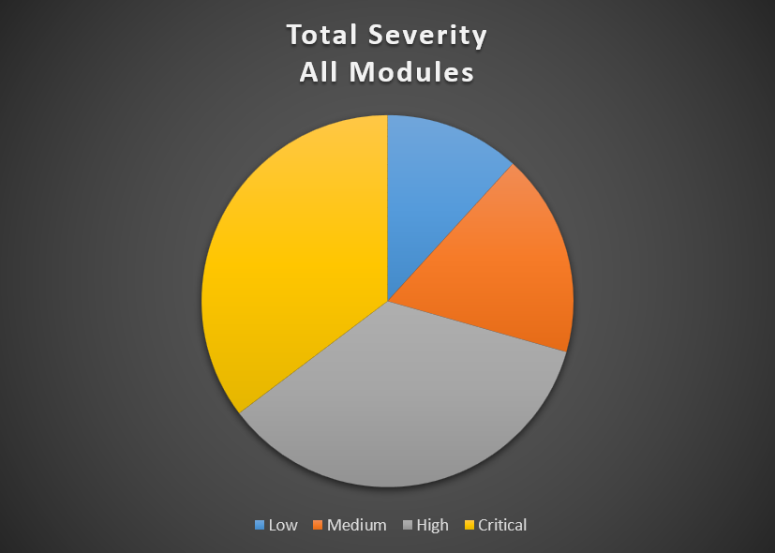
- Defect counts by priority:
Priority | Score
P1 | 9
P2 | 4
P3 | 2
P4 | 2
Total | 17

- Defect counts by severity per module:
Severity Per Module | Low | Medium | High | Critical
Account Management | 0 | 0 | 1 | 1
Authentication | 0 | 1 | 0 | 2
Validation Library | 1 | 0 | 2 | 0
Interest Calculator | 0 | 0 | 1 | 1
Transaction Engine | 0 | 1 | 1 | 1
Loan Processing | 0 | 1 | 1 | 1
Reporting Engine | 1 | 0 | 0 | 0

- Defect counts by priority per module:
Priority Per Module | P1 | P2 | P3 | P4
Account Management | 2 | 0 | 0 | 0
Authentication | 2 | 1 | 0 | 0
Validation Library | 1 | 1 | 0 | 1
Interest Calculator | 1 | 1 | 0 | 0
Transaction Engine | 1 | 1 | 1 | 0
Loan Processing | 2 | 0 | 1 | 0
Reporting Engine | 0 | 0 | 0 | 1

Defect Analysis:
Upon reviewing, most of the defects in the:
- Account Management Module was caused by assignment and logic errors
- Authentication Module was caused by conditions that were never checked
- Interest Calculator Module was caused by wrong formulas being used
- Loan Processing Module was caused by faulty formulas being used
- Reporting Engine Module was caused by not running validation checks on dates
- Transaction Engine Module was caused by incorrect conditional checks
- Validation Module was caused by faulty conditional checks

Coverage Report:
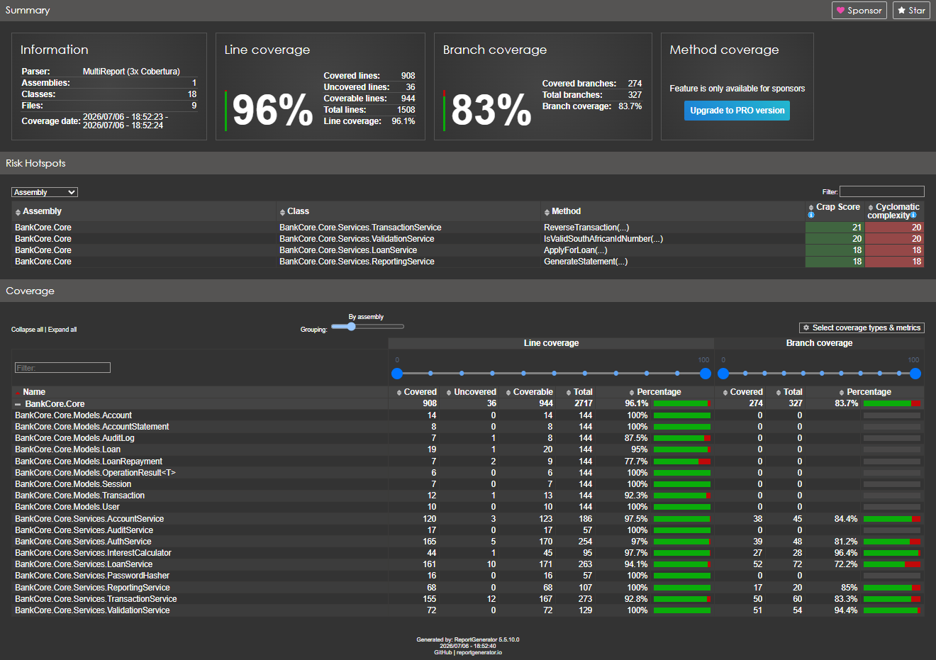

Risk Assessment Update:
Risk ID | Risk Description | Category | Likelihood (H/M/L) | Impact (H/M/L) | Risk Rating | Mitigation Strategy | Actual Results | Owner
R001 | Financial calculation errors in interest module | Functional | High | High | Critical | Boundary value tests + formula verification | Formula errors where found | Tester
R002 | Session token not invalidated on logout | Security | Medium | High | High | Auth test cases + manual trace | Logged out sessions still pass validation | Tester
R003 | Able to transfer money to an account that does not exist, or one which is closed | Functional | Low | High | Medium | Design test cases that verify account status checks | Program does not allow funds to be transferred to non-existant accounts | Tester
R004 | Negative values are accepted when making a deposit | Functional | Medium | High | High | Ensure to make use of equivalence partitioning to test negative input partitions | No negative values are accepted | Tester
R005 | Application throws exceptions that are not handled when null or empty fields are detected | Functional | Medium | Medium | Medium | Check all fields for empty, null, or whitespace fields. | Application throws error messages when invalid data types are detected | Tester
R006 | Tellers are able to access admin-role only functions | Security | Medium | High | High | Implement role-based access control. Test RBAC for all user types | Strong role based access conditions are inforced | Tester
R007 | 1000 sequential transactions exceed acceptable amount of time to process | Performance | Medium | Medium | High | Use the C# builtin stopwatch feature when running test scripts to measure execution time | Processing times are acceptable | Tester
R008 | System freezes when generating a 12-month account statement for an account with 5000+ transactions | Performance | High | Medium | Medium | Use Nunit testing and implement the [Timeout] attribute to enforce performance SLA's | Program does not freeze | Tester
R009 | Passwords are stored as plain text in program code | Security | Low | High | High | Test password hashing enforcement. | Passwords are hashed and salted | Tester
R010 | SQL injection strings and/or special characters crash the program | Robustness | High | High | Critical | Upon testing, ensure to insert known strings that are malicious as input parameters. | Program does not crash, or perform malicious actions when SQL injection strings are entered | Tester

Test Conclusion:
After the test phase has concluded, which has successfully highlighted several business-critical bugs in the financial formulas and conditional statements of the program logic.
After the identified bugs have been corrected (fixed as simulated), both the manual and automated tests have been rerun to eliminate any possibility of regression. Consequently, the BankCore Enterprise Management System is now considered as highly stable, and is ready to be deployed for use. Once the application is deployed, it is highly advisable that the application be monitored to quickly remediate any bugs in the very unlikely event that one occurs.

Recommendations:
Upon the successful completion of the testing phase, the following recommendations can be made:
- It is recommended that the development team double check financial formulas when creating a financial application
- It is also recommended that the development team ensure to use the correct conditional statements to ensure that errors don’t occur at boundaries
- It is recommended that the development team integrate third-party multi factor authentication to ensure that the application remains as secure as possible.
- It is recommended that the development team perform a comprehensive code audit to ensure that the application remains robust and secure against any SQL injection strings.
- It is highly recommended that the development team makes use of stricter session token management policies to ensure that session tokens are invalidated when a user is logged out
- It is recommended that the development team implement CI/CD Integration so that automated tests are run on code every time it gets pushed to the application’s repository.

Lessons Learned:
There are multiple lessons I have learned throughout the course of this testing phase, like how important documentation is on the program logic, as well as how important testing documentation is when it comes to a multiple phase testing phase.
There are a few things I would do differently when it comes to testing an application, like:
- Making sure that you should always remember to push your code to an online repository from the start to prevent data loss.
- I have also learned to make sure that you should always check whether the correct versions of packages are installed to prevent any runtime errors.
- Another huge lesson I have learned is that the quality of documentation is important, and should not be seen as an easy task.

Appendices:

PMT Formula Research:
After research, the formula below is the PMT formula is as follows:
PMT = (PresentValue x rate) / (1 – (1 + rate )^-n
It is derived from the PresentValue (PV) of the ordinary annuity formula:
Step 1: PV = PMT / (1 + r )^1 + PMT / (1 + r )^2 + PMT / (1 + r )^3
Step 2: PV = PMT[1 / (1 + r )^1 + 1 / (1 + r )^2 + 1 / (1 + r )^3]
Step 3: PV = PMT[1/1+r x 1 – (1/1+r)^n / 1 – 1/(1/1+r)]
Step 4: PV = PMT[1 – (1 + r)^-n / r]
Step 5: PMT = (PV x r) / (1 – (1+r)^-n)

Appendix A: Test Plan
File: TestPlan.docx

Appendix B: Test Cases
File: TestCases.xlsx

Appendix C: Test Execution Results:
File: TestCases – Executed.xlsx

Appendix D: Traceability Matrix:
File: TraceabilityMatrix.xlsx

Appendix F: Defect Log
File: DefectLog.xlsx

Appendix G: Risk Register:
File: RiskRegister.xlsx

