**System Architecture**

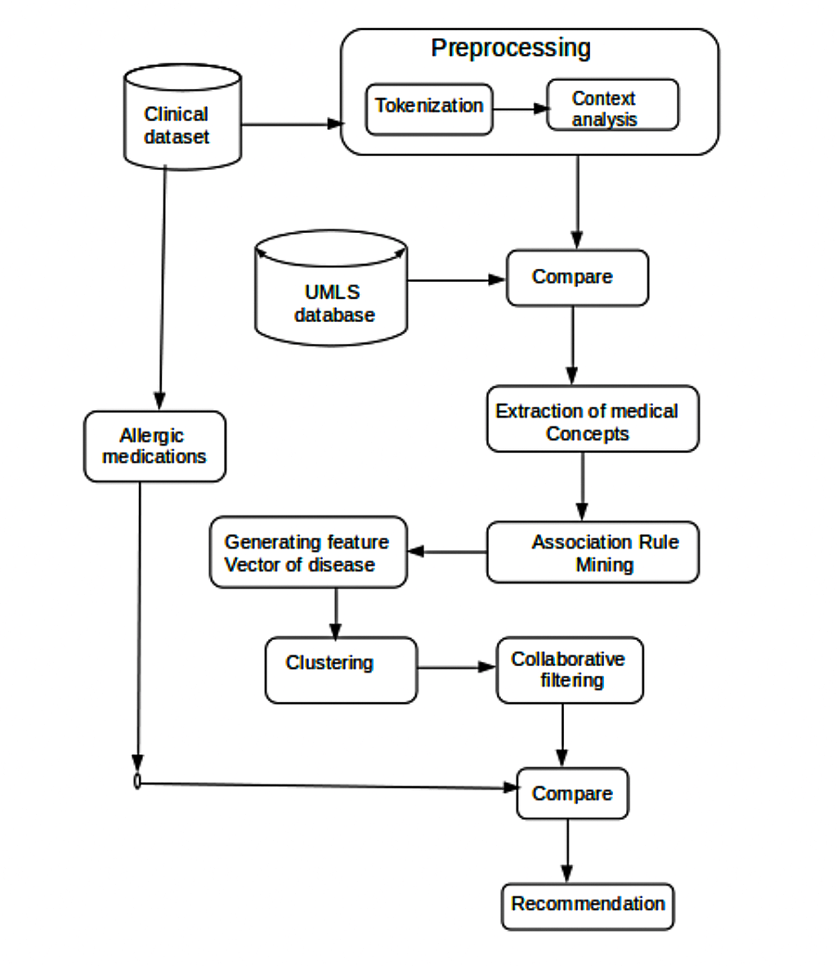

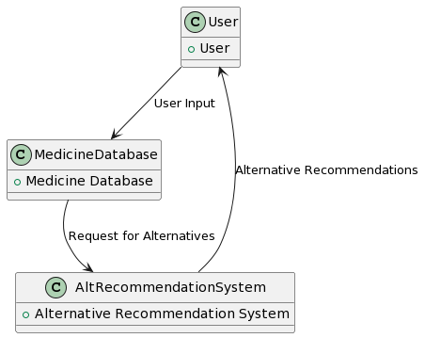

**Dataflow Diagram 0**

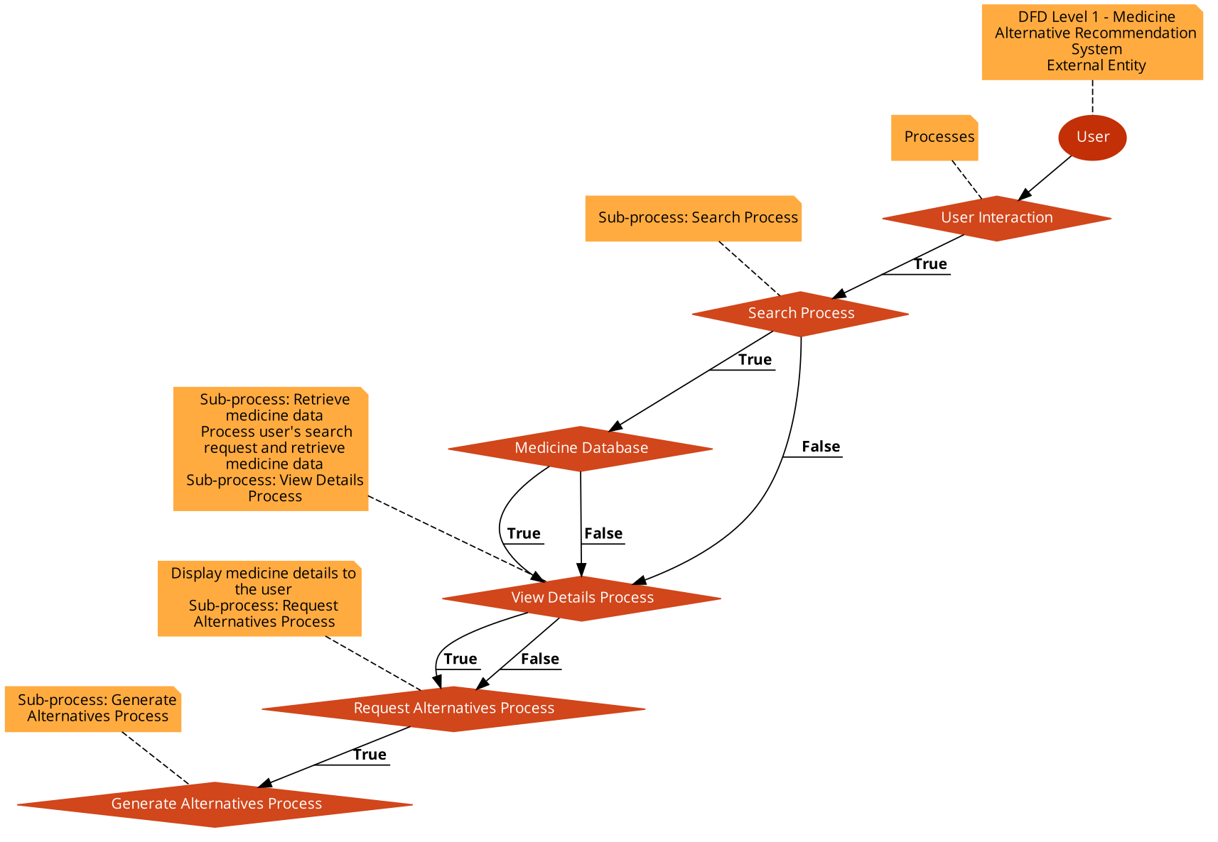

**Dataflow Diagram 1**

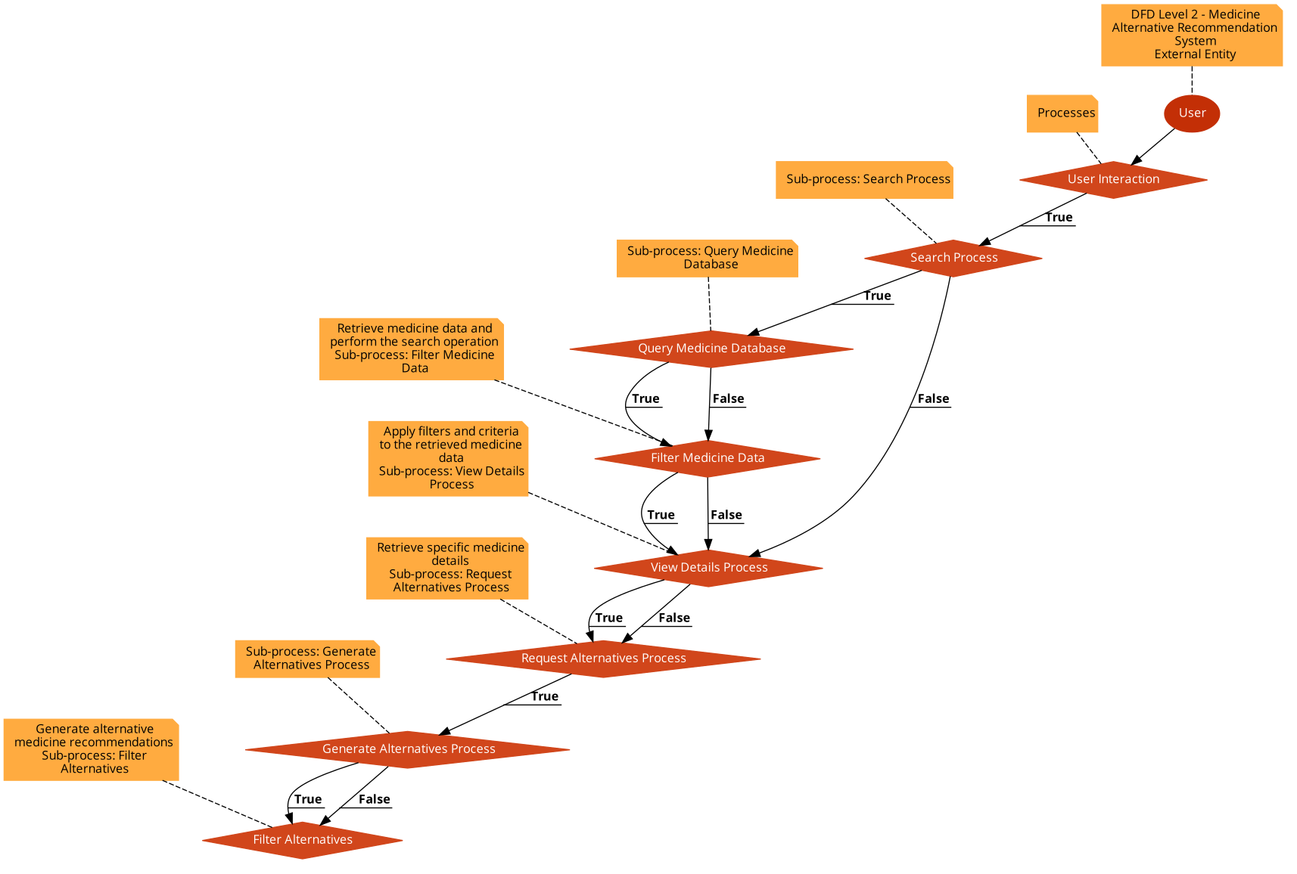



**Dataflow Diagram 2**

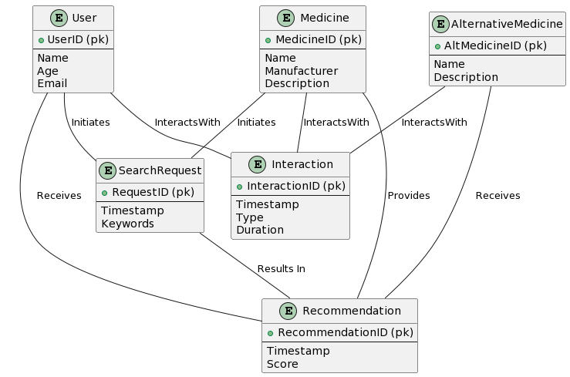

**Entity Relationship Diagram**

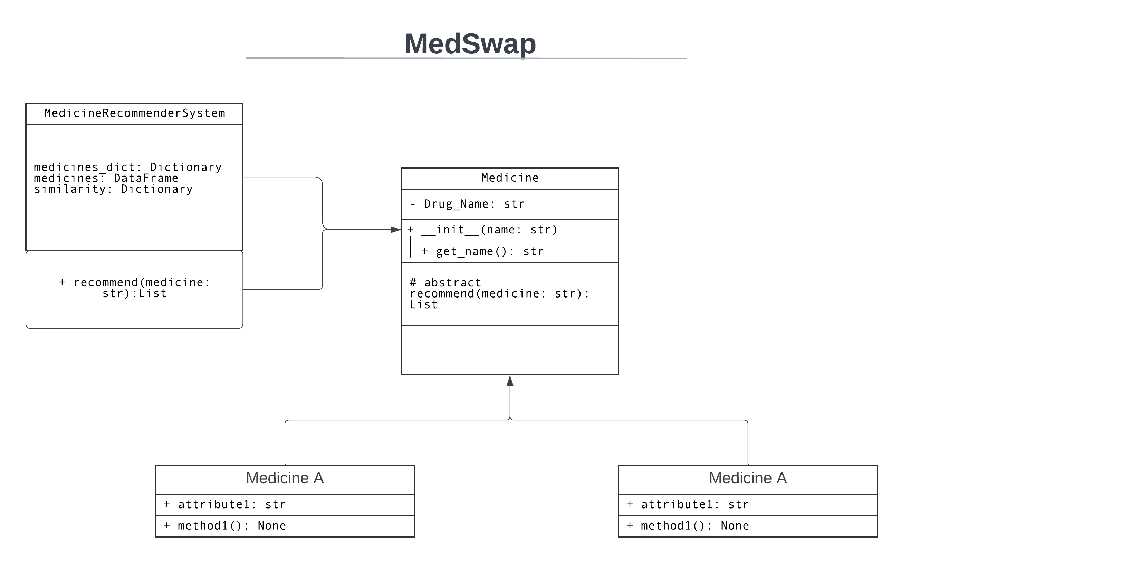

**Class Diagram**

**Users**

Id

first_name

last_name

email

password

level

username

password

allergies

**Drugs**

Id

drug_name

drug_class

dose

drug_dosage

allergies

**Symptoms**

Id

symptoms_name

pob_affected

drug_ids

symptoms_list

**Object Diagram**

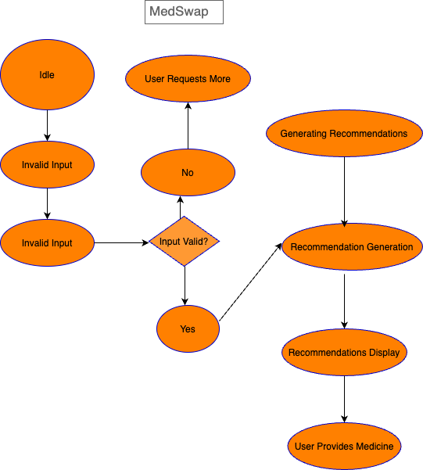

**State Diagram**

**Use Case Diagram**

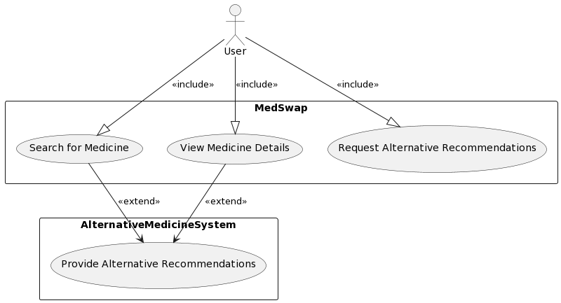

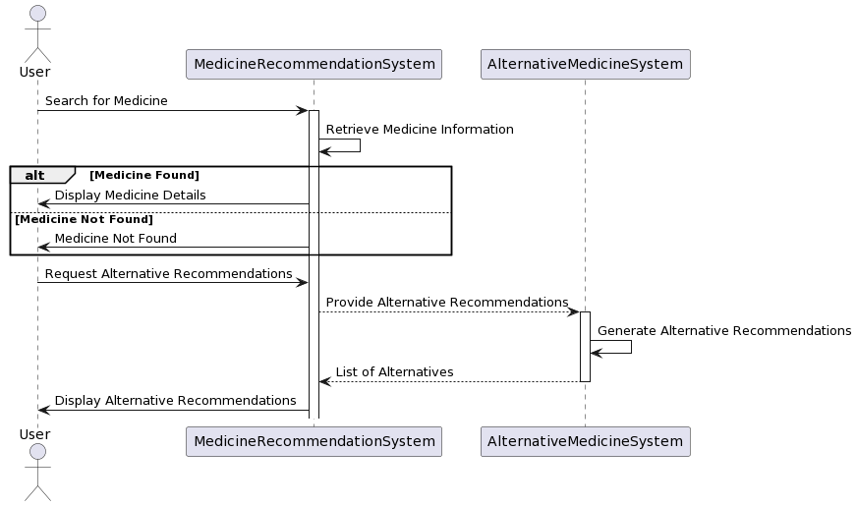

**Sequence Diagram**

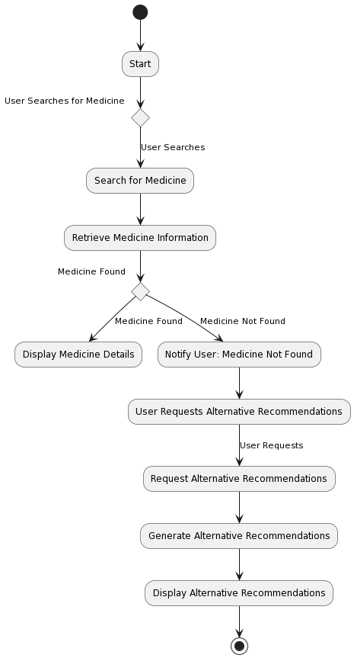

**Activity Diagram**